Supplementary Table 1 Albinism genes and candidate genes analyzed in the exome sequencing.
 | Analyzed Gene | Location | Size (pb) | Exons | Protein (aa) | RefSeq
Albinism related genes | TYR | 11q14.3 | 2485 | 5 | 529 | NM_000372.5
 | OCA2 | 15q12-q13 | 3186 | 24 | 838 | NM_000275
 | TYRP1 | 9p23 | 2851 | 8 | 537 | NM_000550
 | SLC45A2 | 5p13.2 | 1772 | 7 | 530 | NM_016180.5
 | N.I. | 4q24 | N.A. | N.A. | N.A. | N.A.
 | SLC24A5 | 15q21.1 | 1897 | 9 | 500 | NM_205850
 | LRMDA | 10q22.2-q22.3 | 1040 | 7 | 226 | NM_001305581
 | GPR143 | Xp22.2 | 1762 | 9 | 404 | NM_000273
Albinism candidate genes | DCT | 13q32.1 | 5074 | 8 | 519 | NM_001922.5
 | MITF | 3p13 | 4670 | 10 | 504 | NM_198177.3
 | MC1R | 16q24.3 | 3099 | 1 | 317 | NM_002386.3
 | POMC | 2p23.3 | 1128 | 3 | 267 | NM_000939.4
 | ASIP | 20q11.22 | 586 | 3 | 132 | NM_001672.2
 | SLC24A4 | 14q32.12 | 4531  N.I: not identified; N.A: not available. | 18 | 603 | NM_153647.4
 | IRF4 | 6p25.3 | 5314 | 9 | 451 | NM_002460.4
 | TPCN2 | 11q13.3 | 4969 | 25 | 752 | NM_139075.4

Supplementary Table 2 Oculocutaneous Albinism related variants found in the cohort of eight Brazilian individuals.
(+) represent that the variant has been related to albinism, (-) present that the variant has not been related to albinism before the present study; N.Av.: not available; N.Ap: does not apply.

Variant | Gene | Type of mutation | Associated with Albinism | dbSNP | Allele Frequency in dbSNP |  |  |  |  | Pathogenicity Predictions
 |  |  |  |  | gnomAD | ExAC | 1000G | TOPMED |  | SIFT_indel | Mutation Taster | HSP 3.1 | CADD score
c.1217C>T | TYR | missense | + | rs104894313 | T=0.00383 | T=0.00349 | T=0.002 | T=0.00349 |  | N.Ap. | Disease causing | N.Ap. | 32.0
c.1185-2A>G | TYR | splicing | - | rs1289685376 | N.Av. | N.Av. | N.Av. | G=0.00001 |  | N.Ap. | N.Ap. | Affecting Splicing | 24.5
c.140G>A | TYR | missense | + | rs61753180 | A=0.00016 | A=0.00009 | A=0.001 | A=0.00026 |  | N.Ap. | Disease causing | N.Ap. | 27.3
c.1456delG | TYR | frameshift deletion | - | N.Av. | N.Av. | N.Av. | N.Av. | N.Av. |  | Damaging | Disease causing | N.Ap. | 25.3
c.389_391delAGA | TYR | inframe deletion | - | rs1413017181 | delAGA=0.0001 | N.Av. | N.A. | delAGA=0.00001 |  | Damaging | Disease causing | N.Ap. | 17.89
c.1037-7T>A | TYR | splicing | + | rs61754381 | A=0.0002 | N.Av. | A=0.001 | A=0.00042 |  | N.Ap. | N.Ap. | Affecting Splicing | 5.06
c.264delG | SLC45A2 | frameshift deletion | + | rs775387808 | delG=0.00010 | delG=0.00008 | N.Av. | delG=0.00014 |  | Damaging | Disease causing | N.Ap. | N.Av.
c.606G>C | SLC45A2 | missense | + | rs146802593 | G=0.00023 | G=0.0002 | N.Av. | G=0.00013 |  | N.Ap. | Disease causing | N.Ap. | 23.1

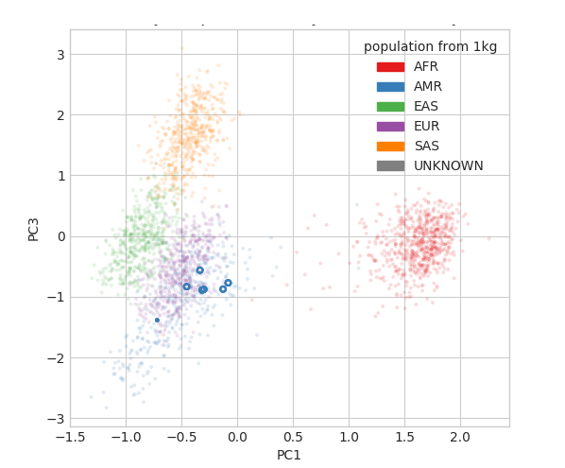
Supplementary Figure 1: Principal component analysis (PCA) of ancestrally analysis. The participants clustered together with markers corresponding to the Ad Mixed American superpopulation (dots circled in blue).

