Supporting Information
β-FeOOH interlayer with abundant oxygen vacancy towards boosting catalytic effect for lithium sulfur batteries
Yingying Liª, Xifei Li^{a,b,c*}, Youchen Hao^{b}, Alibek Kakimov^{b}, Dejun Liª, Qian Sun^{d}, Liang Kou^{e}, Zhanyuan Tian^{e}, Le Shao^{e}, Cheng Zhang^{e}, Jiujun Zhang^{b,f}, Xueliang Sun^{a,b,d}
ªTianjin International Joint Research Centre of Surface Technology for Energy Storage Materials, Energy & Materials Engineering Centre, College of Physics and Materials Science, Tianjin Normal University, Tianjin 300387, China.
^{b}Xi'an Key Laboratory of New Energy Materials and Devices, Institute of Advanced Electrochemical Energy & School of Materials Science and Engineering, Xi’an University of Technology, Xi’an 710048, Shaanxi, China.
^{c}State Center for International Cooperation on Designer Low-carbon &Environmental Materials (CDLCEM), Zhengzhou University, 100 Kexue Avenue, Zhengzhou 450001, China.
^{d}Department of Mechanical and Materials Engineering, University of Western Ontario, London, Ontario N6A 5B9, Canada.
^{e}Shaanxi Coal Chem Ind Technol Res Inst Co Ltd, Xian, Shaanxi 710070, China.
^{f}Department of Chemistry, College of Sciences/Institute for Sustainable Energy, Shanghai University, Shanghai, 200444, China
*Email: xfli2011@hotmail.com
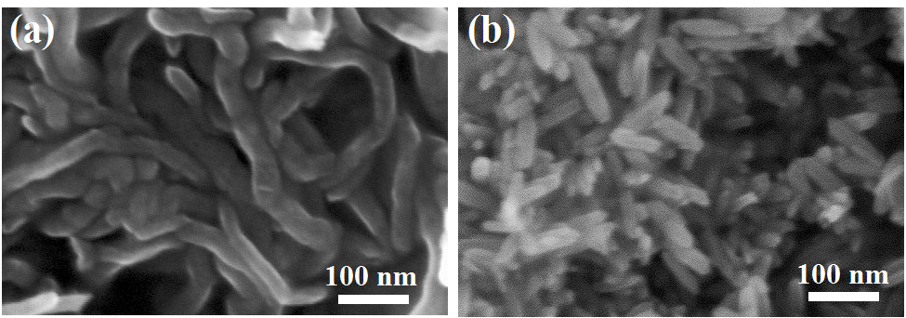
Figure S1. SEM images of (a) CNTs and (b) bare FeOOH sticks.

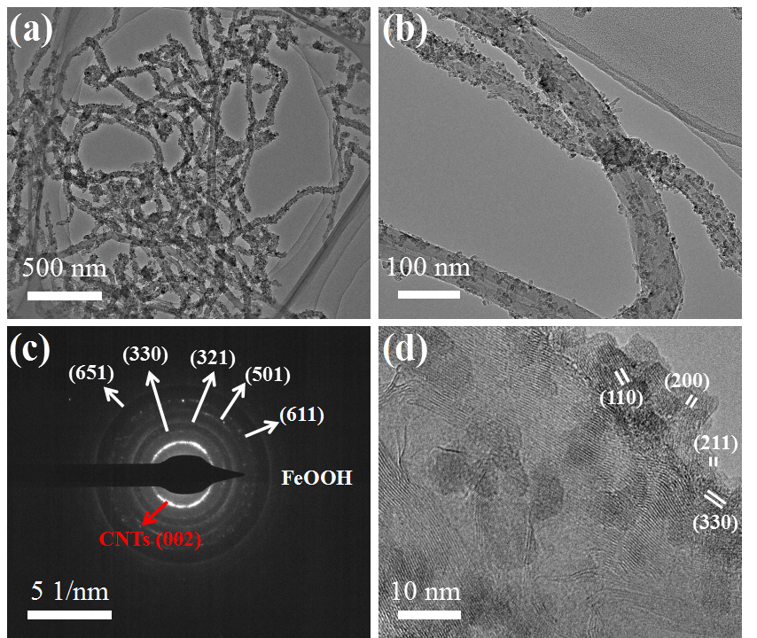
Figure S2. High and low-maganification TEM images of CNTs@FeOOH-II compounds and the corresponding SAED.

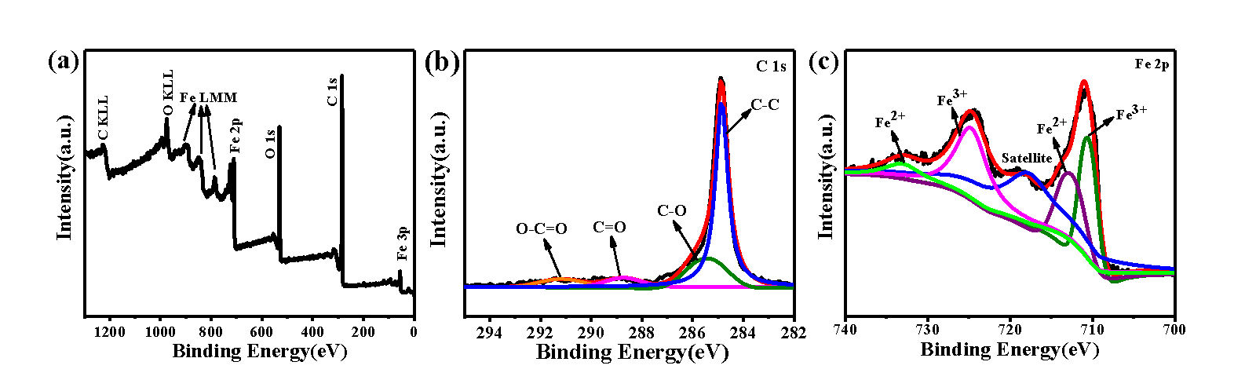
Figure S3. High-resolution XPS spectra of the (a) original XPS survey spectra, (b) C1s and (c) Fe 2p of CNTs@FeOOH-II composite.

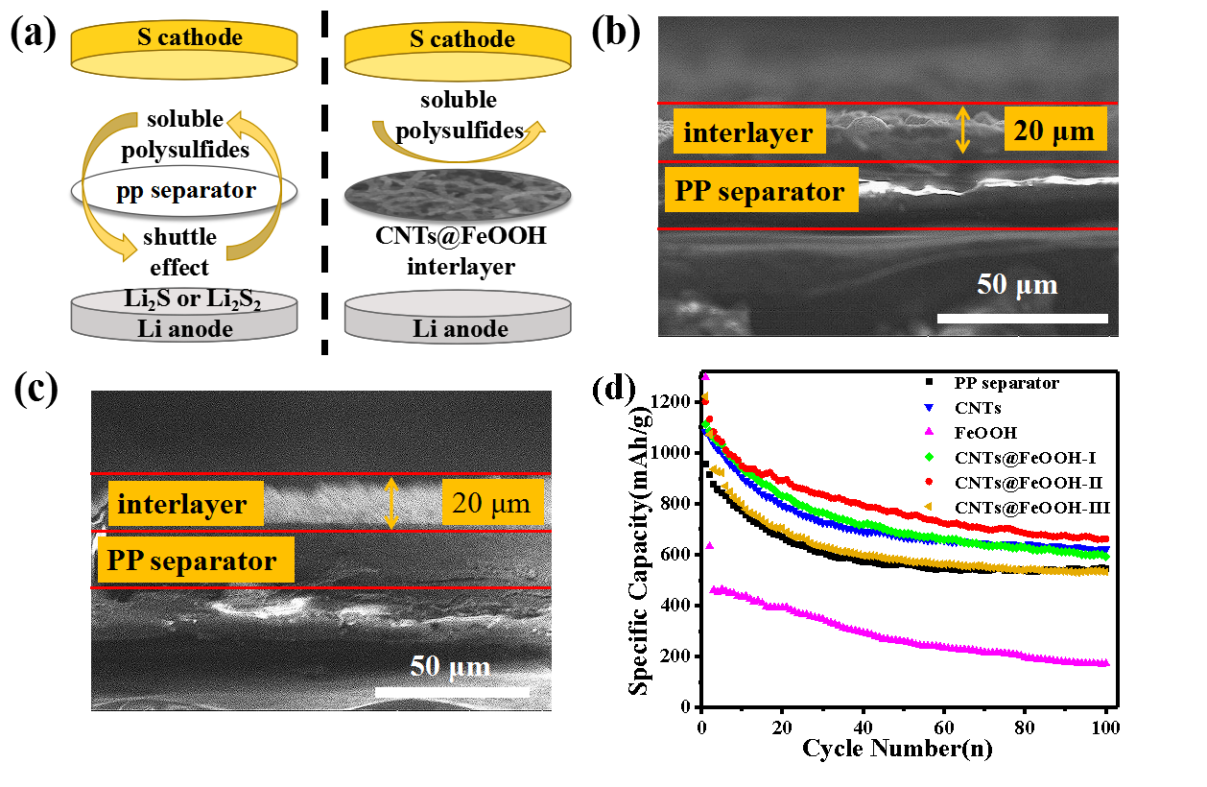
Figure S4. (a) Schematic diagram of conventional and improved Li-S cells; cross section of (b) CNTs@FeOOH-I and (c) CNTs@FeOOH-III interlayer; (d) Cycle performance of batteries with PP, CNTs, FeOOH, and CNTs@FeOOH separator, respectively, at 320 mA g⁻¹.

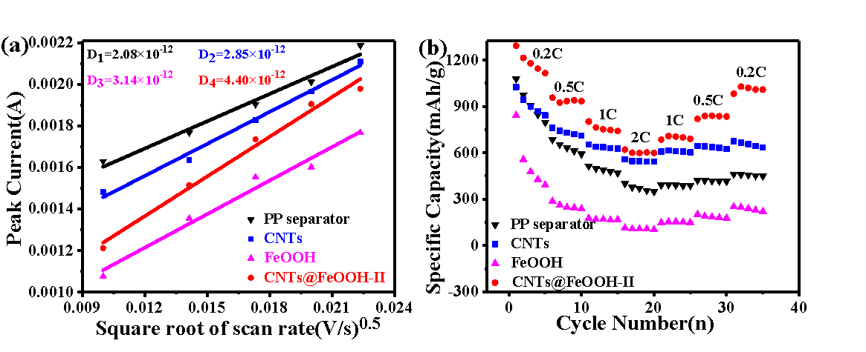
Figure S5. (a) The corresponding relationship between the square root of the scan rate V^{0.5} and peak current Ip of CNTs@FeOOH-II in a voltage range of 1.7–2.8 V vs. Li⁺/Li. (b) rate capability of four kinds of separator.

Table S1 Comparison of the Li-S batteries with different functional interlayer, with results from this work and from the literature
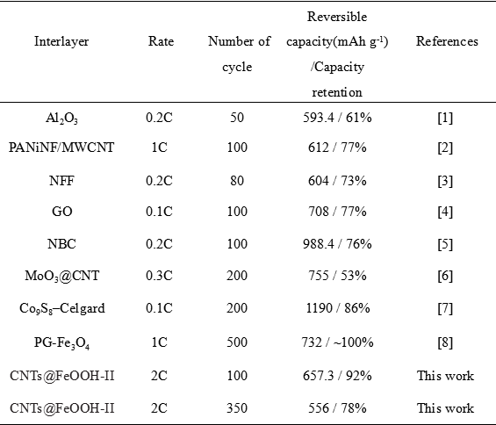

References

[1] Zhang Z; Lai Y; Zhang Z; Zhang K; Li J. Al₂O₃-coated porous separator for enhanced electrochemical performance of lithium sulfur batteries. Electrochimica Acta 2014, 129, 55-61.

[2] Chang C-H; Chung S-H; Manthiram A. Ultra-lightweight PANiNF/MWCNT-functionalized separators with synergistic suppression of polysulfide migration for Li–S batteries with pure sulfur cathodes. Journal of Materials Chemistry A 2015, 3, 18829-18834.

[3] Jia-Qi; Huang T-ZZ; Qiang Zhang; Hong-Jie Peng; Cheng-Meng Chen; and Fei Wei. Permselective Graphene Oxide Membrane for Highly Stable and Anti-Self-Discharge Lithium Sulfur Batteries. ACS Nano 2015, 9 3002–3011.

[4] Zhang K; Qin F; Fang J; Li Q; Jia M; Lai Y; Zhang Z; Li J. Nickel foam as interlayer to improve the performance of lithium–sulfur battery. Journal of Solid State Electrochemistry 2013, 18, 1025-1029.

[5] Cai W; Li G; Zhang K; Xiao G; Wang C; Ye K; Chen Z; Zhu Y; Qian Y. Conductive Nanocrystalline Niobium Carbide as High-Efficiency Polysulfides Tamer for Lithium-Sulfur Batteries. Advanced Functional Materials 2018, 28.

[6] Luo L; Qin X; Wu J; Liang G; Li Q; Liu M; Kang F; Chen G; Li B. An interwoven MoO₃@CNT scaffold interlayer for high-performance lithium–sulfur batteries. Journal of Materials Chemistry A 2018, 6, 8612-8619.

[7] He J; Chen Y; Manthiram A. Vertical Co₉S₈ Hollow Nanowall Arrays Grown on A Celgard Separator as A Multifunctional Polysulfide Barrier for High-Performance Li–S Batteries. Energy & Environmental Science 2018, 11, 2560-2568.

[8] He J; Luo L; Chen Y; Manthiram A. Yolk-Shelled C@Fe₃O₄ Nanoboxes as Efficient Sulfur Hosts for High-Performance Lithium-Sulfur Batteries. Adv Mater 2017, 29.

