Supplementary information
Generation of Transgenic Cloned Buffalo Embryos Harboring the EGFP Gene in the Y Chromosome Using CRISPR/Cas9-Mediated Targeted Integration
Running title: Optimization of Homologous Recombination in Transgenic Cloned Buffalo Embryos

Xiuling Zhao^{1,*}, Junyu Nie^{1,*}, Yuyan Tang¹, Wengtan He¹, Kai Xiao¹, Chunying Pang², Xianwei Liang², Yangqing Lu^{1,**}, Ming Zhang^{1, **}
¹ State Key Laboratory for Conservation and Utilization of Subtropical Agro-Bioresources, Animal Reproduction Institute, Guangxi University, Nanning, 530004, Guangxi, PR China
² Key Laboratory of Buffalo Genetics, Breeding and Reproduction Technology, Ministry of Agriculture and Buffalo Research Institute, Chinese Academy of Agricultural Science, Nanning, Guangxi 530001, PR China
* These two authors contributed equally to this work.
** Corresponding author. E-mail address: luyangqing@126.com (Y.Q. Lu), mingzhang@gxu.edu.cn (M. Zhang)

Contents:
Figure S1. Map of the RGS plasmid.
Figure S2. The percentage of transfected cells, as determined by mCherry expression, was affected by voltage.
Figure S3. The percentage of transfected cells, as determined by mCherry expression, was affected by the number of pulses.
Figure S4. In vitro development of non-transgenic cloned embryos from buffalo.
Table S1. The sequences of the sgRNAs targeting the Ddx3y gene from buffalo.
Table S2. The sequences of the sgRNAs targeting the Actb gene from buffalo.
Table S3. Primers used for amplification of 5’ and 3’ junctions.
Table S4. Primers used for amplification of epigenetic-related genes.
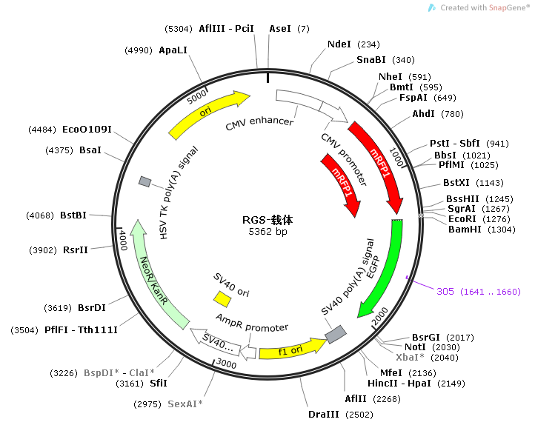
Figure S1. Map of the RGS plasmid.
Figure S2. The percentage of transfected cells, as determined by mCherry expression, was affected by voltage.
Figure S3. The percentage of transfected cells, as determined by mCherry expression, was affected by the number of pulses.
Figure S4. In vitro development of non-transgenic cloned embryos from buffalo.

sgRNA | Sequence (5’-3’)
sgRNA1 | CACGAGCAAGCATCTGAAAG
sgRNA2 | GGTGAGTAAACACAGGGTAC
sgRNA3 | GCACTCATAAAGAATGCACA
Table S1. The sequences of the sgRNAs targeting the Ddx3y gene from buffalo

sgRNA | Sequence (5’-3’)
sgRNA1 | GATCCACATCTGCTGGAAGG
sgRNA2 | CGTCCACCGCAAATGCTTCT
sgRNA3 | GCAGATGTGGATCAGCAAGC
sgRNA4 | CCACCGCAAATGCTTCTAGG
Table S2. The sequences of the sgRNAs targeting the Actin gene from buffalo

Primer | Sequence (5’-3’)
5’ OF | TCAACTCATTTTCATGTGGC
5’ OR | GGCTATGAACTAATGACCC
5’ IF | GTACAGTAGTAATGGCAGTG
5’ IR | GGCTATGAACTAATGACCC
3’ OF | CCCACTGTCCTTTCCTAA
3’ OR | GGTGGTGCTGATATTGGT
3’ IF | CCCACTGTCCTTTCCTAA
3’ IR | GGATGTCACTTGTTGGTG
Table S3. Primers used for amplification of 5’ and 3’ junctions

Gene | Primer | Sequence (5’-3’) | Product size
DNMT1 | F | CTCAGAAGGGAGACGTGGAG | 138 bp
 | R | TAGTAGTCACAGTAGCTGAGGA
DNMT3a | F | GTGCTGTCTCTATTCGATGG | 188 bp
 | R | CCATTCCTGGATATGCTTCTG
HDAC1 | F | ATCGGTTAGGTTGCTTCAATCTG | 168 bp
 | R | TTGTATGGAAGCTCATTAGGGA
HDAC2 | F | ACAGGGTCATCCCATGAAAC | 115 bp
 | R | TTCTTCAGCAGTGGCTTTAT
HDAC3 | F | ATCCGGATGGAGCGTGAAGT | 137 bp
 | R | GTGGCTACACTGTCCGGAAT
GAPDH | F | TCAAGAAGGTGGTGAAGC | 122 bp
 | R | CCCAGCATCGAAGGTAGA
Table S4. Primers used for amplification of epigenetic-related genes

