Supplementary Material

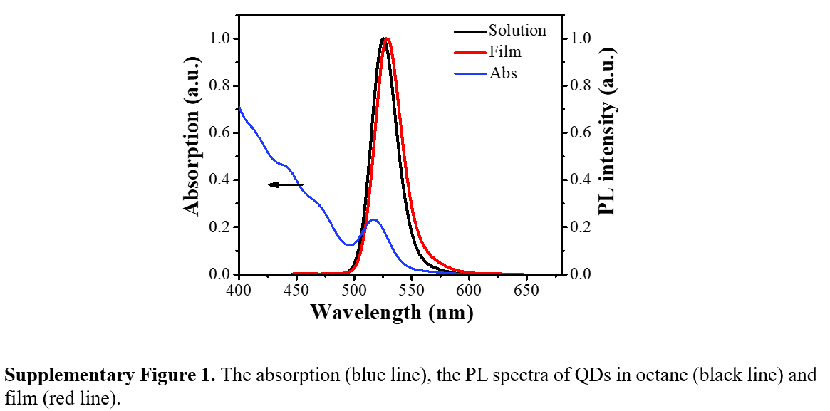

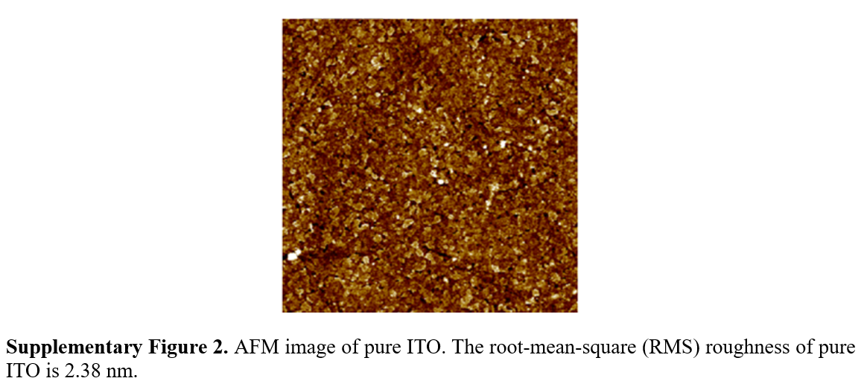
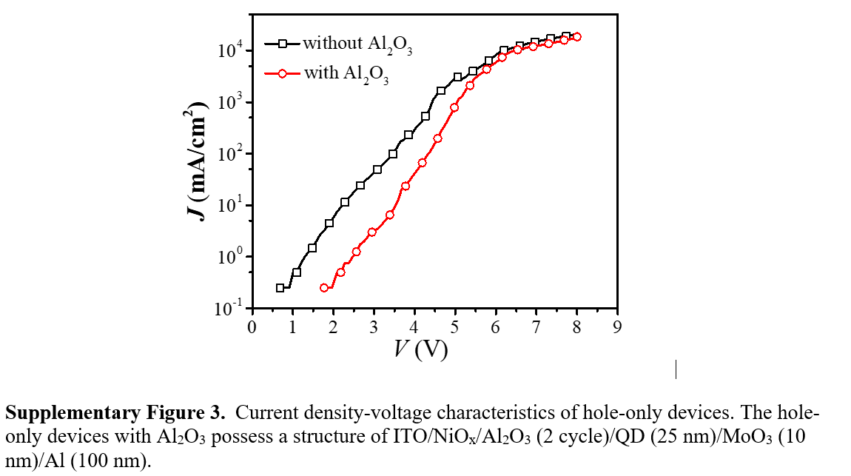

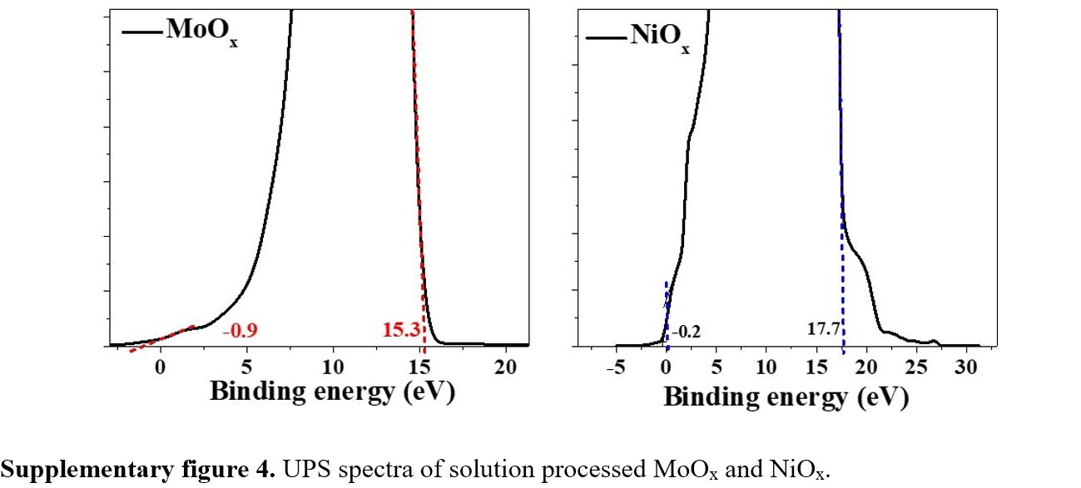

Supplementary Table 1. Summary of the electrical properties of the QLEDs with different cycles of Al₂O₃.
device | V_{T} (V) | L_{max} (cd/m²) | EQE_{max} (%) | η_{A} (cd/A) | η_{P} (lm/W)
0C | 4.1 | 590 (5.9 V) | 1.4 (4.4 V) | 5.4 (4.4 V) | 3.7 (4.4 V)
1C | 4.2 | 4070 (7.3 V) | 3.3 (5.2 V) | 12.0 (5.2 V) | 7.2 (5.2 V)
2C | 4.3 | 4540 (7.5 V) | 3.5 (5.5 V) | 12.8 (5.5 V) | 7.5 (5.4 V)
3C | 4.4 | 3120 (7.9 V) | 2.4 (5.3 V) | 9.0 (5.7 V) | 5.3 (5.2 V)

Supplementary Table 2. Comparison of the performance of all-inorganic QLEDs.
Device Structure | Peak Emission  [nm] | EQE  [%] | Brightness  [cd/m²] | Reference
ITO/NiO¹/QDs/ZnO:SnO₂/Al | 638 | 0.1 | 1950 | Nano Letters 2006, 6 (12), 2991–2994
ITO/NiO²/QDs/ZnO/Al | 628 | 0.01 | 249 | J. Mater. Chem. 2009, 20 (1), 167–172
ITO/NiO²/Al₂O₃²/QDs/ZnO/Al | 530 | ----- | >2000 | ACS Photonics 2017, 4 (5), 1271–1278.
ITO/MoO₃/NiO²/LiF³/QDs/Al₂O₃²/ZnO/Al | 508 | 6.52 | 21600 | Nano Energy 2018, 46, 229–233
ITO/NiO²/QDs/ZnO/Al | 533 | ----- | 4205 | ACS Applied Materials & Interfaces 2018,  10 (17), 14894–14900
ITO/NiO²/Al₂O₃⁴/QDs/ZnO/Al | 527 | 8.1 | 14713 | Nanoscale 2018, 10 (23), 11103–11109.
ITO/Ni_{0.88}Mg_{0.12}O¹/MgO¹/QDs/ZnMgO/Al | 535 | 1.47 | 40000 | ACS Appl. Mater. Interfaces 2019,  11 (12) 11119-11124
ITO/sMoO₃/NiO_{x}²/Al₂O₃⁴/QDs/ZnO/Al | 534 | 5.5 | 9140 | This work

