Supplementary Material
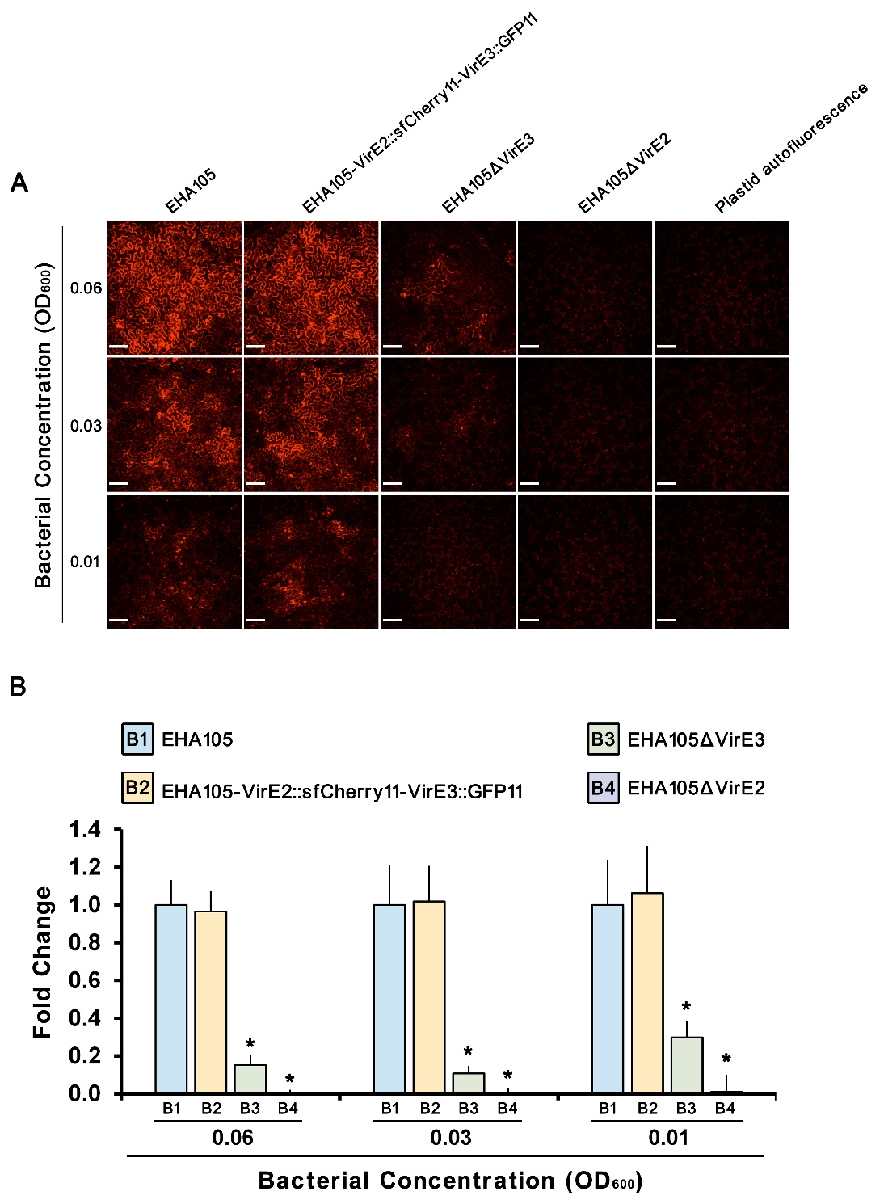
Figure S1. sfCherry11-labeled VirE2 and GFP11-labeled VirE3 function similarly like the untagged proteins inside the plant cell in the transient transformation assay. (A) Wild-type N. benthamiana leaves were infiltrated with different concentrations of A. tumefaciens cells EHA105, EHA105-VirE2::sfCherry11-VirE3::GFP11, EHA105ΔVirE3 or EHA105ΔVirE2 containing a binary plasmid pmC13-Reverse (expressing free mCherry under the CaMV 35S promoter on T-DNA). Scale bars, 100 μm. (B) The fluorescence intensity of transiently expressed mCherry was measured in each image. The intensity was normalized to the control group. Data are presented as means ± SDs of n = 30 independent samples. *p < 0.01.

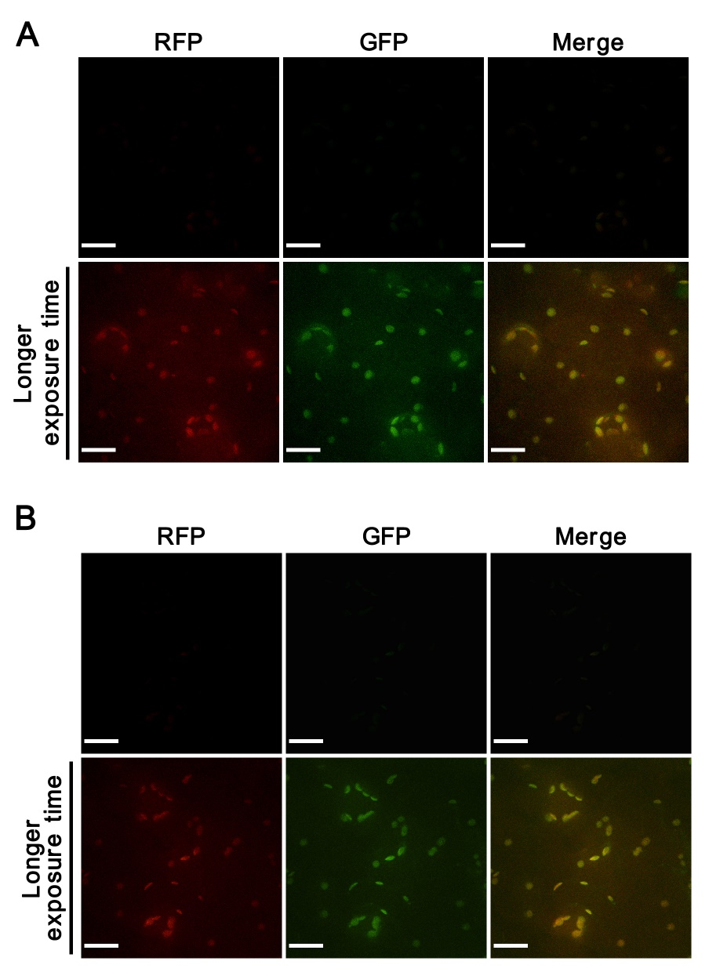
Figure. S2. Split-GFP and split-sfCherry systems do not interfere with each other. (A) Wild-type N. benthamiana leaves were infiltrated with A. tumefaciens strain EHA105virE2::sfCherry11 containing a binary plasmid pGFP1-10 (expressing GFP1–10 on T-DNA), and no fluorescence signal for VirE2 could be detected at two days post agroinfiltration (upper panel). Longer exposure time was used for the same imaging field to detect the autofluorescence of plastids (lower panel). Scale bars, 20 μm. (B) Wild-type N. benthamiana leaves were infiltrated with A. tumefaciens strain EHA105virE3::GFP11 containing a binary plasmid psfCherry1-10 (expressing sfCherry1–10 on T-DNA); and no fluorescence signal for VirE3 could be detected at two days post agroinfiltration (upper panel). Longer exposure time was used for the same imaging field to detect the autofluorescence of plastids (lower panel). Scale bars, 20 μm.
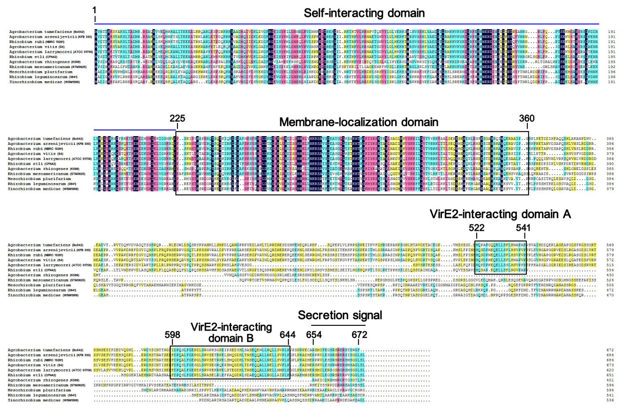
Figure S3. Sequence alignment of Agrobacterium VirE3 and its homologs from Rhizobium/Agrobacterium species. The amino acid sequence of VirE3 from A. tumefaciens (NCBI accession number: WP_012478092.1) was aligned with its homologs from Agrobacterium arsenijevicii (NCBI accession number: WP_045024006.1), Rhizobium rubi (NCBI accession number: GAK72198.1), Agrobacterium vitis (NCBI accession number: WP_012649040.1), Agrobacterium larrymoorei (NCBI accession number: WP_027676208.1), Rhizobium etli (NCBI accession number: AAD55076.1), Agrobacterium rhizogenes (NCBI accession number: WP_012476046.1), Rhizobium mesoamericanum (NCBI accession number: CCM79810.1), Mesorhizobium plurifarium (NCBI accession number: WP_041010510.1), Rhizobium leguminosarum (NCBI accession number: WP_011654520.1) and Sinorhizobium medicae (NCBI accession number: WP_018009501.1) using the DNAMAN software (Version 7.0.2.176). The self-interacting domain, membrane-localization domain, VirE2-interacting domains and the secretion signal motif are delineated. The relevant amino acid positions are indicated.

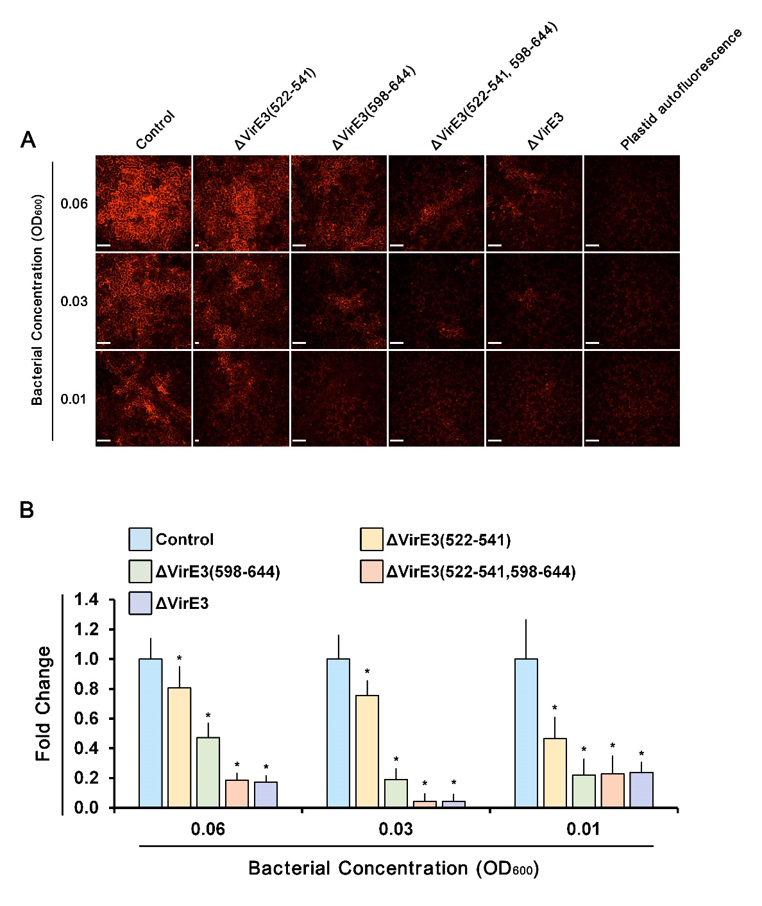
Figure S4. Deletions of VirE2-interacting domains of VirE3 attenuate the transient transformation efficiency of A. tumefaciens. (A) Wild-type N. benthamiana leaves were infiltrated with different concentrations of A. tumefaciens cells EHA105 (control), EHA105ΔVirE3(522-541), EHA105ΔVirE3(598-644), EHA105ΔVirE3(522-541,598-644) or EHA105ΔVirE3 containing a binary plasmid pmC13-Reverse (expressing free mCherry on T-DNA). Scale bars, 100 μm. (B) The fluorescence intensity of transiently expressed mCherry was measured in each image. The intensity was normalized to the control group. Data are presented as means ± SDs of n = 30 independent samples. *p < 0.01.

Supplementary Movie legends
Movie S1. Localization of VirE2-GFP_{comp} in host cells in the presence of wild-type VirE3. N. benthamiana (Nb308A) leaves were infiltrated with A. tumefaciens EHA105virE2::GFP11. The VirE2-GFP_{comp} signals were visualized under a confocal microscope at two days after agroinfiltration. DsRed indicates cellular structures. Scale bar, 20 μm.

Movie S2. Localization of VirE2-GFP_{comp} in host cells in the presence of VirE3 with double deletion of VirE2-interacting domains. N. benthamiana (Nb308A) leaves were infiltrated with A. tumefaciens EHA105virE2::GFP11ΔVirE3(522-541,598-644). The VirE2-GFP_{comp} signals were visualized under a confocal microscope at two days after agroinfiltration. DsRed indicates cellular structures. Scale bar, 20 μm.

Movie S3. Localization of VirE2-GFP_{comp} in host cells in the absence of VirE3. N. benthamiana (Nb308A) leaves were infiltrated with A. tumefaciens EHA105virE2::GFP11ΔVirE3. The VirE2-GFP_{comp} signals were visualized under a confocal microscope at two days after agroinfiltration. DsRed indicates cellular structures. Scale bar, 20 μm.

Table S1. A. tumefaciens Strains used in this study
A. tumefaciens Strains | Relevant characteristics | Source
EHA105 | C58 strain containing pTiBo542 without T-DNA | (Hood et al., 1993)
EHA105ΔVirE2 | EHA105 derivative, with virE2 deleted from pTiBo542 | (Li et al., 2014)
EHA105ΔVirE3 | EHA105 derivative, with virE3 deleted from pTiBo542 | (Li et al., 2018)
EHA105ΔVirE3(522-541) | EHA105 derivative, with the sequence encoding the VirE3 amino acids 522-541 deleted from the Ti plasmid | This Study
EHA105ΔVirE3(598-644) | EHA105 derivative, with the sequence encoding the VirE3 amino acids 596-644 deleted from the Ti plasmid | (Li et al., 2018)
EHA105ΔVirE3(522-541,598-644) | EHA105 derivative, with the sequence encoding the VirE3 amino acids 522-541 and 596-644 deleted from the Ti plasmid | This Study
EHA105virE2::GFP11 | EHA105 derivative, with the GFP11-coding sequence inserted into virE2 on pTiBo542 | (Li et al., 2014)
EHA105virE2::GFP11ΔVirE3(522-541) | EHA105virE2::GFP11 derivative, with the sequences encoding the VirE3 amino acids 522-541 deleted from the Ti plasmid | This Study
EHA105virE2::GFP11ΔVirE3(598-644) | EHA105virE2::GFP11 derivative, with the sequences encoding the VirE3 amino acids 598-644 deleted from the Ti plasmid | (Li et al., 2018)
EHA105virE2::GFP11ΔVirE3(522-541,598-644) | EHA105virE2::GFP11 derivative, with the sequences encoding the VirE3 amino acids 522-541 and 598-644 deleted from the Ti plasmid | This Study
EHA105virE2::GFP11ΔVirE3 | EHA105virE2::GFP11 derivative, with virE3 deleted from the Ti plasmid | (Li et al., 2018)
EHA105virE2::sfCherry11 | EHA105 derivative, with the sfCherry11-coding sequence inserted into virE2 on pTiBo542 | This Study
EHA105virE3::GFP11 | EHA105 derivative, with the GFP11-coding sequence inserted into virE3 on pTiBo542 | (Li et al., 2018)
EHA105virE3::GFP11ΔVirE3(522-541) | EHA105virE3::GFP11 derivative, with the sequences encoding the VirE3 amino acids 522-541 deleted from the Ti plasmid | This Study
EHA105virE3::GFP11ΔVirE3(598-644) | EHA105virE3::GFP11 derivative, with the sequences encoding the VirE3 amino acids 598-644 deleted from the Ti plasmid | (Li et al., 2018)
EHA105virE3::GFP11ΔVirE3(522-541,598-644) | EHA105virE3::GFP11 derivative, with the sequences encoding the VirE3 amino acids 522-541 and 598-644 deleted from the Ti plasmid | This Study
EHA105-VirE2::sfCherry11-VirE3::GFP11 | EHA105virE3::GFP11 derivative, with the sfCherry11-coding sequence inserted into virE2 on the Ti plasmid | This Study

Table S2. Plasmids used in this study
Plasmids | Relevant characteristics | Source
pm-rb | A binary plasmid containing a plant plasma membrane marker; Km^{r} | (Nelson et al., 2007)
pmC13-Reverse | A binary plasmid, with the mCherry coding sequence placed downstream of the CaMV 35S promoter; Km^{r} | (Li et al., 2018)
pXY01 | A binary plasmid for target gene expression under the control of CaMV 35S promoter; Km^{r} | (Li and Pan, 2017)
pGFP1-10 | A binary plasmid, with the GFP1–10 coding sequence placed downstream of the CaMV 35S promoter; Km^{r} | (Li and Pan, 2017)
psfCherry1-10 | pXY01 derivative, with the sfCherry1–10 coding sequence placed downstream of the CaMV 35S promoter; Km^{r} | This Study
pQH308A | A binary plasmid, with the GFP1–10 and DsRed coding sequences on T-DNA; Km^{r} | (Li et al., 2014)
pQH308GR | pQH308A derivative, with the GFP1–10 and sfCherry1–10 coding sequences on T-DNA; Km^{r} | This Study
pGADT7 | Yeast two-hybrid cloning plasmid, with the GAL4 AD domain; Amp^{r} | Clontech
pGADT7-VirE3 | pGADT7 derivative, with the VirE3 coding sequence fused to the GAL4 AD domain; Amp^{r} | (Li et al., 2018)
pGADT7-VirE3(510-551) | pGADT7 derivative, with the VirE3(510-551) coding sequence fused to the GAL4 AD domain; Amp^{r} | This Study
pGADT7-VirE3(596-648) | pGADT7 derivative, with the VirE3(596-648) coding sequence fused to the GAL4 AD domain; Amp^{r} | This Study
pGADT7-VirE3(649-672) | pGADT7 derivative, with the VirE3(649-672) coding sequence fused to the GAL4 AD domain; Amp^{r} | This Study
pGBKT7 | Yeast two-hybrid cloning plasmid, with the GAL4 BD domain; Km^{r} | Clontech
pGBKT7-VirE2 | pGBKT7 derivative, with the VirE2 coding sequence fused to the GAL4 BD domain; Km^{r} | (Li et al., 2018)
pMAL-c2x | MBP tag expression vector; Amp^{r} | New England Biolabs
pMAL-VirE3(510-551) | pMAL-c2x derivative, with the VirE3(510-551) coding sequence fused to the MBP coding sequence; Amp^{r} | This Study
pMAL-VirE3(596-648) | pMAL-c2x derivative, with the VirE3(598-648) coding sequence fused to the MBP coding sequence; Amp^{r} | This Study
pRSET-A | Protein expression vector; Amp^{r} | Invitrogen
pRSET-E2 | pRSET-A derivative, with the VirE2 coding sequence at downstream of the T7 promoter; | This Study
pEx18Km | Counter-selectable plasmid carrying sacB marker; Km^{r} | (Li et al., 2014)
pEx18Km-ΔVirE3(522-541) | pEx18Km derivative, to delete the sequence encoding the VirE3 amino acids 522-541 on pTiBo542; Km^{r} | This Study
pEx18Km-ΔVirE3::S11(522-541) | pEx18Km derivative, to delete the sequence encoding the VirE3 amino acids 522-541 on the Ti plasmid; Km^{r} | This Study
pEx18Km-ΔVirE3(522-541,598-644) | pEx18Km derivative, to delete the sequence encoding the VirE3 amino acids 522-541 and 598-644 on pTiBo542; Km^{r} | This Study
pEx18Km-ΔVirE3::S11(522-541,598-644) | pEx18Km derivative, to delete the sequence encoding the VirE3 amino acids 522-541 and 598-644 on the Ti plasmid; Km^{r} | This Study
pEx18Km-VirE2::sfCherry11 | pEx18Km derivative, to insert the sfCherry11 coding sequence into the virE2 on pTiBo542; Km^{r} | This Study

Table S3. Primers used in this study
Primers | Sequences (5′ to 3′)
E1001 | CGGGTTGCGGAGGATTTTC
E1002 | CTCGGCTCTCTCGTACTGCTCCACGATGGTGTAAGGGCTCCCTGATTGTACGTC
E1003 | GCAGTACGAGAGAGCCGAGGCCAGACACAGCACCACCCGAACGGAAGTTGTAAGC
E1004 | GCGCCTCTTCTTCGGTAATCA
E1005 | CTAGTCTAGAATGGCCATCATCAAGCCG
E1006 | CCGCTCGAGTCAAAAGCTGTTGACGCTTTG
E1007 | AGGCTCTTTCAACCTGTATCCG
E1008 | CCACAGAAACATTGTCCGAGGATGAAGACATCA
E1009 | CTCGGACAATGTTTCTGTGGCAATACATGATGATC
E1010 | GCAGGCCAGGGCTATACGAC
E1011 | CTAGTCTAGATTTTCCAAGATTTCAGTGAAGGC
E1012 | ACGCGTCGACTCGGATGGCCG
P1001 | GCTCTAGAATGGAGGAGGACAACATGGC
P1002 | CGCGGATCCTCAGTCCTCGTTGTGGCTGG
P1003 | CGCGGATCCTCTGCGAAGGACCGGTGATG
P1004 | CCGCTCGAGCTACTCTTGATCATCATGTATTGCCAC
P1005 | CGCGGATCCTCGGGTTTATTGACCCGCAATC
P1006 | CCGCTCGAGTTACGGTGAAGGAACCGGCAG
P1007 | CGCGGATCCTCAAGCCCGAATGCGCGA
P1008 | CCGCTCGAGTTAGAACCCTCTGGAGGTGGAA
P1009 | CGCGGATCCTGCGAAGGACCGGTGATG
P1010 | CGCGGATCCGGGTTTATTGACCCGCAATC
P1011 | CTAGTCTAGAAATAATTTTGTTTAACTTTAAGAAGGAGATATACAT ATGGATCCGTCTAGCAATGAG
P1012 | CGGGGTACCTCAAAAGCTGTTGACGCTTTG

References

Hood, E.E., Gelvin, S.B., Melchers, L.S., and Hoekema, A. (1993). NewAgrobacterium helper plasmids for gene transfer to plants. Transgenic Research 2(4), 208-218.
Li, X., and Pan, S.Q. (2017). Agrobacterium delivers VirE2 protein into host cells via clathrin-mediated endocytosis. Sci Adv 3(3), e1601528. doi: 10.1126/sciadv.1601528.
Li, X., Tu, H., and Pan, S.Q. (2018). Agrobacterium Delivers Anchorage Protein VirE3 for Companion VirE2 to Aggregate at Host Entry Sites for T-DNA Protection. Cell Rep 25(2), 302-311 e306. doi: 10.1016/j.celrep.2018.09.023.
Li, X., Yang, Q., Tu, H., Lim, Z., and Pan, S.Q. (2014). Direct visualization of Agrobacterium-delivered VirE2 in recipient cells. Plant J 77(3), 487-495. doi: 10.1111/tpj.12397.
Nelson, B.K., Cai, X., and Nebenfuhr, A. (2007). A multicolored set of in vivo organelle markers for co-localization studies in Arabidopsis and other plants. Plant J 51(6), 1126-1136. doi: 10.1111/j.1365-313X.2007.03212.x.

