Supplementary Material

Supplementary Tables
Supplementary Table S1. Functional pathways differences at level 2 inferred from 16S rRNA gene sequences using PICRUSt.
KO functional categories |  |  |  | PO |  |  | HC
Level_1 | Level_2 | Level_3 |  | mean% | SD% |  | mean% | SD% | P-value
Environmental Information Processing | Membrane Transport | Transporters |  | 0.072645 | 0.007932 |  | 0.08038 | 0.00937 | <0.001
Environmental Information Processing | Membrane Transport | ABC transporters |  | 0.036335 | 0.004046 |  | 0.038695 | 0.004521 | 0.008
Unclassified | Poorly Characterized | General function prediction only |  | 0.035646 | 0.001376 |  | 0.03502 | 0.001232 | 0.021
Genetic Information Processing | Replication and Repair | DNA repair and recombination roteins |  | 0.027504 | 0.001527 |  | 0.026628 | 0.001922 | 0.015
Genetic Information Processing | Translation | Ribosome |  | 0.023159 | 0.002092 |  | 0.021678 | 0.002537 | 0.002
Genetic Information Processing | Transcription | Transcription factors |  | 0.018883 | 0.001902 |  | 0.020149 | 0.002001 | 0.002024
Metabolism | Enzyme Families | Peptidases |  | 0.018743 | 0.000917 |  | 0.018248 | 0.000856 | 0.007
Metabolism | Nucleotide Metabolism | Pyrimidine metabolism |  | 0.018152 | 0.001257 |  | 0.017304 | 0.001472 | 0.003
Genetic Information Processing | Replication and Repair | Chromosome |  | 0.016372 | 0.000883 |  | 0.015532 | 0.001366 | <0.001
Metabolism | Amino Acid Metabolism | Amino acid related enzymes |  | 0.015033 | 0.000848 |  | 0.014364 | 0.001109 | 0.001
Genetic Information Processing | Translation | Ribosome Biogenesis |  | 0.014793 | 0.000746 |  | 0.014243 | 0.001105 | 0.005
Metabolism | Amino Acid Metabolism | Arginine and proline metabolism |  | 0.012723 | 0.000593 |  | 0.012418 | 0.000787 | 0.034
Metabolism | Energy Metabolism | Methane metabolism |  | 0.011665 | 0.000996 |  | 0.012452 | 0.001156 | <0.001
Genetic Information Processing | Replication and Repair | DNA replication proteins |  | 0.012244 | 0.000854 |  | 0.011672 | 0.001116 | 0.005
Metabolism | Amino Acid Metabolism | Alanine, aspartate and glutamate metabolism |  | 0.010957 | 0.000787 |  | 0.010399 | 0.000938 | 0.002
Metabolism | Amino Acid Metabolism | Cysteine and methionine metabolism |  | 0.00991 | 0.00035 |  | 0.009637 | 0.00042 | <0.001
Genetic Information Processing;; | Folding, Sorting and Degradation | Chaperones and folding catalysts |  | 0.009884 | 0.000674 |  | 0.009201 | 0.0007 | <0.001
Metabolism | Carbohydrate Metabolism | Fructose and mannose metabolism |  | 0.008866 | 0.001022 |  | 0.010167 | 0.002867 | 0.004
Genetic Information Processing | Transcription | Transcription machinery |  | 0.010062 | 0.000992 |  | 0.009431 | 0.001339 | 0.010
Metabolism | Carbohydrate Metabolism | Pentose phosphate pathway |  | 0.00921 | 0.000502 |  | 0.009757 | 0.001128 | 0.003
Unclassified | Metabolism | Others |  | 0.008659 | 0.000757 |  | 0.009562 | 0.000677 | <0.001
Unclassified | Genetic Information Processing | Translation proteins |  | 0.009212 | 0.000461 |  | 0.008807 | 0.000608 | <0.001
Genetic Information Processing | Replication and Repair | Homologous recombination |  | 0.008986 | 0.000588 |  | 0.00865 | 0.000815 | 0.022
Unclassified | Metabolism | Energy metabolism |  | 0.008702 | 0.000717 |  | 0.007865 | 0.000646 | <0.001
Metabolism | Energy Metabolism | Carbon fixation pathways in prokaryotes |  | 0.008544 | 0.000892 |  | 0.00789 | 0.000753 | <0.001
Metabolism | Glycan Biosynthesis and Metabolism | Peptidoglycan biosynthesis |  | 0.008364 | 0.000602 |  | 0.008058 | 0.000744 | 0.029
Metabolism | Carbohydrate Metabolism | Butanoate metabolism |  | 0.006068 | 0.000693 |  | 0.005764 | 0.00077 | 0.045
Environmental Information Processing | Membrane Transport | Bacterial secretion system |  | 0.005955 | 0.000804 |  | 0.005546 | 0.001044 | 0.034
Metabolism | Metabolism of Cofactors and Vitamins | One carbon pool by folate |  | 0.006151 | 0.000516 |  | 0.00569 | 0.000527 | <0.001
Genetic Information Processing | Folding, Sorting and Degradation | Protein export |  | 0.005841 | 0.000419 |  | 0.005546 | 0.000441 | 0.001
Metabolism | Lipid Metabolism | Lipid biosynthesis proteins |  | 0.005779 | 0.000304 |  | 0.005292 | 0.000487 | <0.001
Environmental Information Processing | Membrane Transport | Phosphotransferase system (PTS) |  | 0.003905 | 0.001713 |  | 0.006098 | 0.004539 | 0.002
Metabolism | Metabolism of Terpenoids and Polyketides | Terpenoid backbone biosynthesis |  | 0.005732 | 0.00048 |  | 0.005376 | 0.000591 | 0.002
Metabolism | Metabolism of Cofactors and Vitamins | Thiamine metabolism |  | 0.005546 | 0.000456 |  | 0.005264 | 0.000721 | 0.024
Genetic Information Processing | Translation | Translation factors |  | 0.005237 | 0.000392 |  | 0.004896 | 0.00047 | <0.001
Metabolism | Energy Metabolism | Photosynthesis proteins |  | 0.005079 | 0.000638 |  | 0.004607 | 0.000937 | 0.005
Metabolism | Energy Metabolism | Photosynthesis |  | 0.005054 | 0.000661 |  | 0.00458 | 0.000965 | 0.006
Cellular Processes | Cell Growth and Death | Cell cycle - Caulobacter |  | 0.004925 | 0.000577 |  | 0.004696 | 0.000527 | 0.045
Metabolism | Carbohydrate Metabolism | Citrate cycle (TCA cycle) |  | 0.004875 | 0.000864 |  | 0.004418 | 0.000767 | 0.007
Genetic Information Processing | Folding, Sorting and Degradation | RNA degradation |  | 0.004589 | 0.00027 |  | 0.00426 | 0.000336 | <0.001
Metabolism | Metabolism of Cofactors and Vitamins | Nicotinate and nicotinamide metabolism |  | 0.004256 | 0.000213 |  | 0.004144 | 0.000295 | 0.036
Metabolism | Lipid Metabolism | Glycerolipid metabolism |  | 0.003848 | 0.00042 |  | 0.004361 | 0.000415 | <0.001
Genetic Information Processing | Replication and Repair | Nucleotide excision repair |  | 0.003886 | 0.000362 |  | 0.003692 | 0.000455 | 0.023
Metabolism | Enzyme Families | Protein kinases |  | 0.003151 | 0.000415 |  | 0.003486 | 0.000548 | 0.001
Metabolism | Carbohydrate Metabolism | C5-Branched dibasic acid metabolism |  | 0.003243 | 0.000285 |  | 0.003409 | 0.000364 | 0.014
Metabolism | Metabolism of Terpenoids and Polyketides | Prenyltransferases |  | 0.002855 | 0.000286 |  | 0.002654 | 0.000241 | <0.001
Metabolism | Metabolism of Cofactors and Vitamins | Riboflavin metabolism |  | 0.002451 | 0.00026 |  | 0.002127 | 0.00035 | <0.001
Metabolism | Biosynthesis of Other Secondary Metabolites | Phenylpropanoid biosynthesis |  | 0.002047 | 0.000581 |  | 0.002294 | 0.000555 | 0.036
Unclassified | Metabolism | Carbohydrate metabolism |  | 0.001746 | 0.000358 |  | 0.001926 | 0.00029 | 0.007
Metabolism | Metabolism of Cofactors and Vitamins | Vitamin B6 metabolism |  | 0.001966 | 0.000148 |  | 0.001832 | 0.000178 | <0.001
Unclassified | Genetic Information Processing | Restriction enzyme |  | 0.002075 | 0.000347 |  | 0.001765 | 0.000433 | <0.001
Unclassified | Metabolism | Amino acid metabolism |  | 0.00152 | 0.000339 |  | 0.00178 | 0.000573 | 0.009
Metabolism | Xenobiotics Biodegradation and Metabolism | Chloroalkane and chloroalkene degradation |  | 0.001481 | 0.000745 |  | 0.001735 | 0.000449 | 0.047
Human Diseases | Infectious Diseases | Tuberculosis |  | 0.001649 | 0.00016 |  | 0.001501 | 0.000239 | 0.000612
Genetic Information Processing | Translation | RNA transport |  | 0.001379 | 0.000246 |  | 0.001553 | 0.000229 | 0.000562
Metabolism | Metabolism of Terpenoids and Polyketides | Biosynthesis of ansamycins |  | 0.001374 | 0.000199 |  | 0.001503 | 0.000261 | 0.008
Cellular Processes | Transport and Catabolism | Peroxisome |  | 0.001554 | 0.000224 |  | 0.00132 | 0.000202 | <0.001
Metabolism | Metabolism of Other Amino Acids | D-Glutamine and D-glutamate metabolism |  | 0.001453 | 9.28E-05 |  | 0.001346 | 0.000118 | <0.001
Metabolism | Biosynthesis of Other Secondary Metabolites | Novobiocin biosynthesis |  | 0.001402 | 0.000192 |  | 0.001273 | 0.000127 | <0.001
Metabolism | Metabolism of Terpenoids and Polyketides | Tetracycline biosynthesis |  | 0.001113 | 0.000291 |  | 0.001241 | 0.000336 | 0.048
Metabolism | Biosynthesis of Other Secondary Metabolites | Tropane, piperidine and pyridine alkaloid biosynthesis |  | 0.001133 | 0.000218 |  | 0.001033 | 0.000122 | 0.006
Metabolism | Carbohydrate Metabolism | Ascorbate and aldarate metabolism |  | 0.000725 | 0.000474 |  | 0.001088 | 0.000758 | 0.006
Metabolism | Xenobiotics Biodegradation and Metabolism | Naphthalene degradation |  | 0.000937 | 0.000269 |  | 0.001066 | 0.000301 | 0.029
Environmental Information Processing | Signaling Molecules and Interaction | Bacterial toxins |  | 0.000906 | 0.000201 |  | 0.001045 | 0.000246 | 0.003
Metabolism | Metabolism of Other Amino Acids | Taurine and hypotaurine metabolism |  | 0.00096 | 9.71E-05 |  | 0.000903 | 0.000122 | 0.013
Organismal Systems | Endocrine System | PPAR signaling pathway |  | 0.001071 | 0.000237 |  | 0.000908 | 0.000175 | <0.001
Metabolism | Carbohydrate Metabolism | Inositol phosphate metabolism |  | 0.000747 | 0.000189 |  | 0.000887 | 0.000336 | 0.014
Metabolism | Xenobiotics Biodegradation and Metabolism | Toluene degradation |  | 0.000753 | 0.000436 |  | 0.000559 | 0.000365 | 0.020
Metabolism | Metabolism of Terpenoids and Polyketides | Limonene and pinene degradation |  | 0.000504 | 0.000237 |  | 0.000621 | 0.000305 | 0.038
Metabolism | Xenobiotics Biodegradation and Metabolism | Dioxin degradation |  | 0.000436 | 0.000155 |  | 0.000611 | 0.00021 | <0.001
Metabolism | Xenobiotics Biodegradation and Metabolism | Xylene degradation |  | 0.000417 | 0.000128 |  | 0.000577 | 0.00017 | <0.001
Organismal Systems | Endocrine System | Adipocytokine signaling pathway |  | 0.00063 | 0.000214 |  | 0.000465 | 0.000176 | <0.001
Metabolism | Biosynthesis of Other Secondary Metabolites | Isoquinoline alkaloid biosynthesis |  | 0.00051 | 9.82E-05 |  | 0.000429 | 9.78E-05 | <0.001
Genetic Information Processing | Translation | Ribosome biogenesis in eukaryotes |  | 0.000481 | 4.47E-05 |  | 0.000459 | 5.40E-05 | 0.036
Human Diseases | Metabolic Diseases | Type I diabetes mellitus |  | 0.000487 | 4.94E-05 |  | 0.000454 | 5.96E-05 | 0.005
Metabolism | Metabolism of Terpenoids and Polyketides | Zeatin biosynthesis |  | 0.000495 | 7.37E-05 |  | 0.000441 | 5.90E-05 | <0.001
Human Diseases | Immune System Diseases | Primary immunodeficiency |  | 0.000389 | 0.000139 |  | 0.00045 | 0.000124 | 0.025
Human Diseases | Cancers | Pathways in cancer |  | 0.00046 | 6.48E-05 |  | 0.000438 | 4.18E-05 | 0.045
Organismal Systems | Immune System | NOD-like receptor signaling pathway |  | 0.000443 | 7.70E-05 |  | 0.000411 | 6.32E-05 | 0.026
Metabolism | Lipid Metabolism | Primary bile acid biosynthesis |  | 0.000373 | 0.000128 |  | 0.000435 | 0.00013 | 0.020
Metabolism | Lipid Metabolism | Secondary bile acid biosynthesis |  | 0.000371 | 0.000128 |  | 0.000432 | 0.00013 | 0.022
Metabolism | Xenobiotics Biodegradation and Metabolism | Styrene degradation |  | 0.000111 | 7.20E-05 |  | 0.000179 | 0.000157 | 0.008
Metabolism | Xenobiotics Biodegradation and Metabolism | Atrazine degradation |  | 0.000118 | 8.07E-05 |  | 0.000165 | 0.000139 | 0.046
Environmental Information Processing | Signaling Molecules and Interaction | Cellular antigens |  | 0.000203 | 0.000222 |  | 0.000107 | 0.000112 | 0.009
Metabolism | Biosynthesis of Other Secondary Metabolites | Flavone and flavonol biosynthesis |  | 0.000168 | 6.29E-05 |  | 0.000107 | 6.21E-05 | <0.001
Metabolism | Lipid Metabolism | Arachidonic acid metabolism |  | 0.000148 | 0.000151 |  | 8.53E-05 | 0.00011 | 0.023
Genetic Information Processing | Replication and Repair | Non-homologous end-joining |  | 3.73E-05 | 2.73E-05 |  | 8.19E-05 | 0.000141 | 0.036
Organismal Systems | Digestive System | Protein digestion and absorption |  | 9.72E-05 | 0.000148 |  | 3.88E-05 | 5.58E-05 | 0.013
Human Diseases | Infectious Diseases | Amoebiasis |  | 3.77E-05 | 2.37E-05 |  | 5.82E-05 | 5.68E-05 | 0.025
Human Diseases | Neurodegenerative Diseases | Prion diseases |  | 2.82E-05 | 3.43E-05 |  | 4.77E-05 | 4.98E-05 | 0.028
Genetic Information Processing | Transcription | Basal transcription factors |  | 5.43E-05 | 4.32E-05 |  | 1.95E-05 | 2.32E-05 | <0.001
Metabolism | Lipid Metabolism | Ether lipid metabolism |  | 2.37E-05 | 2.09E-05 |  | 4.02E-05 | 5.02E-05 | 0.040
Metabolism | Glycan Biosynthesis and Metabolism | Various types of N-glycan biosynthesis |  | 4.78E-07 | 9.60E-07 |  | 1.38E-07 | 3.10E-07 | 0.023
Human Diseases | Infectious Diseases | Influenza A |  | 2.36E-07 | 6.81E-07 |  | 9.98E-09 | 2.22E-08 | 0.026
Environmental Information Processing | Membrane Transport | Transporters |  | 0.072645 | 0.007932 |  | 0.08038 | 0.00937 | <0.001
Environmental Information Processing | Membrane Transport | ABC transporters |  | 0.036335 | 0.004046 |  | 0.038695 | 0.004521 | 0.008
Unclassified | Poorly Characterized | General function prediction only |  | 0.035646 | 0.001376 |  | 0.03502 | 0.001232 | 0.020
Note: P value is obtained by T-test. Data are given as mean%,SD%;Abbreviations: PO, primary osteoporosis;HC, normal cognition healthy control; KEGG, Kyoto Encyclopedia of Genes and Genomes; PICRUSt, Phylogenetic Investigation of Communities by Reconstruction of Unobserved States; KO, KEGG Ortholog; SD: standard deviation.

Supplementary Figures

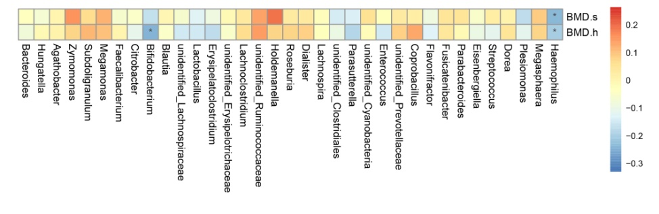
Supplementary Figure S1. Correlation analysis between bone mineral density and species richness at the genus level. Note: The longitudinal information is environmental factor information and the horizontal is species information. The corresponding value of intermediate heat map is Spearman correlation coefficient r, between-1, 1, r<0 is negative correlation, r>0 is positive correlation, marked * means significance test p<0. 05, and marked ** means significance test p<0. 01.

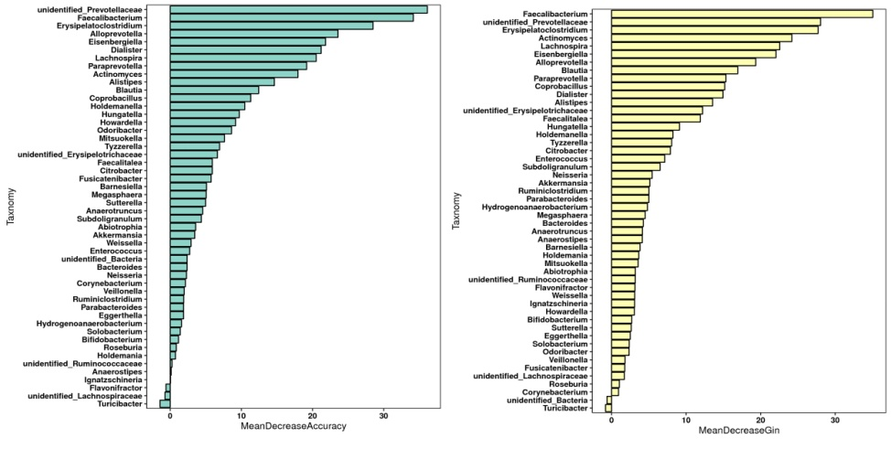
Supplementary Figure S2. Species importance ranking chart. MeanDecreaseAccuracy (left) measures the reduction in the accuracy of random forest prediction by changing the value of a variable into a random number. The higher the value, the more important the variable is. Abscissa: average decline accuracy, longitudinal coordinates: ranked at the top 50 important species; MeanDecreaseGini (right) calculates the influence of each variable on the heterogeneity of the observed values on each node of the classification tree through the Gini index, thus comparing the importance of the variables. The higher the value, the greater the importance of the variable is. Abscissa: average decline Gini index, ordinate: ranked at the top 50 important species.

