Supplementary Material 1

Supplementary Data

Search strategy for disease network (via pubmed)
For reproductive toxicity
reproductive toxicity[Text Word]
reproduction toxicity[Text Word]
oligospermia[Text Word]
menstrual disorder[Text Word]

For leukocytopenia
leukocytopenia[Text Word]
leukopenia[Text Word]
oligoleukocythemia[Text Word]

For renal damage
renal damage[Text Word]
renal injury[Text Word]
renal impairment[Text Word]
kidey damage[Text Word]
kidey injury[Text Word]
kidey impairment[Text Word]

For liver damage
liver damage[Text Word]
liver injury[Text Word]
hepatic injury[Text Word]

Supplementary Figures and Tables

Supplementary Tables
Table 1. Hub anti-RA targets
Gene name | Gene name | Gene name | Gene name | Gene name
AGT | GPR18 | CCL5 | ADRA2C | GRM7
GNG2 | CXCL13 | AGTR2 | GPER1 | CNR1
ANXA1 | ADCY1 | SUCNR1 | CHRM2 | HTR1A
BDKRB2 | ADRA1A | DRD2 | SST | ADRA2A
DRD3 | TACR2 | PF4 | GNAI2 | OXER1
CX3CR1 | TAC1 | NPY2R | OPRK1 | RXFP4
CNR2 | ADRA1D | HTR1B | C5 | ADRA2B
CHRM4 | GNA15 | TAS1R3 | HTR1D | TAS1R1
DRD4 | CXCR4 | ADCY3 | OPRM1 | HCAR2
GABBR1 | PTGER3 | ADORA1 | HCAR3 | TAS1R2

Supplementary Figures

Supplementary Figure S1. CALCIUM SIGNALING PATHWAY
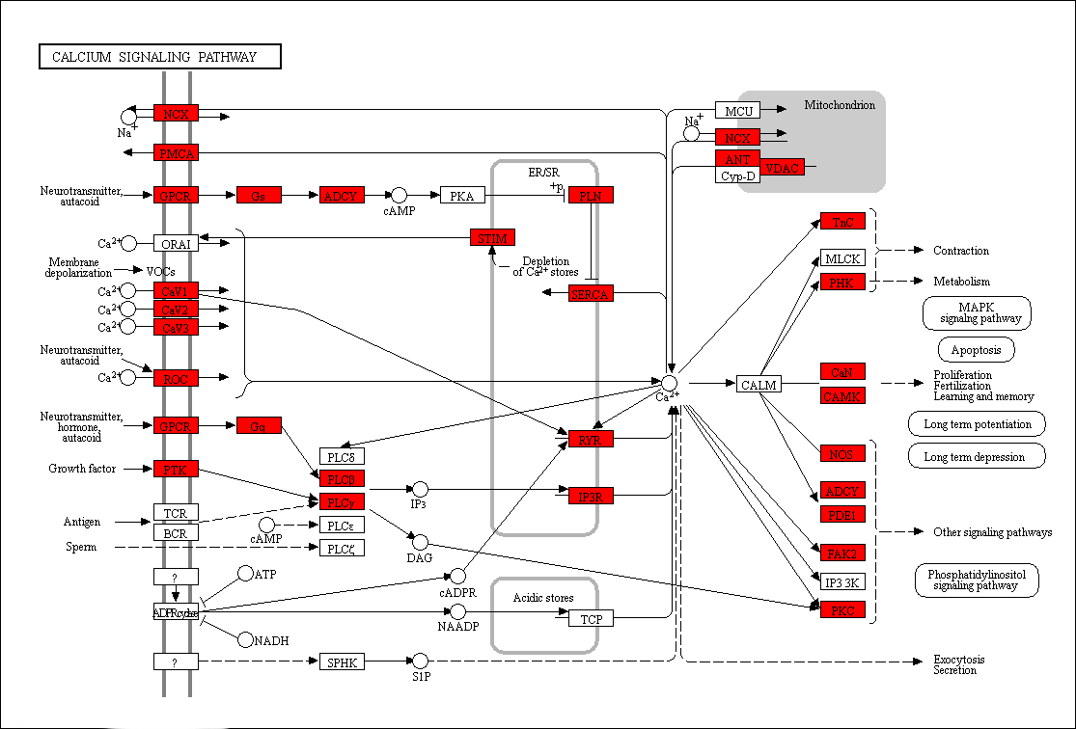

Supplementary Figure S2. TNF SIGNALING PATHWAY
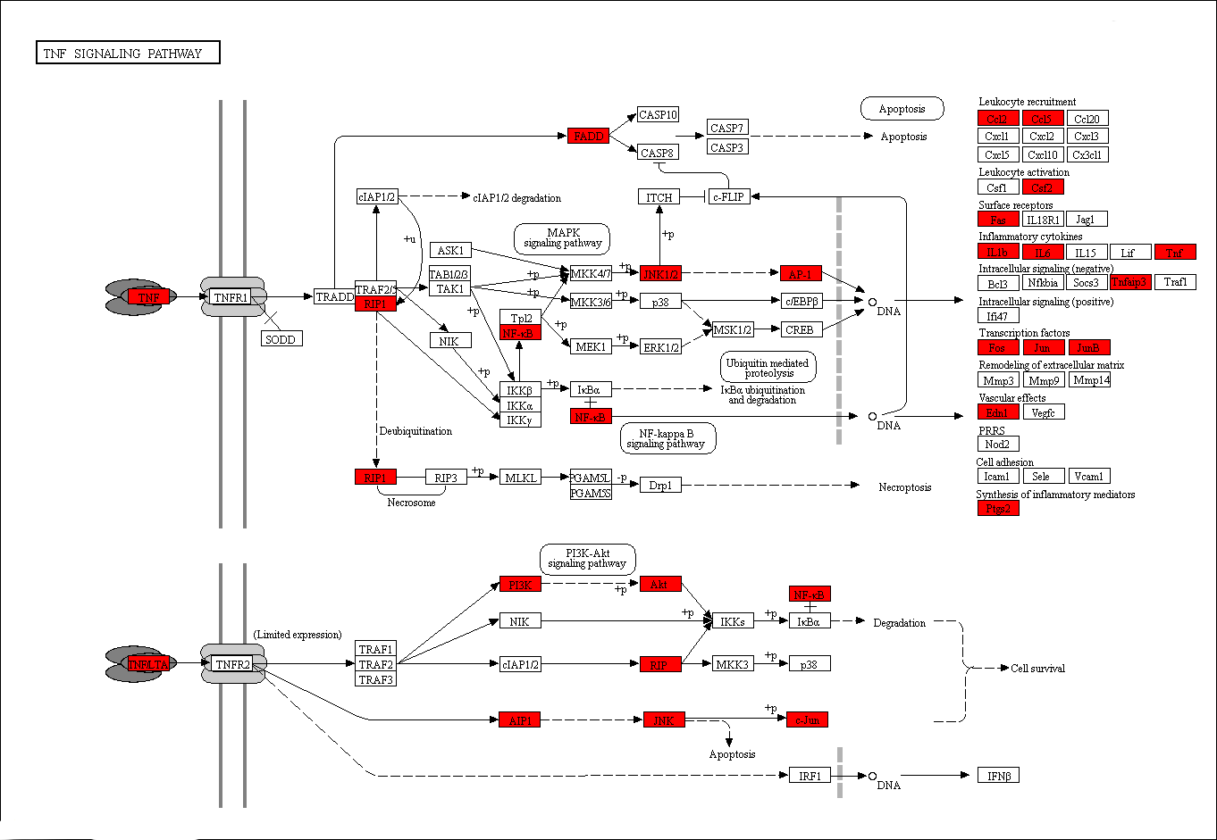

Supplementary Figure S3. cAMP SIGNALING PATHWAY
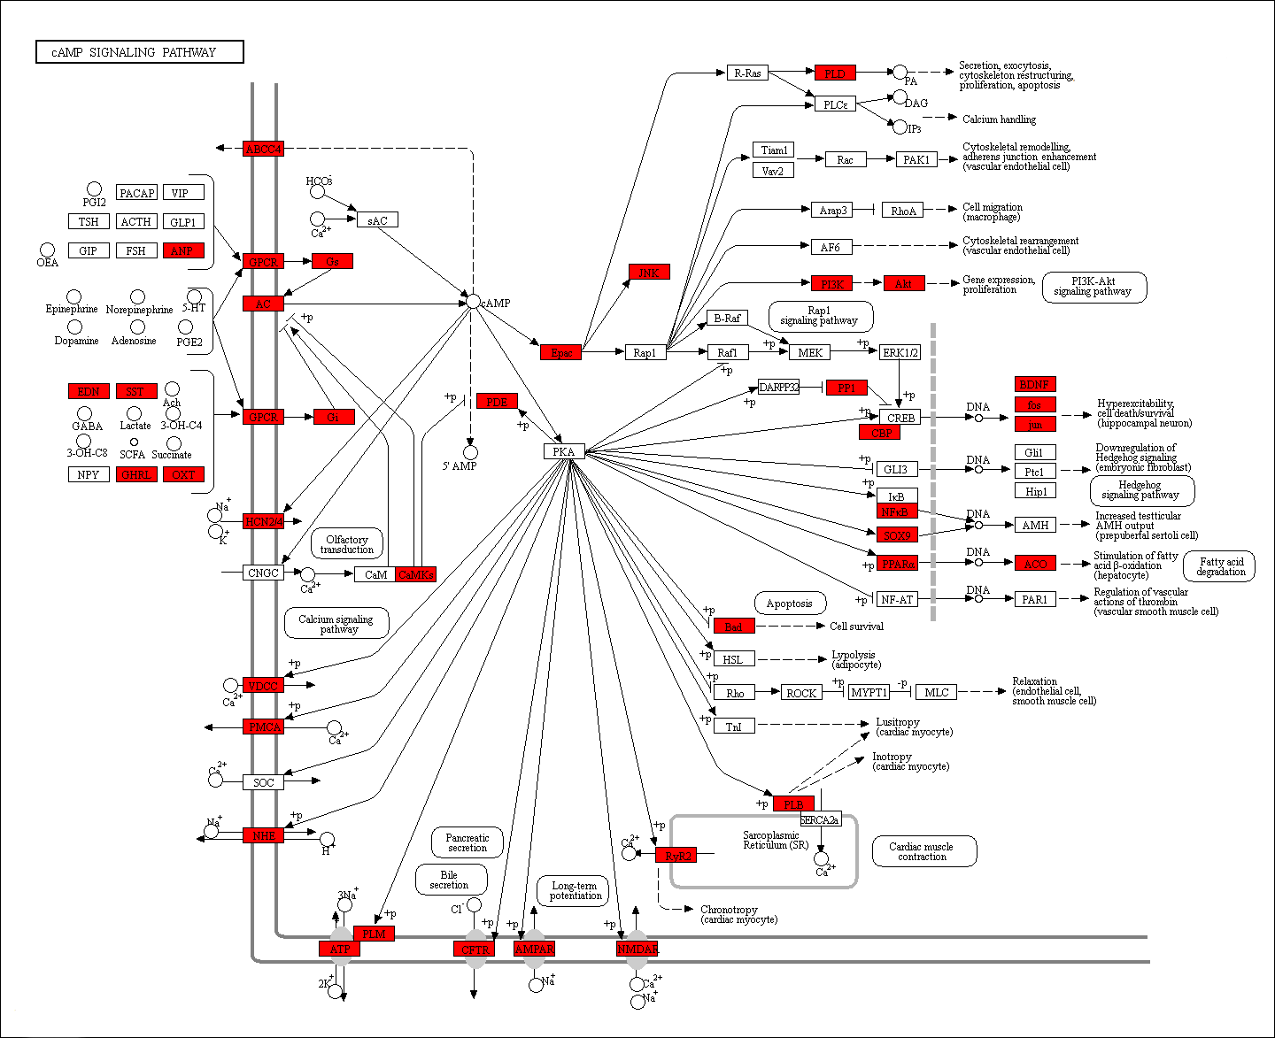

Supplementary Figure S4. PI3K-AKT SIGNALING PATHWAY
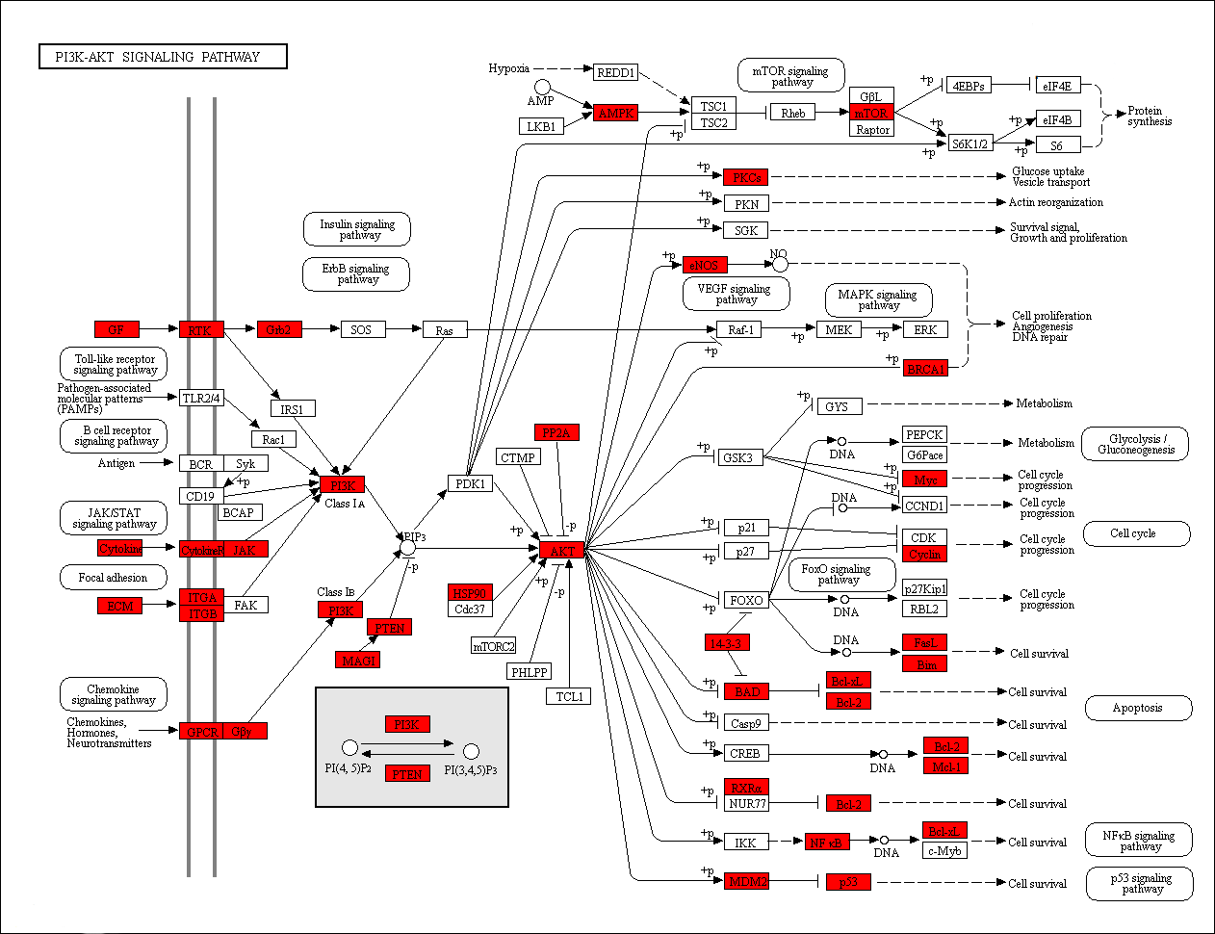

Supplementary Figure S5. Th17 SIGNALING PATHWAY
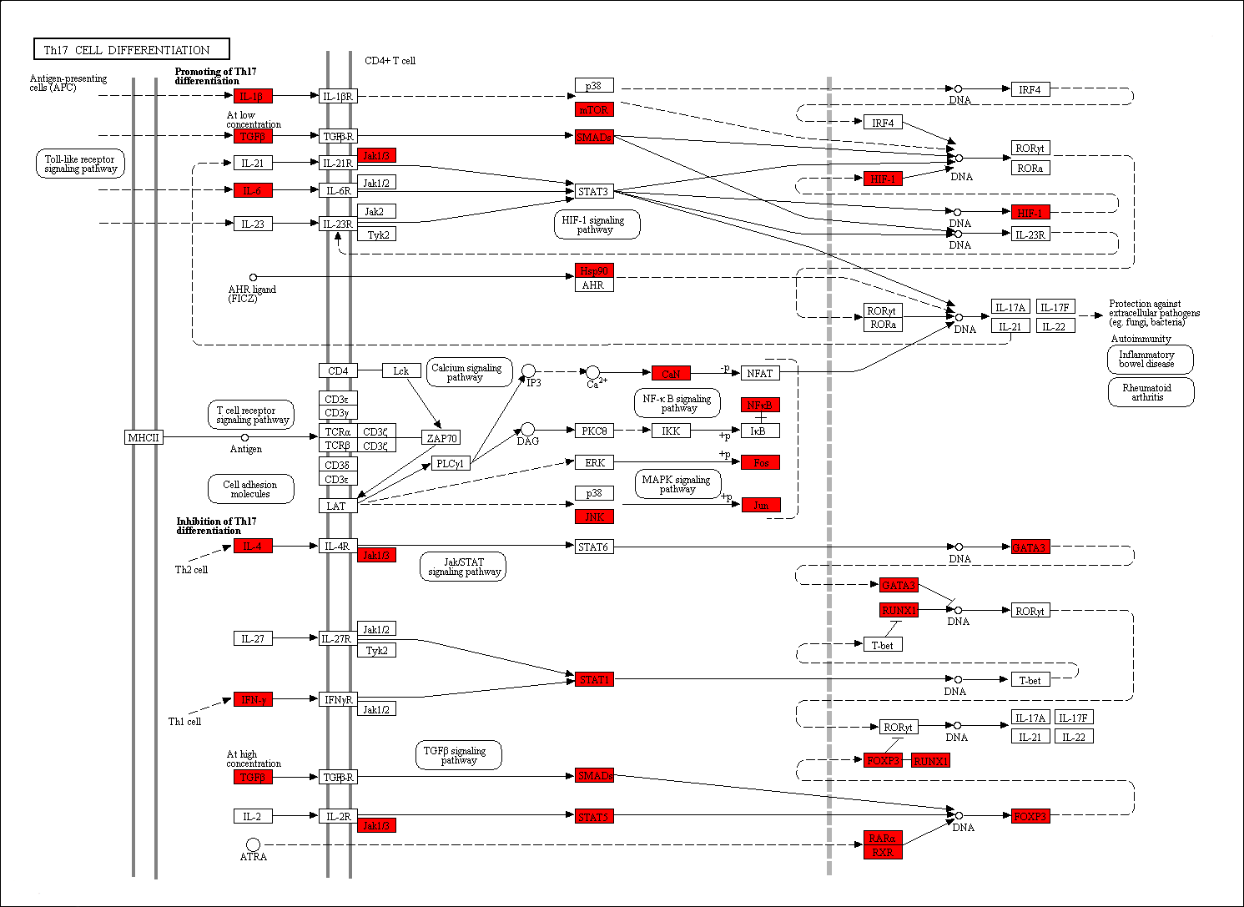

Supplementary Figure S6. IL-17 SIGNALING PATHWAY
