Supplementary Table 1. Sequences for real-time PCR primers
Genes¹ |  | Primer sequence² (5′-3′) | Accession no.
GAPDH |  | F:TGCTGCCCAGAACATCATCC | NM_204305
 |  | R:ACGGCAGGTCAGGTCAACAA
ACC |  | F:AATGGCAGCTTTGGAGGTGT | NM205505
 |  | R:TCTGTTTGGGTGGGAGGTG
FAS |  | F:CCAACGATTACCCGTCTCAA | J03860
 |  | R:CAGGCTCTGTATGCTGTCCAA
SREBP1c |  | F:GCCCTCTGTGCCTTTGTCTTC | AY029224
 |  | R:ACTCAGCCATGATGCTTCTTCC
LXRα |  | F:CAAAGGGAATGAATGAGC | AF492498
 |  | R:AGCCGAAGGGCAAACAC
FXR |  | F:AGTAGAAGCCATGTTCCTCCGTT | AF492497
 |  | R:GCAGTGCATATTCCTCCTGTGTC
ACOX |  | F:ATGTCACGTTCACCCCATCC | NM001006205
 |  | R:AGGTAGGAGACCATGCCAGT
LCAD |  | F:CGTGGTGATTGTGGTTACGGTTA | NM_001006511
 |  | R:TGTTCTCTTTCCCAAGCAAGGC
PPARα |  | F:TCCTTCCCGCTGACCAAA | AF163809
 |  | R:TCCTGCACTGCCTCCACA
PPARγ |  | F:CGAGGAGTCTTCCAACTC | AF163811
 |  | R:CCTGATGGCATTATGTGA
¹ GAPDH, reduced glyceraldehyde-phosphate dehydrogenase; ACC, acetyl-CoA carboxylase; FAS, fatty acid synthetase; SREBP, sterol-regulatory element-binding protein; LXR, the liver X receptor; FXR, farnesoid X receptor; ACOX, acyl-CoA oxidase; LCAD, long-chain acyl-CoA dehydrogenase; PPAR, peroxisome proliferator activated receptor.
² F, forward; R, reverse.
Supplementary Table 2. Alpha diversity of ileal microbiota of aged laying hens
 | ACE estimator | Chao1 estimator | Simpson index | Shannon index
Control | 82.35±3.88 | 82.99±5.57 | 0.24±0.02 | 1.87±0.07
Treatment | 88.96±9.99 | 89.34±11.11 | 0.20±0.06 | 2.02±0.22
P-value | 0.161 | 0.239 | 0.222 | 0.145

A. At phylum level | B. At class level
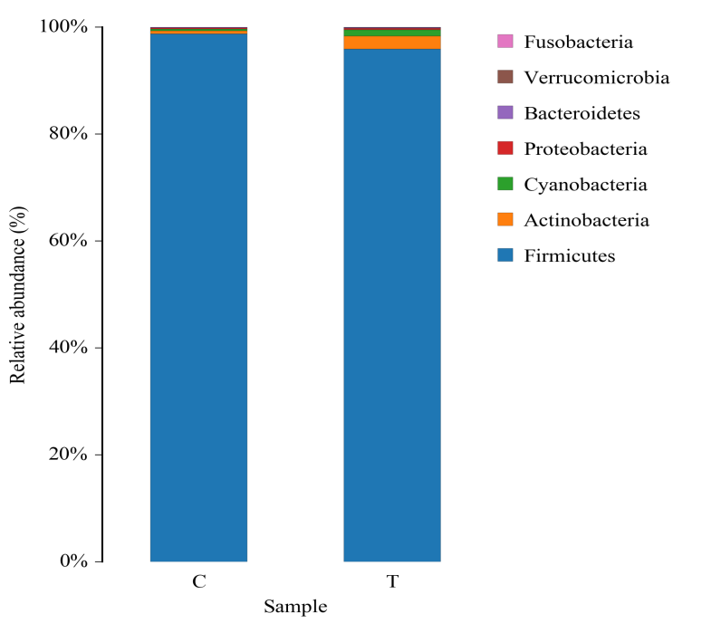 | 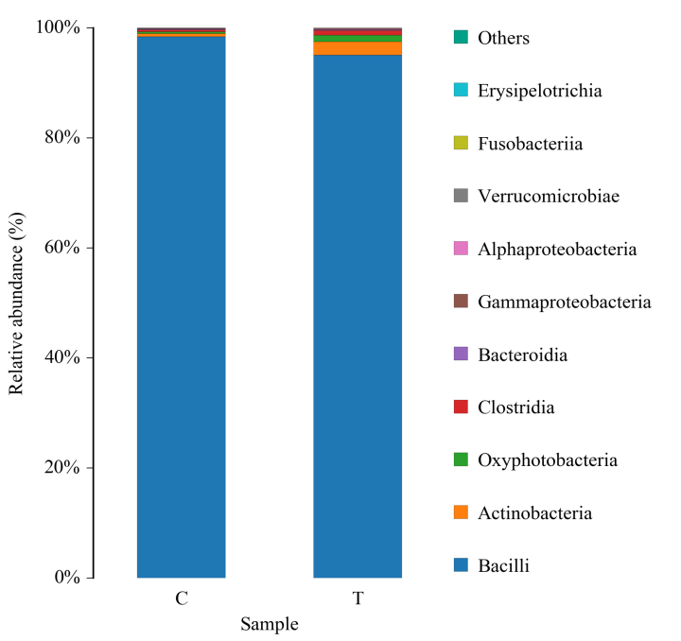
C. At order level | D. At family level
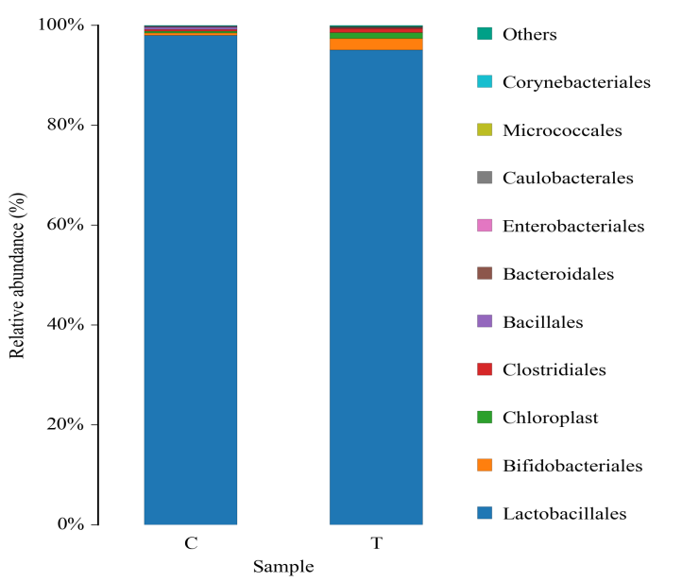 | 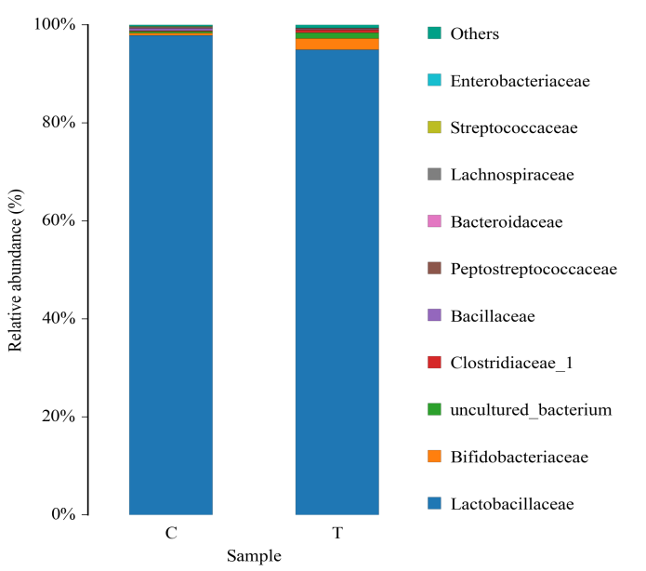
E. At genus level
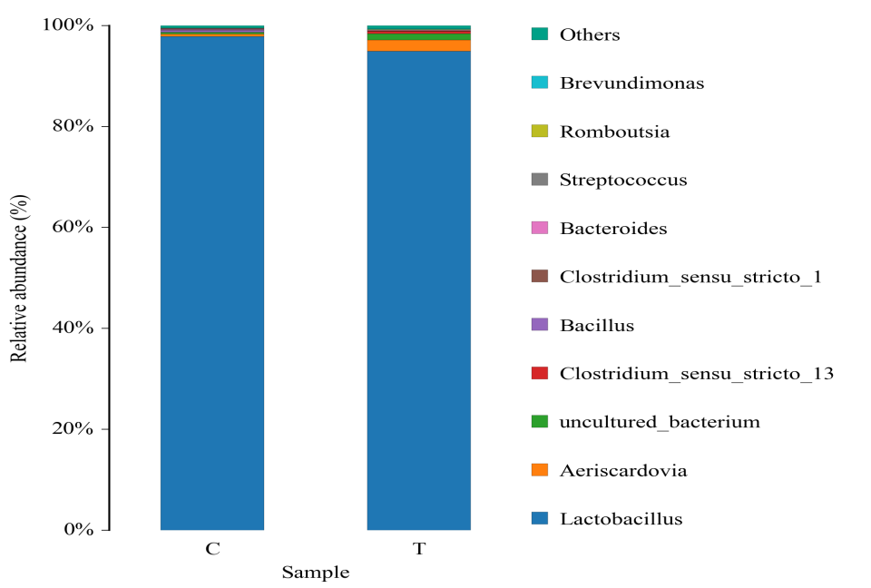
Supplementary Figure 1. Composition of gut microbiota at various taxonomic levels of layers
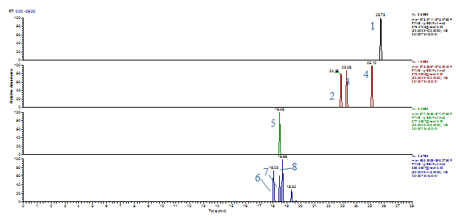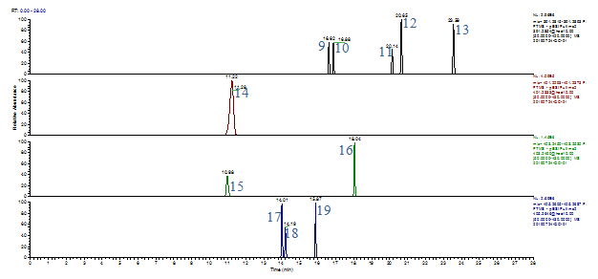
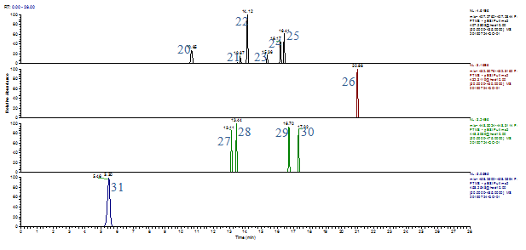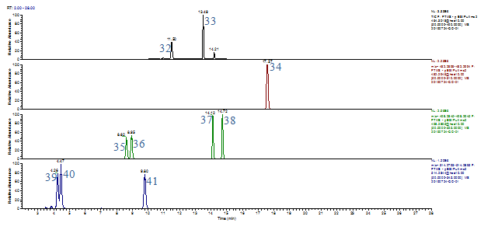
Supplementary Figure 2. Ion recording chromatograms of bile acid standard solutions. (1) DHLCA (dehydrolithocholic acid); (2) ALCA (allolithocholic acid); (3) ILCA (isolithocholic acid); (4 LCA (lithocholic acid); (5) 23-NDCA (23-Nordeoxycholic acid); (6) 7-KLCA (7-ketolithocholic acid); (7) 12-KLCA (12-ketolithocholic acid); (8) ApCA (apocholic acid); (9) UDCA (ursodeoxycholic acid); (10) HDCA (hyodeoxycholic acid); (11) CDCA (chenodeoxycholic acid); (12) DCA (deoxycholic acid); (13) IDCA (isodeoxycholic acid); (14) DHCA (dehydrocholic acid); (15) 7,12-DKLCA (7,12-diketolithocholic acid); (16) 6,7-DKLCA (6,7-diketolithocholic acid); (17) 7-KDCA (7-ketodeoxycholic acid); (18) 12-DHCA (12-dehydrocholic acid); (19) 3-DHCA (3-dehydrocholic acid); (20) UCA (ursocholic acid); (21) αMCA (α-muricholic acid); (22) βMCA (β-muricholic acid); (23) λMCA (λ-muricholic acid); (24) AlCA (allocholic acid); (25) CA (cholic acid); (26) GLCA (glycolithocholic acid); (27) GUDCA (glycoursodeoxycholic acid); (28) GHDCA (glycohyodeoxycholic acid); (29) GCDCA (glycochenodeoxycholic acid); (30) GDCA (glycodeoxycholic acid); (31) GDHCA (glycodehydrocholic acid); (32) GλMCA (glyco-λ-muricholic acid); (33) GCA (glycocholic acid); (34) TLCA (taurolithocholic acid); (35) TUDCA (tauroursodeoxycholic acid); (36) THDCA (taurohyodeoxycholic acid); (37) TCDCA (taurochenodeoxycholic acid); (38) TDCA (taurodeoxycholic acid); (39) TαMCA (tauro α-muricholic acid); (40) TβMCA (tauro β-muricholic acid); (41) TCA (taurocholic acid).

