Functional characterization of lysophosphatidylcholine: Acyl-Coa Acyltransferase genes from sunflower (Helianthus annuus L.)

Supplementary Material

Table S1. List of oligonucleotides used in this study.
GENE/PLASMID | OLIGONUCLEOTIDES | 5´-3´-SEQUENCE | UTILISATION | RESTRICTION ENZYME SEQUENCE
HaLPCAT1 | BamHIHaLPCAT1F  XhoIHaLPCAT1R | TGGATCCATGGATATGGAATCAACGGC  GCCTCGAGTCACTGTTCTTTTCGGGCTT | pMBL-T,  pYES2 and  p23GPD cloning | BamHI  XhoI
 | qHaLPCAT1F  qHaLPCAT1R | GCCTCCATGAGACACTAACAT  GAAGAACACATGAAAACGACAGC | qPCR | -  -
 | pBINPCAT1F  pBINPCAT1R | TTGGATCCATGGATATGGAATCAACGGC  GGCTGCAGTCACTGTTCTTTTCGGGCTT | pBIN19 cloning | BamHI  PstI
HaLPCAT2 | BamHIHaLPCAT2F  XhoIHaLPCAT2R | TGGATCCATGGAAATGGAATCAATGG  CGCTCGAGTCACTGCTCTTTCCGGGCTT | pMBL-T,  pYES2 and  p23GPD cloning | BamHI  XhoI
 | qHaLPCAT2F  qHaLPCAT2R | CCTACACGAAACACTGGCTG  TAAACCTCACTGCTCTTTCCG | qPCR | -  -
 | pBINHaLPCAT2F  pBINHaLPCAT2R | AAGGATCCATGGCGTCGGCGATC  AACTGCAGTCACTGCTCTCTTTCCGGG | pBIN19 cloning | BamHI  PstI
HaLPCAT3 | EcoRIHaLPCAT3F  XhoIHaLPCAT3R | GCGGCGAATTCATGAAAATGGAAGAAATGGC  GCGCTCGAGTTACTTTACTTTTCGGGCTC | pJET1.2,  pYES2 and  p23GPD cloning | EcoRI  XhoI
 | qHaLPCAT3F  qHaLPCAT3R | AAAGCCGCACACATCCAGAG  CCTGTGGTGGTTCTTGAGAG | qPCR | -  -
 | pBINHaLPCAT3F  pBINHaLPCAT3R | TTCCCGGGATGAAAATGGAAGAAATGGC  GGGTCGACTTACTTTACTTTTCGGGCTCTGG | pBIN19 cloning | XmaI  SalI
AtLPCAT1 | AtLPCAT1F  AtLPCAT1R | ATGGATATGAGTTCAATGGCTG  TTATTCTTCTTTACGCGGTTTTG | Gene amplification | -  -
 | pBINAtLPCAT1F  pBINAtLPCAT1R | TAGGTACCATGGATATGAGTTCAATGGCTG  GGTCTAGATTATTCTTCTTTACGCGGTTTTG | pBIN19 cloning | KpnI  XbaI
 | SALK_123480LP ⁽¹⁾⁽²⁾  SALK_123480RP ⁽¹⁾⁽²⁾  SALK_LBb1 | ACTCGGTTCACAGAACCAGTG  AAGCGCGGGAAACTTACTTAC  GCGTGGACCGCTTGCTGCAACT | lpcat1 lpcat2-2 ⁽¹⁾ ⁽²⁾ | -  -  -
 | JW160 ⁽¹⁾  JW217 ⁽¹⁾ | GCGGCCGCATGGATATGAGTTCAATG  GGCGCGCCTTATTCTTCTTTACGCGGTTT | lpcat1 lpcat2.2 ⁽²⁾ | NotI  AscI
 | RTlpcat1_2for  RTlpcat1_2rev | GCAGGCTCACGGGTTATTTA  TTCTTTACGCGGTTTTGGTC | Detection of 3´ expression | -  -
AtLPCAT2 | AtLPCAT2F  AtLPCAT2R | ATGGAATTGCTTGACATGAACTC  TTATTCTTCTTTTCTGGTCTTTGGTC | Gene amplification | -  -
 | pBINAtlpcat2F  pBINAtlpcat2R | TAGGTACCATGGAATTGCTTGACATGAACTC  GGTCTAGATTATTCTTCTTTTCTGGTCTTTGGTC | pBIN19 cloning | KpnI  XbaI
 | RTlpcat2_2for  RTlpcat2_2rev | GCTGTCTGGCATGGACTGTA  GCGACTAGTGTTTCGTGCAA | Detection of 3´expression | -  -
 | SAIL_1213_G01LP ⁽¹⁾  SAIL_1213_G01RP ⁽¹⁾  SAIL_LB1 | GCTTGAAACACAGCTCGAATC  TAACTTCCCATCAGGCATCAG  GCCTTTTCAGAAATGGATAAATAGCCTTGCTTCC | lpcat1 lpcat2-2 ⁽¹⁾ | -  -  -
 | SAIL_357_H01LP ⁽²⁾  SAIL_357_H01RP ⁽²⁾  SAIL_LB2 | TTTGGTTACCAATACATGGCG  GAAGGCGACTAGTGTTTCGTG  GCTTCCTATTATATCTTCCCAAATTACCAATACA | lpcat1 lpcat2.2 ⁽²⁾ | -  -  -
 | JW162 ⁽¹⁾  JW218 ⁽¹⁾ | GCGGCCGCATGGAATTGCTTGACATG  GGCGCGCCTTATTCTTCTTTTCTGGTCTT | lpcat1 lpcat2-2 ⁽¹⁾ | NotI  XhoI
18S | 18S-F  18S-R | GGTAGGCGATTGGCTAACATTGTCTGC  GAGACACCAACAGTCTTTCCTCTGCG | Control | -  -
Actina | qHaACTF  qHaACTR | GCTAACAGGGAAAAGATGACTC  ACTGGCATAAAGAGAAAGCACG | Control | -  -
 | AtActF  AtActR | GGAAGGATCTGTACGGTAAC  TGTGAACGATTCCTGGACCT
 | AtActF  AtActR | GGAAGGATCTGTACGGTAAC  TGTGAACGATTCCTGGACCT
pMBL-T | M13F  M13R | GTAAAACGACGGCCAGT  AGGAAACAGCTATGACCATG | Construct checking | -  -
pJET1.2 | pJET1.2F  pJET1.2R | CGACTCACTATAGGGAGAGCGGC  AAGAACATCGATTTTCCATGGCAG | Construct checking | -  -
pYES2 | GAL1F  CYCR | GTCAAGGAGAAAAAACCCCGGATC  GCGTGACATAACTAATTACATGATGCG | Construct checking | -  -
p423GPD and  p416GPD | GPDF  CYC2R | AAGTATATAAAGACGGTAGG  ATAGGGACCTAGACTTCAGG | Construct checking | -  -
pBIN19::35S | pBIN19F  pBIN19R | GAAAGGGGGATGTGCTGCAAGG  CACACAGGAAACAGCTATGACC | Construct checking | -  -
⁽¹⁾ Wang et al., 2012 ⁽²⁾ Xu et al., 2012

Table S2. Efficiency of amplification and correlation coefficient to the model of Livak and Schmittgen (2001) for the 3 LPCAT genes from sunflower and the control actin gene.

Gene | Efficiency | R2
 | (%)
HaLPCAT1 | 92.4 | 0.997
HaLPCAT2 | 102.6 | 0.984
HaLPCAT3 | 105.1 | 0.997
HaActin | 100.0 | 0.996

Figure S1. Sequence alignment of HaLPCATs with the related LPCATs from higher plants with their different motifs and the RE signal. Identical residues are highlighted as black boxes, highly conserved residues as dark grey boxes and semiconservative changes as light grey boxes.

Figure S2. Hydrophobocity graphs of TMDs of HaLPCATs.

HaLPCAT 1

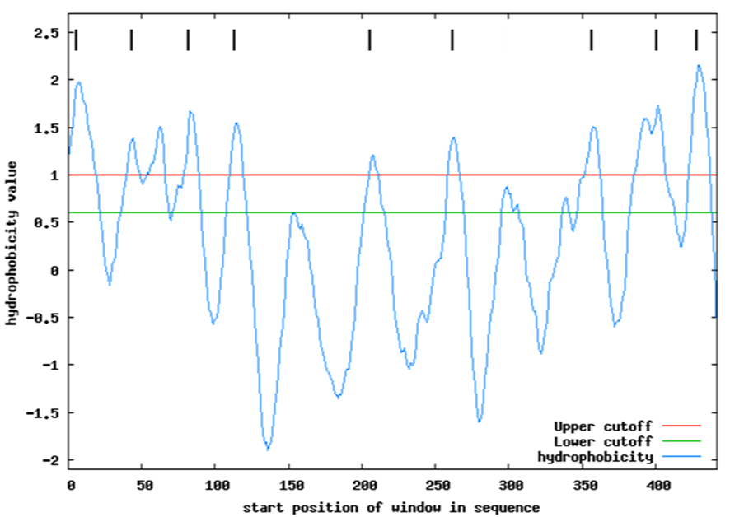
HaLPCAT 2

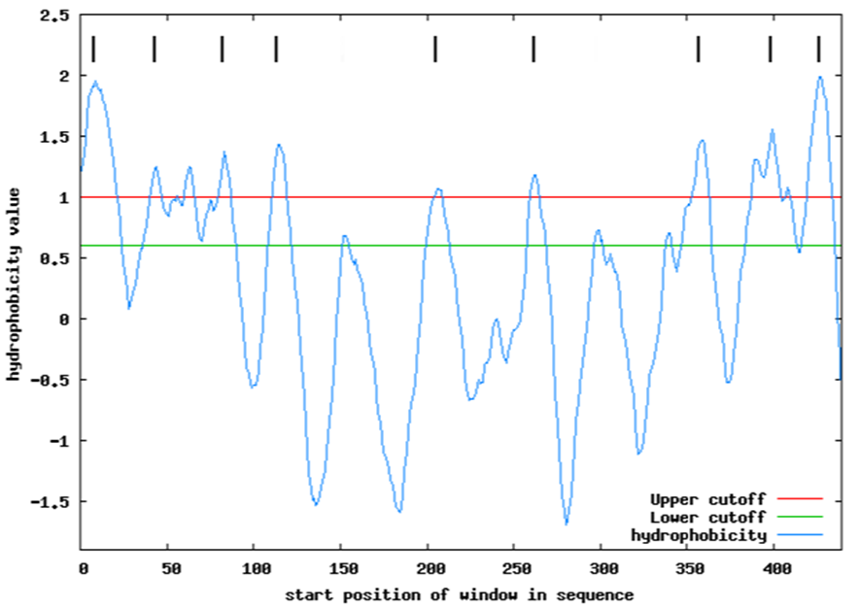

HaLPCAT 3

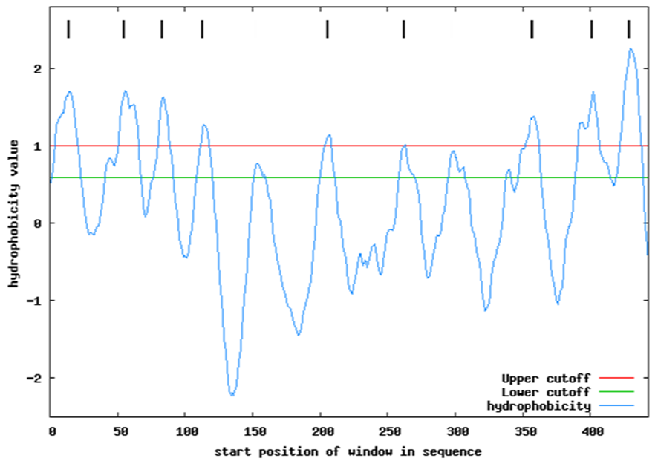

Figure S3. Subcellular location prediction of HaLPCAT proteins.

Figure S4. Studies on the influence of reaction time (A) and amount of protein (B) in the activity HaLPCAT1 in the direct reaction assayed in yeast microsomes. Data represent the average value of three independent determinations plus minus standard deviation. pYES2::HaLPCAT1 (-■-), empty pYES2 (-●-).

