Supporting information
One-Pot Deconstruction and Conversion of Lignocellulose into Reducing Sugars by Pyridinium Based Ionic Liquid‒Metal Salt System

Sadia Naz ª, Maliha Uroos ^{a, *}, Azmat Mehmood Asim ª, Nawshad Muhammad ^{b,} and Faiz Ullah Shah ^{c},*
ª Institute of Chemistry, University of the Punjab, 54000, Lahore, Pakistan
^{b} Interdisciplinary Research Centre in Biomedical Materials (IRCBM), COMSATS University Islamabad, Lahore Campus, 54600, Lahore, Pakistan
^{c} Chemistry of Interfaces, Luleå University of Technology, 971 87 Luleå, Sweden
*Corresponding authors: malihauroos.chem@pu.edu.pk; and faiz.ullah@ltu.se

Fig. S1. Standard DNS curve for glucose concentration.

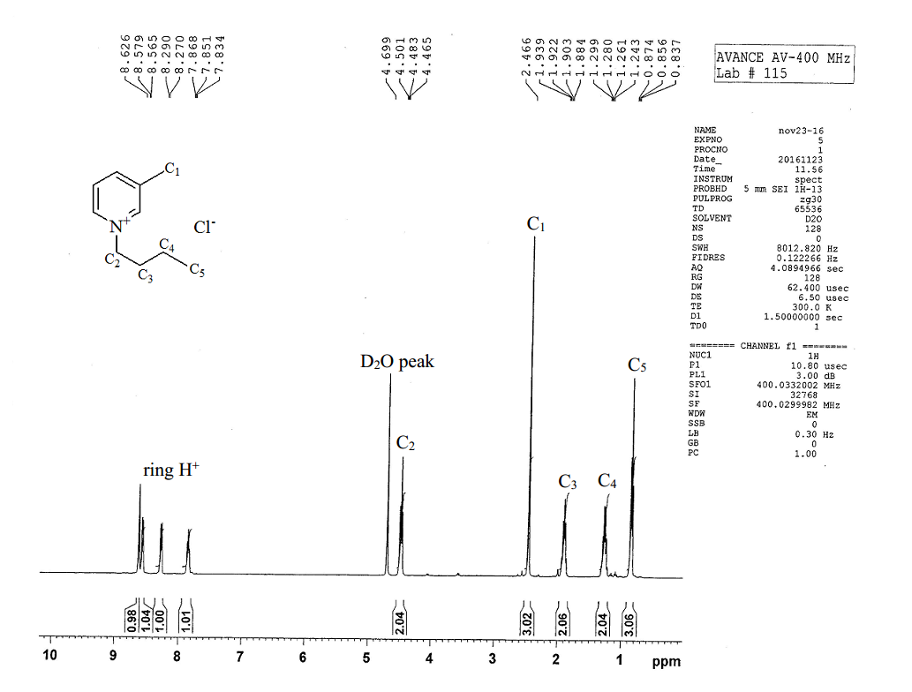
Fig. S2. ¹HNMR of [BMPy]Cl.

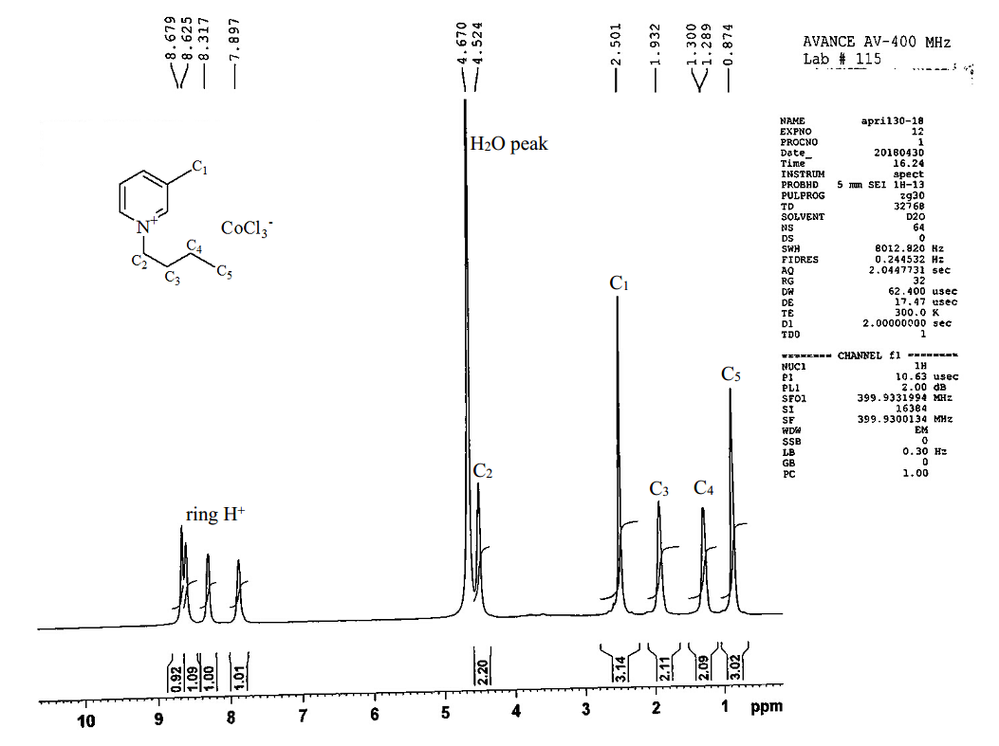
Fig. S3. ¹HNMR of regenerated [BMPy]Cl.

Fig. S4. Effect of different metal chlorides on delignified wheat straw/cellulose rich material (CRM).

Fig. S5. Effect of different metal chlorides added in IL for lignin extraction.

Fig. S6. FTIR analysis of originally synthesized and regenerated [BMPy]Cl.

Table S1. Effect of different process variables on one-pot conversion and deconstruction of wheat straw and their analysis of variance (ANOVA) at 0.05 level of confidence showing that X₁, X₂, X₃ and X₄ are not significantly different.
Sr. No. | Catalyst loading (%) | Time  (h) | Temp.  (°C) | Biomass size (μm) | TRS  (%) | % Conversion | % Delignification
 | X₁ | X₂ | X₃ | X₄
1 | 1 | 2.0 | 100 | 100 | 37 | 12 | 8
2 | 2 | 2.0 | 100 | 100 | 43 | 12 | 8
3 | 3 | 2.0 | 100 | 100 | 44 | 12 | 15
4 | 5 | 2.0 | 100 | 100 | 45 | 15 | 39
5 | 7 | 2.0 | 100 | 100 | 47 | 20 | 57
6 | 10 | 2.0 | 100 | 100 | 70 | 32 | 67
7 | 13 | 2.0 | 100 | 100 | 16 | 14 | 65
8 | 16 | 2.0 | 100 | 100 | 55 | 15 | 54
9 | 10 | 0.5 | 100 | 100 | 41 | 17 | 20
10 | 10 | 1.0 | 100 | 100 | 65 | 25 | 45
11 | 10 | 1.5 | 100 | 100 | 66 | 31 | 64
12 | 10 | 2.5 | 100 | 100 | 63 | 30 | 65
13 | 10 | 3.0 | 100 | 100 | 62 | 20 | 59
14 | 10 | 2.0 | 80 | 100 | 29 | 12 | 62
15 | 10 | 2.0 | 120 | 100 | 71 | 15 | 40
16 | 10 | 2.0 | 100 | 250 | 60 | 27 | 65
17 | 10 | 2.0 | 100 | 500 | 39 | 15 | 60
18 | 10 | 2.0 | 100 | 100 | 62 | 19 | 54
19 | 10 | 2.0 | 100 | 100 | 40 | 5 | 47

ANOVA
Variable X₁ |  |  |  |  |  |  |  | Sum of Squares |  |  | df |  |  | Mean Square |  |  | F |  |  | Sig. value
TRS  R² = 0.4531 | Between Groups |  |  | (Combined) |  |  |  | 1853.018 |  |  | 7 |  |  | 264.717 |  |  | 1.302 |  |  | .334
 |  |  |  | Linear Term |  | Weighted |  | 136.680 |  |  | 1 |  |  | 136.680 |  |  | .672 |  |  | .430
 |  |  |  |  |  | Deviation |  | 1716.337 |  |  | 6 |  |  | 286.056 |  |  | 1.407 |  |  | .295
 |  |  |  | Quadratic Term |  | Weighted |  | 285.721 |  |  | 1 |  |  | 285.721 |  |  | 1.405 |  |  | .261
 |  |  |  |  |  | Deviation |  | 1430.617 |  |  | 5 |  |  | 286.123 |  |  | 1.407 |  |  | .295
 | Within Groups |  |  |  |  |  |  | 2236.667 |  |  | 11 |  |  | 203.333
 | Total |  |  |  |  |  |  | 4089.684 |  |  | 18
Conversion  R² = 0.22669 | Between Groups |  |  | (Combined) |  |  |  | 229.439 |  |  | 7 |  |  | 32.777 |  |  | .461 |  |  | .844
 |  |  |  | Linear Term |  | Weighted |  | 69.215 |  |  | 1 |  |  | 69.215 |  |  | .973 |  |  | .345
 |  |  |  |  |  | Deviation |  | 160.224 |  |  | 6 |  |  | 26.704 |  |  | .375 |  |  | .880
 |  |  |  | Quadratic Term |  | Weighted |  | 121.760 |  |  | 1 |  |  | 121.760 |  |  | 1.711 |  |  | .217
 |  |  |  |  |  | Deviation |  | 38.464 |  |  | 5 |  |  | 7.693 |  |  | .108 |  |  | .988
 | Within Groups |  |  |  |  |  |  | 782.667 |  |  | 11 |  |  | 71.152
 | Total |  |  |  |  |  |  | 1012.105 |  |  | 18
Delignification  R² = 0.71022 | Between Groups |  |  | (Combined) |  |  |  | 5190.947 |  |  | 7 |  |  | 741.564 |  |  | 3.851 |  |  | .023
 |  |  |  | Linear Term |  | Weighted |  | 4031.910 |  |  | 1 |  |  | 4031.910 |  |  | 20.940 |  |  | .001
 |  |  |  |  |  | Deviation |  | 1159.037 |  |  | 6 |  |  | 193.173 |  |  | 1.003 |  |  | .470
 |  |  |  | Quadratic Term |  | Weighted |  | 862.879 |  |  | 1 |  |  | 862.879 |  |  | 4.481 |  |  | .058
 |  |  |  |  |  | Deviation |  | 296.159 |  |  | 5 |  |  | 59.232 |  |  | .308 |  |  | .898
 | Within Groups |  |  |  |  |  |  | 2118.000 |  |  | 11 |  |  | 192.545
 | Total |  |  |  |  |  |  | 7308.947 |  |  | 18
Variable X₂
TRS  R² = 0.24444 |  |  | Between Groups |  | (Combined) |  |  |  |  | 999.684 |  |  | 5 |  |  | 199.937 |  | .841 |  |  | .544
 |  |  |  |  | Linear Term |  | Unweighted |  |  | 92.658 |  |  | 1 |  |  | 92.658 |  | .390 |  |  | .543
 |  |  |  |  |  |  | Weighted |  |  | 19.056 |  |  | 1 |  |  | 19.056 |  | .080 |  |  | .782
 |  |  |  |  |  |  | Deviation |  |  | 980.628 |  |  | 4 |  |  | 245.157 |  | 1.031 |  |  | .428
 |  |  |  |  | Quadratic Term |  | Unweighted |  |  | 61.105 |  |  | 1 |  |  | 61.105 |  | .257 |  |  | .621
 |  |  |  |  |  |  | Weighted |  |  | 87.449 |  |  | 1 |  |  | 87.449 |  | .368 |  |  | .555
 |  |  |  |  |  |  | Deviation |  |  | 893.179 |  |  | 3 |  |  | 297.726 |  | 1.253 |  |  | .331
 |  |  | Within Groups |  |  |  |  |  |  | 3090.000 |  |  | 13 |  |  | 237.692
 |  |  | Total |  |  |  |  |  |  | 4089.684 |  |  | 18
Conversion  R² = 0.41219 |  |  | Between Groups |  | (Combined) |  |  |  |  | 417.177 |  |  | 5 |  |  | 83.435 |  | 1.823 |  |  | .177
 |  |  |  |  | Linear Term |  | Unweighted |  |  | 3.289 |  |  | 1 |  |  | 3.289 |  | .072 |  |  | .793
 |  |  |  |  |  |  | Weighted |  |  | 2.685 |  |  | 1 |  |  | 2.685 |  | .059 |  |  | .812
 |  |  |  |  |  |  | Deviation |  |  | 414.492 |  |  | 4 |  |  | 103.623 |  | 2.264 |  |  | .118
 |  |  |  |  | Quadratic Term |  | Unweighted |  |  | 49.133 |  |  | 1 |  |  | 49.133 |  | 1.074 |  |  | .319
 |  |  |  |  |  |  | Weighted |  |  | 20.936 |  |  | 1 |  |  | 20.936 |  | .457 |  |  | .511
 |  |  |  |  |  |  | Deviation |  |  | 393.556 |  |  | 3 |  |  | 131.185 |  | 2.867 |  |  | .077
 |  |  | Within Groups |  |  |  |  |  |  | 594.929 |  |  | 13 |  |  | 45.764
 |  |  | Total |  |  |  |  |  |  | 1012.105 |  |  | 18
Delignification  R² = 0.20668 |  |  | Between Groups |  | (Combined) |  |  |  |  | 1510.590 |  |  | 5 |  |  | 302.118 |  | .677 |  |  | .648
 |  |  |  |  | Linear Term |  | Unweighted |  |  | 811.732 |  |  | 1 |  |  | 811.732 |  | 1.820 |  |  | .200
 |  |  |  |  |  |  | Weighted |  |  | 655.001 |  |  | 1 |  |  | 655.001 |  | 1.469 |  |  | .247
 |  |  |  |  |  |  | Deviation |  |  | 855.589 |  |  | 4 |  |  | 213.897 |  | .480 |  |  | .750
 |  |  |  |  | Quadratic Term |  | Unweighted |  |  | 343.637 |  |  | 1 |  |  | 343.637 |  | .770 |  |  | .396
 |  |  |  |  |  |  | Weighted |  |  | 10.653 |  |  | 1 |  |  | 10.653 |  | .024 |  |  | .880
 |  |  |  |  |  |  | Deviation |  |  | 844.936 |  |  | 3 |  |  | 281.645 |  | .631 |  |  | .608
 |  |  | Within Groups |  |  |  |  |  |  | 5798.357 |  |  | 13 |  |  | 446.027
 |  |  | Total |  |  |  |  |  |  | 7308.947 |  |  | 18
Variable X3
TRS  R² = 1 |  | Between Groups |  |  | (Combined) |  |  |  |  | 882.155 |  |  | 2 |  |  | 441.077 |  | 2.200 |  |  | .143
 |  |  |  |  | Linear Term |  | Unweighted |  |  | 882.000 |  |  | 1 |  |  | 882.000 |  | 4.400 |  |  | .052
 |  |  |  |  |  |  | Weighted |  |  | 882.000 |  |  | 1 |  |  | 882.000 |  | 4.400 |  |  | .052
 |  |  |  |  |  |  | Deviation |  |  | .155 |  |  | 1 |  |  | .155 |  | .001 |  |  | .978
 |  |  |  |  | Quadratic Term |  | Unweighted |  |  | .155 |  |  | 1 |  |  | .155 |  | .001 |  |  | .978
 |  |  |  |  |  |  | Weighted |  |  | .155 |  |  | 1 |  |  | .155 |  | .001 |  |  | .978
 |  | Within Groups |  |  |  |  |  |  |  | 3207.529 |  |  | 16 |  |  | 200.471
 |  | Total |  |  |  |  |  |  |  | 4089.684 |  |  | 18
Conversion  R² = 0.05567 |  | Between Groups |  |  | (Combined) |  |  |  |  | 56.341 |  |  | 2 |  |  | 28.170 |  | .472 |  |  | .632
 |  |  |  |  | Linear Term |  | Unweighted |  |  | 4.500 |  |  | 1 |  |  | 4.500 |  | .075 |  |  | .787
 |  |  |  |  |  |  | Weighted |  |  | 4.500 |  |  | 1 |  |  | 4.500 |  | .075 |  |  | .787
 |  |  |  |  |  |  | Deviation |  |  | 51.841 |  |  | 1 |  |  | 51.841 |  | .868 |  |  | .365
 |  |  |  |  | Quadratic Term |  | Unweighted |  |  | 51.841 |  |  | 1 |  |  | 51.841 |  | .868 |  |  | .365
 |  |  |  |  |  |  | Weighted |  |  | 51.841 |  |  | 1 |  |  | 51.841 |  | .868 |  |  | .365
 |  | Within Groups |  |  |  |  |  |  |  | 955.765 |  |  | 16 |  |  | 59.735
 |  | Total |  |  |  |  |  |  |  | 1012.105 |  |  | 18
Delignification  R² = 0.03788 |  | Between Groups |  |  | (Combined) |  |  |  |  | 276.830 |  |  | 2 |  |  | 138.415 |  | .315 |  |  | .734
 |  |  |  |  | Linear Term |  | Unweighted |  |  | 242.000 |  |  | 1 |  |  | 242.000 |  | .551 |  |  | .469
 |  |  |  |  |  |  | Weighted |  |  | 242.000 |  |  | 1 |  |  | 242.000 |  | .551 |  |  | .469
 |  |  |  |  |  |  | Deviation |  |  | 34.830 |  |  | 1 |  |  | 34.830 |  | .079 |  |  | .782
 |  |  |  |  | Quadratic Term |  | Unweighted |  |  | 34.830 |  |  | 1 |  |  | 34.830 |  | .079 |  |  | .782
 |  |  |  |  |  |  | Weighted |  |  | 34.830 |  |  | 1 |  |  | 34.830 |  | .079 |  |  | .782
 |  | Within Groups |  |  |  |  |  |  |  | 7032.118 |  |  | 16 |  |  | 439.507
 |  | Total |  |  |  |  |  |  |  | 7308.947 |  |  | 18
Variable X₄
TRS  R² = 0.05423 |  | Between Groups |  | (Combined) |  |  |  |  | 221.802 |  |  | 2 |  |  | 110.901 |  |  |  | .459 |  |  | .640
 |  |  |  | Linear Term |  | Weighted |  |  | 55.652 |  |  | 1 |  |  | 55.652 |  |  |  | .230 |  |  | .638
 |  |  |  |  |  | Deviation |  |  | 166.150 |  |  | 1 |  |  | 166.150 |  |  |  | .687 |  |  | .419
 |  |  |  | Quadratic Term |  | Weighted |  |  | 166.150 |  |  | 1 |  |  | 166.150 |  |  |  | .687 |  |  | .419
 |  | Within Groups |  |  |  |  |  |  | 3867.882 |  |  | 16 |  |  | 241.743
 |  | Total |  |  |  |  |  |  | 4089.684 |  |  | 18
Conversion  R² = 0.08705 |  | Between Groups |  | (Combined) |  |  |  |  | 88.105 |  |  | 2 |  |  | 44.053 |  |  |  | .763 |  |  | .483
 |  |  |  | Linear Term |  | Weighted |  |  | .003 |  |  | 1 |  |  | .003 |  |  |  | .000 |  |  | .994
 |  |  |  |  |  | Deviation |  |  | 88.102 |  |  | 1 |  |  | 88.102 |  |  |  | 1.526 |  |  | .235
 |  |  |  | Quadratic Term |  | Weighted |  |  | 88.102 |  |  | 1 |  |  | 88.102 |  |  |  | 1.526 |  |  | .235
 |  | Within Groups |  |  |  |  |  |  | 924.000 |  |  | 16 |  |  | 57.750
 |  | Total |  |  |  |  |  |  | 1012.105 |  |  | 18
Delignification  R² = 0.07469 |  | Between Groups |  | (Combined) |  |  |  |  | 545.889 |  |  | 2 |  |  | 272.944 |  |  |  | .646 |  |  | .537
 |  |  |  | Linear Term |  | Weighted |  |  | 371.917 |  |  | 1 |  |  | 371.917 |  |  |  | .880 |  |  | .362
 |  |  |  |  |  | Deviation |  |  | 173.972 |  |  | 1 |  |  | 173.972 |  |  |  | .412 |  |  | .530
 |  |  |  | Quadratic Term |  | Weighted |  |  | 173.972 |  |  | 1 |  |  | 173.972 |  |  |  | .412 |  |  | .530
 |  | Within Groups |  |  |  |  |  |  | 6763.059 |  |  | 16 |  |  | 422.691
 |  | Total |  |  |  |  |  |  | 7308.947 |  |  | 18

