AhTE1761 AhTE1761
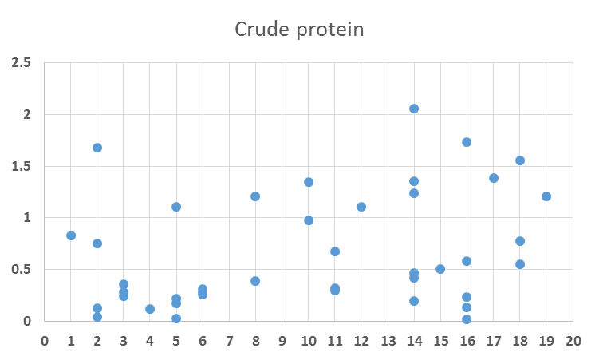
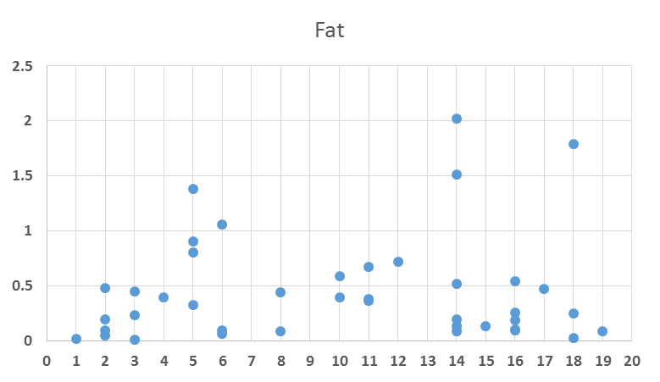

–Log₁₀(p)
–Log₁₀(p)

Position Position
a) Fat content b) Crude protein content
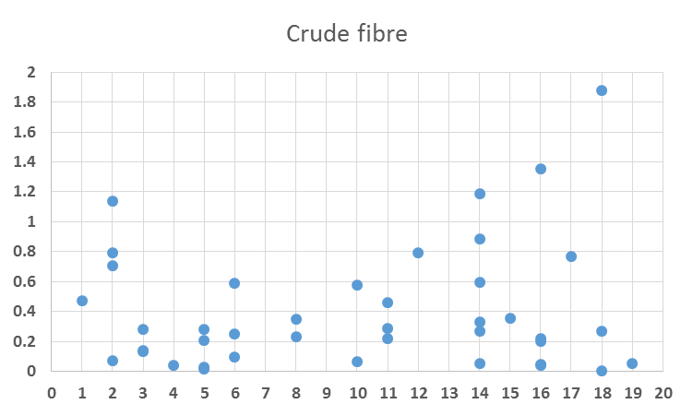
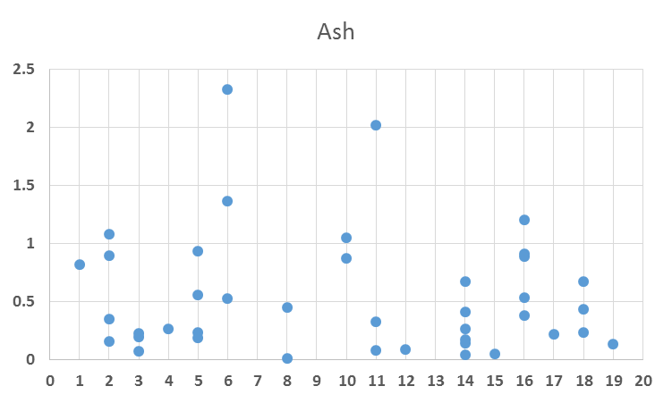
AhTE1363 AhTE2000

–Log₁₀(p)
–Log₁₀(p)

Position Position
c) Ash content d) Crude fibre content
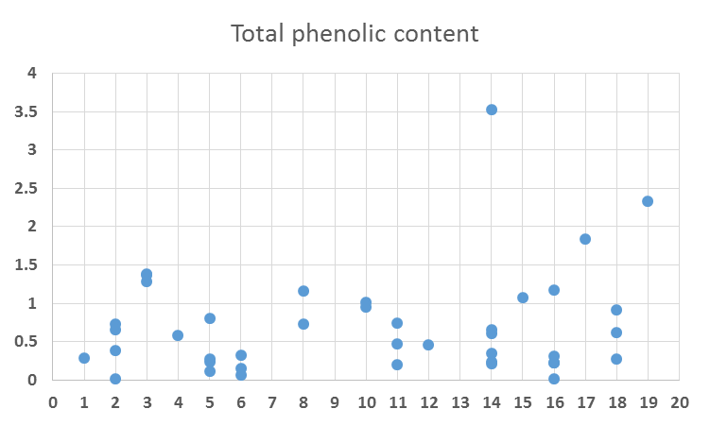
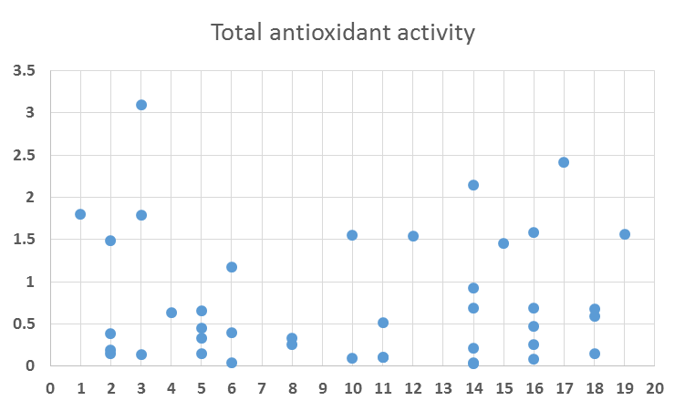
AhTE0189 AhTE0474

–Log₁₀(p)
–Log₁₀(p)

Position Position
e) Total polyphenolic content e) Total antioxidant activity

Supplementary Figure 1: Manhattan plot showing association of markers with nutritional traits like fat content, crude protein, ash, crude fibre, total polyphenolic content and total antioxidant activity

