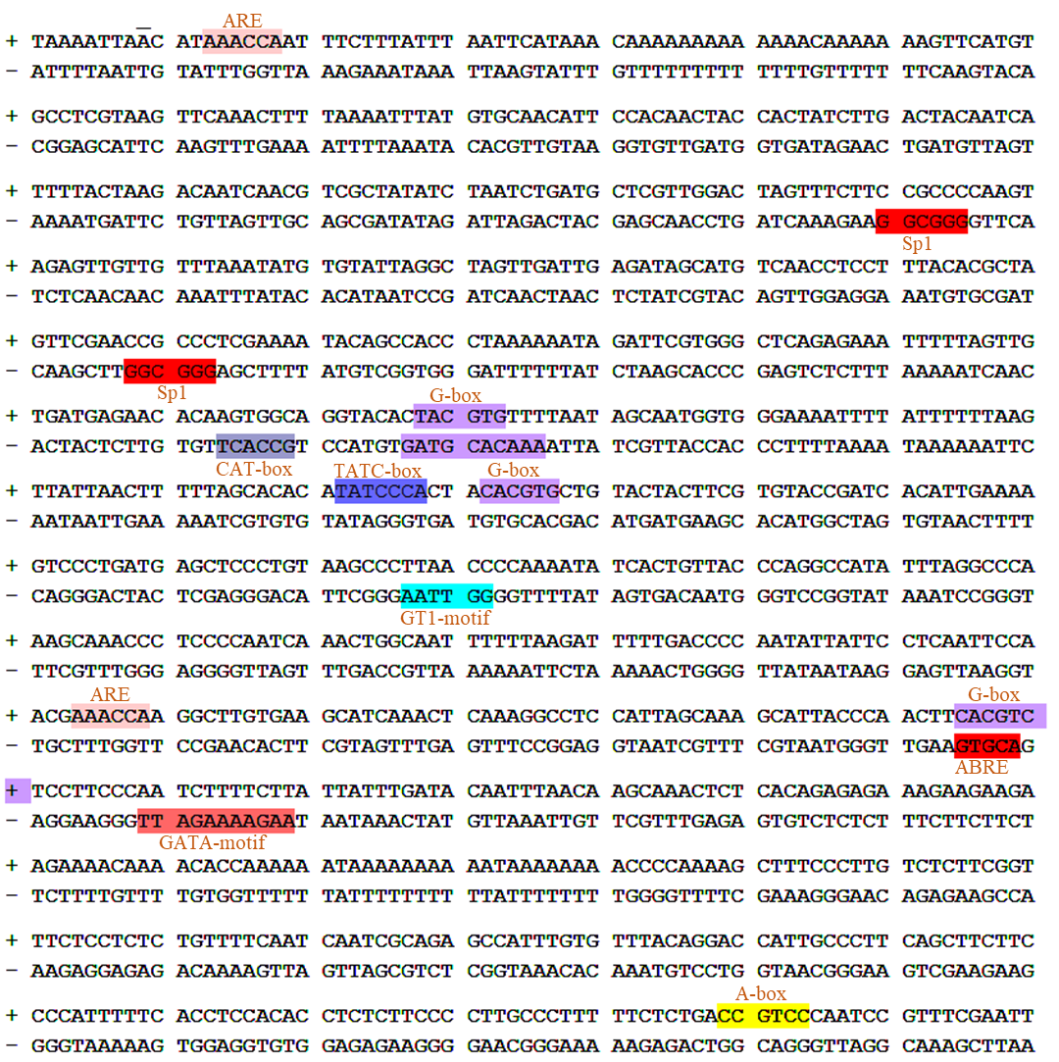
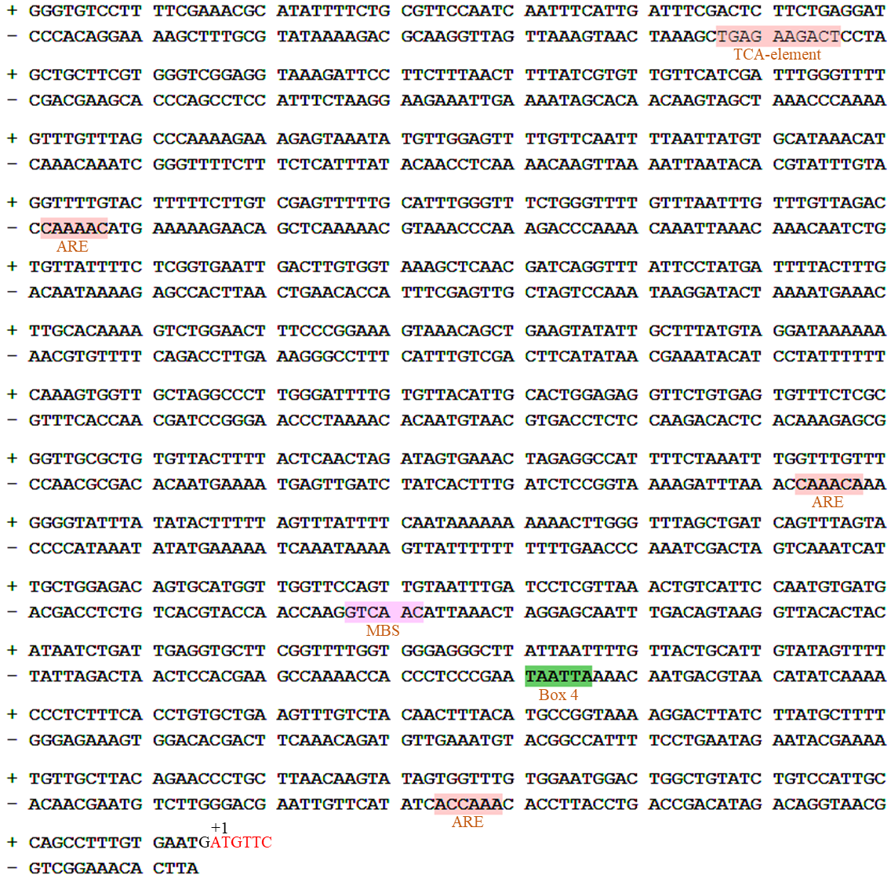
Fig. S1 Putative cis-regulatory elements in promoter region of MdATG9, as predicted from PlantCARE database. Letters in red indicates the coding sequence of MdATG9.
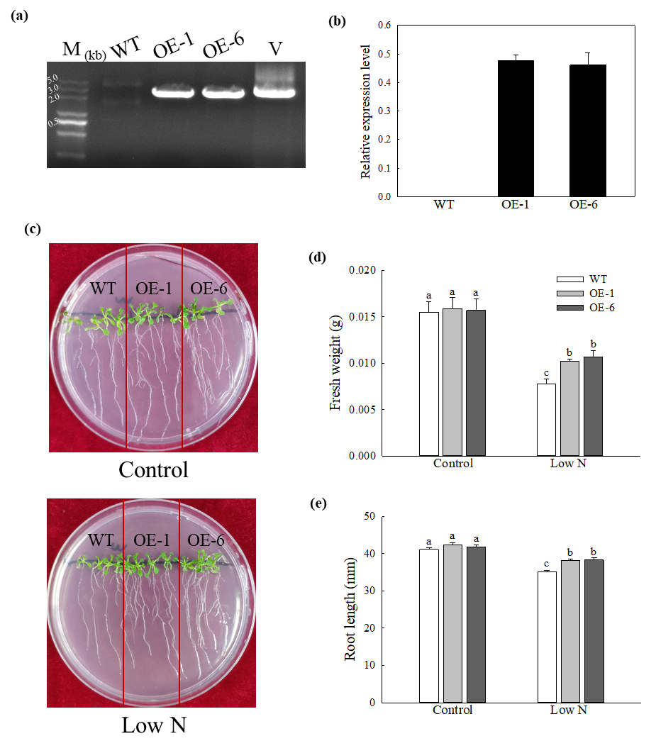
Fig. S2 Heterologous expression of MdATG9 in Arabidopsis confers enhanced tolerance to nitrogen starvation. (a) PCR with gDNA. Lanes M, molecular marker DL5000; WT, non-transformed wild-type; OE-1 and OE-6, MdATG9-transgenic lines; V, positive plasmid control. (b) qPCR analysis of MdATG9 transcripts in Arabidopsis lines OE-1 and OE-6. (c) Phenotypes of WT and transgenic Arabidopsis plants grew on normal MS media or nitrogen-limitation media for 15d. Plant (d) fresh weights and (e) root lengths are recorded. Data are the means of ten replicates with SE. Different letters indicate significant differences between treatments, according to one-way ANOVA and Tukey’s multiple range test (P <0.05).
Supplemental Table1 Predicted cis-regulatory elements with putative functions identified in promoter of MdATG9 using PlantCARE database.
Cis-element | Positions | Sequences | Putative function
ARE | 13 (+) | AAACCA | cis-acting regulatory element essential for the anaerobic induction
 | 634 (+) | AAACCA
 | 1190 (-) | AAACCA
 | 1531 (-) | AAACCA
 | 1854 (-) | AAACCA
Sp1 | 200 (-) | GGGCGG | light responsive element
 | 288 (-) | GGGCGG
G-box | 377 (-) | TAACACGTAG | cis-acting regulatory element involved in light responsiveness
 | 378 (+) | TACGTG
 | 452 (+) | CACGTG
 | 695 (+) | CACGTC
CAT-box | 364 (-) | GCCACT | cis-acting regulatory element related to meristem expression
TATC-box | 442 (+) | TATCCCA | cis-acting element involved in gibberellin-responsiveness
GT1-motif | 517 (-) | GGTTAA | light responsive element
ABRE | 695 (-) | ACGTG | cis-acting element involved in the abscisic acid responsiveness
GATA-motif | 709 (-) | AAGATAAGATT | part of a light responsive element
TCA-element | 1037 (-) | TCAGAAGAGG | cis-acting element involved in salicylic acid responsiveness
MBS | 1637 (-) | CAACTG | MYB binding site involved in drought-inducibility
Box 4 | 1721 (-) | ATTAAT | part of a conserved DNA module involved in light responsiveness

Supplemental Table2 Primers used in this study
Gene | Sequence (5'-3') | Purpose
ATG9 | F: ATGTTCGGTAGGTTGAAGGGTG | cloning Sequence
 | R: CTATGGCTTTATTTCCGGAGTTTCT
sATG9 | F: GGGGACAAGTTTGTACAAAAAAGCAGGC  TTCATGTTCGGTAGGTTGAAGGG | Vector construction for sub-cellular localization
R: GGGGACCACTTTGTACAAGAAAGCTGGG
TTTGGCTTTATTTCCGGAGTTT
ATG9pro | F: TTCATGTGCCTCGTAAGTTCAAAC | Cloning the promoter of MdATG9
 | R: CATTCACAAAGGCTGGCAATGG
oeATG9 | F: CGGGATCCATGTTCGGTAGGTTGAAGGG | Vector construction for plant transformation
 | R: GGGGTACCTGGCTTTATTTCCGGAGTTT
dATG9 | F: GAGAACACGGGGGACTCTAGA | DNA confirmation of MdATG9 for transgenic identification
 | R: CGATCGGGGAAATTCGAGCTC
qATG9 | F: GTTTATTGCAGACTTCACGG | Quantitative expression of MdATG9
 | R: GCCTCTTGGAGGAGAATATG
MDH | F: CGTGATTGGGTACTTGGAAC | Reference gene used in real-time PCR
 | R: TGGCAAGTGACTGGGAATGA
qATG3a | F: AAGGGGGCGGAGATGGTTC | Quantitative expression of MdATG3a
 | R: GCACTTAGAGACGAGGTTATCGC
qATG3b | F: AGGGAGATGGTTTTGAAACAGA | Quantitative expression of MdATG3b
 | R: ACTTAGAGACGAGGTTATCGC
qATG5 | F: GCAGGTCGTGTTCCAGTTC | Quantitative expression of MdATG5
 | R: CCTCCTCCTCCTTGTATCTCAA
qATG7a | F: GCGGATATGAGCAACCTTGGC | Quantitative expression of MdATG7a
 | R: ATCAATAGGCGCAACGACATCA
qATG7b | F: ATCGGTAACAGGAGTAAGTCGG | Quantitative expression of MdATG7b
 | R: TTTATCAAGCGCATGAAAGCCT
qATG8c | F: GCGTTCAAGATGGAGCACCCTC | Quantitative expression of MdATG8c
 | R: CAGCCCTTTCCACAACCACTGG
qATG8i | F: GCAGCAGGCTTCACTTGACTCC | Quantitative expression of MdATG8i
 | R: GGAATCCATGCGACTGGCTGTT
qATG10 | F: TGGAACCAGCGAGTGGATGAAG | Quantitative expression of MdATG10
 | R: ACAACTGAGAGCCAAGACACCA
qNRT1.1 | F: TCCTTTATGCTCTGCTTGCTC | Quantitative expression of MdNRT1.1
 | R: GGGACTGTGGTTGAGATGGT
qNRT2.5 | F: TCGATCTGAAACTCCACACG | Quantitative expression of MdNRT2.5
 | R: ACTTCTTCGCCACAACATCC
qNIA1 | F: AACCCGCCGATAAACAGAC | Quantitative expression of MdNIA1
 | R: GTTCGCAGTTGAAGGGATGT
qNIA2 | F: CGGGAAGAAAGTCACACGAG | Quantitative expression of MdNIA2
 | R: CCAGAAACACCAGCACCAGT
qSUSY2 | F: TGTGGTTGGTGGTTACATGGATG | Quantitative expression of MdSUSY2
 | R: GCTGCTATCCATCGGAACTGAC
qSUSY3 | F: TTATGGTTTCTGGAAGTATGTGTC | Quantitative expression of MdSUSY3
 | R: GTCGATGGCTTCAGGAACAGATT

