Supplementary Material

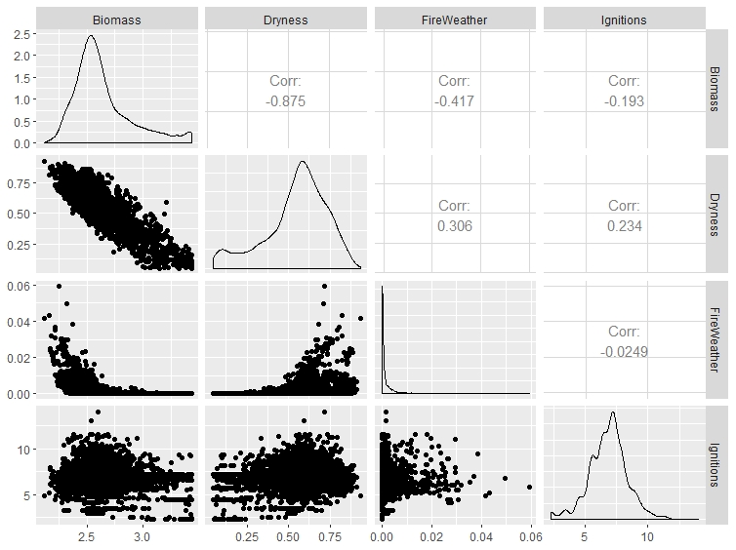
Supplementary Figure 1. Correlation matrix for four major determinants of fire in forests. Units are: a) log steady state litter fuel load in t ha⁻¹; b) proportion of the fire season where PET > precipitation; c) proportion of the fire season where FFDI > 50; d) log ignitions per fire season.

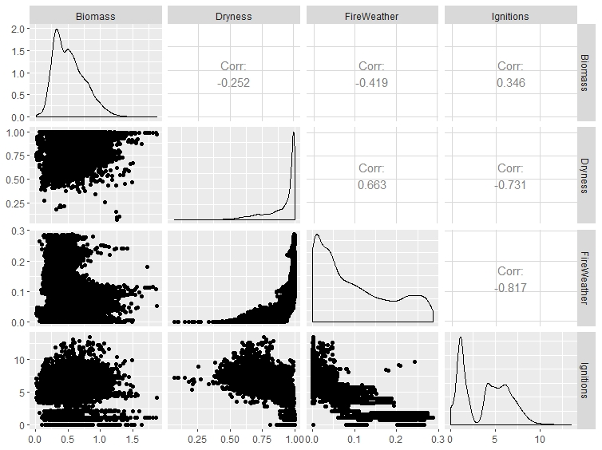
Supplementary Figure 2. Correlation matrix for four major determinants of fire in grasslands. Units are: a) log mean annual grass biomass in t ha⁻¹; b) proportion of the fire season where PET > precipitation; c) proportion of the fire season where FFDI > 50; d) log ignitions per fire season.

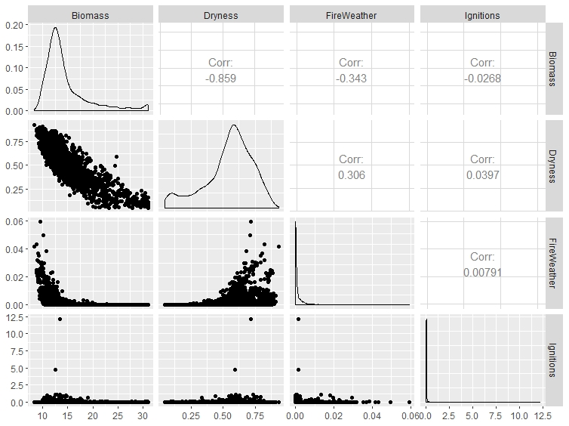
Supplementary Figure 3. As for Figure 1, but with biomass and ignitions untransformed. Units are: a) steady state litter fuel load in t ha⁻¹; b) proportion of the fire season where PET > precipitation; c) proportion of the fire season where FFDI > 50; d) ignitions per fire season.

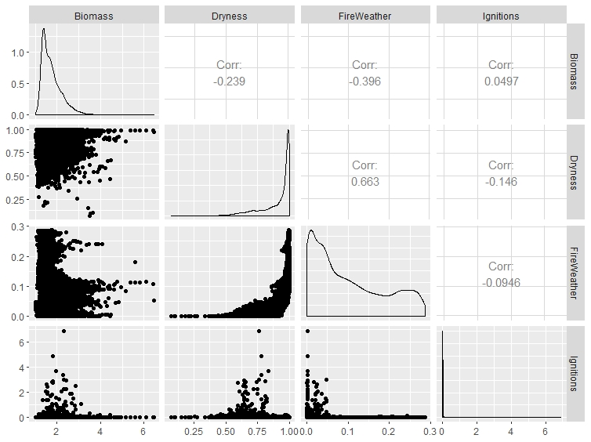
Supplementary Figure 4. As for Figure 2, but with biomass and ignitions untransformed. Units are: a) mean annual grass biomass in t ha⁻¹; b) proportion of the fire season where PET > precipitation; c) proportion of the fire season where FFDI > 50; d) ignitions per fire season.

