**Supplementary Figures and Figure Legends**



**Supplementary Figure 1. Dose-response curves for inhibition LPS-stimulated human whole blood by L745337**. Increasing concentrations of L745337 (0.001-100 mg/ml) or DMSO were incubated with 1 ml of heparinized human whole blood stimulated with LPS (10 µg/ml) for 24 h. PGE2 and TXB2 were assessed by immunoassays. Results were reported as % of inhibition (mean ± SEM, n=3). The IC50 and the Interval of Confidence (CI) values are reported in mg/ml.

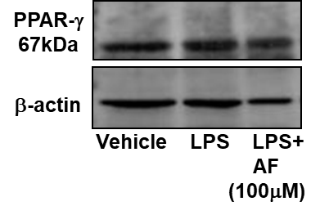

**Supplementary Figure 2. PPAR expression in isolated human monocytes.** Human monocytes (1.5-2 x 106 cells/ml) were incubated with vehicle or LPS (10 µg/ml) for 24 h at 37 ⁰C, in the absence and in the presence of AF3485 (100 µM); Western blot analysis of PPARγ is reported and β-actin was assessed as protein loading control.

**Supplementary Table 1. Baseline values of PGE2 and TXB2 in human whole blood and isolated human monocytes.**

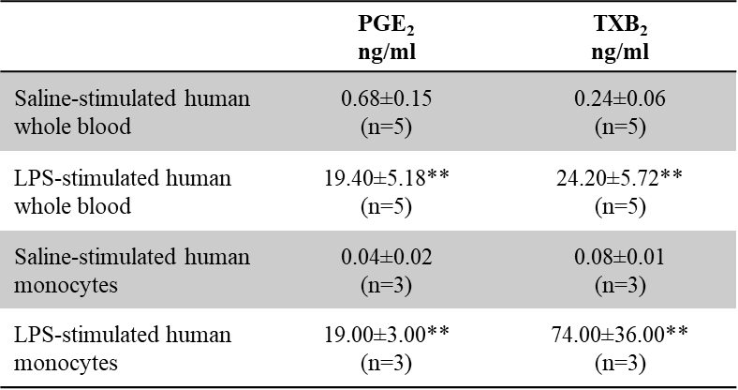

Data are reported as mean±SD; **P<0.01 versus the same prostanoid in the saline-stimulated condition.