Supplementary Material

Figure S1. A flow chart of sequencing, assembly, annotation, and analysis process for Tibetan black bear genome
Table S1. Summary information for raw sequencing reads and filtered reads
Table S2. Genome assembly information
Table S3. Comparison of the completeness of genome among five bear species in this study using mammalia_odb9 BUSCOs
Table S4. Conversation of syntenic relationships between dog chromosomes and Tibetan black bear scaffolds
Table S5. Details of repeat annotation for Tibetan black bear
Table S6. Summary statistics for functional annotation
Table S7. Summary statistics for predicted genes compared with annotation of other genomes

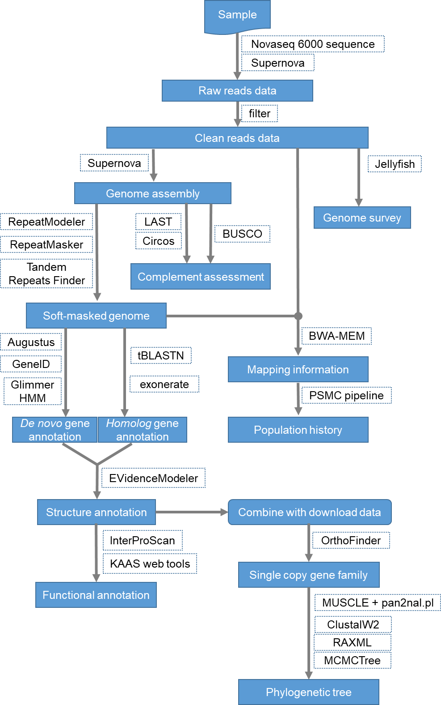
Figure S1. A flow chart of sequencing, assembly, annotation, and analysis process for Tibetan black bear genome

File | Raw reads | Raw bases (bp) | Clean reads | Clean bases (bp)
QC 0152 NDHX00177-AK831 L1 | 76,389,658 | 11,458,448,700 | 74,433,200 | 11,164,980,000
QC 0152 NDHX00177-AK831 L2 | 76,094,210 | 11,414,131,500 | 74,263,848 | 11,139,577,200
QC 0152 NDHX00177-AK832 L1 | 84,841,112 | 12,726,166,800 | 83,189,584 | 12,478,437,600
QC 0152 NDHX00177-AK832 L2 | 84,461,972 | 12,669,295,800 | 82,936,486 | 12,440,472,900
QC 0152 NDHX00177-AK833 L1 | 69,827,448 | 10,474,117,200 | 68,100,394 | 10,215,059,100
QC 0152 NDHX00177-AK833 L2 | 69,541,002 | 10,431,150,300 | 67,929,434 | 10,189,415,100
QC 0152 NDHX00177-AK834 L1 | 94,672,102 | 14,200,815,300 | 92,507,550 | 13,876,132,500
QC 0152 NDHX00177-AK834 L2 | 94,281,492 | 14,142,223,800 | 92,274,684 | 13,841,202,600
QC 0162 NDHX00177-AK831 L1 | 71,686,522 | 10,752,978,300 | 70,382,322 | 10,557,348,300
QC 0162 NDHX00177-AK831 L2 | 67,959,308 | 10,193,896,200 | 66,681,870 | 10,002,280,500
QC 0162 NDHX00177-AK832 L1 | 80,039,040 | 12,005,856,000 | 78,991,054 | 11,848,658,100
QC 0162 NDHX00177-AK832 L2 | 75,798,244 | 11,369,736,600 | 74,779,722 | 11,216,958,300
QC 0162 NDHX00177-AK833 L1 | 66,402,858 | 9,960,428,700 | 65,245,018 | 9,786,752,700
QC 0162 NDHX00177-AK833 L2 | 62,781,654 | 9,417,248,100 | 61,647,500 | 9,247,125,000
QC 0162 NDHX00177-AK834 L1 | 89,019,200 | 13,352,880,000 | 87,616,588 | 13,142,488,200
QC 0162 NDHX00177-AK834 L2 | 84,309,840 | 12,646,476,000 | 82,938,160 | 12,440,724,000
QC 0163 NDHX00177-AK831 L1 | 68,563,612 | 10,284,541,800 | 66,878,046 | 10,031,706,900
QC 0163 NDHX00177-AK831 L2 | 70,553,216 | 10,582,982,400 | 68,915,118 | 10,337,267,700
QC 0163 NDHX00177-AK832 L1 | 76,041,628 | 11,406,244,200 | 74,710,842 | 11,206,626,300
QC 0163 NDHX00177-AK832 L2 | 78,226,438 | 11,733,965,700 | 76,947,428 | 11,542,114,200
QC 0163 NDHX00177-AK833 L1 | 62,974,562 | 9,446,184,300 | 61,491,126 | 9,223,668,900
QC 0163 NDHX00177-AK833 L2 | 64,958,776 | 9,743,816,400 | 63,515,136 | 9,527,270,400
QC 0163 NDHX00177-AK834 L1 | 84,305,028 | 12,645,754,200 | 82,495,704 | 12,374,355,600
QC 0163 NDHX00177-AK834 L2 | 86,713,792 | 13,007,068,800 | 84,964,126 | 12,744,618,900
Total | 1,840,442,714 | 276,066,407,100 | 1,803,834,940 | 270,575,241,000

Table S1. Summary information for raw sequencing reads and filtered reads

Table S2. Genome assembly information
 | Species | N50 | N60 | N70 | N80 | N90 | Longest | Shortest | Total
Scaffold(bp) | Tibetan black bear | 26,803,000 | 18,859,362 | 13,463,345 | 10,191,868 | 3,842,341 | 78,658,804 | 500 | 2,373,600,990
 | Panda | 1,281,781 | 1,021,505 | 777,973 | 559,162 | 312,670 | 6,047,896 | 100 | 2,299,509,015
 | Polar bear | 15,940,661 | 13,021,217 | 8,656,630 | 5,608,078 | 3,219,439 | 67,462,175 | 200 | 2,301,379,344
 | Brown bear | 36,708,181 | 26,537,321 | 19,211,889 | 13,463,457 | 7,357,467 | 92,727,749 | 234 | 2,328,659,882
 | American black bear | 189,900 | 144,626 | 102,501 | 61,920 | 18,831 | 2,352,914 | 201 | 2,588,393,918
Contig(bp) | Tibetan black bear | 145,966 | 116,988 | 89,220 | 63,158 | 34,925 | 972,066 | 48 | 2,357,716,920
 | Panda | 39,886 | 31,466 | 23,965 | 17,020 | 9,848 | 434,635 | 10 | 2,245,312,831
 | Polar bear | 46,506 | 36,246 | 27,260 | 18,730 | 10,413 | 477,788 | 200 | 2,263,021,934
 | Brown bear | 314,844 | 248,301 | 193,011 | 137,242 | 77,985 | 2,374,379 | 50 | 2,312,446,669
 | American black bear | 11,705 | 9,358 | 7,240 | 5,097 | 2,772 | 141,485 | 0 | 2,451,851,856

Table S3. Comparison of the completeness of genome among five bear species in this study using mammalia_odb9 BUSCOs
Species | Tibetan black bear | American black bear | Polar bear | Brown bear | Giant panda
Total number of matches to ortholog | 95.90% | 86.30% | 94.70% | 96.10% | 95.20%
Complete one-to-one match to ortholog | 94.40% | 85.70% | 94.30% | 95.20% | 94.90%
Complete match of multi-gene copies to ortholog | 1.50% | 0.60% | 0.40% | 0.90% | 0.30%
Fragmented match to ortholog | 1.80% | 9.10% | 3.00% | 1.90% | 2.60%
No match to ortholog | 2.30% | 4.60% | 2.30% | 2.00% | 2.20%

Table S4. Conversation of syntenic relationships between dog chromosomes and Tibetan black bear scaffolds
Dog chromosome | Number | Tibetan black bear Scaffolds
chr22 | 1 | Scaffold00001
chr23 | 1 | Scaffold00008
chr31 | 1 | Scaffold00021
chr26 | 2 | Scaffold00047 | Scaffold00038
chr14 | 2 | Scaffold00018 | Scaffold00005
chr8 | 2 | Scaffold00011 | Scaffold00034
chr17 | 2 | Scaffold00022 | Scaffold00016
chr36 | 2 | Scaffold00004 | Scaffold00017
chr28 | 2 | Scaffold00023 | Scaffold00027
chr10 | 2 | Scaffold00022 | Scaffold00012
chr32 | 2 | Scaffold00025 | Scaffold00003
chr37 | 2 | Scaffold00004 | Scaffold00032
chr29 | 2 | Scaffold00006 | Scaffold00040
chr35 | 2 | Scaffold00030 | Scaffold00040
chr38 | 2 | Scaffold00067 | Scaffold00042
chr30 | 3 | Scaffold00045 | Scaffold00056 | Scaffold00069
chr18 | 3 | Scaffold00026 | Scaffold00068 | Scaffold00005
chr3 | 3 | Scaffold00009 | Scaffold00029 | Scaffold00010
chr12 | 3 | Scaffold00020 | Scaffold00030 | Scaffold00002
chr33 | 3 | Scaffold00021 | Scaffold00015 | Scaffold00062
chr27 | 3 | Scaffold00070 | Scaffold00059 | Scaffold00061
chr13 | 3 | Scaffold00006 | Scaffold00025 | Scaffold00010
chr20 | 3 | Scaffold00072 | Scaffold00054 | Scaffold00024
chr19 | 3 | Scaffold00001 | Scaffold00003 | Scaffold00017
chr6 | 3 | Scaffold00013 | Scaffold00053 | Scaffold00039
chr34 | 3 | Scaffold00071 | Scaffold00015 | Scaffold00008
chr24 | 3 | Scaffold00049 | Scaffold00057 | Scaffold00048
chrX | 3 | Scaffold00035 | Scaffold00074 | Scaffold00043
chr21 | 4 | Scaffold00026 | Scaffold00036 | Scaffold00044 | Scaffold00068
chr16 | 4 | Scaffold00018 | Scaffold00032 | Scaffold00065 | Scaffold00005
chr25 | 4 | Scaffold00004 | Scaffold00032 | Scaffold00001 | Scaffold00003
chr7 | 4 | Scaffold00033 | Scaffold00067 | Scaffold00039 | Scaffold00007
chr11 | 4 | Scaffold00028 | Scaffold00031 | Scaffold00066 | Scaffold00051
chr9 | 4 | Scaffold00031 | Scaffold00055 | Scaffold00060 | Scaffold00063
chr1 | 5 | Scaffold00019 | Scaffold00046 | Scaffold00050 | Scaffold00002 | Scaffold00007
chr15 | 5 | Scaffold00012 | Scaffold00013 | Scaffold00025 | Scaffold00041 | Scaffold00003
chr4 | 5 | Scaffold00071 | Scaffold00014 | Scaffold00009 | Scaffold00027 | Scaffold00038
chr5 | 6 | Scaffold00013 | Scaffold00019 | Scaffold00052 | Scaffold00036 | Scaffold00037 | Scaffold00058
chr2 | 8 | Scaffold00019 | Scaffold00009 | Scaffold00028 | Scaffold00052 | Scaffold00041 | Scaffold00073 | Scaffold00064 | Scaffold00008

Table S5. Details of repeat annotation for Tibetan black bear
Type |  | Number | Length (bp) | Percent (%)
Class I | LTR | 389,058 | 126,101,966 | 5.31
 | LINE | 1,550,309 | 593,952,434 | 25.02
 | SINE | 939,648 | 148,636,166 | 6.26
Class II | DNA Transposon | 386,805 | 74,996,585 | 3.16
 | RC/Helitron | 1,736 | 370,463 | 0.02
Satellite |  | 1,227 | 446,524 | 0.02
Low complexity |  | 100,077 | 5,324,762 | 0.22
Simple repeat |  | 641,139 | 28,408,018 | 1.20
TRF |  | 437,332 | 30,709,449 | 1.29
Others |  | 2,062 | 243,673 | 0.01
Unknown |  | 16,059 | 7,981,670 | 0.34
Total |  | 4,465,452 | 973,392,800 | 41.01

Table S6. Summary statistics for functional annotation
Database | Number | Percentage
GO | 13,049 | 71.29%
InterPro | 16,995 | 92.85%
PANTHER | 17,752 | 96.98%
Pfam | 16,537 | 90.35%
SUPERFAMILY | 13,491 | 73.71%
KEGG | 12,248 | 66.91%
Total | 17,814 | 97.32%

Table S7. Summary statistics for predicted genes compared with annotation of other genomes
Gene set | Numbers | Average Gene Length (bp) | Average CDS Length (bp) | Average Exon number | Average Exon Length (bp) | Average Intron Length (bp)
Brown bear | 19,560 | 40,925.70 | 1,709.85 | 9.72 | 175.88 | 4,496.39
Dog | 19,414 | 43,101.15 | 1,702.57 | 9.81 | 173.50 | 4,697.46
Human | 22,767 | 46,447.03 | 1,711.50 | 9.65 | 177.35 | 5,171.62
Mouse | 23,440 | 37,134.84 | 1,642.86 | 9.06 | 181.32 | 4,403.18
Giant panda | 18,886 | 39,248.75 | 1,664.86 | 9.82 | 169.50 | 4,260.07
Polar bear | 18,571 | 39,325.01 | 1,618.41 | 9.71 | 166.60 | 4,326.83
Tibetan black bear | 18,304 | 40,203.80 | 1,700.48 | 9.61 | 176.89 | 4,470.18
Tiger | 17,908 | 41,420.42 | 1,647.96 | 9.98 | 165.05 | 4,426.80

