Supplementary Material

Supplementary Table
Supplementary Table 1. Determination of crystallinity of hp-SSIIa-op by ¹³C CP/MAS NMR
Sample Code | Classification | % Double Helix  (±1) | % Single helix  (±0.5) | % Non-ordered  (±2) | Crystalline polymorph
SS5 | hp-SSIIa-op | 37 | 2 | 61 | A
SS3 | hp-SSIIa-op | 33 | 2 | 65 | A
Nipponbare | wild type | 34 | 4 | 62 | A

Supplementary Figures
Supplementary Figure 1. X-ray diffraction pattern of hp-SSIIa-op SS5 (hp-SSIIa) displaying A-type crystalline polymorph similar to Nipponbare. Data are offset for clarity.

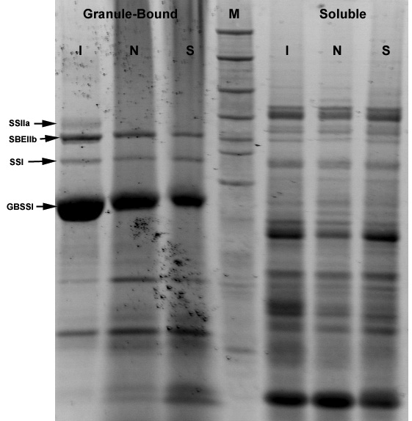
Supplementary Figure 2. Visualisation of granule-bound and soluble proteins in hp-SSIIa-op (SS5) (S) compared to its parent Nipponbare (N) and IR64 (I). Major protein bands are labelled based on BenchMark unstained protein ladder (M).

Supplementary Figure 3. Expression of (A) SSI and (B) SSIIa at 15 dpa of Nipponbare compared to hp-SSIIa opaque (SS5) transgenic line.

