**Supplementary Information S5**

**Figure S5.1**

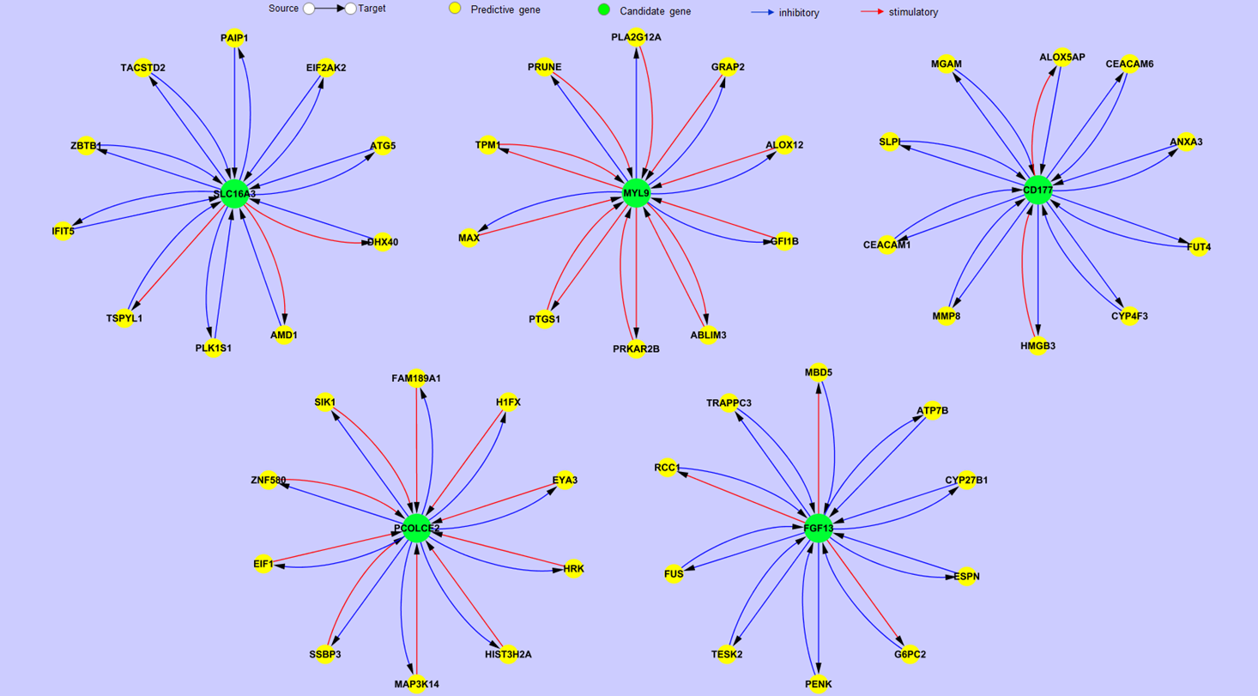

**Figure S5.2**

