Supplementary Material
Search Strategy of four database
PubMed
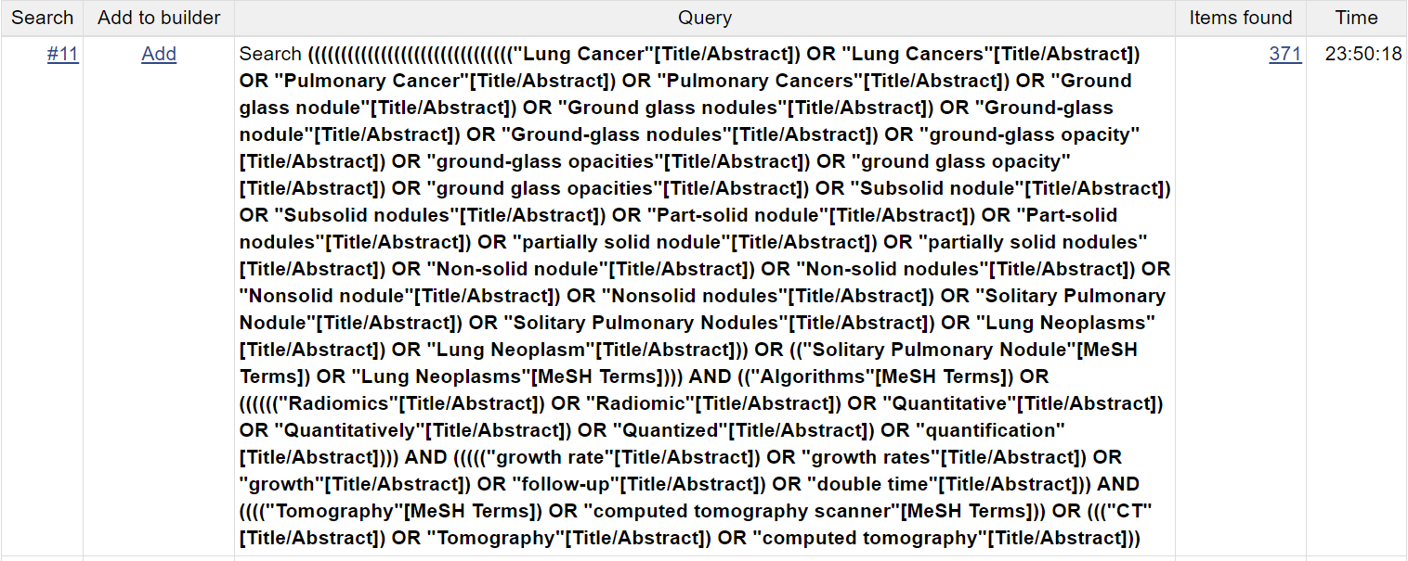
Web of Science
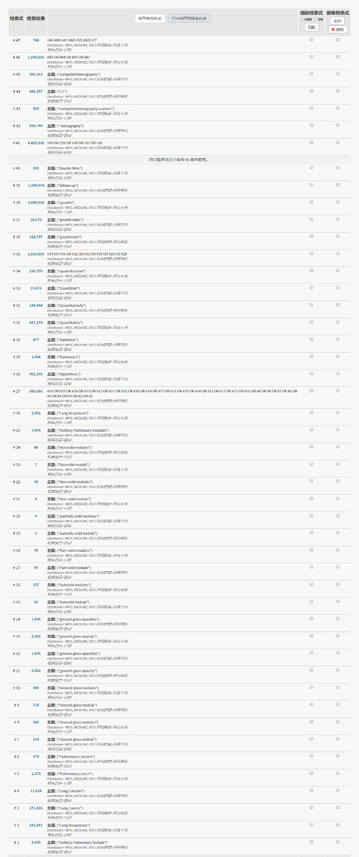
Embase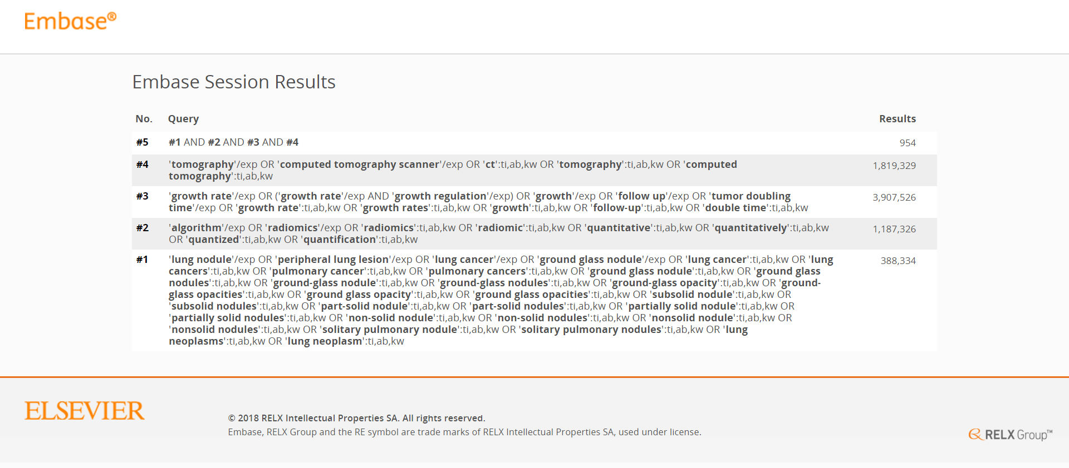
Cochrane Library
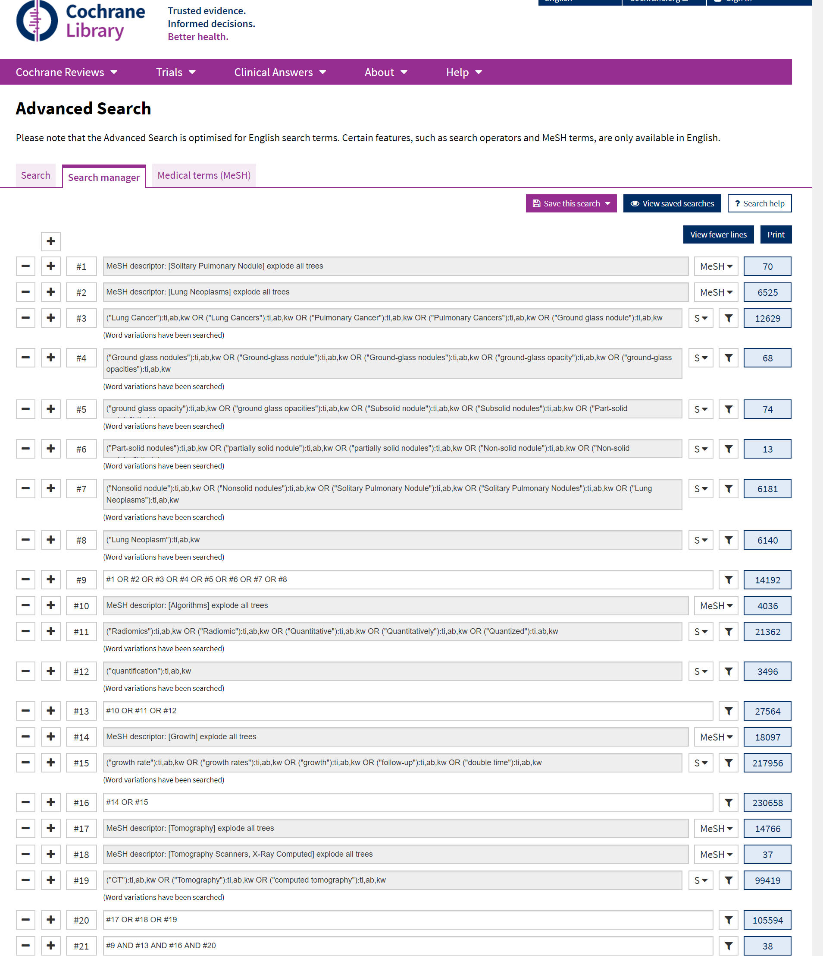
Study | Information of CT scanning follow-up
Bak SH et al. ^{[12]} | 24.2 ±16.9 months (range, 2.2-64.9 months)
Tamura M et al. ^{[13]} | 26.1±4.6months (Mean ± SD)
Eguchi T et al. ^{[14]} | 57 months (range, 24.1-113.6 months)
Chang B et al. ^{[15]} | 59 months (range, 25-140 months)
Borghesi A et al. ^{[16]} | 573 days (range, 126–1128 days)
Oda S et al. ^{[17]} | 188 days (range, 34–1486 days)
Hiramatsu M et al. ^{[18]} | 1048 days (range, 177-3269 days)
Lee SW et al. ^{[19]} | 48 months (range, 24-99 months)
Kobayashi Y et al. ^{[20]} | 4.2 years (range,0.5–12.0 years)
Matsuguma H et al. ^{[21]} | 29 months (range, 1-136 months)
Supplement Table. Information of CT scanning follow-up

