Supplementary Materials
Fig.S1 Feature selection results of using the statistically significant features with SVM-RFE approach in the training set: (A) 20 optimal features selected using the DFC-based features with statistical significance; (B) six optimal features selected using the SFC-based features with statistical significance; (C) 13 optimal features selected using both the DFC- and SFC-based features with statistical significance.

(A)

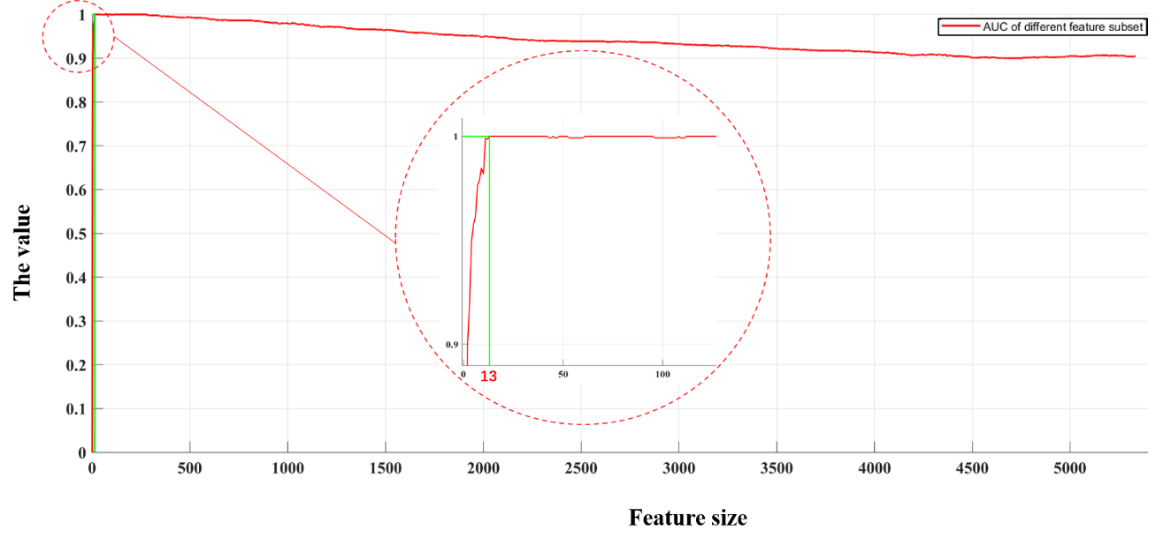
(B)

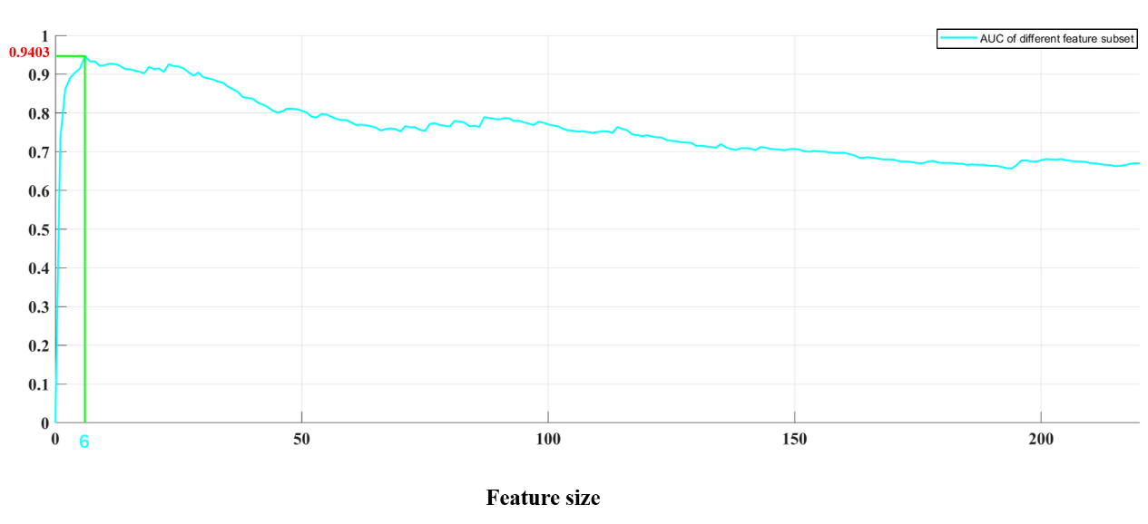
(C)

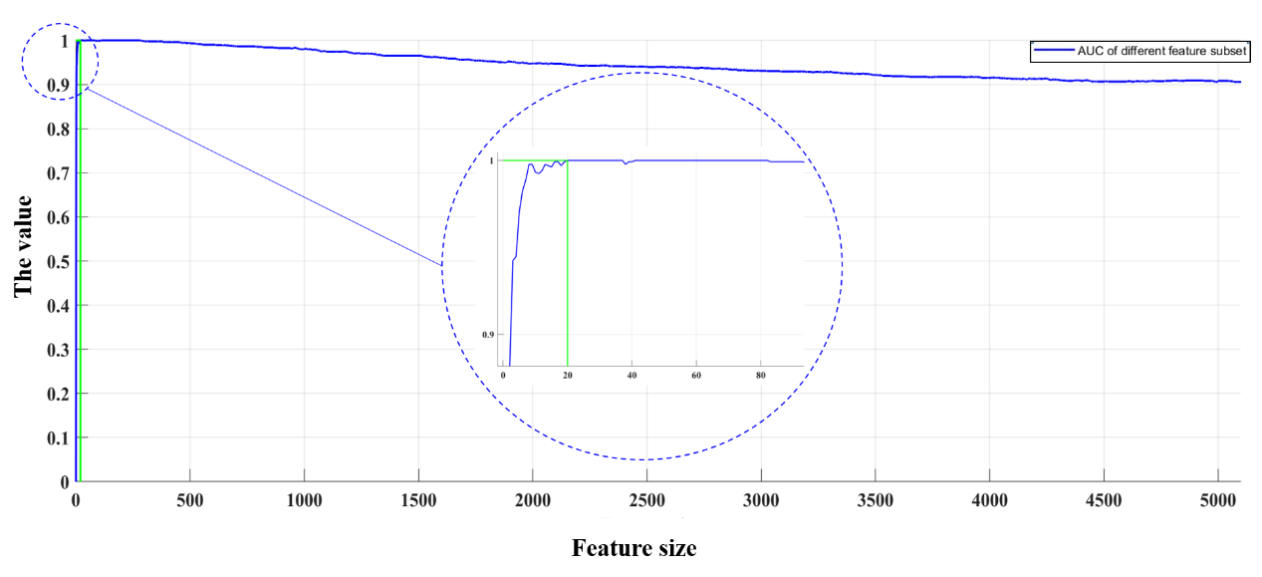

Fig. S2 the ROC curves of using the optimal models with the testing set
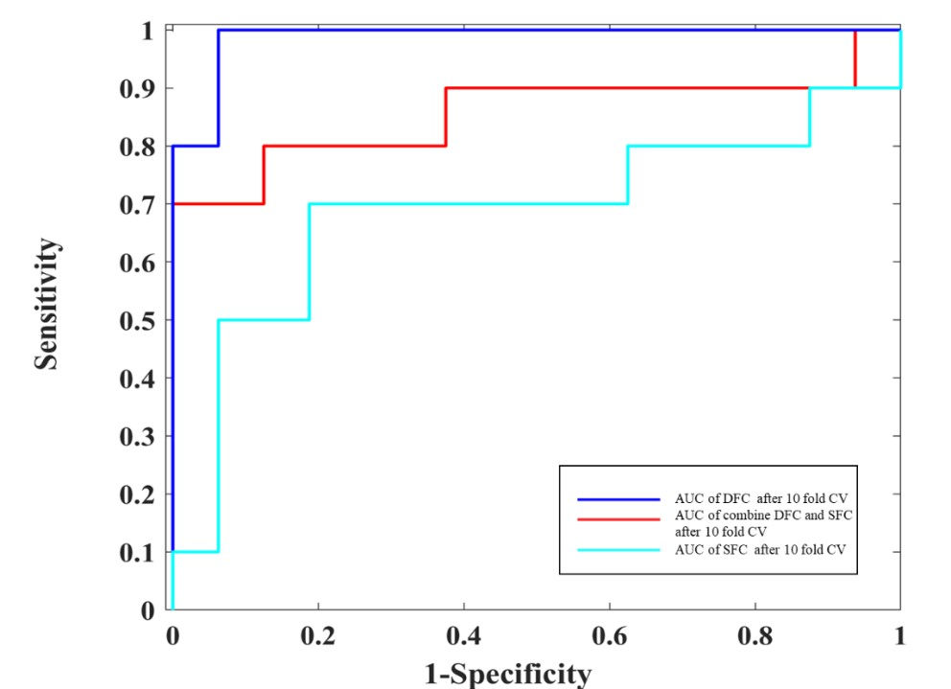

Figure S3 Feature selection results of using the statistically significant features with SVM-RFE approach in the training set: (A) 12 optimal features selected using the DFC-based features with statistical significance; (B) five optimal features selected using the SFC-based features with statistical significance; (C) 14 optimal features selected using both the DFC- and SFC-based features with statistical significance.

(A)
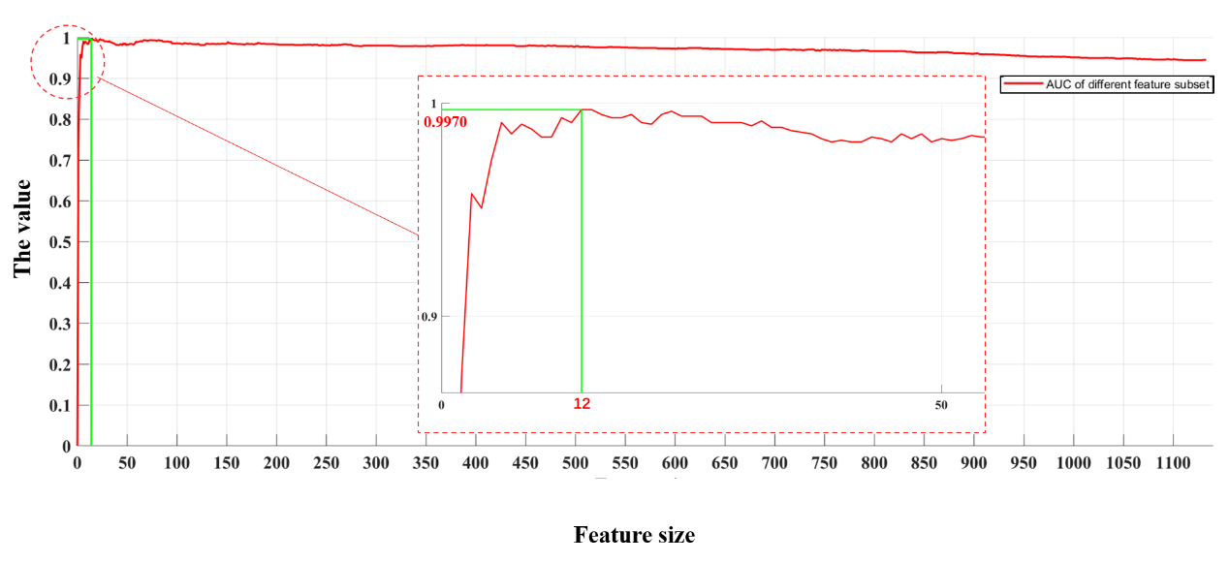
(B)
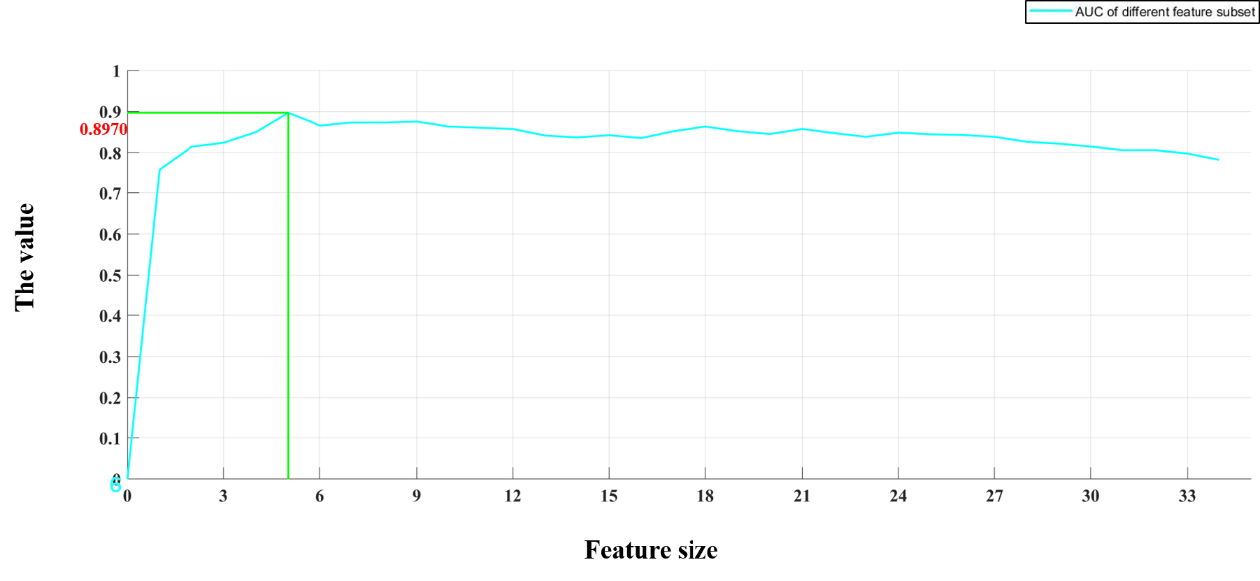
(C)
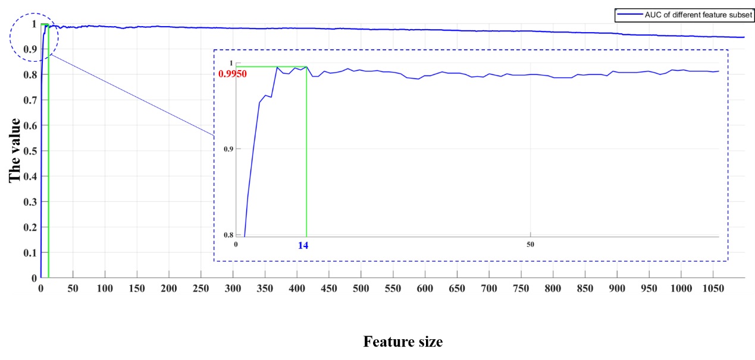
Fig. S4 the ROC curves of using the optimal models with the testing set
