Supplementary Material

Supplementary Figures and Tables

Supplementary Tables

Supplementary Table 1. Fish communities present in the sampled river basins adapted from Ellender et al. (2011) and Skelton (2001).
Species | Swartkops | Kouga
Native
African Longfin Eel (Anguilla mossambica) | ✓ | ✓
Giant Mottled Eel (Anguilla marmorata) | ✓ | ✓
Eastern Cape Redfn (Pseudobarbus afer) | ✓
Gamtoos Redfin (Pseudobarbus swartzi) |  | ✓
Goldie Barb (Enteromius pallidus) | ✓ | ✓
Cape Kurper (Sandelia capensis) | ✓ | ✓
River Goby (Glossogobius callidus) | ✓ | ✓
Non-native
Common Carp (Cyprinus carpio) | ✓ | ✓
African Sharptooth Catfish (Clarias gariepinus) | ✓ | ✓
Largemouth Bass (Micropterus salmoides) | ✓ | ✓
Smallmouth Bass (Micropterus dolomieu) | ✓ | ✓
Spotted Bass (Micropterus punctulatus) | ✓
Banded Tilapia (Tilapia sparmanii) | ✓ | ✓

Supplementary table 2. Species-specific primers (cytb) designed for this study
Name | Primer Sequence | bp | Tm (°C) | GC % | Product Length
Redfin_184f | GCATTTTCATCAGTAGCCCAT | 21 | 56.63 | 42.86 | 132 bp
Redfin_315r | GCCGTAGTATAGTCCTCGAG | 20 | 56.46 | 55.00
Kurper_226f | AGGAGAAGAACTACGCCTG | 19 | 56.17 | 52.63 | 137 bp
Kurper_367r | GGCTGACTTATCCGAAATCTC | 21 | 56.22 | 47.62

Supplementary table 3. Detection and non-detection for underwater cameras, snorkel surveys, and eDNA – qPCR data for biological and technical PCR replicates.
Species | Pseudobarbus swartzi |  |  |  |  |  | Sandelia capensis
Site | Ca | Sn | eDNA B1 | eDNA B2 | eDNA B3 | Mean Cq | Ca | Sn | eDNA B1 | eDNA B2 | eDNA B3 | Mean Cq
BK1 | 1 | 1 | - | - | - | - | 1 | 1 | - | - | - | -
BK10 | 1 | 1 | - | - | - | - | 1 | 1 | - | - | - | -
BK11 | 1 | 1 | - | - | - | - | 0 | 0 | - | - | - | -
BK12 | 1 | 1 | 2/3 | 3/3 | 0/3 | 32.86 | 0 | 0 | 0/3 | 0/3 | 0/3 | -
BK14 | 1 | 1 | - | - | - | - | 0 | 0 | - | - | - | -
BK16 | 1 | 1 | - | - | - | - | 1 | 1 | - | - | - | -
BK17 | 1 | 1 | - | - | - | - | 1 | 1 | - | - | - | -
BK18 | 1 | 1 | - | - | - | - | 1 | 1 | - | - | - | -
BK2 | 1 | 1 | - | - | - | - | 1 | 1 | - | - | - | -
BK23 | 1 | 1 | - | - | - | - | 1 | 1 | - | - | - | -
BK27 | 1 | 1 | 2/3 | 2/3 | 3/3 | 33.56 | 1 | 1 | 1/3 | 3/3 | 1/3 | 33.1
BK3 | 1 | 1 | 2/3 | - | 1/3 | 33.01 | 1 | 1 | 2/3 | - | 1/3 | 34.05
BK31 | 1 | 1 | - | - | - | - | 1 | 1 | - | - | - | -
BK32 | 1 | 1 | 0/3 | 0/3 | 3/3 | 34.51 | 1 | 1 | 0/3 | 1/3 | 2/3 | 34.76
BKConf | 1 | 1 | - | - | - | - | 1 | 0 | - | - | - | -
BKe | 1 | 0 | - | - | - | - | 0 | 0 | - | - | - | -
BKNF | 0 | 0 | - | - | - | - | 0 | 0 | - | - | - | -
Bos1 | 0 | 0 | - | - | - | - | 0 | 0 | - | - | - | -
Bos10 | 0 | 1 | - | - | - | - | 0 | 0 | - | - | - | -
Bos11 | 1 | 1 | - | - | - | - | 1 | 1 | - | - | - | -
Bos12 | 1 | 1 | - | - | - | - | 1 | 0 | - | - | - | -
Bos13 | 1 | 1 | - | - | - | - | 1 | 0 | - | - | - | -
Bos14 | 1 | 1 | 3/3 | 3/3 | 3/3 | 29.63 | 0 | 0 | 2/3 | 0/3 | 0/3 | 34.4
Bos15 | 1 | 1 | - | - | - | - | 0 | 0 | - | - | - | -
Bos16 | 1 | 1 | - | - | - | - | 0 | 0 | - | - | - | -
Bos17 | 1 | 1 | 3/3 | 3/3 | 3/3 | 28.02 | 0 | 0 | 0/3 | 0/3 | 0/3 | -
Bos18 | 0 | 0 | - | - | - | - | 0 | 0 | - | - | - | -
Bos19 | 0 | 0 | - | - | - | - | 0 | 0 | - | - | - | -
Bos2 | 0 | 0 | - | - | - | - | 1 | 1 | - | - | - | -
Bos20 | 0 | 0 | - | - | - | - | 0 | 0 | - | - | - | -
Bos21 | 0 | 0 | - | - | - | - | 0 | 0 | - | - | - | -
Bos22 | 0 | 0 | - | - | - | - | 0 | 0 | - | - | - | -
Bos23 | 0 | 0 | - | - | - | - | 0 | 0 | - | - | - | -
Bos3 | 1 | 1 | 3/3 | 3/3 | 3/3 | 32.19 | 1 | 1 | 3/3 | 3/3 | 3/3 | 31.32
Bos4 | 1 | 1 | - | - | - | - | 1 | 1 | - | - | - | -
Bos5 | 0 | 0 | 0/3 | 0/3 | 0/3 | - | 0 | 0 | 0/3 | 0/3 | 0/3 | -
Bos6 | 0 | 0 | - | - | - | - | 0 | 1 | - | - | - | -
Bos7 | 1 | 1 | - | - | - | - | 1 | 1 | - | - | - | -
Bos8 | 1 | 1 | 3/3 | 3/3 | 3/3 | 32.77 | 1 | 1 | 3/3 | 1/3 | 2/3 | 32.77
Bos9 | 1 | 1 | 3/3 | 0/3 | 3/3 | 29.73 | 1 | 1 | 3/3 | 1/3 | 2/3 | 31.8
FK1.2 | 1 | 1 | - | - | - | - | 0 | 0 | - | - | - | -
FK10 | 0 | 0 | - | - | - | - | 0 | 0 | - | - | - | -
FK21 | 1 | 1 | - | - | - | - | 1 | 1 | - | - | - | -
FK22 | 1 | 1 | 0/3 | 2/3 | 2/3 | 35.55 | 1 | 1 | 2/3 | 2/3 | 0/3 | 33.7
FK23 | 1 | 1 | - | - | - | - | 1 | 1 | - | - | - | -
FK24 | 1 | 1 | - | - | - | - | 1 | 1 | - | - | - | -
FK3 | 1 | 1 | - | - | - | - | 0 | 1 | - | - | - | -
FK4 | 1 | 1 | - | - | - | - | 1 | 1 | - | - | - | -
FK5 | 1 | 1 | 0/3 | 0/3 | 0/3 | - | 1 | 1 | 0/3 | 0/3 | 0/3 | -
FK8 | 1 | 1 | - | - | - | - | 0 | 0 | - | - | - | -
FK9 | 1 | 1 | - | - | - | - | 0 | 0 | - | - | - | -
Fkbwf | 1 | 1 | 0/3 | 3/3 | 0/3 | 30.37 | 0 | 0 | 0/3 | 0/3 | 0/3 | -
FKwf | 0 | 0 | 0/3 | 0/3 | 0/3 | - | 0 | 0 | 0/3 | 0/3 | 0/3 | -
K1 | 0 | 0 | 0/3 | 0/3 | 0/3 | - | 0 | 0 | 0/3 | 0/3 | 0/3 | -
K2 | 0 | 0 | - | - | - | - | 0 | 0 | - | - | - | -
K3 | 0 | 0 | 0/3 | 0/3 | 0/3 | - | 0 | 0 | 0/3 | 0/3 | 0/3 | -
K4 | 0 | 0 | 0/3 | 0/3 | 0/3 | - | 0 | 0 | 0/3 | 0/3 | 0/3 | -
WK | 1 | 1 | - | - | - | - | 1 | 1 | - | - | - | -
WK2 | 1 | 1 | - | - | - | - | 0 | 0 | - | - | - | -
WK21 | 1 | 1 | 0/3 | 0/3 | 3/3 | 30.37 | 0 | 0 | 0/3 | 0/3 | 0/3 | -
WK22 | 1 | 1 | - | - | - | - | 0 | 0 | - | - | - | -
WK23 | 1 | 0 | - | - | - | - | 1 | 1 | - | - | - | -
WK24 | 1 | 1 | 0/3 | 0/3 | 1/3 | 36.13 | 1 | 1 | 2/3 | 0/3 | 0/3 | 35.83
WK3 | 1 | 1 | 0/3 | 2/3 | 1/3 | 32.15 | 1 | 1 | 0/3 | 2/3 | 0/3 | 33.2
WK4 | 1 | 0 | - | - | - | - | 0 | 0 | - | - | - | -
WK5 | 0 | 0 | - | - | - | - | 1 | 0 | - | - | - | -
WKWF | 1 | 1 | 0/3 | 0/3 | 0/3 | - | 0 | 0 | 0/3 | 0/3 | 0/3 | -
Ca: detection with Camera survey; Sn: detection with Snorkel survey; eDNA B1-3: proportion of technical replicates returning a “hit” in each eDNA biological replicate; Mean Cq: qPCR quantification cycle; -:no survey with method

Supplementary Figures

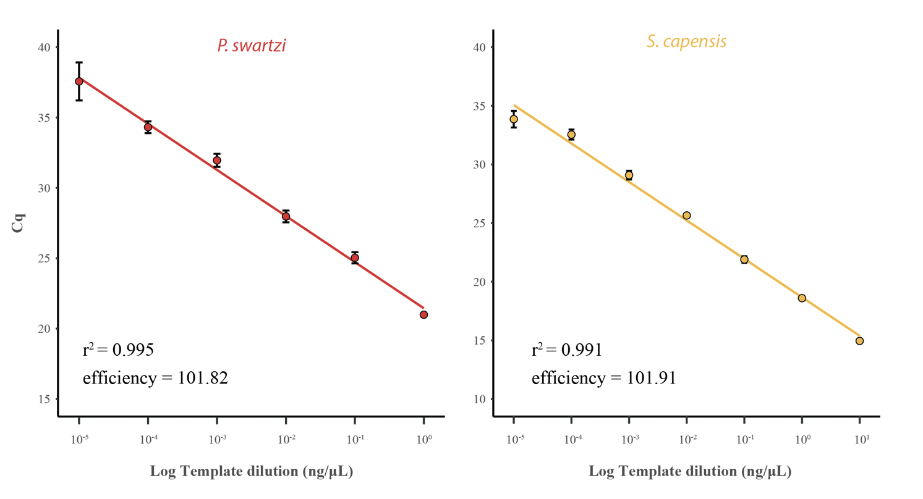Supplementary Figure 1. Standard curve generated with serially diluted Pseudobarbus swartzi and Sandelia capensis genomic DNA. Dilution gradient represents genomic DNA concentrations from 10 ng/μL to 1 × 10⁻⁶ ng/μL determined using a Qubit Fluorometer. The LOD was determined to be 1 × 10⁻⁴ ng/μL for Pseudobarbus swartzi and 1 × 10⁻⁵ ng/μL for Sandelia capensis.

