Supplementary

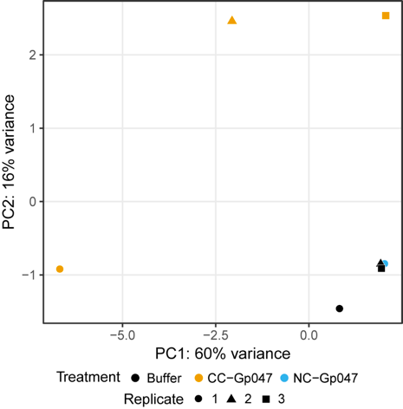

Figure S1. Principal component analysis of differentially-expressed C. jejuni 11168 genes 30 min following exposure to CC-FlaGrab, NC-FlaGrab or buffer. Plots were generated using the data from the 500 genes with the greatest variation in expression across samples.
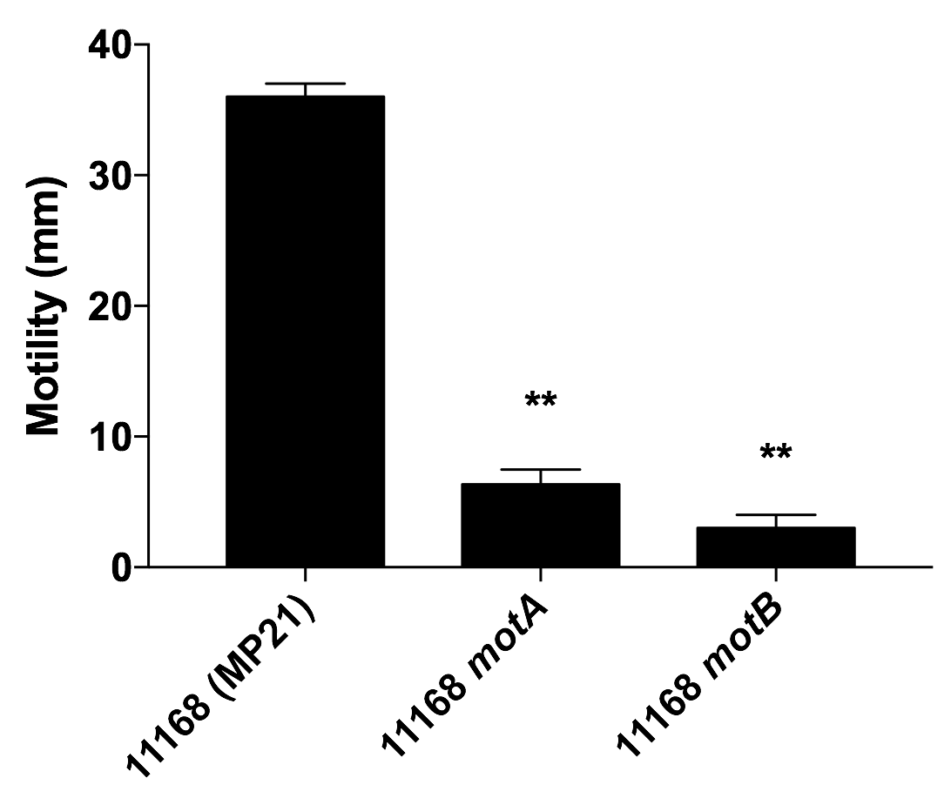

Figure S2. Motility of Campylobacter jejuni 11168 MP21 ∆motA and ∆motB mutants compared to wild type cells, as indicated by the diameter of cell spread in 0.4% MH agar after 47 h. Results depict the average, standard deviation and p-value (student’s T-test) for three replicates (p < 0.01 (**)).

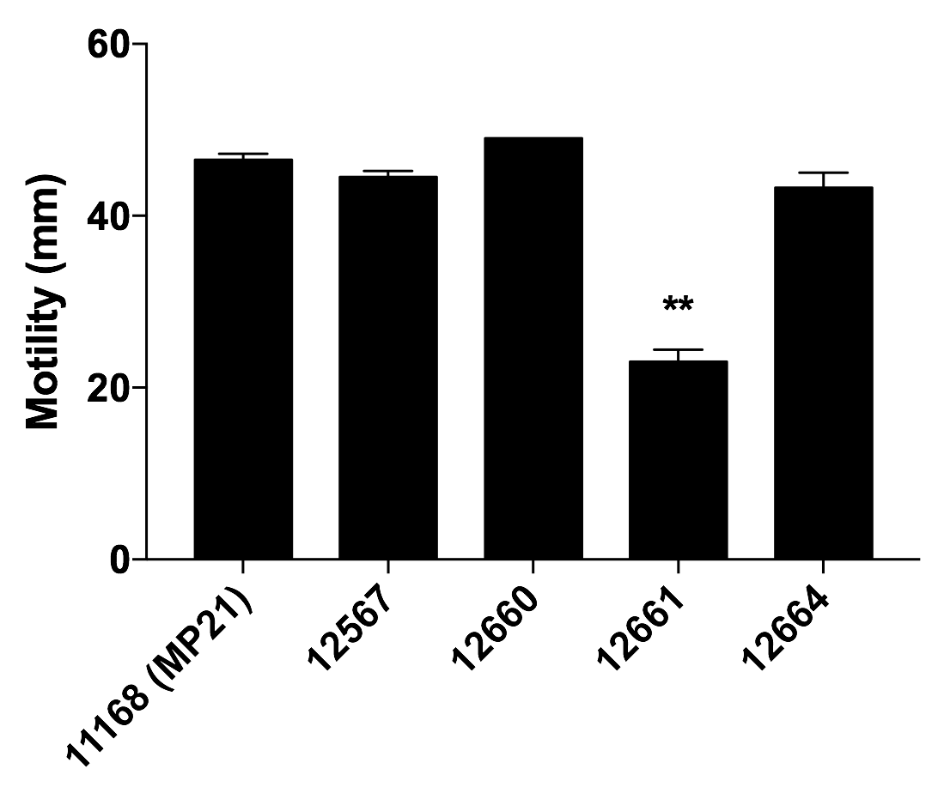

Figure S3. Motility of Campylobacter jejuni strains as indicated by the diameter of cell spread in 0.4% MH agar after 52 h. Results depict the average, standard deviation and p-value (student’s T-test) for two replicates (p < 0.01 (**)).

A
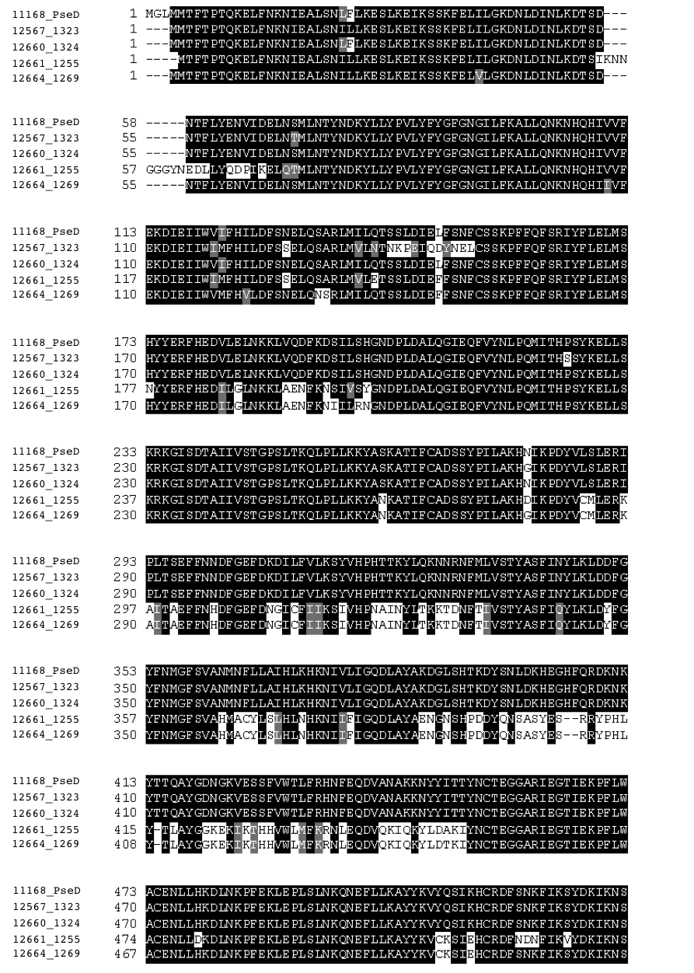

B
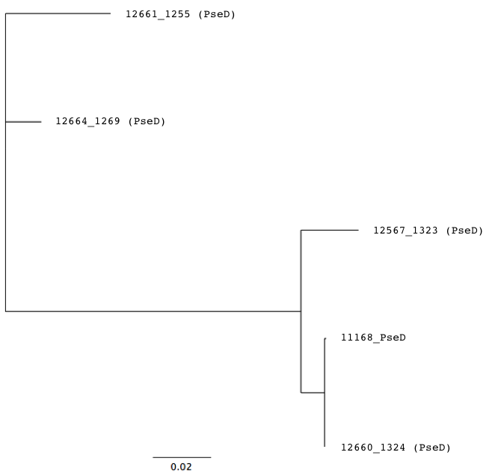
Figure S4. PseD amino acid sequence alignment (A) and a phylogenetic tree (B) depicting the relationship between PseD between the five strains.

Supplementary Methods

Motility Assay
Bacterial motility was tested in soft agar as described previously (Waseh et al., 2010). Briefly, Mueller Hinton plates containing 0.4% agar were prepared the day before the motility assay. After overnight growth (16-18 hrs), cells were suspended in PBS and set to an O.D₆₀₀ of 1.0 in PBS. Five μL of the cell suspension was inoculated into the centre of each agar plate by lightly piercing the agar surface with a 10-μL pipette tip. Plates were allowed to dry undisturbed before being incubated right-side-up at 37ºC overnight under microaerobic conditions suitable for Campylobacter growth. As an indicator of motility, the diameter of cell growth spread was measured with a ruler after 47-52 hours.

References
Waseh, S., Hanifi‐Moghaddam, P., Coleman, R., Masotti, M., Ryan, S., Foss, M., et al. (2010) Orally administered P22 phage tailspike protein reduces salmonella colonization in chickens: prospects of a novel therapy against bacterial infections. PLoS ONE 5: e13904.

