Supplementary Material

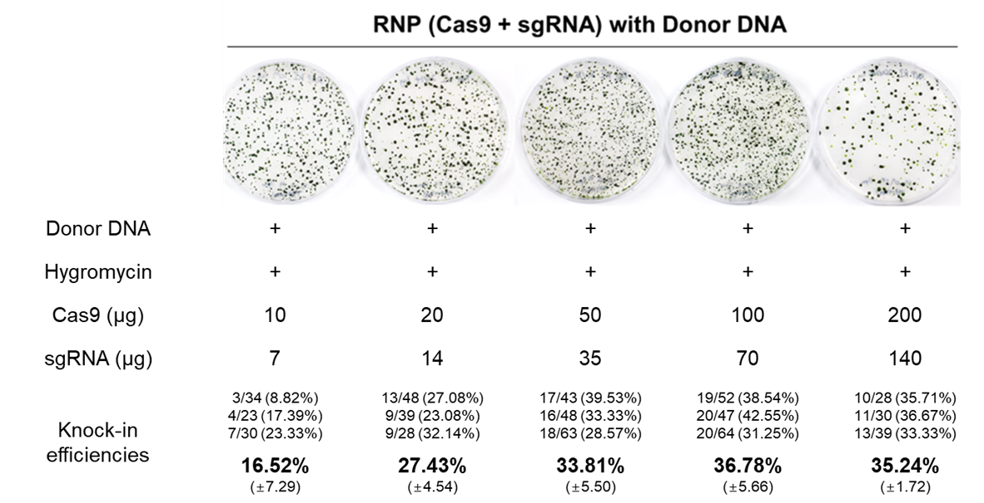
Supplementary Figure 1. Improvement of gene-editing efficiency based on CRISPR-Cas9 using additional selection strategy with donor DNA. Gene-editing efficiency increased with gradual increase in Cas9 and gRNA amounts from (10 + 7) µg to (100 + 70)µg Cas9+gRNA.

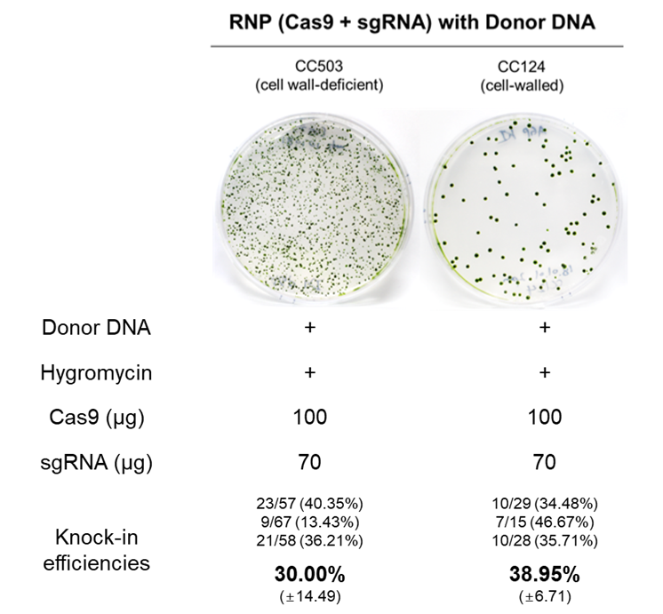
Supplementary Figure 2. Validation of gene-editing efficiency in different cell types. Mutation efficiency of C. reinhardtii CC503 (cell wall-deficient) and CC124 (cell-walled) strains.

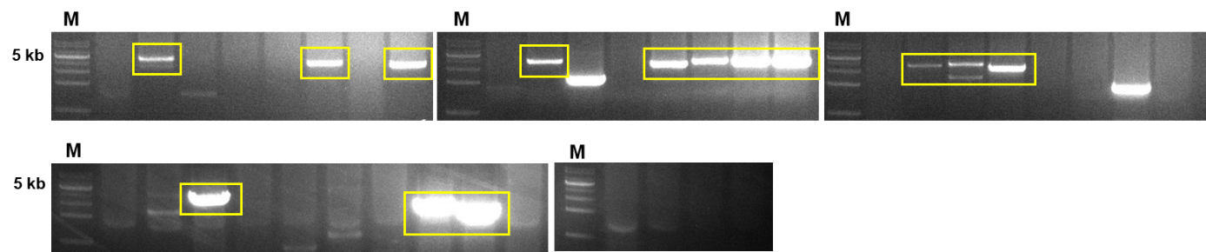
Supplementary Figure 3. Target-specific DNA insertion (3.2 kb) conjugated with CRISPR-Cas9. PCR of DNA extracted from pale green colonies of CrFTSY knock-out C. reinhardtii. PCR product bigger than 3 kb (marked by the yellow box) is detected only in the candidates where DNA fragment was inserted. 14 positive colonies of 39 candidates were confirmed. M, 1 kb DNA ladder.

(a)
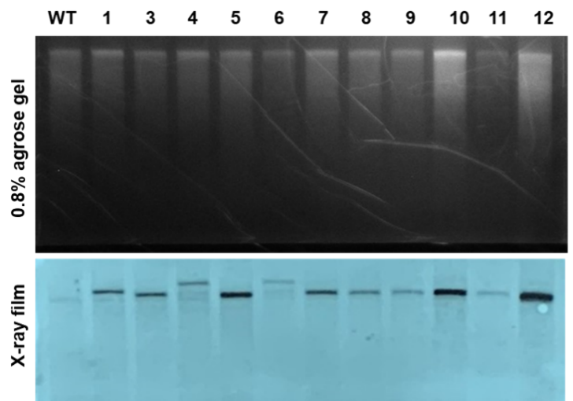
(b)
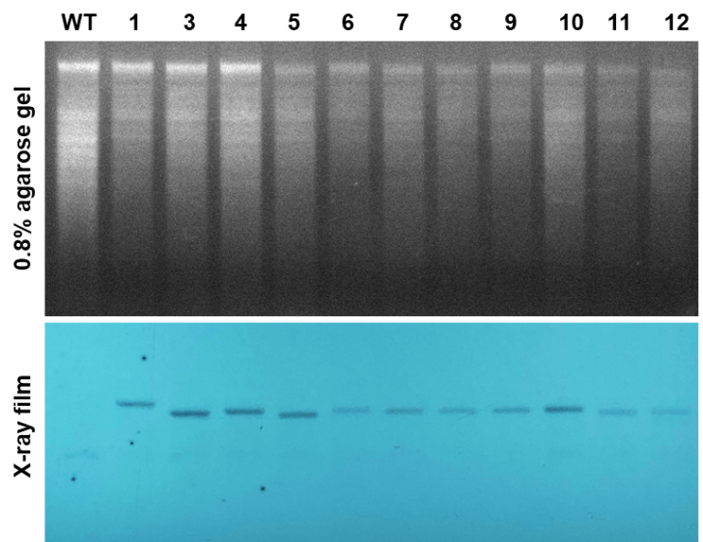
Supplementary Figure 4. Southern blot for validation of copy number of inserted DNA fragment. Extracted genomic DNA was digested by a) Sma I and b) Pvu II blotted on membrane. aph7 probe was used for detection of DNA integration. Luminescence signal was visualized on X-ray film.

(a)
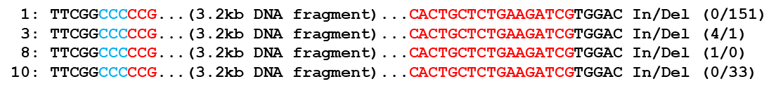
(b)
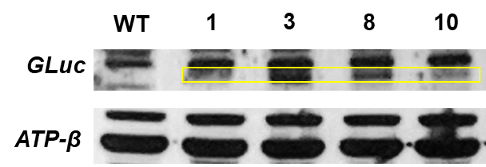
Supplementary Figure 5. Western blot for validation of heterologous gene expression. a) Four different transformants were chose for the analysis based on their sequence on In/Del, b) Expression of Gaussia luciferase was detected by specific antibody (upper layer). ATP-β antibody was used as reference (down layer).

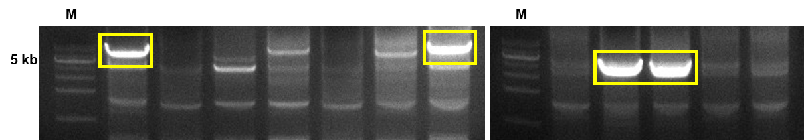
Supplementary Figure 6. Target-specific DNA insertion (6.4 kb) conjugated with CRISPR-Cas9. PCR of DNA extracted from pale green colonies of CrFTSY knock-out C. reinhardtii. 4 positive colonies of 12 candidates were clearly confirmed. M, 1 kb DNA ladder.

