Table 1. The sea surface wind speed and direction of Pattani weather observing at station. Data were calculated as the average during 2015 to 2017.
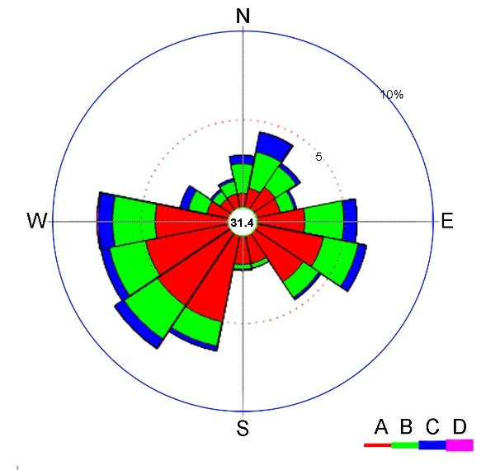
Speed: A 0.00 - <5.40 km/h
B 5.40 - <8.86 km/h
C 8.86 - <16.09 km/h
D 16.09 - <24.95 km/h
Direction | Percentage
 | A | B | C | D | Total
N | 0.8 | 1.6 | 0.5 | 0.0 | 2.9
NNE | 1.1 | 2.1 | 1.1 | 0.0 | 4.3
NE | 1.5 | 1.4 | 0.2 | 0.0 | 3.1
ENE | 1.4 | 0.8 | 0.1 | 0.0 | 2.3
E | 2.8 | 2.2 | 0.7 | 0.0 | 5.7
ESE | 3.9 | 2.0 | 0.4 | 0.0 | 6.3
SE | 3.4 | 1.1 | 0.1 | 0.0 | 4.6
SSE | 1.7 | 0.3 | 0.0 | 0.0 | 2.0
S | 1.7 | 0.3 | 0.0 | 0.0 | 2.0
SSW | 5.1 | 1.4 | 0.2 | 0.0 | 6.7
SW | 5.0 | 2.3 | 0.6 | 0.0 | 7.9
WSW | 4.8 | 2.1 | 0.5 | 0.0 | 7.4
W | 4.2 | 2.4 | 0.8 | 0.1 | 7.5
WNW | 1.2 | 1.1 | 0.5 | 0.0 | 2.8
NW | 0.7 | 0.5 | 0.2 | 0.0 | 1.4
NNW | 0.8 | 0.8 | 0.1 | 0.0 | 1.7
Calm | 31.4
Total | 40.1 | 22.4 | 6.0 | 0.1 | 100
Data source: The Thai Meteorological Department, Ministry of Digital Economy and Society (http://www.aws-observation.tmd.go.th)

