Supplementary Material

Plant growth-promoting methylobacteria increase the biomass of biotechnologically relevant microalgae
Lisa Krug^{1,2}, Christina Morauf³, Christina Donat³, Henry Müller¹, Tomislav Cernava^{1*} and Gabriele Berg¹
¹Institute of Environmental Biotechnology, Graz University of Technology, Petersgasse 12, 8010 Graz, Austria
²ACIB GmbH, Petersgasse 14, 8010 Graz, Austria
³bio-ferm GmbH, Erber Campus 1, 3131 Getzersdorf, Austria

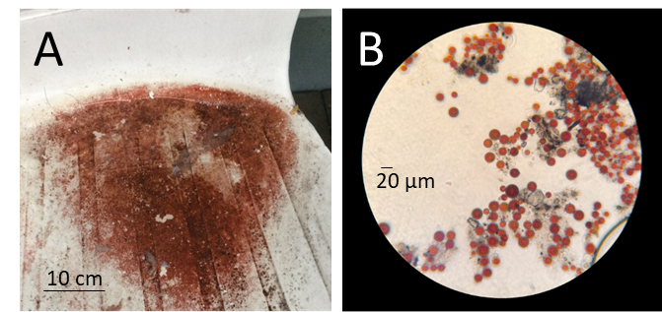
Supplementary Figure S1. Macroscopic and microscopic visualization of the sampled biofilm with a typical coloration for microalgae-dominated communities. Samples obtained from outdoor furniture showed indications for the presence of Haematococcus sp. due to the specific red color (A). A microscopic observation confirmed a high abundance of microalgae in the obtained samples (B).

Supplementary Figure S2. Micrographs of isolated algae from the biofilm. C. vulgaris G1-G (A), S. vacuolatus G1-O (B) and H. lacustris G1-R (C) were isolated from a microalgae dominated biofilm. Pure cultures were obtained by subcultivation. Scale bar: 20 µm
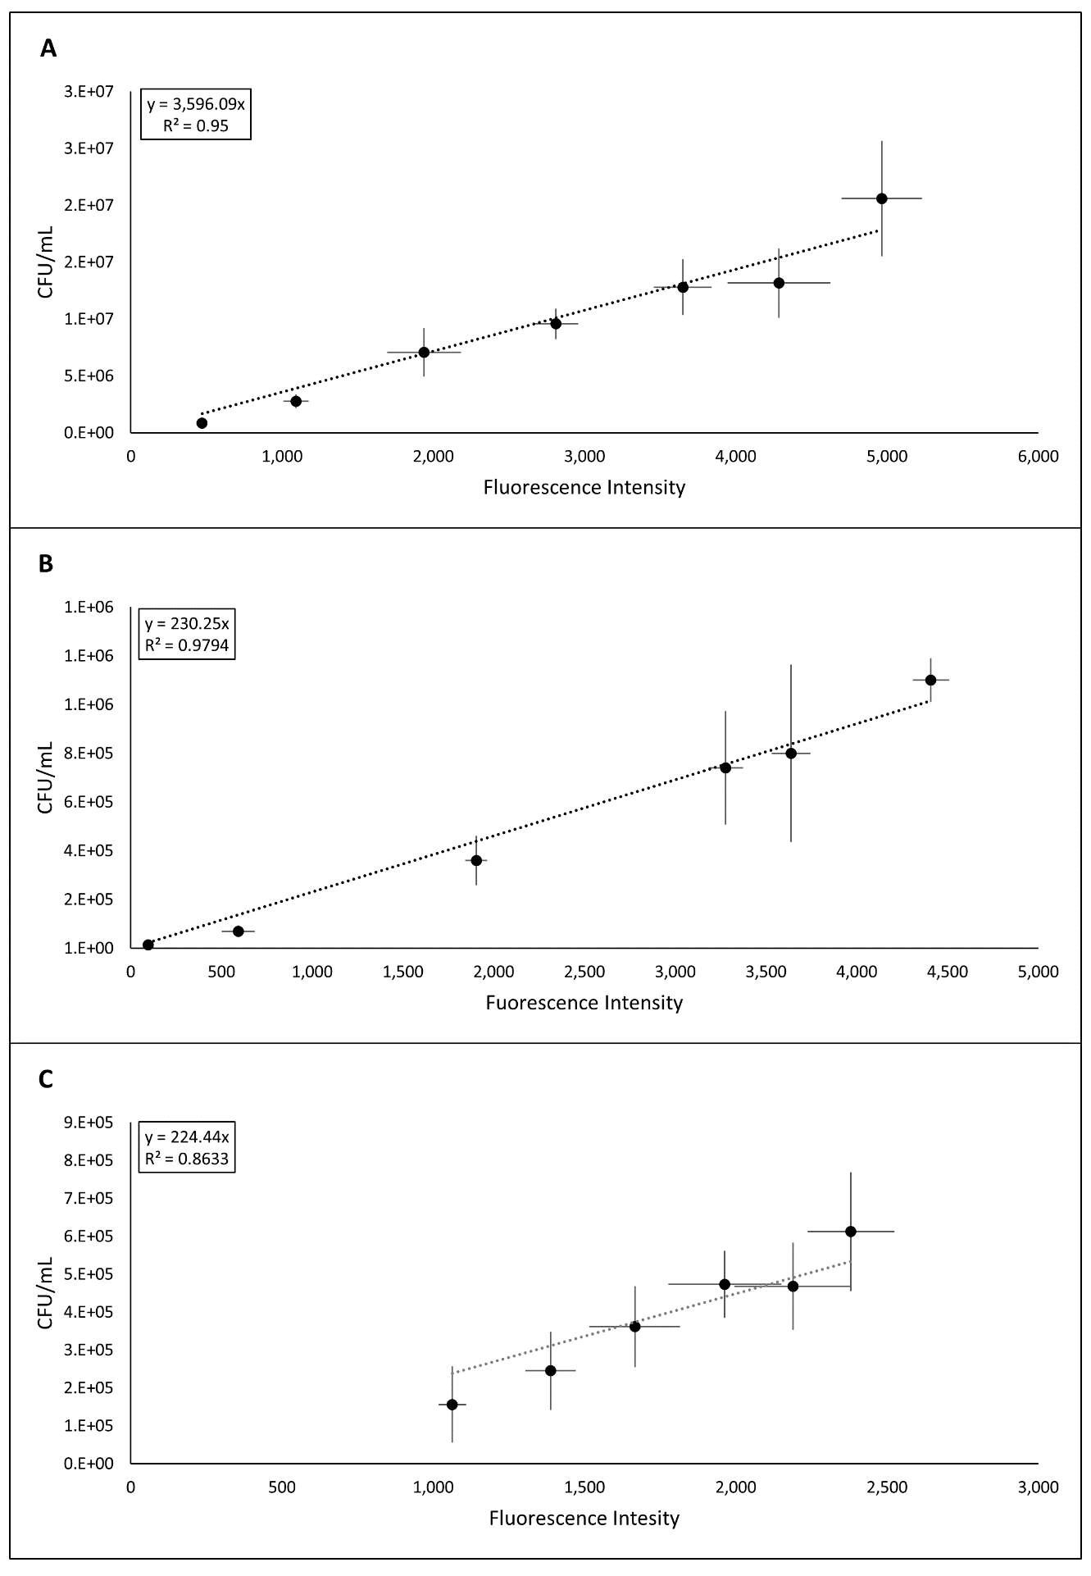
Supplementary Figure S3. Indirect determination of algal cell counts with fluorescence intensity measurements. Correlation between fluorescence intensity and algal cell count for C. vulgaris G1-G (A), S. vacuolatus G1-O (B) and H. lacustris G1-R (C).
Supplementary Table S1. Closest alignment hits of features representing the genus Methylobacterium. Sequences were aligned against the NCBI nucleotide collection using the BLAST algorithm.
Feature ID | Closest NCBI hit | Accessions NO.
3372941629954ad743c804e88345969d | Methylobacterium indicum strain DP28.3 | MK968432.1
6e98ad9b6beaa6c0546f6cc9b274d0fa | Uncultured Methylobacterium sp. | LC466937.1
ac829040ac43f4d961a191fd8e5a915d | Methylobacterium sp. strain I-S-R3-1 | MK398052.1
d8456fac09d0bb7dfd62de648ca0a933 | Methylobacterium sp. 14-324 | EF558714.1
f58bba003c01c620836eafcae31a7198 | Methylobacterium sp. CSCXZN6.6 | LC484783.1

Supplementary Table S2A. Calculated C. vulgaris G1-G cell count after seven days and 14 days of incubation. Algal cell count of mixed cultures with differing initial bacterial cell densities (OD₆₀₀ = 0.2 and 0.5) were compared with control cultures where no additional bacteria were added. Significances were calculated using ANOVA for normally distributed values and the Kruskal-Wallis test for non-parametric analyses including Bonferroni multiple test correction. Asterisk indicates significant differences (p-value ≤ 0.05) in algal cell count compared to control samples after the respective time of incubation.
M. extorquens Rab1
 | T7  [× 10⁶ CFU/mL] | difference in CFU count after 7 days | T14  [× 10⁶ CFU/mL] | difference in CFU count after 14 days
control | 2.16 ± 0.12 |  | 2.96 ± 0.54
OD₆₀₀ 0.2 | 1.74 ± 0.18* | -20% | 3.43 ± 0.37 | +16%
OD₆₀₀ 0.5 | 1.78 ± 0.18* | -18% | 3.13 ± 0.42 | +6%
M. mesophilicum Sab1
 | T7  [× 10⁶ CFU/mL] | difference in CFU count after 7 days | T14  [× 10⁶ CFU/mL] | difference in CFU count after 14 days
control | 2.16 ± 0.12 |  | 2.96 ± 0.54
OD₆₀₀ 0.2 | 1.81 ± 0.15* | -16% | 3.63 ± 0.66 | +23%
OD₆₀₀ 0.5 | 1.90 ± 0.07 | -12% | 3.36 ± 0.30 | +14%
M. goesingense Vab1
 | T7  [× 10⁶ CFU/mL] | difference in CFU count after 7 days | T14  [× 10⁶ CFU/mL] | difference in CFU count after 14 days
control | 2.16 ± 0.12 |  | 2.96 ± 0.54
OD₆₀₀ 0.2 | 1.73 ± 0.22* | -20% | 2.98 ± 0.43 | +1%
OD₆₀₀ 0.5 | 1.64 ± 0.21* | -24% | 3.23 ± 0.51 | +9%
M. goesingense Vab2
 | T7  [× 10⁶ CFU/mL] | difference in CFU count after 7 days | T14  [× 10⁶ CFU/mL] | difference in CFU count after 14 days
control | 2.16 ± 0.12 |  | 2.96 ± 0.54
OD₆₀₀ 0.2 | 1.88 ± 0.19* | -13% | 2.59 ± 0.56* | -12%
OD₆₀₀ 0.5 | 2.08 ± 0.21 | -4% | 3.05 ± 0.43 | +3%

Supplementary Table S2B. Fluorescence intensities obtained with C. vulgaris G1-G and four methylobacteria after seven days and 14 days of incubation.
M. extorquens Rab1
 | T7 | T14
control | 601 ± 47 | 822 ± 150
OD₆₀₀ 0.2 | 483 ± 51 | 954 ± 103
OD₆₀₀ 0.5 | 496 ± 50 | 871 ± 116
M. mesophilicum Sab1
 | T7 | T14
control | 601 ± 47 | 822 ± 150
OD₆₀₀ 0.2 | 504 ± 42 | 1009 ± 182
OD₆₀₀ 0.5 | 530 ± 21 | 934 ± 83
M. goesingense Vab1
 | T7 | T14
control | 601 ± 47 | 822 ± 150
OD₆₀₀ 0.2 | 481 ± 61 | 829 ± 120
OD₆₀₀ 0.5 | 457 ± 60 | 899 ± 142
M. goesingense Vab2
 | T7 | T14
control | 601 ± 47 | 822 ± 150
OD₆₀₀ 0.2 | 523 ± 52 | 720 ± 156
OD₆₀₀ 0.5 | 578 ± 57 | 921 ± 197

Supplementary Table S3A. Calculated S. vacuolatus G1-O cell count after seven days and 14 days of incubation. Algal cell count of mixed cultures with differing initial bacterial cell densities (OD₆₀₀ = 0.2 and 0.5) were compared with control cultures where no additional bacteria were added. Significances were calculated using ANOVA for normally distributed values and the Kruskal-Wallis test for non-parametric analyses including Bonferroni multiple test correction. Asterisk indicates significant differences (p-value ≤ 0.05) in algal cell count compared to control samples after the respective time of incubation.
M. extorquens Rab1
 | T7  [× 10⁵ CFU/mL] | difference in CFU count after 7 days | T14  [× 10⁵ CFU/mL] | difference in CFU count after 14 days
control | 1.01 ± 0.01 |  | 2.56 ± 0.27
OD₆₀₀ 0.2 | 1.38 ± 0.12* | +36% | 3.04 ± 0.38 | +15%
OD₆₀₀ 0.5 | 1.48 ± 0.14* | +47% | 2.93 ± 0.36 | +10%
M. mesophilicum Sab1
 | T7  [× 10⁵ CFU/mL] | difference in CFU count after 7 days | T14  [× 10⁵ CFU/mL] | difference in CFU count after 14 days
control | 1.01 ± 0.01 |  | 2.56 ± 0.27
OD₆₀₀ 0.2 | 1.31 ± 0.11* | +30% | 2.71 ± 0.27 | +2%
OD₆₀₀ 0.5 | 1.30 ± 0.12* | +28% | 2.85 ± 0.39 | +8%
M. goesingense Vab1
 | T7  [× 10⁵ CFU/mL] | difference in CFU count after 7 days | T14  [× 10⁵ CFU/mL] | difference in CFU count after 14 days
control | 1.01 ± 0.01 |  | 2.56 ± 0.27
OD₆₀₀ 0.2 | 1.35 ± 0.14* | +34% | 3.02 ± 0.56 | +14%
OD₆₀₀ 0.5 | 1.73 ± 0.23* | +72% | 3.49 ± 0.36* | +32%
M. goesingense Vab2
 | T7  [× 10⁵ CFU/mL] | difference in CFU count after 7 days | T14  [× 10⁵ CFU/mL] | difference in CFU count after 14 days
control | 1.01 ± 0.01 |  | 2.56 ± 0.27
OD₆₀₀ 0.2 | 1.29 ± 0.13* | +28% | 3.36 ± 0.53* | +27%
OD₆₀₀ 0.5 | 1.62 ± 0.25* | +60% | 3.48 ± 0.68* | +32%

Supplementary Table S3B. Fluorescence intensities obtained with S. vacuolatus G1-O and four methylobacteria after seven days and 14 days of incubation.
M. extorquens Rab1
 | T7 | T14
control | 437 ± 42 | 1150 ± 119
OD₆₀₀ 0.2 | 597 ± 52 | 1319 ± 165
OD₆₀₀ 0.5 | 644 ± 62 | 1272 ± 156
M. mesophilicum Sab1
 | T7 | T14
control | 437 ± 42 | 1150 ± 119
OD₆₀₀ 0.2 | 570 ± 49 | 1178 ± 117
OD₆₀₀ 0.5 | 563 ± 54 | 1239 ± 171
M. goesingense Vab1
 | T7 | T14
control | 437 ± 42 | 1150 ± 119
OD₆₀₀ 0.2 | 588 ± 61 | 1435 ± 298
OD₆₀₀ 0.5 | 753 ± 98 | 1515 ± 155
M. goesingense Vab2
 | T7 | T14
control | 437 ± 42 | 1150 ± 119
OD₆₀₀ 0.2 | 561 ± 56 | 1460 ± 231
OD₆₀₀ 0.5 | 702 ± 110 | 1514 ± 296

Supplementary Table S4A. Calculated H. lacustris G1-R cell count after seven days of incubation. Algal cell count of mixed cultures with differing initial bacterial cell densities (OD₆₀₀ = 0.2 and 0.5) were compared with control cultures where no additional bacteria were added. Significances were calculated using ANOVA for normally distributed values and the Kruskal-Wallis test for non-parametric analyses including Bonferroni multiple test correction. Asterisk indicates significant differences (p-value ≤ 0.05) in algal cell count compared to control samples after the respective time of incubation.
M. extorquens Rab1
 | T7  [× 10⁴ CFU/mL] | difference in CFU count after 7 days
control | 2.00 ± 0.29
OD₆₀₀ 0.2 | 2.44 ± 0.54 | +22%
OD₆₀₀ 0.5 | 8.15 ± 1.77* | +308%
M. mesophilicum Sab1
 | T7  [× 10⁴ CFU/mL] | difference in CFU count after 7 days
control | 2.00 ± 0.29
OD₆₀₀ 0.2 | 7.06 ± 1.63* | +254%
OD₆₀₀ 0.5 | 24.03 ± 0.24* | +1,104%
M. goesingense Vab1
 | T7  [× 10⁴ CFU/mL] | difference in CFU count after 7 days
control | 2.00 ± 0.29
OD₆₀₀ 0.2 | 3.68 ± 1.27 | +84%
OD₆₀₀ 0.5 | 28.08 ± 0.81* | +1,307%
M. goesingense Vab2
 | T7  [× 10⁴ CFU/mL] | difference in CFU count after 7 days
control | 2.00 ± 0.29
OD₆₀₀ 0.2 | 3.22 ± 0.86 | +61%
OD₆₀₀ 0.5 | 24.14 ± 2.81* | +1,109%

Supplementary Table S4B. Fluorescence intensities obtained with H. lacustris G1-R and four methylobacteria after seven days of incubation.
M. extorquens Rab1
 | T7
control | 89 ± 13
OD₆₀₀ 0.2 | 109 ± 24
OD₆₀₀ 0.5 | 364 ± 79
M. mesophilicum Sab1
 | T7
control | 89 ± 13
OD₆₀₀ 0.2 | 315 ± 73
OD₆₀₀ 0.5 | 1073 ± 106
M. goesingense Vab1
 | T7
control | 89 ± 13
OD₆₀₀ 0.2 | 164 ± 57
OD₆₀₀ 0.5 | 1254 ± 215
M. goesingense Vab2
 | T7
control | 89 ± 13
OD₆₀₀ 0.2 | 172 ± 101
OD₆₀₀ 0.5 | 1078 ± 126

