Efficient delivery of triptolide plus a miR-30-5p inhibitor through the use of near infrared laser responsive or CADY modified MSNs for efficacy in rheumatoid arthritis therapeutics
Xiaonan Zhangª, Xin Zhang^{b}, Xipeng Wangª, Tao Wangª, Bin Baiª, Na Zhangª, Yanjiao Zhaoª, Yang Yu*ª, Bing Wang*ª
ªInstitute of Biochemistry and Molecular Biology, College of Life and Health Sciences, Northeastern University, Shenyang, 110819, P. R. China
^{b}Department of Rheumatology and Immunology, China-Japan Union Hospital of Jilin University, Changchun, 130033, P.R. China

Supplementary materials
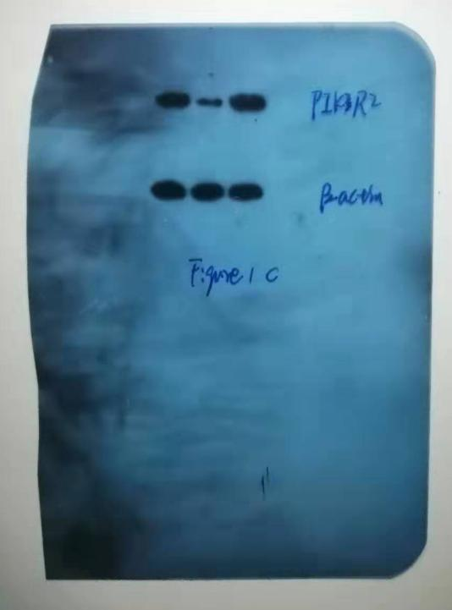
Supplementary figure 1 The original data of figure 1C

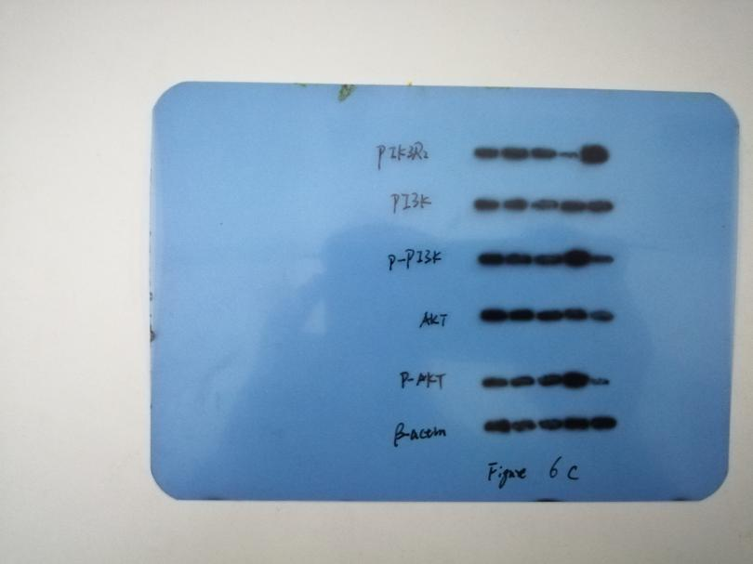
Supplementary figure 2 The original data of figure 6C

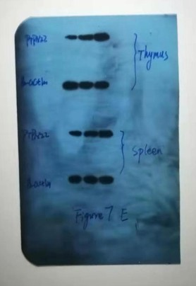

Supplementary figure 3 The original data of figure 7E

The biocompatibility of MSNs, MSNs@CADY and MSNs@PCM in mice
48 mice were randomly divided into 4 groups (PBS control group, 500 ug/mL MSNs, 500 ug/mL MSNs@CADY, 500 ug/mL MSNs@PCM), 6 male and 6 female in each group. All mice were deprived of food for 12h and then injected with nanoparticles at a dose of 100mg/kg, while the control group was given the same volume of PBS. The toxicity of the mice was observed for 7 days. The time in which symptoms appear, worsen, reduce or die, and the number of animals with these reactions were recorded. Subsequently, the mortality of animals was calculated. The results showed that a final concentration of 500 ug/mL MSNs, MSNs@CADY and MSNs@PCM had caused no significant toxic reaction in the experimental group, and there was no significant difference in the weight change between the experimental group and the PBS control group (Supplementary figure 4).
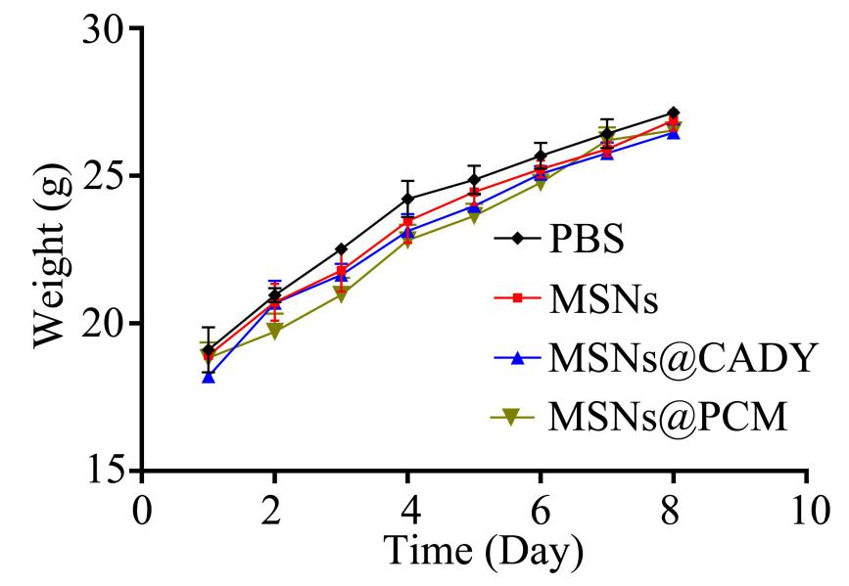
Supplementary figure 4 Effects of MSNs, MSNs@CADY and MSNs@PCM on body weight of mice.

Genes | Primers
miR-30a-5p | F 5’-GGGTGTAAACATCCTCGAC-3’  R 5’-CAGTGCGTGTCGTGGAGT-3’
U6 | F 5’-CTCGCTTCGGCAGCACA-3’;  R 5’-AACGCTTCACGAATTTGCGT-3’
PTPN22 | F 5’-CCGAATTCCGATGGACCAAAGAGAAATTCTGC-3’  R 5’-CCGAATTCGGCATGGACCAAAGAGAAATTCTGC-3’
PIK3R2 | F 5'-GCACCACGAGGAACGCACTT-3'  R 5'-CGTCCACTACCACGGAGCAG-3'
AKT | F 5'-CGGATCCTGACCAAAAACC-3'  R 5'-TCATGATGTCCGTGGTCAAT-3'
GAPDH | F 5'-GCACCGAGTTCGCTGCATTAT-3'  R 5'-GCCTATTATTATACGTCCCATG-3'
Supplementary table 1. Primers used in the article

