Supplemental Table 1. Differentially expressed genes in stimulated samples for time to deliver term at FDR of 0.1. We included the following covariates in the linear model: intercept, time to delivery, and gestational age at birth. In the table, we show the top 170 genes for the time to delivery term. See Figure 2 for a full network analysis on all genes.
Gene symbol | Coefficient (log2) | Average expression (log2) | Unadjusted p-value | Adjusted p-value
IFNL1 | -0.06 | 4.9 | 8e-07 | 0.018
NEURL1B | -0.03 | 4.4 | 2e-06 | 0.020
INPP5A | 0.03 | 4.7 | 3e-06 | 0.020
SNORD18A | 0.13 | 5.7 | 4e-06 | 0.024
KRT33A | -0.02 | 4.8 | 1e-05 | 0.049
PAQR4 | -0.03 | 5.2 | 1e-05 | 0.049
MICB | -0.03 | 5.6 | 2e-05 | 0.057
RBMS2 | -0.03 | 5.0 | 2e-05 | 0.058
ATP1A4 | -0.03 | 4.7 | 2e-05 | 0.058
GAS6 | -0.02 | 5.0 | 3e-05 | 0.061
CISD3 | -0.03 | 5.7 | 3e-05 | 0.069
TMEM150B | -0.03 | 5.3 | 4e-05 | 0.069
ETV4 | -0.03 | 4.5 | 4e-05 | 0.069
MTX1 | -0.02 | 5.3 | 4e-05 | 0.069
IFNAR1 | -0.02 | 3.6 | 5e-05 | 0.069
ASPRV1 | -0.03 | 4.1 | 6e-05 | 0.069
MMP2 | -0.02 | 5.3 | 6e-05 | 0.069
TOGARAM1 | 0.03 | 3.6 | 7e-05 | 0.069
BOLA1 | -0.02 | 6.1 | 7e-05 | 0.069
HLA-DQB2 | -0.03 | 5.7 | 7e-05 | 0.069
HLA-DQB2 | -0.03 | 5.7 | 7e-05 | 0.069
IL22RA1 | -0.03 | 4.7 | 7e-05 | 0.069
MICB | -0.03 | 5.4 | 8e-05 | 0.071
MS4A15 | -0.02 | 4.6 | 8e-05 | 0.071
KCTD5 | 0.03 | 6.1 | 8e-05 | 0.071
FRY | 0.02 | 3.8 | 9e-05 | 0.072
SNORD4B | 0.08 | 6.0 | 9e-05 | 0.072
PRG2 | -0.02 | 3.7 | 1e-04 | 0.072
CIB2 | -0.04 | 6.2 | 1e-04 | 0.072
RNPC3 | 0.04 | 4.8 | 1e-04 | 0.072
NBR2 | 0.02 | 4.8 | 1e-04 | 0.072
LSP1P5 | -0.02 | 4.8 | 1e-04 | 0.075
LINC00630 | 0.02 | 3.7 | 1e-04 | 0.075
TCTN3 | 0.04 | 5.1 | 1e-04 | 0.075
MICA | -0.02 | 5.1 | 1e-04 | 0.075
NTN3 | -0.02 | 5.6 | 1e-04 | 0.075
IL27 | -0.03 | 5.8 | 1e-04 | 0.075
MAPK8 | 0.03 | 5.2 | 1e-04 | 0.075
FOXD4L6 | -0.03 | 5.4 | 1e-04 | 0.077
KCNG4 | -0.02 | 4.6 | 1e-04 | 0.077
SLC16A8 | -0.02 | 5.3 | 1e-04 | 0.077
PRR19 | -0.03 | 4.4 | 2e-04 | 0.077
ELP1 | 0.03 | 5.1 | 2e-04 | 0.077
MIR210HG | -0.04 | 5.8 | 2e-04 | 0.077
TNK2 | -0.02 | 6.5 | 2e-04 | 0.077
ULK4 | 0.02 | 4.1 | 2e-04 | 0.077
LY6D | -0.02 | 5.2 | 2e-04 | 0.077
MIR596 | -0.04 | 5.9 | 2e-04 | 0.077
EPOP | -0.03 | 4.8 | 2e-04 | 0.077
LHFPL4 | -0.02 | 5.2 | 2e-04 | 0.077
TBC1D3P1-DHX40P1 | 0.02 | 4.8 | 2e-04 | 0.077
LRRC30 | -0.03 | 4.2 | 2e-04 | 0.077
ARHGAP27 | -0.02 | 5.6 | 2e-04 | 0.077
FCN2 | -0.02 | 6.2 | 2e-04 | 0.077
MIR210HG | -0.06 | 6.0 | 2e-04 | 0.077
PWAR5 | 0.05 | 3.8 | 2e-04 | 0.077
MATN4 | -0.02 | 4.9 | 2e-04 | 0.077
TNKS | 0.03 | 4.5 | 2e-04 | 0.077
ADAM33 | -0.03 | 5.7 | 2e-04 | 0.077
HLA-DQB2 | -0.03 | 5.7 | 2e-04 | 0.077
HLA-DQB2 | -0.03 | 5.7 | 2e-04 | 0.077
SNORD20 | 0.05 | 5.8 | 2e-04 | 0.077
AHI1 | 0.03 | 3.5 | 2e-04 | 0.077
RNU4ATAC | 0.08 | 10.0 | 2e-04 | 0.077
NFS1 | 0.01 | 5.0 | 2e-04 | 0.077
CTD-2297D10.2 | -0.03 | 4.7 | 2e-04 | 0.077
PNPLA5 | -0.02 | 4.5 | 2e-04 | 0.077
THTPA | -0.03 | 5.3 | 2e-04 | 0.077
CDK18 | -0.03 | 5.2 | 2e-04 | 0.077
BEGAIN | -0.02 | 4.9 | 2e-04 | 0.077
SLC2A10 | -0.03 | 4.5 | 3e-04 | 0.079
OR7E91P | -0.02 | 4.1 | 3e-04 | 0.079
SLC25A47 | -0.02 | 5.2 | 3e-04 | 0.079
ATP23 | 0.03 | 5.1 | 3e-04 | 0.079
C1QB | -0.03 | 5.5 | 3e-04 | 0.079
PRKCI | 0.03 | 4.5 | 3e-04 | 0.084
PFDN4 | 0.02 | 4.3 | 3e-04 | 0.085
DRD5 | -0.03 | 5.2 | 3e-04 | 0.089
HIST2H2AC | 0.04 | 10.0 | 3e-04 | 0.089
SLC27A3 | -0.02 | 5.2 | 3e-04 | 0.089
FBXL20 | 0.03 | 3.6 | 3e-04 | 0.089
CDK8 | 0.03 | 4.4 | 3e-04 | 0.090
HLA-DQB2 | -0.03 | 5.6 | 3e-04 | 0.091
HLA-DQB2 | -0.03 | 5.6 | 3e-04 | 0.091
GLCE | 0.02 | 3.5 | 4e-04 | 0.091
MIR3178 | -0.03 | 5.8 | 4e-04 | 0.091
ISOC2 | -0.02 | 5.5 | 4e-04 | 0.091
FAM90A8P | -0.03 | 5.2 | 4e-04 | 0.091
TMEM249 | -0.02 | 4.9 | 4e-04 | 0.092
NUS1P3 | 0.03 | 4.2 | 4e-04 | 0.092
TMEM9 | -0.02 | 5.2 | 4e-04 | 0.092
PTBP2 | 0.03 | 4.1 | 4e-04 | 0.092
TTC3P1 | -0.02 | 3.9 | 4e-04 | 0.092
SCRN2 | -0.02 | 5.4 | 4e-04 | 0.092
GRM6 | -0.03 | 4.8 | 4e-04 | 0.092
MIR4277 | -0.03 | 4.9 | 4e-04 | 0.092
SMTNL2 | -0.02 | 5.0 | 4e-04 | 0.092
NRXN2 | -0.02 | 5.2 | 4e-04 | 0.092
TGM2 | -0.03 | 5.6 | 4e-04 | 0.092
ADAD2 | -0.02 | 5.4 | 4e-04 | 0.092
FNDC8 | -0.02 | 3.8 | 4e-04 | 0.092
TPBGL | -0.03 | 4.3 | 4e-04 | 0.092
TMEM161B | 0.02 | 3.8 | 4e-04 | 0.092
SMKR1 | -0.02 | 5.3 | 4e-04 | 0.092
ITGA3 | -0.01 | 5.3 | 4e-04 | 0.092
RTTN | 0.02 | 3.5 | 4e-04 | 0.092
RARG | -0.03 | 5.5 | 5e-04 | 0.092
TMEM229B | -0.03 | 5.9 | 5e-04 | 0.092
IFNA8 | -0.13 | 4.2 | 5e-04 | 0.092
MIR3650 | -0.03 | 5.6 | 5e-04 | 0.092
UBR3 | 0.03 | 4.3 | 5e-04 | 0.092
ITGA9 | -0.02 | 4.4 | 5e-04 | 0.092
PRKCA | 0.05 | 6.1 | 5e-04 | 0.092
MUC6 | -0.02 | 5.5 | 5e-04 | 0.092
OLIG2 | -0.02 | 4.7 | 5e-04 | 0.092
PDGFRL | -0.04 | 5.4 | 5e-04 | 0.092
KPNB1 | -0.06 | 5.4 | 5e-04 | 0.092
BHLHA15 | -0.02 | 5.9 | 5e-04 | 0.092
LOC105373383 | -0.03 | 4.8 | 5e-04 | 0.092
MICB | -0.03 | 6.0 | 5e-04 | 0.092
GPR3 | -0.03 | 4.5 | 5e-04 | 0.092
SDS | -0.02 | 4.8 | 5e-04 | 0.092
UBQLNL | -0.03 | 3.5 | 5e-04 | 0.092
ANGPTL4 | -0.03 | 5.0 | 5e-04 | 0.092
MICB | -0.04 | 6.1 | 5e-04 | 0.092
THAP11 | -0.03 | 4.1 | 5e-04 | 0.092
IFNL3 | -0.03 | 5.5 | 5e-04 | 0.092
FKBP2 | -0.02 | 7.2 | 5e-04 | 0.092
OR5B21 | 0.05 | 5.5 | 5e-04 | 0.092
TTPAL | 0.02 | 4.4 | 5e-04 | 0.092
HLA-DQB2 | -0.02 | 5.6 | 5e-04 | 0.092
HLA-DQB2 | -0.02 | 5.6 | 5e-04 | 0.092
ODF3L1 | -0.02 | 3.8 | 6e-04 | 0.093
MICB | -0.03 | 6.0 | 6e-04 | 0.093
ZNF710 | -0.02 | 5.6 | 6e-04 | 0.093
SYCN | -0.03 | 5.1 | 6e-04 | 0.093
TMEM176B | -0.02 | 5.8 | 6e-04 | 0.093
NCR3LG1 | 0.05 | 4.7 | 6e-04 | 0.094
MIR338 | -0.03 | 4.4 | 6e-04 | 0.095
ALPP | -0.02 | 5.0 | 6e-04 | 0.095
ATF5 | -0.03 | 6.2 | 6e-04 | 0.095
MYMK | -0.02 | 5.4 | 6e-04 | 0.095
HRCT1 | -0.02 | 5.9 | 6e-04 | 0.095
ST7L | 0.02 | 3.6 | 6e-04 | 0.095
RRBP1 | -0.04 | 6.6 | 6e-04 | 0.095
NARF | -0.03 | 6.4 | 6e-04 | 0.096
PLEKHA1 | 0.02 | 5.0 | 6e-04 | 0.096
ZNF385A | -0.02 | 5.2 | 6e-04 | 0.096
LRG1 | -0.02 | 5.1 | 7e-04 | 0.096
ANGPTL6 | -0.02 | 5.1 | 7e-04 | 0.096
FAF1 | 0.02 | 4.3 | 7e-04 | 0.096
NPW | -0.02 | 5.0 | 7e-04 | 0.096
LINC01619 | 0.03 | 3.8 | 7e-04 | 0.096
IFNA17 | -0.15 | 3.9 | 7e-04 | 0.096
LINC00566 | 0.02 | 4.2 | 7e-04 | 0.096
ACADS | -0.02 | 5.3 | 7e-04 | 0.096
NEK1 | 0.03 | 4.5 | 7e-04 | 0.096
ERVH48-1 | -0.03 | 4.2 | 7e-04 | 0.096
ZNF296 | -0.03 | 5.2 | 7e-04 | 0.096
ANKRA2 | 0.02 | 5.1 | 7e-04 | 0.096
AGXT | -0.02 | 5.3 | 7e-04 | 0.099
FAM168A | -0.02 | 4.9 | 7e-04 | 0.099
MOB3B | -0.03 | 5.0 | 7e-04 | 0.099
NAF1 | 0.06 | 5.3 | 7e-04 | 0.099
TFAP2E | -0.02 | 4.9 | 7e-04 | 0.099
MROH6 | -0.02 | 6.0 | 8e-04 | 0.099
TRIB3 | -0.02 | 5.5 | 8e-04 | 0.099
CCNQP1 | -0.02 | 5.5 | 8e-04 | 0.099
FUOM | -0.02 | 5.6 | 8e-04 | 0.099
GHRL | -0.02 | 4.7 | 8e-04 | 0.099

Supplementary Figures

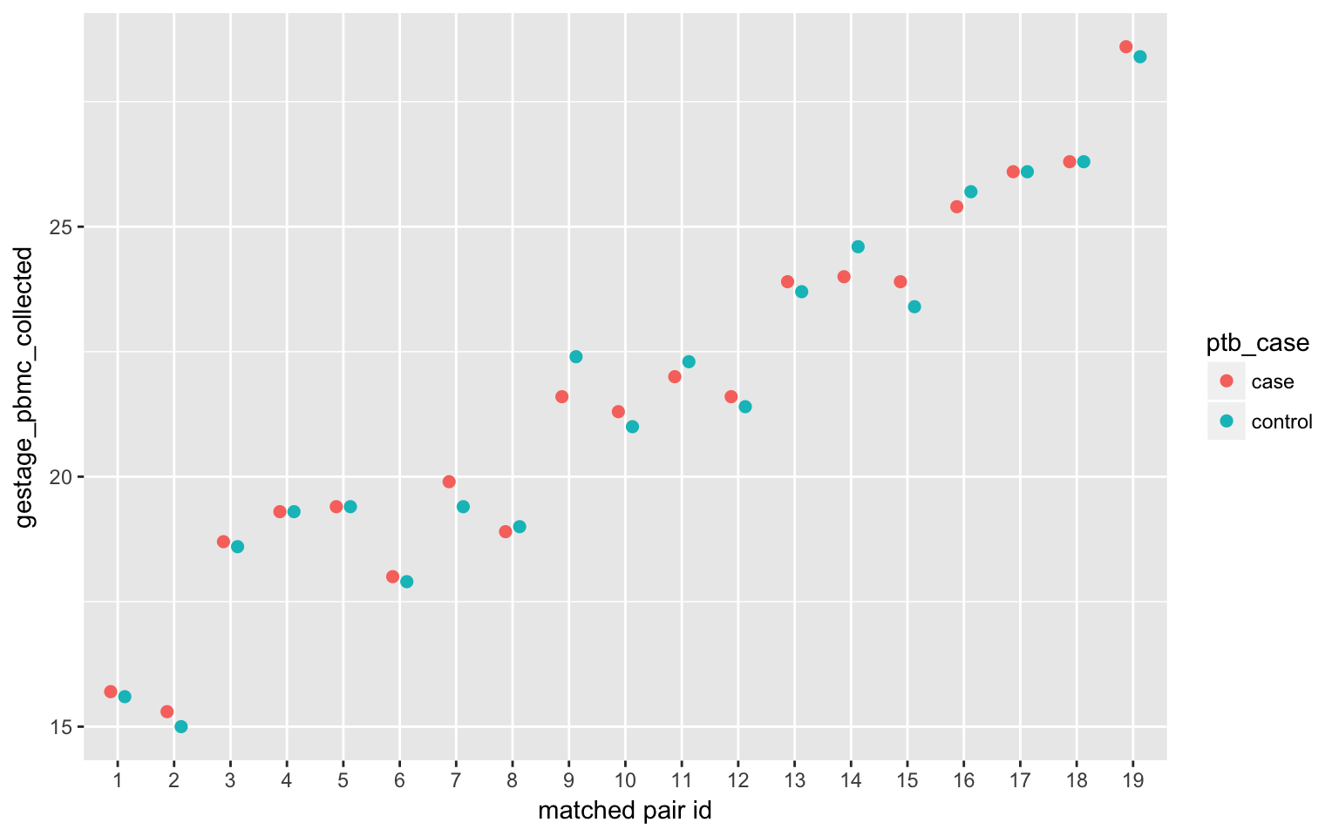
Supplementary Figure 1A: Matched stimulated samples with the smallest average absolute distance across all the matched pairs.

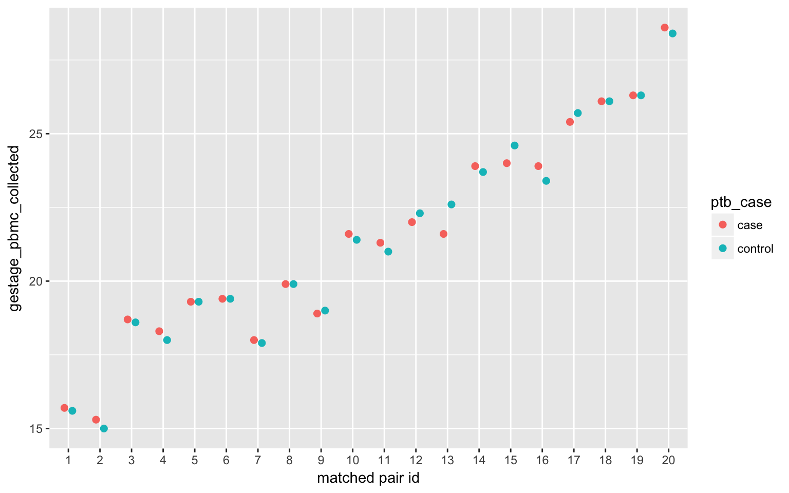Supplementary Figure 1B: Matched unstimulated samples with the smallest average absolute distance across all the matched pairs.

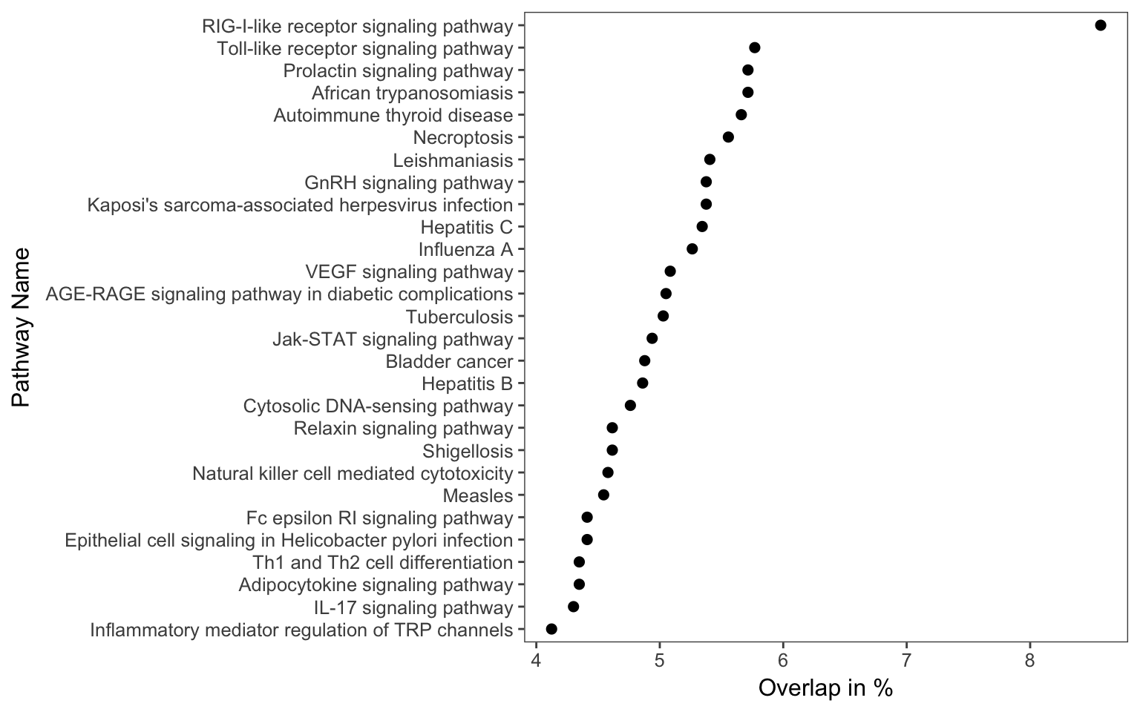
Supplementary Figure 2. Pathway analysis. Overlap between our discovered network with known pathways in KEGG. Number of genes that our network on known pathways have in common. We only show pathways with at least 5% gene overlap.

