Supplementary Material

# Supplementary Table

**Table S1.** Key specific challenges according to A) target end market, B) stages in the biodiscovery value chain, and C) organisation type.

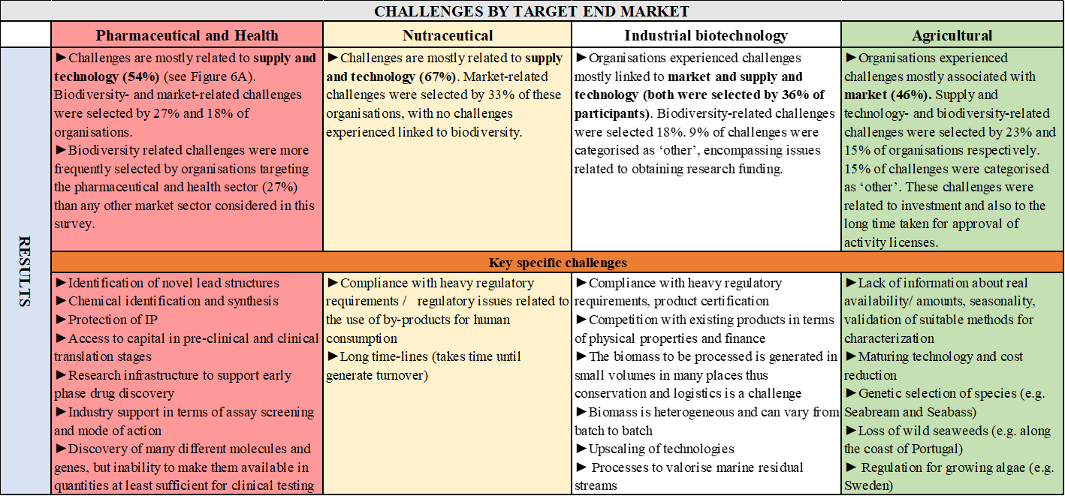

**A**



**B**



**C**