Supplementary materials for:

Investigation of The Lactic Acid Bacteria in Kazak Cheese and Their Contributions to Cheese Fermentation
Jie Li┼, Qian Huang┼, Xiaochun Zheng, Zhengkai Ge, Ke Lin, Dandan Zhang, Yu Chen, Bin Wang*, Xuewei Shi*

Food College, Shihezi University, Shihezi 832000, Xinjiang Uygur Autonomous Region, P. R. China.
* Corresponding authors
E-mail addresses: B. W.: binwang0228@shzu.edu.cn; X. S.: shixuewei@shzu.edu.cn
Tel.: 86-0993-2058093
┼ These authors contributed equally to this work.
Catalog
Supplementary tables 1
Table S1. Similarity alignment of gene sequence 1
Table S2. Identification and enzyme activity of LAB (U/mL) 2
Table S3. Construction of fingerprints of volatile compounds in cheeses 3
Table S4. Concentrations of volatile compounds in cheeses (µg/kg) 4
Supplementary figures 6
Figure S1. Hydrolysis halo of selected strains 6
Figure S2. Numbers of viable bacteria in cheeses at different fermentation periods (cfu/kg) 7
Figure S3. Construction of volatile compound fingerprints for the LABs 8
Figure S4. Radar analysis of flavor compounds 9

Supplementary tables

Table S1. Similarity alignment of gene sequence
Strain | Size (bp) | Identification | Similarity (%) | Accession number
B1 | 1,059 | Lactobacillus casei strain NWAFU1544 | 97.68 | MG551218.1
B2 | 1,151 | Lactobacillus casei strain NWAFU1544 | 98.68 | MG551218.1
B3 | 1,252 | Lactobacillus casei strain NWAFU1575 | 96.88 | MG551255.1
B4 | 1,243 | Lactobacillus casei strain NWAFU1544 | 96.76 | MG551249.1
B5 | 1,233 | Lactobacillus paracasei strain 05 | 97.03 | JN560834.1
B6 | 1,237 | Lactobacillus helveticus strain hstb-6 | 97.83 | KX822707.1
B7 | 1,153 | Lactobacillus helveticus strain LH5 | 97.28 | CP019581.1
B8 | 1,102 | Streptococcus thermophilus strain N4L | 99.73 | LS974444.1
B9 | 1,080 | Streptococcus thermophilus strain ST3 | 99.26 | MG815652.1
B10 | 1,019 | Lactobacillus rhamnosus strain A5 | 98.41 | MK329243.1
B11 | 1,250 | Lactococcus lactis strain Sourdough M5 | 97.39 | MG754635.1
B12 | 1,222 | Lactobacillus rhamnosus strain 8 | 97.7 | MN030350.1
B13 | 1,226 | Streptococcus thermophilus strain N4L | 97.32 | LS974444.1
B14 | 1,226 | Weissella confusa strain RCB331 | 97.19 | KT260543.1
B15 | 1,219 | Streptococcus thermophilus strain KLDS 3.0606 | 98.84 | EU419603.1
B16 | 1,051 | Weissella confusa strain FB054 | 96.51 | MF945623.1
B17 | 1,178 | Lactococcus lactis strain Sourdough M8 | 98.16 | MG754628.1
B18 | 1,160 | Lactococcus gravieae strain def2 | 99.10 | MH198321.1
B19 | 1,169 | Leuconostoc lactis strain A4584 | 98.80 | MN441494.1
B20 | 1,211 | Leuconostoc lactis strain KLDS 5.0604 | 98.75 | EU419606.1
B21 | 1,217 | Leuconostoc lactis strain A4584 | 97.81 | MN441494.1
B22 | 1,050 | Lactobacillus plantarum strain CP2 | 99.52 | MN244500.1

Table S2. Identification and enzyme activity of LAB (U/mL)
Identification | Number | Protease activity | Lipase activity | β-galactosidase activity
Streptococcus thermophilus | B8 | 124 ± 1.32 | 87 ± 1.13 | 162 ± 1.21
Weissella confusa | B14 | 139 ± 1.03 | 96 ± 1.06 | —
Lactobacillus helveticus | B6 | 103 ± 0.94 | 115 ± 1.65 | —
Lactococcus rhamnosus | B10 | 120 ± 1.25 | — | 186 ± 1.17
Leuconostoc lactis | B19 | 87 ± 0.87 | — | 157 ± 1.35
Lactobacillus paracasei | B5 | 113 ± 1.06 | — | —
Leuconostoc lactis | B20 | 105 ± 0.95 | — | —
Lactobacillus casei | B4 | 96 ± 0.78 | — | —
Lactobacillus helveticus | B7 | — | 83 ± 0.88 | 106 ± 1.18
Lactobacillus casei | B1 | 86 ± 0.88 | 94 ± 0.82 | 138 ± 1.33
Leuconostoc lactis | B21 | 102 ± 1.14 | — | —
Weissella confusa | B16 | 98 ± 0.92 | 87 ± 0.91 | —
Streptococcus thermophilus | B9 | 118 ± 2.03 | 68 ± 0.76 | —
Streptococcus thermophilus | B13 | 102 ± 1.06 | 73 ± 0.95 | —
Streptococcus thermophilus | B15 | 116 ± 1.31 | — | 140 ± 1.67
Lactococcus lactis | B11 | 113 ± 1.48 | 77 ± 0.85 | —
Lactobacillus casei | B3 | — | — | 158 ± 1.42
Lactobacillus casei | B2 | 96 ± 0.92 | 87 ± 0.97 | 155 ± 1.75
¹ Symbol “—” stands for undetectable.
² Data is expressed as the mean ± standard deviation and three replicate analyses (n = 3) of three replicate samples.

Table S3. Construction of fingerprints of volatile compounds in cheeses
Number | Flavor compounds | Time (min) | LrC-5 | StC | WcC | LhC
1 | Ethyl acetate | 2.36 |  | 10.028* |  | −0.909
2 | Ethanol | 2.73 | 8.140* | 38.015* |  | −0.981
3 | Ethyl butanoate | 4.25 |  |  | 1.278 | −0.743
4 | Hexanal | 5.20 |  |  |  | 1.424
5 | Isobutanol | 5.91 |  | −0770
6 | Isoamyl acetate | 6.25 |  | −0.474 |  | 6.954*
7 | Pentyl acetate | 7.81 |  | +1
8 | 5-Methyl-2-hexanone | 8.24 |  |  |  | −1
9 | Isoamylol | 9.63 |  |  |  | −1
10 | Ethyl hexanoate | 10.56 | 1.912
11 | Hexyl acetate | 12.47 | 16.959* |  |  | 2.134
12 | Octanal | 13.156 | +1
13 | 2-Heptenal | 14.85 | +1 |  |  | +1
14 | Prenol | 15.00 |  |  |  | 1.492
15 | Ethyl l-lactate | 16.15 | 2.942 | 4.069* | 1.091 | 2.490
16 | Hexanol | 16.74 |  |  |  | 4.495*
17 | Ethyl caprylate | 21.29 | 7.421* | 1.532 | 3.783 | 6.954*
18 | Acetic acid | 22.06 | 16.137* |  |  | 8.725*
19 | 2-Nonenal | 26.59 |  |  |  | −0.862
20 | Propanoic acid | 27.26 |  | 2.835
21 | Butanoic acid | 32.26 | +1 |  |  | +1
22 | α-Cumyl alcohol | 36.52 |  | 1.984
23 | 2-Methylpentanoic acid | 36.93 | 62.935* |  |  | 32.762*
24 | Phenethyl acetate | 38.2 |  | +1
25 | Hexanoic acid | 40.66 |  | +1
26 | Phenylethyl alcohol | 41.00 |  | +1
27 | Heptanoic acid | 42.42 |  |  |  | 1.203
28 | 3-Butanolal | 50.80 | 1.445
29 | Benzoic acid | 52.14 |  |  |  | 1.871
¹ Symbol "+1" and "−1" indicated compounds that are formed and disappeared in the later stages of fermentation.
² The data was calculated as (late peak area − initial peak area) / initial peak area.
³ Symbol "*" indicated that the compound changes significantly.

Table S4. Concentrations of volatile compounds in cheeses (µg/kg)
Compounds | RI | LrC | StC | WcC | LhC
Alcohols
Ethanol | 1,482 | 17.740 ± 4.190^{b} | 290.176 ± 45.573ª | 304.318 ± 46.775ª | 2.322 ± 0.902^{b}
Isobutanol | 1,526 | 1.542 ± 0.335^{c} | 15.909 ± 2.072^{b} | 54.540 ± 4.678ª | 0.654 ± 0.078^{c}
Isoamylol | 1,142 | — | 176.202 ± 4.972^{b} | 819.311 ± 34.614ª | 36.402 ± 2.479^{c}
Pentanol | 1,265 | 33.034 ± 0.419ª | 17.939 ± 1.657^{b} | 36.204 ± 6.549ª | 2.096 ± 0.225^{d}
Prenol | 1,037 | 7.215 ± 0.647 | — | 19.365 ± 4.678 | —
Hexanol | 1,374 | 0.545 ± 0.042^{d} | 44.454 ± 0.829^{b} | 75.401 ± 3.742ª | 19.925 ± 2.479^{c}
2-Nonen-1-ol | 1,026 | 8.891 ± 0.251^{b} | 5.842 ± 0.373^{c} | 17.868 ± 2.748ª | 3.629 ± 0.158^{c}
2-Ethylhexanol | 974 | 2.338 ± 0.419^{b} | 3.480 ± 0.043ª | 3.461 ± 0.047ª | 0.834 ± 0.008^{c}
1-Octanol | 2,157 | 0.930 ± 0.017^{d} | 63.264 ± 1.657ª | 25.539 ± 1.871^{b} | 4.170 ± 0.135^{c}
2,3-Butanediol | 1,237 | 1.927 ± 0.168^{d} | 153.622 ± 7.557ª | 124.515 ± 6.874^{b} | 67.778 ± 2.930^{c}
1-Nonanol | 1,743 | 6.570 ± 0.335^{b} | 2.817 ± 0.124^{c} | 8.232 ± 0.561ª | 3.043 ± 0.902^{c}
α-Cumyl alcohol | 1,174 | 0.712 ± 0.025^{c} | 2.154 ± 0.207^{b} | 2.994 ± 0.281ª | —
Phenylethyl alcohol | 1,837 | 0.117 ± 0.021^{d} | 28.090 ± 2.900^{b} | 153.703 ± 10.291ª | 11.315 ± 0.902^{c}
2-Methyloctan-3-ol | 1,275 | 0.696 ± 0.168 | 1.657 ± 0.414 | — | —
Aldehydes
Hexanal | 1,368 | 18.335 ± 4.190^{c} | 95.206 ± 2.072ª | 54.072 ± 3.742^{b} | 15.801 ± 1.803^{d}
2-Heptenal | 1,623 | 1.265 ± 0.251^{c} | 11.973 ± 0.829ª | — | 7.889 ± 1.352^{b}
Nonanal | 1,346 | 5.958 ± 0.168^{d} | 13.092 ± 1.243^{c} | 58.375 ± 3.742ª | 17.401 ± 1.803^{b}
Decanal | 1,573 | — | 12.222 ± 0.829ª | 7.858 ± 0.561^{b} | 2.637 ± 0.451^{c}
Benzaldehyde | 1,355 | 0.737 ± 0.084^{b} | — | 36.110 ± 1.054ª | 0.676 ± 0.025^{b}
2-Nonenal | 1,257 | 1.274 ± 0.168 | — | — | 9.489 ± 1.127
3-Butanolal | 1,085 | 0.327 ± 0.024^{b} | 0.456 ± 0.066^{b} | 2.058 ± 0.187ª | 0.316 ± 0.007^{b}
Octanal | 1,548 | — | 2.154 ± 0.124^{c} | 3.368 ± 0.187^{b} | 4.688 ± 0.451ª
Acids
Acetic acid | 1,758 | 246.070 ± 8.38^{d} | 1295.185 ± 91.146^{b} | 2137.056 ± 168.390ª | 753.647 ± 56.350^{c}
Propanoic acid | 1,029 | 0.570 ± 0.050^{d} | 45.283 ± 5.414ª | 28.346 ± 3.742^{b} | 7.686 ± 1.127^{c}
Isobutyric acid | 1,437 | 14.204 ± 0.168^{d} | 134.150 ± 2.900^{b} | 311.615 ± 8.420ª | 41.406 ± 1.578^{c}
Butanoic acid | 1,192 | 27.998 ± 5.028^{d} | 185.524 ± 6.215^{b} | 311.615 ± 5.613ª | 107.786 ± 2.029^{c}
3-Methylbutanoic acid | 1,090 | 59.054 ± 7.542^{c} | 238.844 ± 4.557^{b} | 528.838 ± 8.420ª | 62.323 ± 2.479^{c}
2-Methylpentanoic acid | 1,039 | 57.018 ± 0.503^{b} | 19.886 ± 3.314^{c} | 12.255 ± 0.561^{d} | 105.532 ± 2.479ª
Hexanoic acid | 964 | 43.358 ± 0.754^{d} | 262.376 ± 2.900^{b} | 400.113 ± 13.097ª | 104.834 ± 2.930^{c}
Heptanoic acid | 1,354 | 0.520 ± 0.024^{d} | 5.320 ± 0.166ª | 3.929 ± 0.157^{b} | 1.082 ± 0.225^{c}
Octanoic acid | 1,503 | 16.148 ± 0.503^{c} | — | 149.119 ± 8.420ª | 37.146 ± 2.902^{b}
Nonanoic acid | 1,374 | 0.520 ± 0.084^{b} | 3.687 ± 0.207ª | 5.332 ± 1.871ª | 0.609 ± 0.023^{b}
Decanoic acid | 1,097 | 3.143 ± 0.154^{d} | 13.755 ± 2.041^{b} | 26.007 ± 1.678ª | 7.326 ± 1.356^{c}
Benzoic acid | 1,275 | 5.799 ± 0.587^{c} | 18.519 ± 1.249^{b} | 38.168 ± 1.878ª | 6.942 ± 1.127^{c}
Esters
Ethyl acetate | 1,379 | 14.531 ± 2.514^{c} | 111.488 ± 5.386^{b} | 538.942 ± 12.162ª | 19.858 ± 1.352^{c}
Isobutyl acetate | 1,027 | — | 7.582 ± 1.243 | 7.858 ± 1.871 | —
Ethyl butanoate | 1,768 | 5.045 ± 0.335 | — | — | 4.035 ± 0.451
Isoamyl acetate | 1,942 | 104.113 ± 4.190^{c} | 358.079 ± 37.287^{b} | 2243.423 ± 121.615ª | 418.681 ± 24.743^{b}
Pentyl acetate | 1,274 | 13.081 ± 1.642^{b} | — | 70.630 ± 2.807ª | 72.556 ± 2.930ª
Ethyl hexanoate | 1,354 | 3.520 ± 0.503^{c} | 24.029 ± 1.657^{b} | 46.214 ± 4.678ª | 47.131 ± 1.803ª
Hexyl acetate | 1,736 | 2.564 ± 0.168^{c} | 1.657 ± 0.414^{c} | 16.091 ± 1.459^{b} | 27.025 ± 2.029ª
Ethyl l-lactate | 1,932 | 3.327 ± 0.526^{d} | 39.731 ± 2.9^{b} | 139.670 ± 7.484ª | 17.085 ± 1.352^{c}
Heptyl acetate | 1,093 | 1.089 ± 0.078^{d} | 6.090 ± 0.249ª | 4.303 ± 0.574^{b} | 3.426 ± 0.225^{c}
Ethyl caprylate | 1,127 | 45.487 ± 2.541^{b} | 17.939 ± 2.072^{d} | 39.478 ± 2.807^{c} | 75.599 ± 2.254ª
Octyl acetate | 1,425 | 0.578 ± 0.168 | — | — | 0.564 ± 0.068
Butyrolactone | 1,237 | — | 2.154 ± 0.034 | — | 1.127 ± 0.676
Ethyl caprate | 1,358 | — | — | — | 8.678 ± 1.127
Phenethyl acetate | 1,642 | 11.472 ± 2.136^{c} | 13.838 ± 3.362^{c} | 215.259 ± 9.355ª | 86.103 ± 15.778^{b}
5-Decanolide | 1,138 | 0.503 ± 0.059^{c} | 13.755 ± 1.015ª | 2.526 ± 0.146^{b} | 0.947 ± 0.113^{c}
1,3-Diacetoxypropane | 1,029 | — | 1.326 ± 0.083 | — | 0.541 ± 0.088
Ketones
Acetol | 1,528 | 0.109 ± 0.004^{b} | 2.983 ± 0.124^{b} | 141.354 ± 10.107ª | —
3-Methyl-2-hexanone | 976 | — | — | 0.164 ± 0.001 | —
5-Methyl-2-hexanone | 1,069 | 16.584 ± 1.676^{c} | 184.364 ± 4.557ª | 60.620 ± 2.807^{b} | 2.299 ± 0.451^{d}
2-Heptanone | 1,463 | 5.657 ± 0.135^{c} | 27.924 ± 2.486ª | 1.965 ± 0.094^{d} | 8.205 ± 0.902^{b}
Acetoin | 1,137 | — | 103.078 ± 1.243ª | 12.723 ± 1.871^{b} | 7.168 ± 0.120^{c}
6-Methylhept-5-en-2-one | 1,265 | — | 11.518 ± 0.414^{b} | 12.629 ± 0.936ª | 3.584 ± 0.551^{c}
2-Nonanone | 1,386 | 10.165 ± 2.745^{c} | 46.692 ± 2.486ª | 36.578 ± 2.567^{b} | 2.029 ± 0.676^{d}
2-Undecanone | 963 | 0.712 ± 0.003^{b} | 5.800 ± 1.203ª | 5.145 ± 0.281ª | —
¹ Data are expressed as the mean ± standard deviation from three replicate analyses (n = 3) of three replicate samples.
² The different lowercase letters in each row indicated a significant difference between the samples (P < 0.05).
³ LrC, StC, WcC, and LhC represented samples collected at the fifth stage.
⁴ The symbol “—” indicated that the compound was not detected.

Supplementary figures
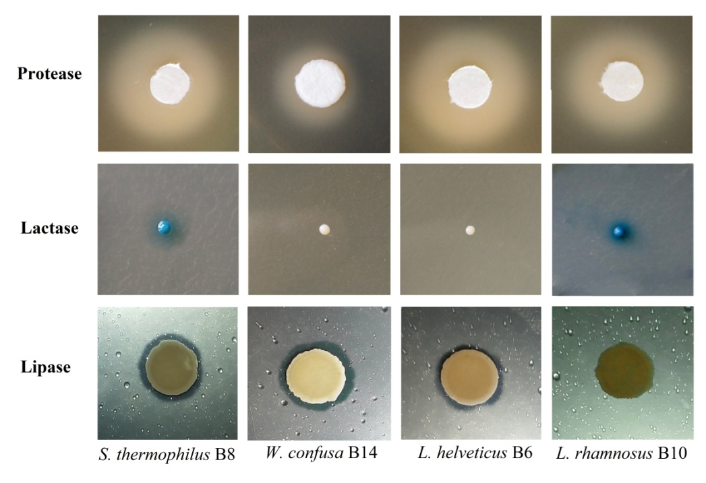

Figure S1. Hydrolysis halo of selected strains
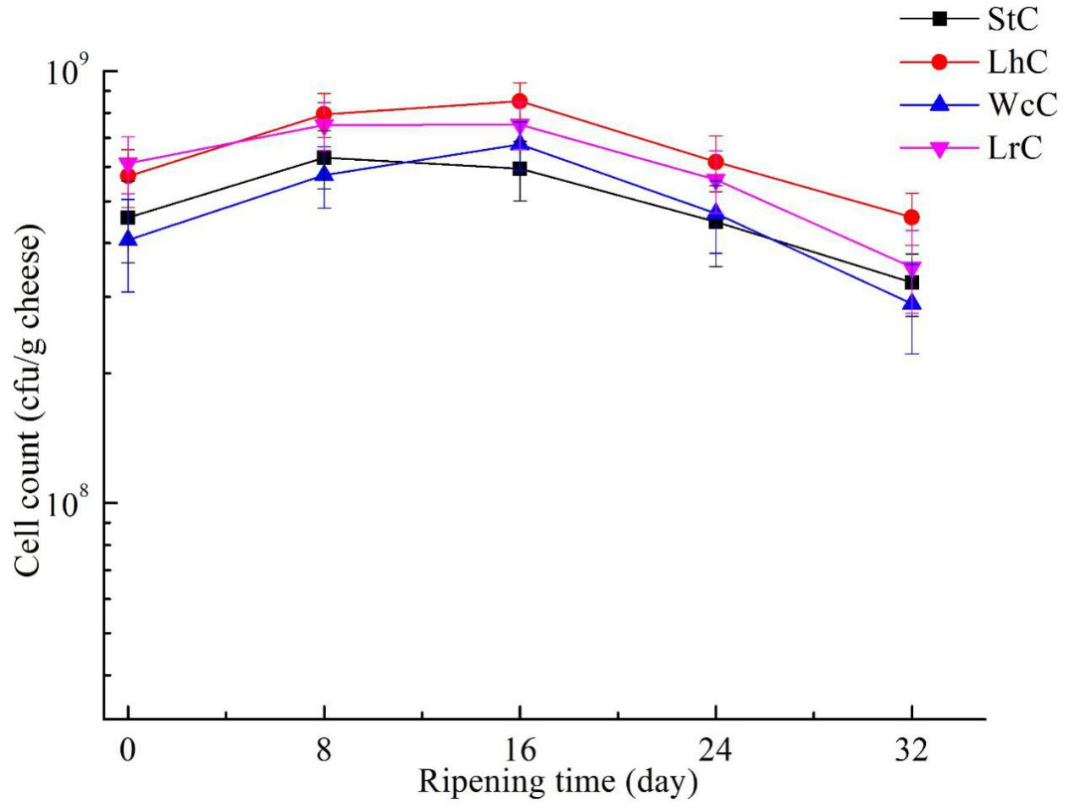

Figure S2. Numbers of viable bacteria in cheeses at different fermentation periods (cfu/kg)
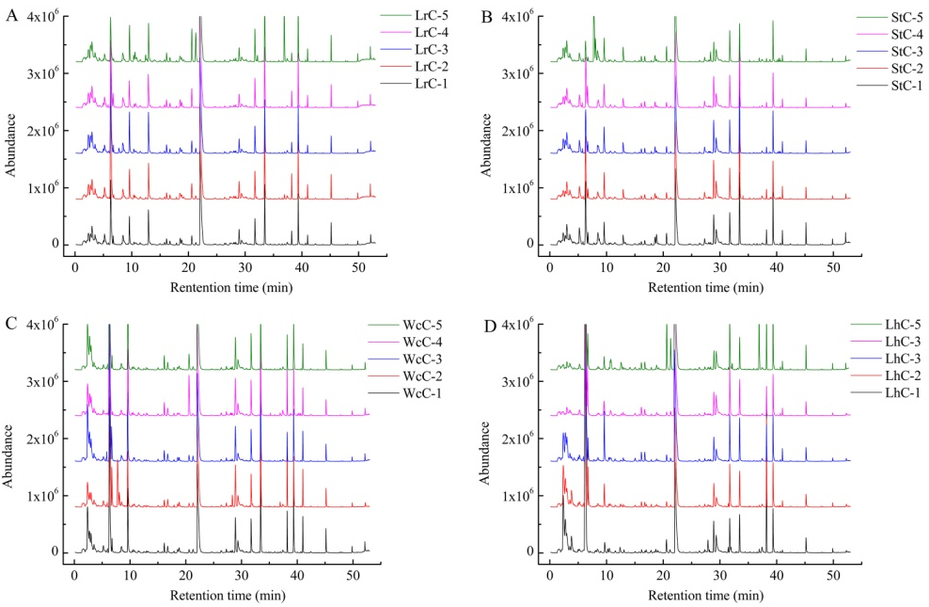

Figure S3. Construction of volatile compound fingerprints for the LABs
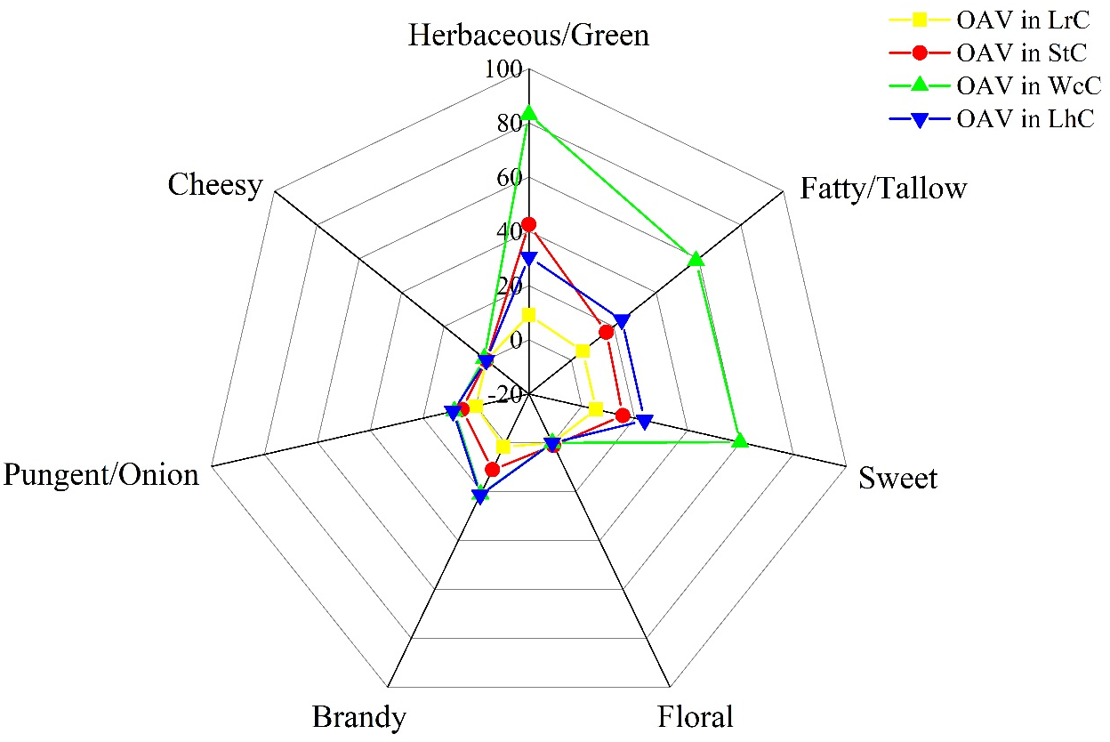

Figure S4. Radar analysis of flavor compounds

