Supplementary Material

**Heat waves alter carbon allocation and combined with drought result in massive mortality in Aleppo pine**

**Benjamin Birami1*, Marielle Gattmann1, Arnd G. Heyer2, Rüdiger Grote1, Almut Arneth1, Nadine K. Ruehr1\***

1Institute of Meteorology and Climate Research - Atmospheric Environmental Research (IMK-IFU), Karlsruhe Institute of Technology KIT, Germany 2Institute of Biomaterials and Biomolecular Systems - Plant-Biotechnology, University of Stuttgart, Germany

*Correspondence:

Corresponding Authors: Benjamin Birami, Tel: +49 8821 183 215, Email: [benjamin.birami@kit.edu](mailto:benjamin.birami@kit.edu), Nadine Ruehr, Tel: +49 8821 183 230, Email: [nadine.ruehr@kit.edu](mailto:Nadine.ruehr@kit.edu)

**Table S1:** Greenhouse facility plan for the temperature control by temperature steps of 3 hours for the light phase and 6 hours for the dark phase. Values of each temperature step are derived from field measurements at the Yatir forest measurement site (Israel, monthly mean over 10 years 2004 – 2014).

|  |  |  |  |  |  |  |  |  |  |  |  |  |
| --- | --- | --- | --- | --- | --- | --- | --- | --- | --- | --- | --- | --- |
| T [°C]  hour of day | Jan | Feb | Mar | Apr | Mai | Jun | Jul | Aug | Sep | Oct | Nov | Dec |
| 0-6 | 8.9 | 10.1 | 11.6 | 14 | 16.3 | 18.9 | 18.7 | 19.4 | 18.2 | 16.4 | 13 | 10 |
| 6-9 | 8.5 | 10 | 11.9 | 15.1 | 18.8 | 21.6 | 20.4 | 20.6 | 19.1 | 17 | 13.1 | 9.8 |
| 9-12 | 11.6 | 13.3 | 15.7 | 18.7 | 22.5 | 25.7 | 24.6 | 25.2 | 23.7 | 21.4 | 17.2 | 13.2 |
| 12-15 | 13.7 | 15.4 | 18.1 | 21.3 | 25.1 | 28.7 | 27.8 | 28.6 | 26.7 | 23.9 | 19.1 | 15.1 |
| 15-18 | 12.6 | 14.5 | 17.1 | 20.3 | 23.8 | 27.4 | 26.7 | 27.2 | 24.9 | 21.8 | 17.3 | 13.5 |
| 18-20 | 10.5 | 12.1 | 14.1 | 17.2 | 20.4 | 23.9 | 23.3 | 23.6 | 21.4 | 18.9 | 14.9 | 11.5 |
| 20-0 | 9.7 | 10.9 | 12.5 | 15.2 | 18 | 20.9 | 20.5 | 21.1 | 19.5 | 17.5 | 13.9 | 10.7 |

**Table S2:** Averages (upper table) and Standard error of mean (lower table) of all analyzed metabolites and parameters except of gas exchange measurement data. Values of metabolites are in µmol gDW-1, Water potential (WP) is in MPa. Needle water content (NW) and root water content (RW) are in [g%]. Status depicts a numerical value for living (1) and dead (0) seedlings. “Part” depict shoots (N) and roots (R).



**Table S3:** Linear mixed effect model output that tested for interaction of the treatment group (drought, heat, heat-drought) and the experimental time-period (before stress, heat wave 1, heat release 1, heat wave 2, heat release 2, wet recovery) against the control. Experimental time-periods are equivalent to the visually highlighted experimental condition in Fig. 1 (main text). Chamber identity and day of year were assigned to random effects. Significance codes are depicted as follows: p ≤ 0 ‘***’ 0.001 ‘**’ 0.01 ‘*’ 0.05 ‘.’ 0.1 ‘’ 1. Non-significant differences are marked with n.s..











**Table S4:** Results of Analysis of Variance Analysis (ANOVA) for metabolites and chlorophyll fluorescence parameters. Analysis was done to reveal differences between the treatments and the control within a sampling period (post-stress, recovery). Significance is given with: 0 ‘***’ 0.001 ‘**’ 0.01 ‘*’ and n.s (not significant).

|  |  |  |  |  |  |  |
| --- | --- | --- | --- | --- | --- | --- |
|  | Estimate | Std. Error | t value | Pr(<|t|) | | Significance |
| Part: Needles | | Period: Stress | | Metabolite: sNSC | | |
| Intercept | 175.487 | 34.769 | 5.047 | 7.16e-05 | | *** |
| Drought | 46.922 | 51.179 | 0.917 | 0.371 | | n.s. |
| Heat | 4.083 | 49.171 | 0.083 | 0.935 | | n.s. |
| Heat-Drought | -7.219 | 63.480 | -0.114 | 0.911 | | n.s. |
|  | | | | Metabolite: Starch | | |
| Intercept | 33.513 | 7.050 | 4.754 | 0.000107 | | *** |
| Drought | -20.404 | 10.377 | -1.966 | 0.062639 | | n.s. |
| Heat | -20.714 | 9.654 | -2.146 | 0.043738 | | * |
| Heat-Drought | -13.572 | 11.691 | -1.161 | 0.258720 | | n.s. |
|  |  |  |  | Metabolite: CS | | |
| Intercept | 117.86 | 28.35 | 4.157 | 0.000446 | | *** |
| Drought | 11.87 | 41.73 | 0.284 | 0.778904 | | n.s. |
| Heat | 41.60 | 38.82 | 1.072 | 0.296076 | | n.s. |
| Heat-Drought | 31.86 | 47.02 | 0.678 | 0.505419 | | n.s. |
|  |  |  |  | Metabolite: Cyclitols | | |
| Intercept | 285.74 | 60.42 | 4.729 | 0.000128 | | *** |
| Drought | -162.77 | 88.93 | -1.830 | 0.082167 | | n.s. |
| Heat | 68.34 | 85.45 | 0.800 | 0.433203 | | n.s. |
| Heat-Drought | -60.27 | 100.19 | -0.602 | 0.554264 | | n.s. |
|  |  |  |  | Metabolite: totalC | | |
| Intercept | 647.57 | 93.79 | 6.904 | 1.05e-06 | | *** |
| Drought | -138.96 | 138.06 | -1.006 | 0.326 | | n.s. |
| Heat | 19.71 | 128.43 | 0.153 | 0.880 | | n.s. |
| Heat-Drought | -30.56 | 171.25 | -0.178 | 0.860 | | n.s. |
|  |  |  |  | Metabolite: Nitrate | | |
| Intercept | 1.6923 | 1.0855 | 1.559 | 0.13394 | | n.s. |
| Drought | -0.1414 | 1.5978 | -0.088 | 0.93033 | | n.s. |
| Heat | 3.6216 | 1.4864 | 2.436 | 0.02382 | | * |
| Heat-Drought | 5.7304 | 1.8001 | 3.183 | 0.00447 | | ** |
|  |  |  |  | Metabolite: Proline | | |
| Intercept | 15.397 | 8.969 | 1.717 | 0.101 | | n.s. |
| Drought | 1.572 | 13.203 | 0.119 | 0.906 | | n.s. |
| Heat | 16.048 | 12.282 | 1.307 | 0.205 | | n.s. |
| Heat-Drought | 16.648 | 14.874 | 1.119 | 0.276 | | n.s. |
|  |  |  |  | Parameter: WP | | |
| Intercept | -0.6600 | 0.1478 | -4.466 | 0.000390 | | *** |
| Drought | -0.7900 | 0.2001 | -3.948 | 0.001151 | | ** |
| Heat | -0.5067 | 0.2001 | -2.532 | 0.022186 | | * |
| Heat-Drought | -1.1067 | 0.2413 | -4.586 | 0.000304 | | *** |
|  |  |  |  | Parameter: qP | | |
| Intercept | 0.40319 | 0.04961 | 8.128 | 3.2e-06 | | *** |
| Drought | -0.08941 | 0.07015 | -1.275 | 0.22660 | | n.s. |
| Heat | -0.11655 | 0.07015 | -1.661 | 0.12253 | | n.s. |
| Heat-Drought | -0.25835 | 0.07015 | -3.683 | 0.00313 | | ** |
|  |  |  |  | Parameter: ETR | | |
| Intercept | 98.010 | 9.913 | 9.887 | 1.07e-07 | | *** |
| Drought | -28.384 | 13.299 | -2.134 | 0.050986 | | * |
| Heat | -37.362 | 13.299 | -2.809 | 0.013921 | | * |
| Heat-Drought | -73.353 | 14.018 | -5.233 | 0.000127 | | *** |
|  |  |  |  | Parameter: PhiPSII | | |
| Intercept | 0.18484 | 0.02091 | 8.840 | 1.33e-06 | | *** |
| Drought | -0.05043 | 0.02957 | -1.705 | 0.1138 | | n.s. |
| Heat | -0.06021 | 0.02957 | -2.036 | 0.0644 | | n.s. |
| Heat-Drought | -0.14334 | 0.02957 | -4.847 | 0.0004 | | *** |
|  |  |  |  | Parameter: Fv`/Fm` | | |
| Intercept | 0.45935 | 0.04173 | 11.008 | 1.26e-07 | | *** |
| Drought | -0.03290 | 0.05901 | -0.558 | 0.587414 | | n.s. |
| Heat | -0.03210 | 0.05901 | -0.544 | 0.596490 | | n.s. |
| Heat-Drought | -0.28669 | 0.05901 | -4.858 | 0.000393 | | *** |
|  |  |  |  | Parameter: -Π | | |
| Intercept | 1.45354 | 0.12355 | 11.765 | 1.36e-09 | | *** |
| Drought | 0.08364 | 0.17472 | 0.479 | 0.6383 | | n.s. |
| Heat | 0.08677 | 0.17472 | 0.497 | 0.6258 | | n.s. |
| Heat-Drought | 0.41590 | 0.21399 | 1.944 | 0.0687 | | n.s |
|  |  |  |  |  | |  |
| Part: Needles | | Period: Post-Stress | | Metabolite: sNSC | | |
| Intercept | 277.863 | 22.147 | 12.546 | 1.55e-12 | | *** |
| Drought | -8.204 | 29.713 | -0.276 | 0.7847 | | n.s. |
| Heat | -43.866 | 30.438 | -1.441 | 0.1615 | | n.s. |
| Heat-Drought | 73.586 | 42.408 | 1.735 | 0.0946 | | n.s. |
|  |  |  |  | Metabolite: Starch | | |
| Intercept | 56.949 | 15.135 | 3.763 | 0.000791 | | *** |
| Drought | -31.380 | 21.404 | -1.466 | 0.153760 | | n.s. |
| Heat | -6.979 | 21.990 | -0.317 | 0.753326 | | n.s. |
| Heat-Drought | -41.303 | 31.506 | -1.311 | 0.200519 | | n.s. |
|  |  |  |  | Metabolite: CS | | |
| Intercept | 94.782 | 13.090 | 7.241 | 6.99e-08 | | *** |
| Drought | -8.544 | 18.513 | -0.462 | 0.64799 | | n.s. |
| Heat | 36.582 | 19.020 | 1.923 | 0.06466 | | n.s. |
| Heat-Drought | 76.944 | 27.250 | 2.824 | 0.00865 | | ** |
|  |  |  |  | Metabolite: Cyclitols | | |
| Intercept | 232.31 | 33.00 | 7.041 | 1.17e-07 | | *** |
| Drought | -42.49 | 46.66 | -0.911 | 0.370 | | n.s. |
| Heat | -43.55 | 47.94 | -0.908 | 0.371 | | n.s. |
| Heat-Drought | 318.21 | 68.69 | 4.633 | 7.57e-05 | | *** |
|  |  |  |  | Metabolite: totalC | | |
| Intercept | 752.42 | 59.40 | 12.666 | 1.25e-12 | | *** |
| Drought | -115.61 | 79.70 | -1.451 | 0.1589 | | n.s. |
| Heat | -116.82 | 81.64 | -1.431 | 0.1644 | | n.s. |
| Heat-Drought | 355.85 | 113.75 | 3.128 | 0.0043 | | ** |
|  |  |  |  | Metabolite: Nitrate | | |
| Intercept | 2.0951 | 0.5173 | 4.050 | 0.000388 | | *** |
| Drought | -1.0836 | 0.7131 | -1.520 | 0.140219 | | n.s. |
| Heat | -0.2633 | 0.7316 | -0.360 | 0.721739 | | n.s. |
| Heat-Drought | 2.4061 | 1.0346 | 2.326 | 0.027802 | | * |
|  |  |  |  | Metabolite: Proline | | |
| Intercept | 11.950 | 8.673 | 1.378 | 0.179191 | | n.s. |
| Drought | -1.244 | 12.266 | -0.101 | 0.919970 | | n.s. |
| Heat | 19.962 | 12.602 | 1.584 | 0.124418 | | n.s. |
| Heat-Drought | 76.689 | 18.055 | 4.248 | 0.000216 | | *** |
|  |  |  |  | Parameter: WP | | |
| Intercept | -0.9800 | 0.1002 | -9.785 | 2.31e-07 | | *** |
| Drought | -0.0800 | 0.1416 | -0.565 | 0.5818 | | n.s. |
| Heat | -0.2800 | 0.1416 | -1.977 | 0.0697 | | n.s. |
| Heat-Drought | -0.4200 | 0.1874 | -2.242 | 0.0431 | | * |
|  |  |  |  | Parameter: qP | | |
| Intercept | 0.460310 | 0.0567840 | 8.106 | 5.76e-06 | | *** |
| Drought | -0.04475 | 0.08030 | -0.557 | 0.588 | | n.s. |
| Heat | 0.000849 | 0.0803047 | 0.011 | 0.992 | | n.s. |
| Heat-Drought | -0.12076 | 0.0867390 | -1.392 | 0.191 | | n.s. |
|  |  |  |  | Parameter: ETR | | |
| Intercept | 116.097 | 7.807 | 14.872 | 1.27e-12 | | *** |
| Drought | -20.049 | 11.491 | -1.745 | 0.0957 | | n.s. |
| Heat | -18.102 | 10.409 | -1.739 | 0.0967 | | n.s. |
| Heat-Drought | -10.557 | 14.253 | -0.741 | 0.4671 | | n.s. |
|  |  |  |  | Parameter: PhiPSII | | |
| Intercept | 0.214833 | 0.027599 | 7.784 | 8.47e-06 | *** | |
| Drought | -0.03192 | 0.039031 | -0.818 | 0.4308 | n.s. | |
| Heat | -0.00485 | 0.039031 | -0.124 | 0.9033 | n.s. | |
| Heat-Drought | -0.08084 | 0.042159 | -1.918 | 0.0815 | n.s. | |
|  |  |  |  | Parameter: Fv`/Fm` | | |
| Intercept | 0.46536 | 0.02735 | 17.014 | 3.01e-09 | *** | |
| Drought | -0.02417 | 0.03868 | -0.625 | 0.5448 | n.s. | |
| Heat | -0.01024 | 0.03868 | -0.265 | 0.7960 | n.s. | |
| Heat-Drought | -0.11225 | 0.04178 | -2.687 | 0.0212 | * | |
|  |  |  |  | Parameter: -Π | | |
| Intercept | 1.88320 | 0.08254 | 22.817 | 3.44e-14 | | *** |
| Drought | -0.36916 | 0.09920 | -3.722 | 0.0017 | | ** |
| Heat | -0.28048 | 0.10655 | -2.632 | 0.0175 | | * |
| Heat-Drought | 0.11664 | 0.14296 | 0.816 | 0.4258 | | n.s. |
|  |  |  |  |  | |  |
| Part: Roots | | Period: Stress | | Metabolite: sNSC | | |
| Intercept | 90.57 | 10.82 | 8.371 | 3.95e-08 | *** | |
| Drought | -42.95 | 15.93 | -2.697 | 0.013497 | * | |
| Heat | -70.83 | 14.82 | -4.781 | 0.000101 | *** | |
| Heat-Drought | -88.22 | 17.94 | -4.917 | 7.30e-05 | *** | |
|  |  |  |  | Metabolite: Starch | | |
| Intercept | 20.279 | 3.752 | 5.404 | 2.32e-05 | *** | |
| Drought | -11.739 | 5.523 | -2.125 | 0.04559 | * | |
| Heat | -16.415 | 5.138 | -3.195 | 0.00436 | ** | |
| Heat-Drought | -19.526 | 6.223 | -3.138 | 0.00497 | ** | |
|  |  |  |  | Metabolite: CS | | |
| Intercept | 48.838 | 5.293 | 9.228 | 7.77e-09 | *** | |
| Drought | -10.878 | 7.791 | -1.396 | 0.177230 | n.s. | |
| Heat | -18.978 | 7.247 | -2.619 | 0.016049 | * | |
| Heat-Drought | -34.346 | 8.777 | -3.913 | 0.000799 | *** | |
|  |  |  |  | Metabolite: Cyclitols | | |
| Intercept | 155.83 | 23.14 | 6.735 | 1.49e-06 | *** | |
| Drought | -50.98 | 35.84 | -1.422 | 0.17034 | n.s. | |
| Heat | -46.12 | 31.68 | -1.456 | 0.16100 | n.s. | |
| Heat-Drought | -119.14 | 38.37 | -3.105 | 0.00558 | ** | |
|  |  |  |  | Metabolite: totalC | | |
| Intercept | 318.64 | 34.07 | 9.353 | 6.17e-09 | *** | |
| Drought | -136.36 | 50.15 | -2.719 | 0.012857 | * | |
| Heat | -154.02 | 46.65 | -3.301 | 0.003398 | ** | |
| Heat-Drought | -264.20 | 56.50 | -4.676 | 0.000129 | *** | |
|  |  |  |  | Metabolite: Nitrate | | |
| Intercept | 105.64 | 17.76 | 5.948 | 6.65e-06 | *** | |
| Drought | 17.50 | 26.14 | 0.669 | 0.511 | n.s. | |
| Heat | 20.95 | 24.32 | 0.861 | 0.399 | n.s. | |
| Heat-Drought | -24.75 | 29.45 | -0.840 | 0.410 | n.s. | |
|  |  |  |  | Metabolite: Proline | | |
| Intercept | 26.419 | 2.392 | 11.047 | 3.30e-10 | *** | |
| Drought | -14.141 | 3.520 | -4.017 | 0.000624 | *** | |
| Heat | -8.785 | 3.275 | -2.683 | 0.013938 | * | |
| Heat-Drought | -22.010 | 3.966 | -5.550 | 1.66e-05 | *** | |
|  |  |  |  | Parameter: -Π | | |
| Intercept | 0.87905 | 0.19369 | 4.539 | 0.000179 | *** | |
| Drought | 0.60329 | 0.28510 | 2.116 | 0.046454 | * | |
| Heat | 0.06231 | 0.26522 | 0.235 | 0.816521 | n.s. | |
| Heat-Drought | 0.55576 | 0.32119 | 1.730 | 0.098250 | n.s. | |
|  |  |  |  |  |  | |
| Part: Roots | | Period: Post-Stress | | Metabolite: sNSC | | |
| Intercept | 50.441 | 4.848 | 10.405 | 3.98e-11 | *** | |
| Drought | -3.414 | 6.856 | -0.498 | 0.6224 | n.s. | |
| Heat | -9.716 | 7.044 | -1.379 | 0.1787 | n.s. | |
| Heat-Drought | -22.330 | 10.091 | -2.213 | 0.0352 | * | |
|  |  |  |  | Metabolite: Starch | | |
| Intercept | 7.809 | 2.537 | 3.078 | 0.00463 | ** | |
| Drought | 9.101 | 3.588 | 2.536 | 0.01706 | * | |
| Heat | 3.496 | 3.687 | 0.948 | 0.35110 | n.s. | |
| Heat-Drought | -3.208 | 5.282 | -0.607 | 0.54855 | n.s. | |
|  |  |  |  | Metabolite: CS | | |
| Intercept | 37.737 | 5.133 | 7.352 | 5.25e-08 | *** | |
| Drought | 3.021 | 7.259 | 0.416 | 0.680 | n.s. | |
| Heat | -8.290 | 7.458 | -1.112 | 0.276 | n.s. | |
| Heat-Drought | -14.062 | 10.684 | -1.316 | 0.19 | n.s. | |
|  |  |  |  | Metabolite: Cyclitols | | |
| Intercept | 169.36 | 18.97 | 8.930 | 1.1e-09 | *** | |
| Drought | -36.30 | 26.82 | -1.353 | 0.18678 | n.s. | |
| Heat | 16.12 | 27.56 | 0.585 | 0.56327 | n.s. | |
| Heat-Drought | -118.10 | 39.48 | -2.991 | 0.00574 | ** | |
|  |  |  |  | Metabolite: totalC | | |
| Intercept | 267.1153 | 22.7984 | 11.716 | 2.61e-12 | *** | |
| Drought | -29.3553 | 32.2418 | -0.910 | 0.37034 | n.s. | |
| Heat | -0.1547 | 33.1253 | -0.005 | 0.99631 | n.s. | |
| Heat-Drought | -159.462 | 47.4586 | -3.360 | 0.00226 | ** | |
|  |  |  |  | Metabolite: Nitrate | | |
| Intercept | 128.835 | 14.895 | 8.650 | 2.14e-09 | *** | |
| Drought | -23.8135 | 21.064 | -1.130 | 0.268 | n.s. | |
| Heat | 4.743 | 21.641 | 0.219 | 0.828 | n.s. | |
| Heat-Drought | 35.778 | 31.005 | 1.154 | 0.258 | n.s. | |
|  |  |  |  | Metabolite: Proline | | |
| Intercept | 2.2307 | 0.2844 | 7.843 | 1.53e-08 | *** | |
| Drought | -0.3072 | 0.4022 | -0.764 | 0.451 | n.s. | |
| Heat | -0.3189 | 0.4132 | -0.772 | 0.447 | n.s. | |
| Heat-Drought | -0.2175 | 0.5921 | -0.367 | 0.716 | n.s. | |
|  |  |  |  | Parameter: -Π | | |
| Intercept | 1.0134 | 0.1486 | 6.821 | 2.07e-07 | *** | |
| Drought | 0.2765 | 0.2101 | 1.316 | 0.199 | n.s. | |
| Heat | 0.1277 | 0.2159 | 0.591 | 0.559 | n.s. | |
| Heat-Drought | 0.9002 | 0.3093 | 2.911 | 0.007 | ** | |

Table S5: Results of multiple comparison test (Tukey HSD) calculated from ANOVA tables that yielded significant treatment effects. Listed below are the extracted adjusted *p* ≤ 0.05 for all groups within a “Harvest”. “Part” depicts plant organ (Shoot = N, Root =R), “Harvest” depicts period (II = post-stress, III = recovery).

|  |  |  |  |  |
| --- | --- | --- | --- | --- |
| Treatment | Part | Harvest | Metabolite | p adj |
|  |  |  |  |  |
| HD-C | N | II | Nitrate | 0.0214659 |
| HD-CD | N | II | Nitrate | 0.0222330 |
| CD-C | N | II | WP | 0.0056924 |
| HD-C | N | II | WP | 0.0015601 |
| HD-C | N | II | qP | 0.0143740 |
| H-C | N | II | ETR | 0.0596938 |
| HD-C | N | II | ETR | 0.0006491 |
| HD-CD | N | II | ETR | 0.0206220 |
| HD-C | N | II | PhiPSII | 0.0019557 |
| HD-CD | N | II | PhiPSII | 0.0370529 |
| HD-C | N | II | Fv`/Fm’ | 0.0019203 |
| HD-CD | N | II | Fv`/Fm’ | 0.0049181 |
| HD-H | N | II | Fv`/Fm’ | 0.0048043 |
| H-C | R | II | sNSC | 0.0005420 |
| HD-C | R | II | sNSC | 0.0003950 |
| H-C | R | II | Starch | 0.0209324 |
| HD-C | R | II | Starch | 0.0237123 |
| HD-C | R | II | CS | 0.0041108 |
| HD-C | R | II | Cyclitols | 0.0263386 |
| CD-C | R | II | totalC | 0.0575419 |
| H-C | R | II | totalC | 0.0165367 |
| HD-C | R | II | totalC | 0.0006926 |
| CD-C | R | II | Proline | 0.0032292 |
| HD-C | R | II | Proline | 0.0000913 |
| HD-H | R | II | Proline | 0.0128814 |
| HD-H | N | III | sNSC | 0.0429869 |
| HD-C | N | III | CS | 0.0406311 |
| HD-CD | N | III | CS | 0.0196521 |
| HD-C | N | III | Cyclitols | 0.0004180 |
| HD-CD | N | III | Cyclitols | 0.0000787 |
| HD-H | N | III | Cyclitols | 0.0000903 |
| HD-C | N | III | totalC | 0.0210000 |
| HD-CD | N | III | totalC | 0.0012667 |
| HD-H | N | III | totalC | 0.0014140 |
| HD-CD | N | III | Nitrate | 0.0102790 |
| HD-C | N | III | Proline | 0.0011698 |
| HD-CD | N | III | Proline | 0.0009742 |
| HD-H | N | III | Proline | 0.0213430 |
| HD-CD | N | III | -Π | 0.0076173 |
| HD-H | N | III | -Π | 0.0407579 |
| HD-C | R | III | Cyclitols | 0.0277008 |
| HD-H | R | III | Cyclitols | 0.0115458 |
| HD-C | R | III | totalC | 0.0114547 |
| HD-CD | R | III | totalC | 0.0487846 |
| HD-H | R | III | totalC | 0.0128068 |
| HD-C | R | III | -Π | 0.0333670 |
|  |  |  |  |  |

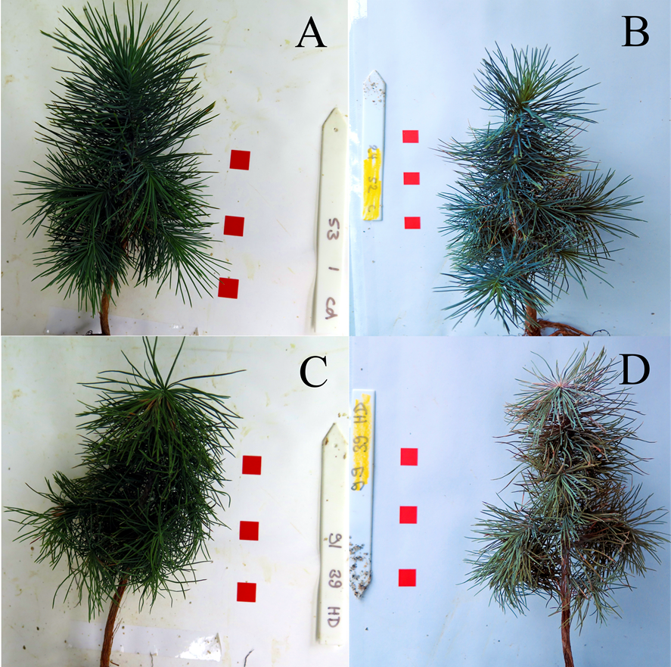

**Figure S1:** Visual verification of living **(A, B)** and dead **(C, D)** seedlings. Pictures where taken during the harvesting periods (pre-stress, stress and recovery). Due to unfavorable light conditions we applied automated white correction and automated color correction.

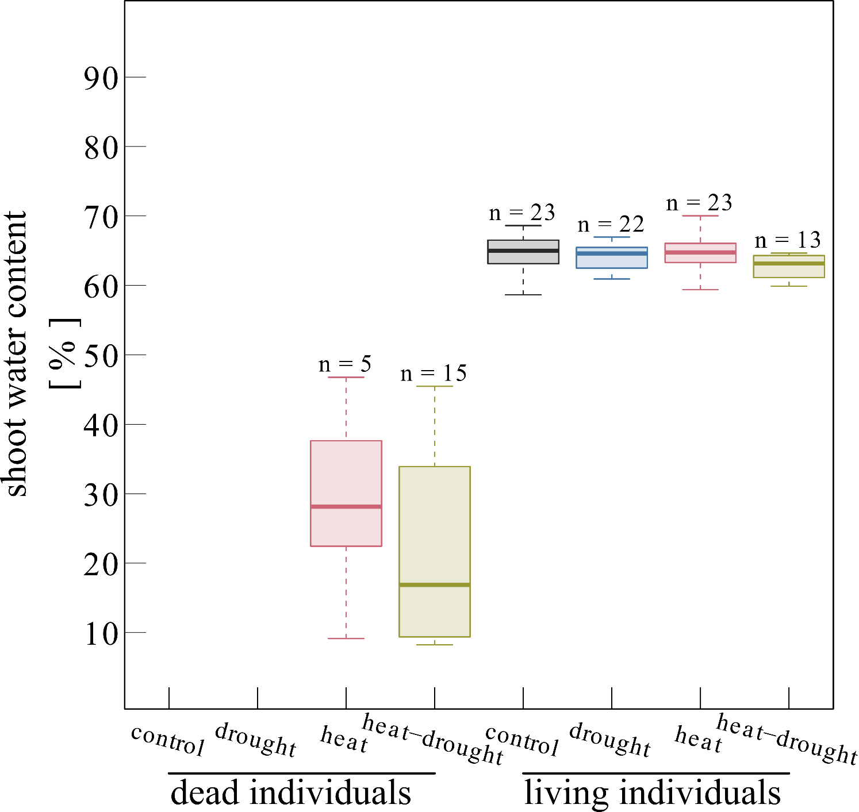

**Figure S2:** Percent of shoot water content depicted per treatment. Water content is given as percentage of fresh weight (FW). Seedlings were considered dead if the shoot water content declined below 55%.

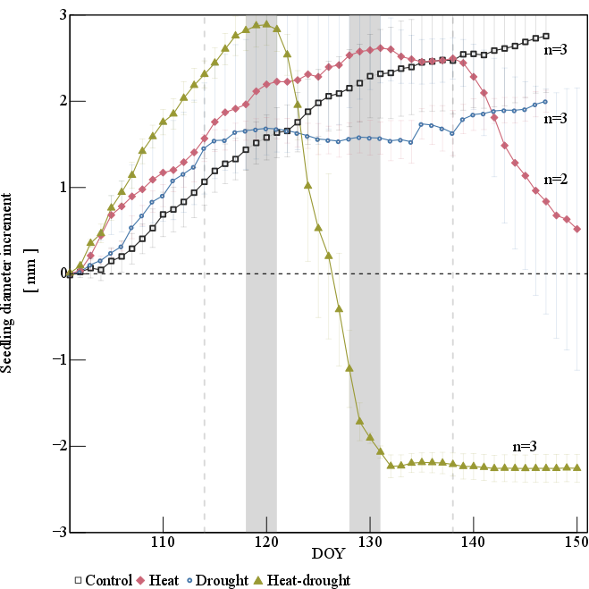

**Figure S3:** Stem diameter increment increase of *Pinus halepensis* seedlings subjected to either control (black hollow squares), drought (blue hollow circles), heat (red squares) or heat-drought (green triangle). The two heat waves are depicted by the grey areas. The drought phase is indicated by grey vertical dotted lines. The error bars are ±1 SE (n=3).

**Figure S4:** Relationships between proline accumulation in µmol gDW-1 and peak area change of Cl-1 signal per gDW. Values are means of harvesting period (pre-stress, stress, recovery) and treatment (control, drought, heat, heat-drought) with ±1SE. Values represent all samples per group without division in living or dead seedlings. We used Cl-1 peak area because we did not quantify this ion with standard rows.