Supplementary Material 3:
Supplementary Figures

Figure S1. Boxplots of diameter at breast height (DBH in cm) (top) and competition index Hegyi (bottom) separately for Beech (grey) and fir (blue) trees. Data refers to measurements in 2016 at four sites (see x-axis). Stars are inserted to indicate differences between the two species separately for each site (Wilcoxon tests, ****<0.0001, ns= not significant).

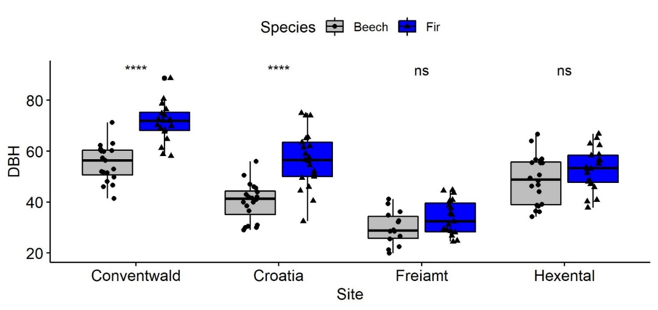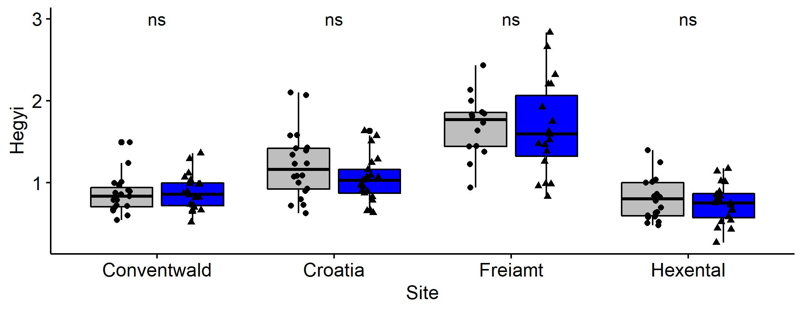

Figure S2. Boxplot of mean complementarity (%) of basal area increments (BAI) of the 2 species beech (grey) and fir (blue) at 4 sites (see x-axis) Data refers to years 2000-2016. Complementarity of BAI reflects the average BAI of trees experiencing interspecific interactions compared to that of trees which are subjected to intraspecific interactions (se eq. 8 for calculation). Stars are inserted to indicate differences between the species for each site (Wilcoxon tests, **= p < 0.01, ****<0.001, ns= not significant).
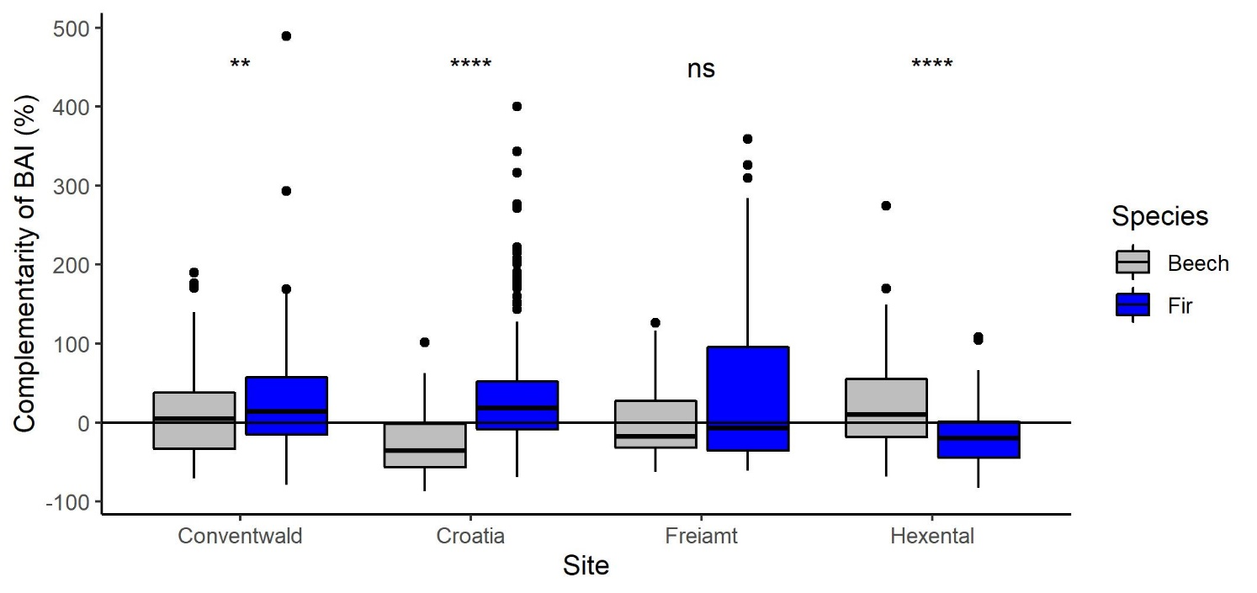

Figure S3. Relationship of DBH and Hegyi for 160 trees of Beech (grey) and fir (blue) of all 4 sites jointly. 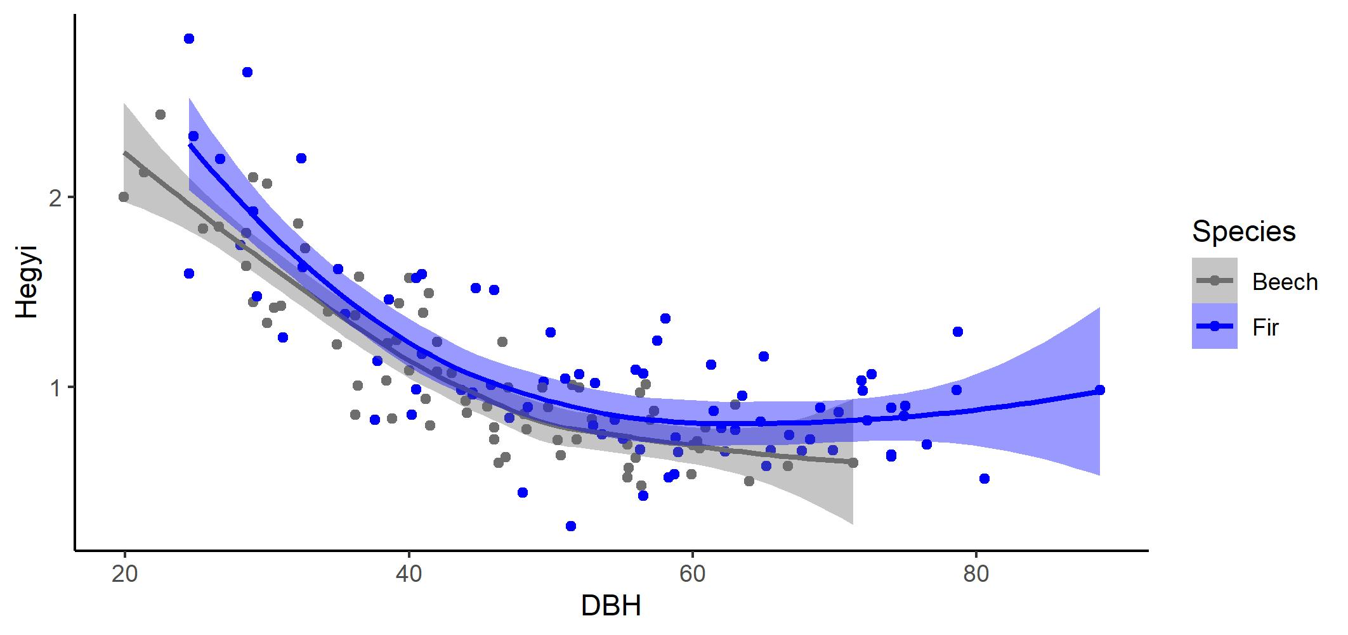

Figure S4 Comparisons of mean (SE) of annual basal area increments (BAI) of Beech (left) and Fir (right) among years differing in climatic conditions (dry, normal and wet years). Data refers to 14-20 trees from four sites (Conventwald, Croatia, Freiamt, Hexental). Classification of years (2000-2016) into wet, normal and dry is based on SPEI values for a 3-months-long period ending in August: <-1= dry, -1 to +1 = normal and >1 = wet. P-values are based on pairwise-comparisons with Wilcoxon test separately for each species.
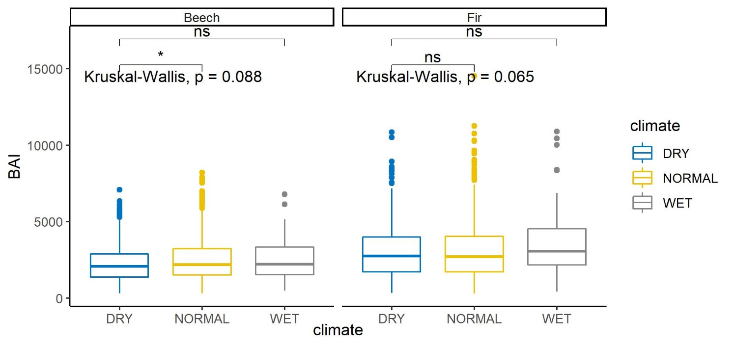
Figure S5 Boxplots of mean basal area increments (BAI) of the 2 species beech (grey) and fir (blue) fir in dry, normal and wet years. Data refers to 14-20 trees from four sites (Conventwald, Croatia, Freiamt, Hexenta). Classification of years (2000-2016) into wet, normal and dry is based on SPEI values for a 3-months-long period ending in August: <-1= dry, -1 to +1 = normal and >1 = wet. Stars are inserted to indicate differences between the species for each climatic condition separately (Wilcoxon tests, ****<0.001.
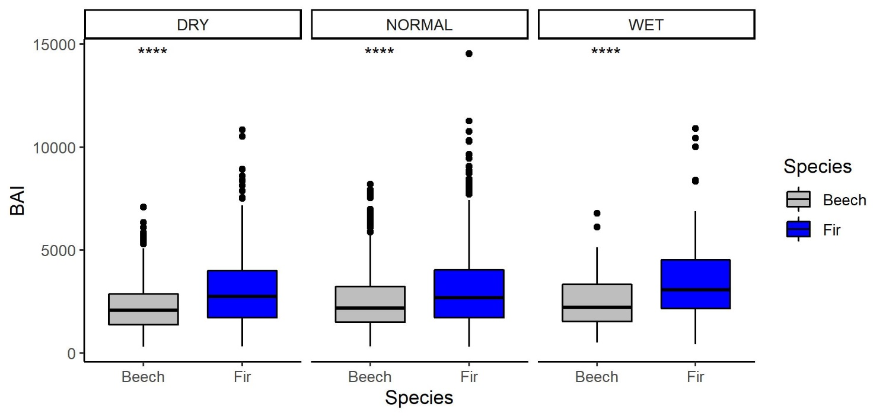
Figure S6 Comparison of growth response to drought between Beech (grey) and fir (blue) trees growing at 4 sites (see x-axis). Growth resistance during drought (a, b), growth recovery following drought (c, d) and growth resilience to drought (e, f) according to eq. a-c in main text. Stars are inserted to indicate differences between the species for each site and index separately (t-tests for resistance and resilience and Wilcoxon test for recovery, **= p < 0.01, ns= not significant). 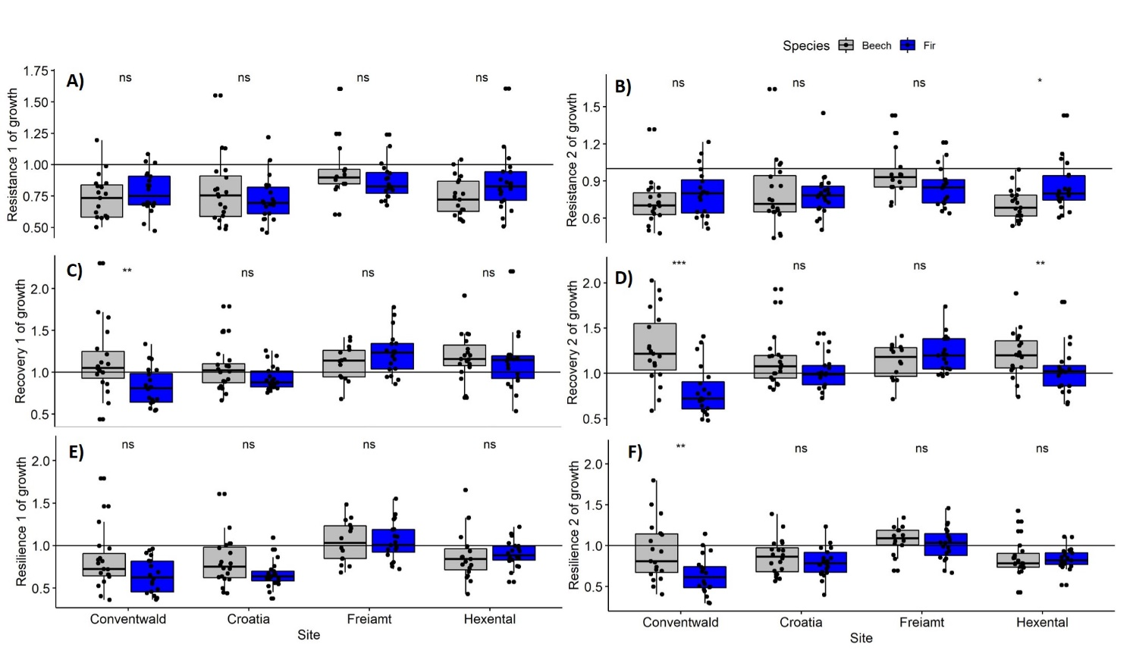
Figure S7 Boxplots of carbon isotope discrimination δ¹³C in wood in years 2002, 2003 and 2004 separately for Beech (left) and fir (right). Data refers to 14-20 trees from four sites (Conventwald, Croatia, Freiamt, Hexental). Stars are inserted to indicate significant differences between 2 successive years: **P<0.01, ****P<0.0001 using t-tests.
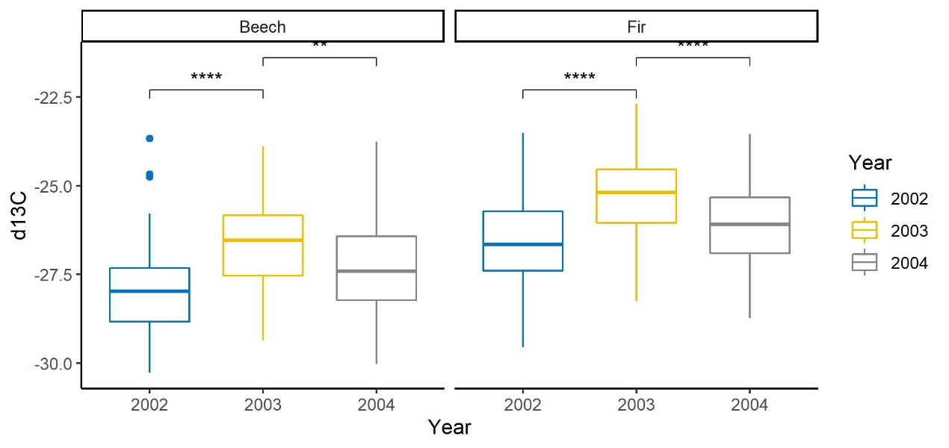
Figure S8 Boxplots of carbon isotope discrimination in wood for years 2002, 2003 and 2004 separately for the two species (Beech (grey) and fir (blue)) and for the 4 sites (Conventwald, Croatia, Freiamt, Hexental). Stars are inserted to indicate significant differences between species for a given year and site. *P<0.05, **P<0.01 ***P<0.001 ****P<0.0001 based on t-tests. 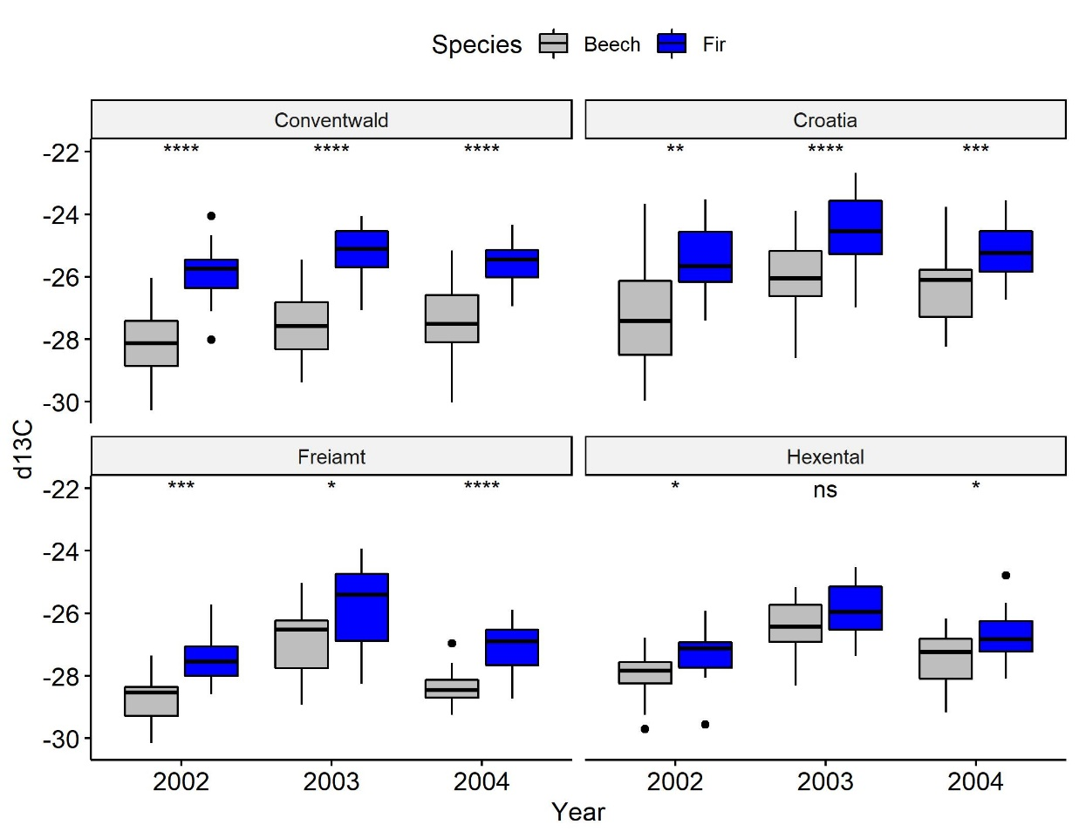
Fig. S9. Comparison of isotopic response to drought between Beech and fir trees growing at 4 sites (Conventwald, Croatia, Freiamt, and Hexental). Resistance during drought (top), recovery following drought (middle) and resilience to drought (bottom) according to eq. 4a-c in main text; ns indicates no differences between the species for each site and index (t-tests). 