Supplementary Material 4: DROUGHT YEAR ANALYSIS
Julia Schwarz

load libraries
rm(list=ls(all=TRUE))
set.seed(1234)
library(lme4)
library(lmerTest)
library(effects)
library(tidyr)
library(sciplot)
library(RColorBrewer)
library(psych)
library(MuMIn)
library(dplyr)
library(stringr)
library(ggplot2)
library(qpcR)
library(effects)
library(nlme)
library(geoR)
library(AICcmodavg)
library(piecewiseSEM)
library(emmeans)
library(inlabru)
library(gridExtra)
library(ggsci)
library(car)
library(MASS)
library(rcompanion)
library(flexsurv)
library(ggpubr)

DROUGHT YEAR ANALYSIS to anaylse the effect of mixing on drought tolerance of beech and fir trees using the following response variables regarding the growth and isotopic variation throughout the drought period. For tree growth, we calculated three drought response variables by dividing the observed growth into resistance of radial growth to drought (RES), its recovery from drought (REC) and the resilience to drought (RESIL) as suggested by (Lloret et al. 2011)

Response variables
rm(list=ls(all=TRUE))
data <- read.delim ("../Data/new2003.txt")
str(data)
## 'data.frame': 152 obs. of 26 variables:
## $ Tree : Factor w/ 152 levels "CoBu01","CoBu02",..: 1 2 3 4 5 6 7 8 9 10 ...
## $ Site : Factor w/ 4 levels "Conventwald",..: 1 1 1 1 1 1 1 1 1 1 ...
## $ Species : Factor w/ 2 levels "Beech","Fir": 1 1 1 1 1 1 1 1 1 1 ...
## $ Year : int 2003 2003 2003 2003 2003 2003 2003 2003 2003 2003 ...
## $ DBH : num 68.9 56.5 59.7 49.7 57.6 ...
## $ nbor_density : Factor w/ 2 levels "high","low": 2 2 2 2 2 2 1 2 2 2 ...
## $ prop_largertrees: num 50 75 33.3 75 50 ...
## $ Proplargertrees : Factor w/ 2 levels "higher","lower": 2 1 2 1 2 2 2 2 1 1 ...
## $ mixing_cat : Factor w/ 2 levels "1_monospecific",..: 2 2 1 2 2 1 1 1 2 2 ...
## $ BAI : num 2184 2226 1688 1183 2527 ...
## $ RingWidth : num 1.07 1.347 0.963 0.822 1.498 ...
## $ RES1 : num 0.768 0.5 0.987 1.194 0.924 ...
## $ REC1 : num 0.859 1.051 1.481 1.071 0.438 ...
## $ RESIL1 : num 0.659 0.526 1.462 1.279 0.405 ...
## $ relResil : num -0.1084 0.0253 0.4749 0.085 -0.5188 ...
## $ d13C2002 : num -26 -28.3 -27.1 -27.2 -28.6 ...
## $ d13C2003 : num -26.2 -26.9 -27.5 -25.7 -27.8 ...
## $ d13C2004 : num -25.2 -29 -28 -26.4 -27.3 ...
## $ d13C2002std : num 6.03 8.32 7.07 7.22 8.57 ...
## $ d13C2003std : num 6.21 6.88 7.46 5.67 7.82 ...
## $ d13C2004std : num 5.16 8.99 7.98 6.42 7.32 ...
## $ RES13C : num 1.029 0.827 1.054 0.786 0.912 ...
## $ REC13C : num 0.831 1.306 1.071 1.132 0.936 ...
## $ RESIL13C : num 0.855 1.08 1.128 0.89 0.854 ...
## $ predrBAI : num 2560 3831 2317 933 2749 ...
## $ martonne_vegper : num 2.55 2.55 2.55 2.55 2.55 ...
summary(data)
## Tree Site Species Year DBH
## CoBu01 : 1 Conventwald:39 Beech:72 Min. :2003 Min. :14.14
## CoBu02 : 1 Croatia :41 Fir :80 1st Qu.:2003 1st Qu.:31.43
## CoBu03 : 1 Freiamt :33 Median :2003 Median :44.37
## CoBu04 : 1 Hexental :39 Mean :2003 Mean :43.98
## CoBu05 : 1 3rd Qu.:2003 3rd Qu.:55.54
## CoBu06 : 1 Max. :2003 Max. :84.73
## (Other):146
## nbor_density prop_largertrees Proplargertrees mixing_cat
## high:58 Min. : 0.00 higher: 35 1_monospecific:61
## low :94 1st Qu.: 14.29 lower :117 2_mixed :91
## Median : 33.33
## Mean : 34.76
## 3rd Qu.: 50.00
## Max. :100.00
##
## BAI RingWidth RES1 REC1
## Min. : 427.4 Min. :0.2485 Min. :0.4570 Min. :0.4384
## 1st Qu.:1324.2 1st Qu.:1.3515 1st Qu.:0.6629 1st Qu.:0.8591
## Median :2198.4 Median :1.7973 Median :0.7885 Median :1.0433
## Mean :2462.3 Mean :2.0176 Mean :0.7993 Mean :1.0683
## 3rd Qu.:3277.8 3rd Qu.:2.4813 3rd Qu.:0.9058 3rd Qu.:1.2077
## Max. :7081.4 Max. :6.0205 Max. :1.6041 Max. :2.3037
##
## RESIL1 relResil d13C2002 d13C2003
## Min. :0.3609 Min. :-0.74241 Min. :-30.27 Min. :-29.37
## 1st Qu.:0.6408 1st Qu.:-0.10998 1st Qu.:-28.10 1st Qu.:-26.85
## Median :0.8136 Median : 0.03463 Median :-27.35 Median :-25.95
## Mean :0.8415 Mean : 0.04219 Mean :-27.19 Mean :-25.99
## 3rd Qu.:0.9854 3rd Qu.: 0.14609 3rd Qu.:-26.16 3rd Qu.:-25.11
## Max. :1.7899 Max. : 1.01292 Max. :-23.51 Max. :-22.68
## NA's :3 NA's :3
## d13C2004 d13C2002std d13C2003std d13C2004std
## Min. :-30.03 Min. :-10.275 Min. :-9.368 Min. :-10.027
## 1st Qu.:-27.71 1st Qu.: -8.013 1st Qu.:-6.653 1st Qu.: -7.650
## Median :-26.73 Median : -7.241 Median :-5.714 Median : -6.590
## Mean :-26.72 Mean : -6.458 Mean :-5.329 Mean : -6.061
## 3rd Qu.:-25.80 3rd Qu.: -5.930 3rd Qu.:-4.976 3rd Qu.: -5.692
## Max. :-23.54 Max. : 9.118 Max. : 8.475 Max. : 8.987
## NA's :4 NA's :3 NA's :3 NA's :4
## RES13C REC13C RESIL13C predrBAI
## Min. :0.5027 Min. :0.6496 Min. :0.7046 Min. : 515.8
## 1st Qu.:0.7161 1st Qu.:0.9999 1st Qu.:0.8436 1st Qu.: 1651.4
## Median :0.8238 Median :1.1323 Median :0.9382 Median : 2863.4
## Mean :0.8458 Mean :1.1424 Mean :0.9452 Mean : 3135.9
## 3rd Qu.:0.9423 3rd Qu.:1.2741 3rd Qu.:1.0103 3rd Qu.: 4142.0
## Max. :1.6477 Max. :1.8580 Max. :1.6521 Max. :10995.1
## NA's :3 NA's :4 NA's :4
## martonne_vegper
## Min. :1.866
## 1st Qu.:1.866
## Median :2.552
## Mean :2.391
## 3rd Qu.:2.602
## Max. :2.602
##
resp= c(which(names(data)=="RES1"), which(names(data)=="REC1"), which(names(data)=="RESIL1") ,which(names(data)=="RES13C"), which(names(data)=="REC13C"), which(names(data)=="RESIL13C"))
oldpar <- par(mfrow = c(4,3))
for (i in resp){
hist((data[,i]), main = colnames(data)[i], breaks = 30)
}
par(oldpar)
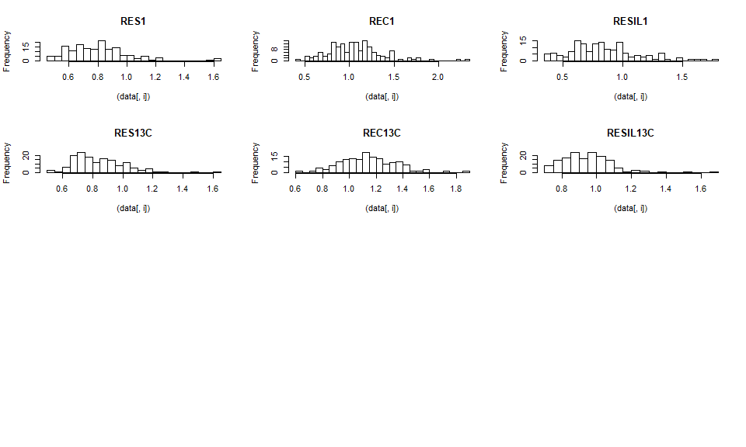
attach(data)
hist(log(RES1), breaks = 40)
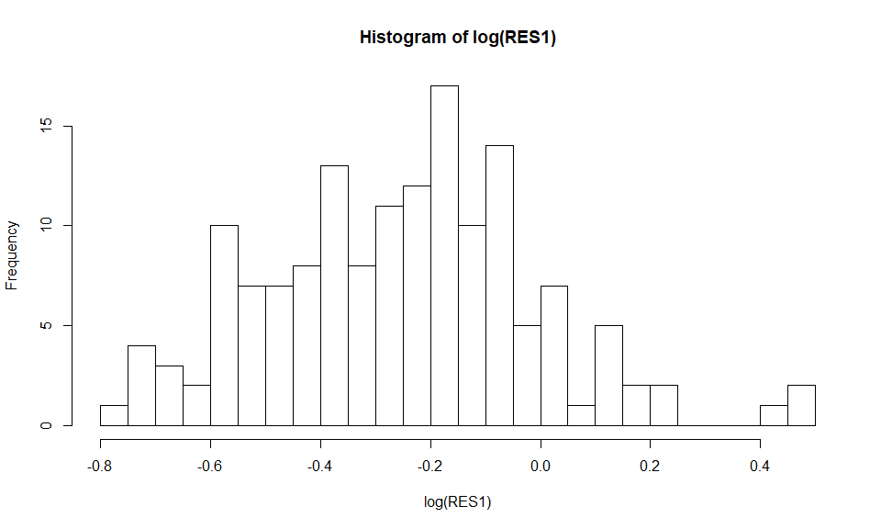
shapiro.test(log(RES1))
##
## Shapiro-Wilk normality test
##
## data: log(RES1)
## W = 0.98593, p-value = 0.1264
qqnorm(log(RES1))# ok
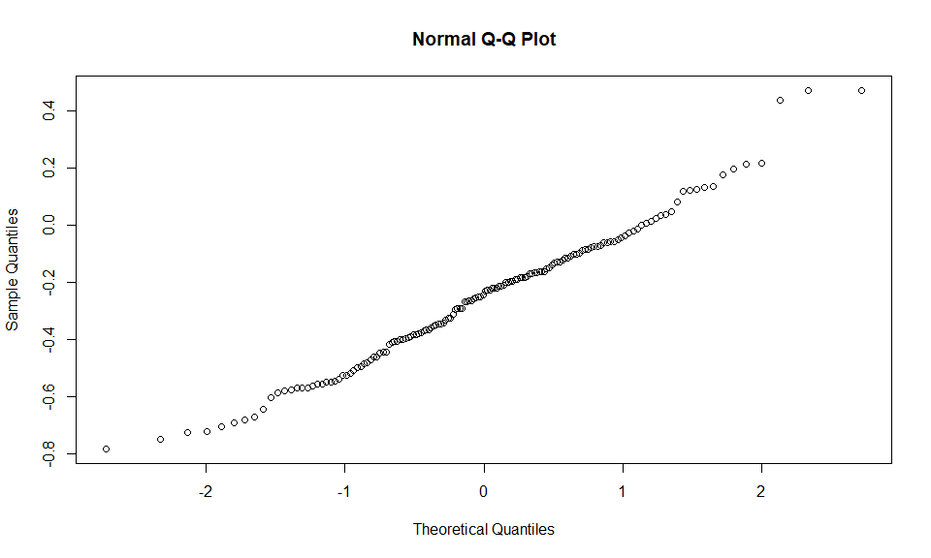
hist(log(REC1), breaks = 40)
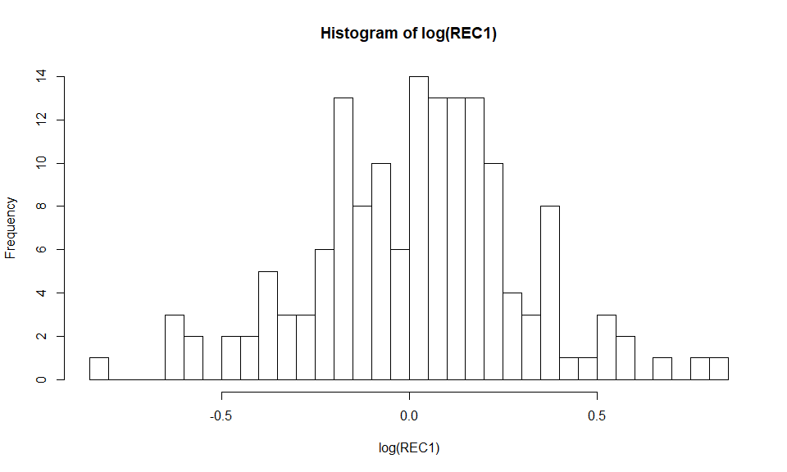
shapiro.test(log(REC1)) #ok
##
## Shapiro-Wilk normality test
##
## data: log(REC1)
## W = 0.99079, p-value = 0.4274
qqnorm(log(REC1))
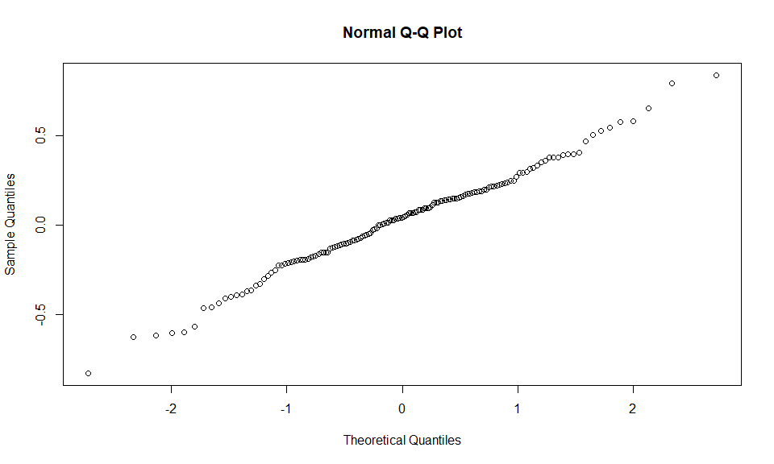
hist(log(RESIL1), breaks = 40)
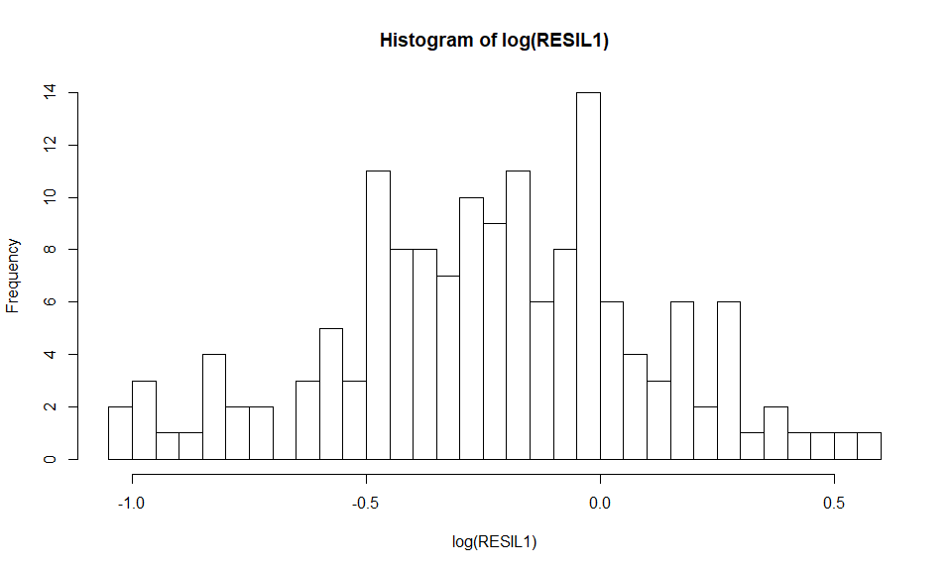
shapiro.test(log(RESIL1))# ok
##
## Shapiro-Wilk normality test
##
## data: log(RESIL1)
## W = 0.98987, p-value = 0.3454
qqnorm(log(RESIL1))
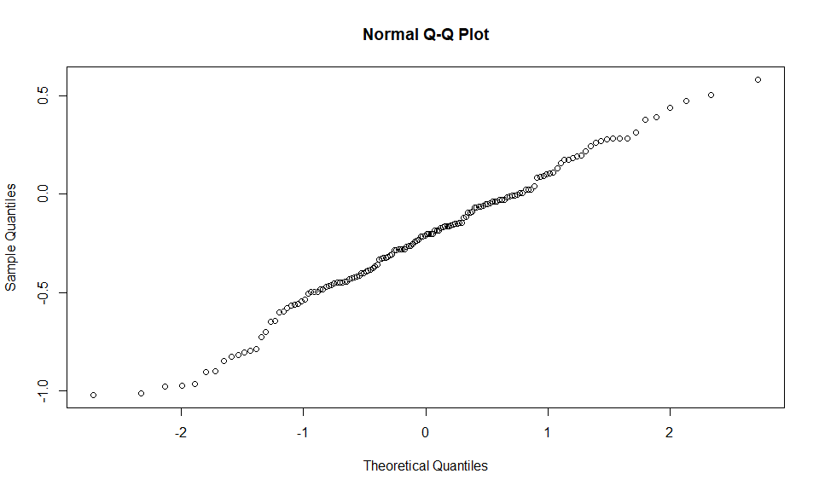
hist(RES13C, breaks=40)
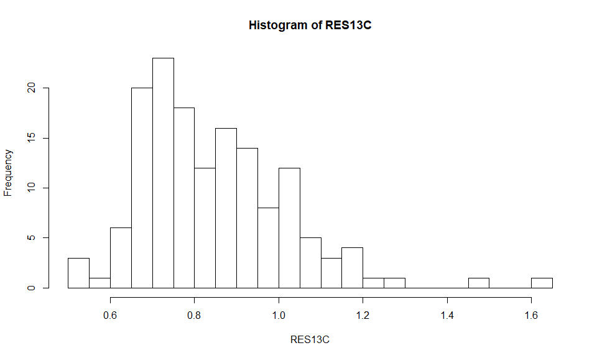
shapiro.test(log(RES13C))# ok
##
## Shapiro-Wilk normality test
##
## data: log(RES13C)
## W = 0.98318, p-value = 0.06569
qqnorm(log(RES13C))
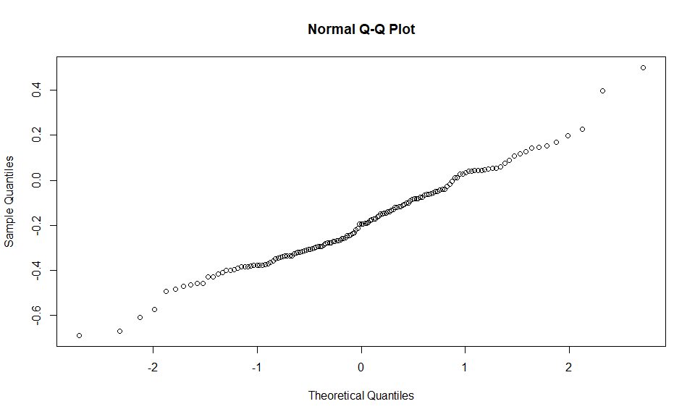
hist(REC13C, breaks=40)
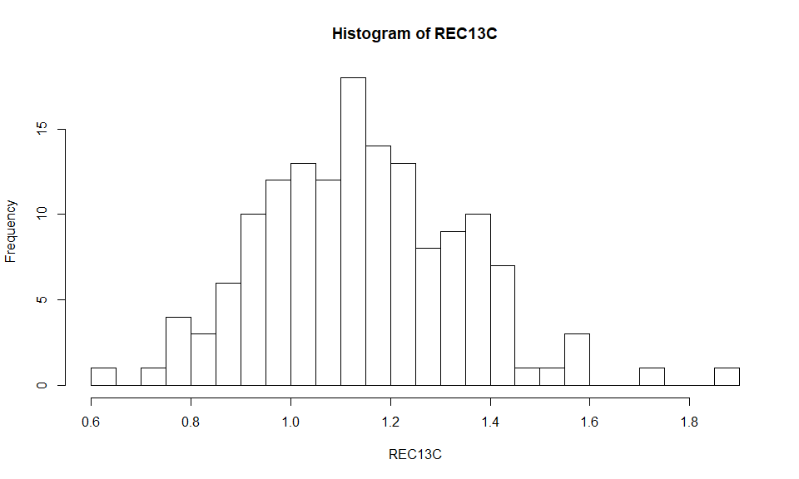
shapiro.test(REC13C)# ok
##
## Shapiro-Wilk normality test
##
## data: REC13C
## W = 0.9881, p-value = 0.2384
qqnorm(REC13C)
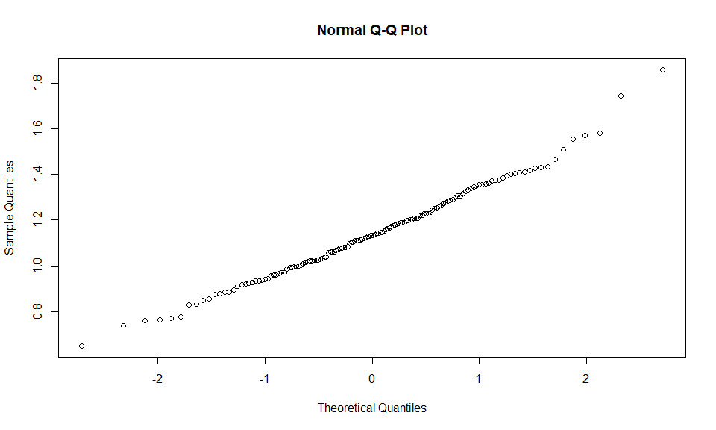
hist(RESIL13C, breaks=40)
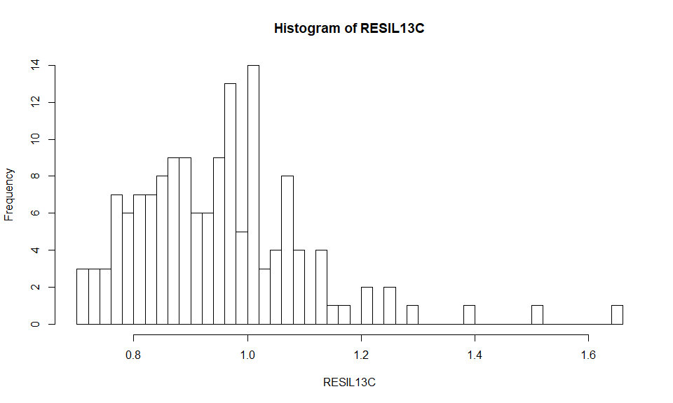
shapiro.test(log(RESIL13C))
##
## Shapiro-Wilk normality test
##
## data: log(RESIL13C)
## W = 0.9688, p-value = 0.001898
qqnorm(log(RESIL13C))
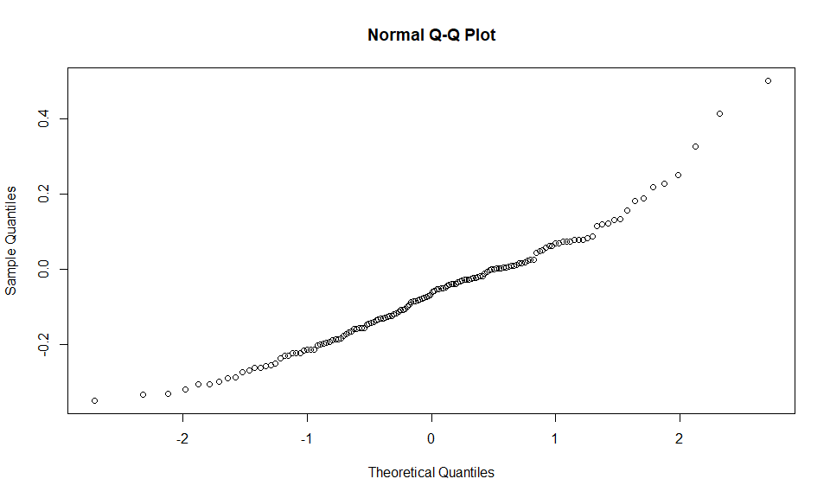 #Collinearity analysis: VIF : https://hlplab.wordpress.com/2011/02/24/diagnosing-collinearity-in-lme4/
vif.mer <- function (fit) {
## adapted from rms::vif
v <- vcov(fit)
nam <- names(fixef(fit))
## exclude intercepts
ns <- sum(1 * (nam == "Intercept" | nam == "(Intercept)"))
if (ns > 0) {
v <- v[-(1:ns), -(1:ns), drop = FALSE]
nam <- nam[-(1:ns)]
}
d <- diag(v)^0.5
v <- diag(solve(v/(d %o% d)))
names(v) <- nam
v
}
##pre-correlation analysis for the predictors

correlation matrix among responses:
pairs((data[resp]), lower.panel = panel.smooth, diag.panel = panel.hist, upper.panel = panel.cor)
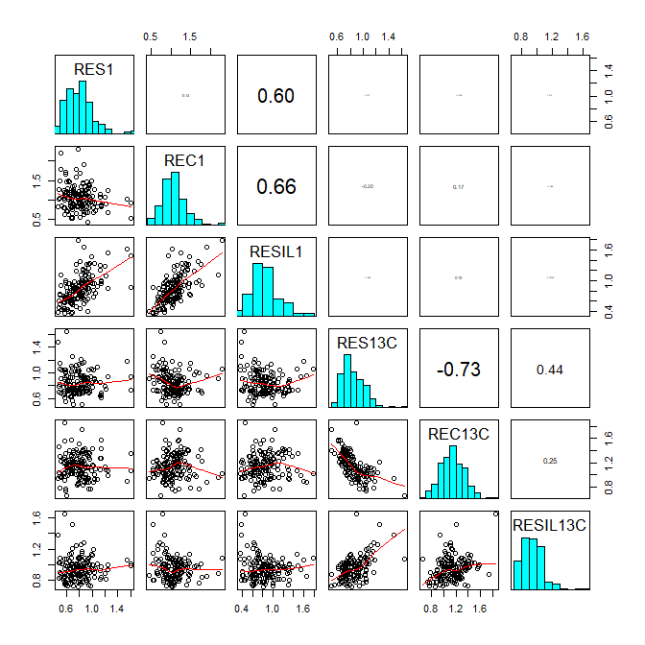 # Predictors ## Fixed effects and responses
finalPred = resp= c(which(names(data)=="DBH"),
which(names(data)=="mixing_cat"),
which(names(data)=="Species"))
pairs(data[,finalPred], lower.panel = panel.smooth, diag.panel = panel.hist, upper.panel = panel.cor)
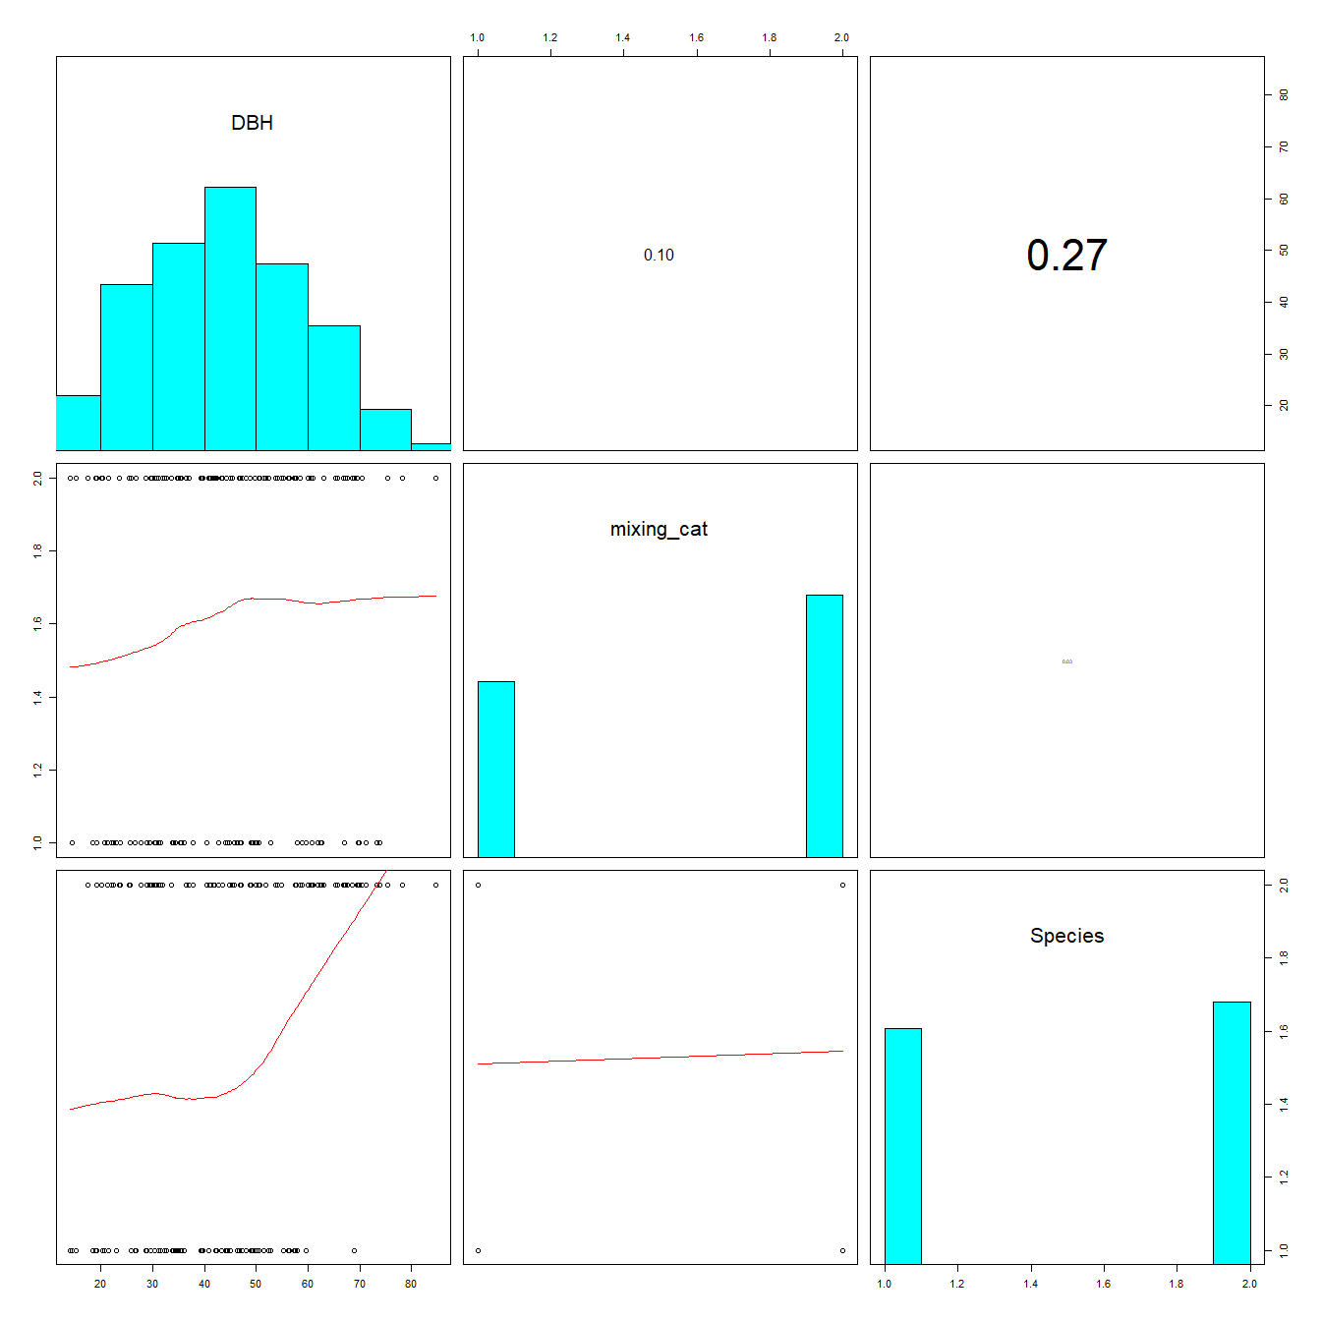 ## LMMs with only mixing category, DBH and Species plus their interactions as fixed effects. ###Random effect structure selection: For comparing random structures via AIC keep fixed effects constant and use REML!!! ### AIC is a good option to use, see also Zuur et al. 2009, We should use full model with as many interactions as possible.
lme_r1 <- lme(log(RES1) ~ mixing_cat + scale(DBH) + Species + mixing_cat*Species + mixing_cat*scale(DBH) ,random= ~1|Site , data=data)
lme_r2 <- lme(log(RES1) ~ mixing_cat + scale(DBH) + Species + mixing_cat*Species + mixing_cat*scale(DBH) ,random= ~1|Species , data=data)
lme_r3 <- lme(log(RES1) ~ mixing_cat + scale(DBH) + Species + mixing_cat*Species + mixing_cat*scale(DBH) ,random= ~1|Species/Site , data=data)
aictab(mget(str_subset(ls(), "lme_r")))# sites!!!
## Warning in aictab.AIClme(mget(str_subset(ls(), "lme_r"))):
## Model selection for fixed effects is only appropriate with method=ML:
## REML (default) should only be used to select random effects for a constant set of fixed effects
##
## Model selection based on AICc:
##
## K AICc Delta_AICc AICcWt Cum.Wt Res.LL
## lme_r1 8 38.85 0.00 0.63 0.63 -10.92
## lme_r2 8 41.08 2.23 0.21 0.83 -12.04
## lme_r3 9 41.48 2.63 0.17 1.00 -11.11
summary(lme_r1)
## Linear mixed-effects model fit by REML
## Data: data
## AIC BIC logLik
## 37.84507 61.71392 -10.92253
##
## Random effects:
## Formula: ~1 | Site
## (Intercept) Residual
## StdDev: 0.06908895 0.2382267
##
## Fixed effects: log(RES1) ~ mixing_cat + scale(DBH) + Species + mixing_cat * Species + mixing_cat * scale(DBH)
## Value Std.Error DF t-value p-value
## (Intercept) -0.22601661 0.05804351 143 -3.893917 0.0002
## mixing_cat2_mixed -0.06673792 0.05902298 143 -1.130711 0.2601
## scale(DBH) -0.01428630 0.04008886 143 -0.356366 0.7221
## SpeciesFir -0.04477553 0.06588241 143 -0.679628 0.4978
## mixing_cat2_mixed:SpeciesFir 0.12150678 0.08274518 143 1.468445 0.1442
## mixing_cat2_mixed:scale(DBH) -0.00994692 0.04193521 143 -0.237197 0.8128
## Correlation:
## (Intr) mxn_2_ s(DBH) SpcsFr m_2_:S
## mixing_cat2_mixed -0.610
## scale(DBH) 0.290 -0.190
## SpeciesFir -0.604 0.557 -0.376
## mixing_cat2_mixed:SpeciesFir 0.454 -0.739 0.197 -0.757
## mixing_cat2_mixed:scale(DBH) -0.203 0.244 -0.679 0.256 -0.297
##
## Standardized Within-Group Residuals:
## Min Q1 Med Q3 Max
## -2.09470193 -0.67020656 -0.09944568 0.53929517 3.19561973
##
## Number of Observations: 152
## Number of Groups: 4
# model check:
plot(lme_r1) #looks good
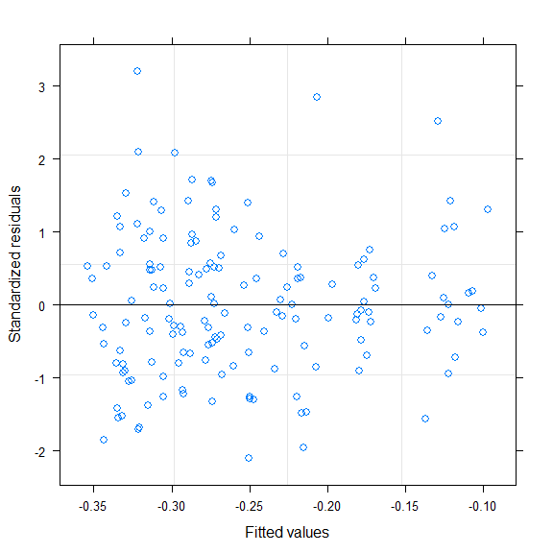
qqnorm(resid(lme_r1))
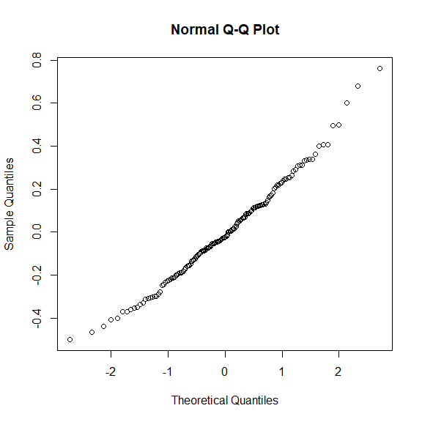
##checking predictor
plot(data$DBH,resid(lme_r1,type="pearson")) # looks a bit tredny...do we need to adjust variance structure?
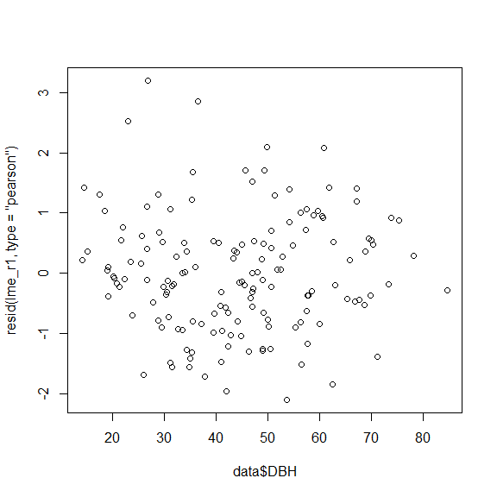
lme_v1 <- lme_r1
lme_v2 <- lme(log(RES1) ~ mixing_cat + scale(DBH) + Species + mixing_cat*Species + mixing_cat*scale(DBH)
,random= ~1|Site
,weights = varPower( form = ~ DBH)
,data=data)
plot(lme_v2)
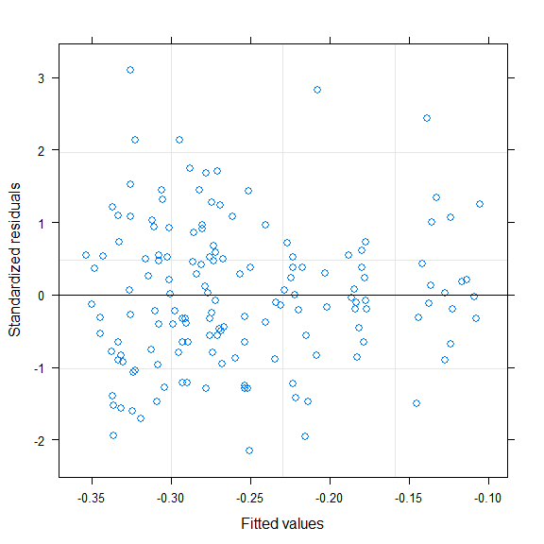
lme_v3 <- lme(log(RES1) ~ mixing_cat + scale(DBH) + Species + mixing_cat*Species + mixing_cat*scale(DBH)
,random= ~1|Site
,weights = varExp( form = ~ DBH)
,data=data)
plot(lme_v3)
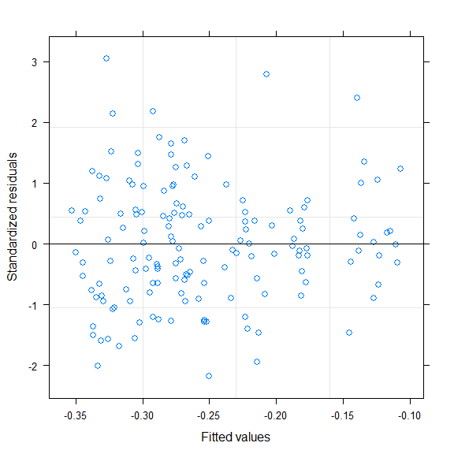
aictab(mget(str_subset(ls(), "lme_v")))# aictab: no adjustement of varaince structure needed
## Warning in aictab.AIClme(mget(str_subset(ls(), "lme_v"))):
## Model selection for fixed effects is only appropriate with method=ML:
## REML (default) should only be used to select random effects for a constant set of fixed effects
##
## Model selection based on AICc:
##
## K AICc Delta_AICc AICcWt Cum.Wt Res.LL
## lme_v1 8 38.85 0.00 0.55 0.55 -10.92
## lme_v3 9 40.50 1.65 0.24 0.80 -10.62
## lme_v2 9 40.87 2.02 0.20 1.00 -10.80
summary(lme_v1)# same as lme_r1
## Linear mixed-effects model fit by REML
## Data: data
## AIC BIC logLik
## 37.84507 61.71392 -10.92253
##
## Random effects:
## Formula: ~1 | Site
## (Intercept) Residual
## StdDev: 0.06908895 0.2382267
##
## Fixed effects: log(RES1) ~ mixing_cat + scale(DBH) + Species + mixing_cat * Species + mixing_cat * scale(DBH)
## Value Std.Error DF t-value p-value
## (Intercept) -0.22601661 0.05804351 143 -3.893917 0.0002
## mixing_cat2_mixed -0.06673792 0.05902298 143 -1.130711 0.2601
## scale(DBH) -0.01428630 0.04008886 143 -0.356366 0.7221
## SpeciesFir -0.04477553 0.06588241 143 -0.679628 0.4978
## mixing_cat2_mixed:SpeciesFir 0.12150678 0.08274518 143 1.468445 0.1442
## mixing_cat2_mixed:scale(DBH) -0.00994692 0.04193521 143 -0.237197 0.8128
## Correlation:
## (Intr) mxn_2_ s(DBH) SpcsFr m_2_:S
## mixing_cat2_mixed -0.610
## scale(DBH) 0.290 -0.190
## SpeciesFir -0.604 0.557 -0.376
## mixing_cat2_mixed:SpeciesFir 0.454 -0.739 0.197 -0.757
## mixing_cat2_mixed:scale(DBH) -0.203 0.244 -0.679 0.256 -0.297
##
## Standardized Within-Group Residuals:
## Min Q1 Med Q3 Max
## -2.09470193 -0.67020656 -0.09944568 0.53929517 3.19561973
##
## Number of Observations: 152
## Number of Groups: 4
plot(lme_v1)
# was the same for all other indices so no need to change random strucure, so we go directly to final models with REML
#growth resistance
lme_res1<- lme(log(RES1) ~ mixing_cat + scale(DBH) + Species + mixing_cat*Species + mixing_cat*scale(DBH) ,random= ~1|Site , method="REML" ,data=data)
fit <- lme_res1
summary(fit)
## Linear mixed-effects model fit by REML
## Data: data
## AIC BIC logLik
## 37.84507 61.71392 -10.92253
##
## Random effects:
## Formula: ~1 | Site
## (Intercept) Residual
## StdDev: 0.06908895 0.2382267
##
## Fixed effects: log(RES1) ~ mixing_cat + scale(DBH) + Species + mixing_cat * Species + mixing_cat * scale(DBH)
## Value Std.Error DF t-value p-value
## (Intercept) -0.22601661 0.05804351 143 -3.893917 0.0002
## mixing_cat2_mixed -0.06673792 0.05902298 143 -1.130711 0.2601
## scale(DBH) -0.01428630 0.04008886 143 -0.356366 0.7221
## SpeciesFir -0.04477553 0.06588241 143 -0.679628 0.4978
## mixing_cat2_mixed:SpeciesFir 0.12150678 0.08274518 143 1.468445 0.1442
## mixing_cat2_mixed:scale(DBH) -0.00994692 0.04193521 143 -0.237197 0.8128
## Correlation:
## (Intr) mxn_2_ s(DBH) SpcsFr m_2_:S
## mixing_cat2_mixed -0.610
## scale(DBH) 0.290 -0.190
## SpeciesFir -0.604 0.557 -0.376
## mixing_cat2_mixed:SpeciesFir 0.454 -0.739 0.197 -0.757
## mixing_cat2_mixed:scale(DBH) -0.203 0.244 -0.679 0.256 -0.297
##
## Standardized Within-Group Residuals:
## Min Q1 Med Q3 Max
## -2.09470193 -0.67020656 -0.09944568 0.53929517 3.19561973
##
## Number of Observations: 152
## Number of Groups: 4
r.squaredGLMM(fit)
## Warning: 'r.squaredGLMM' now calculates a revised statistic. See the help
## page.
## R2m R2c
## [1,] 0.02063386 0.09661552
plot(allEffects(fit, partial.residuals=T))
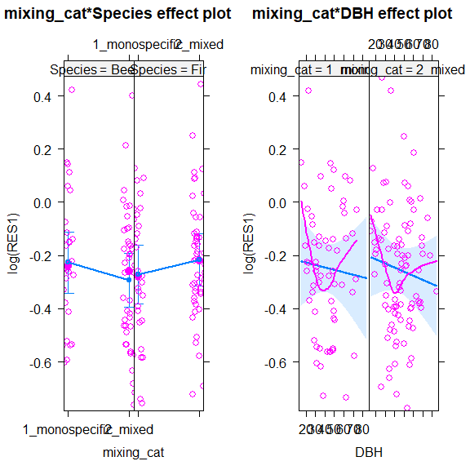
# normally distributed?
qqnorm(resid(fit))
#Checking residuals
plot(fit, resid(., scaled=TRUE) ~ fitted(.) , abline = 0)
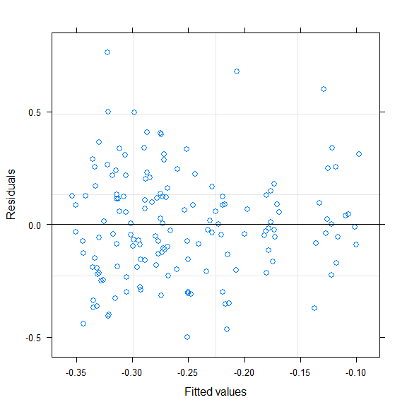
plot(fit, resid(., scaled=TRUE) ~ DBH , abline = 0)
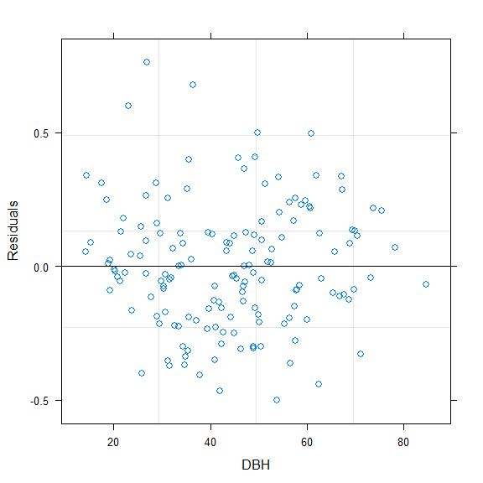
#growth recovery
lme_rec <- lme(log(REC1) ~ mixing_cat + Species + scale(DBH) + mixing_cat*Species + mixing_cat*scale(DBH), random= ~1|Site ,method="REML", data=data)
summary(lme_rec)
## Linear mixed-effects model fit by REML
## Data: data
## AIC BIC logLik
## 44.58783 68.45668 -14.29391
##
## Random effects:
## Formula: ~1 | Site
## (Intercept) Residual
## StdDev: 0.05258697 0.2446966
##
## Fixed effects: log(REC1) ~ mixing_cat + Species + scale(DBH) + mixing_cat * Species + mixing_cat * scale(DBH)
## Value Std.Error DF t-value p-value
## (Intercept) -0.00411834 0.05439800 143 -0.0757075 0.9398
## mixing_cat2_mixed 0.10113936 0.06060763 143 1.6687562 0.0974
## SpeciesFir 0.06147968 0.06713684 143 0.9157369 0.3613
## scale(DBH) -0.03000968 0.03890261 143 -0.7714054 0.4417
## mixing_cat2_mixed:SpeciesFir -0.17079989 0.08497547 143 -2.0099904 0.0463
## mixing_cat2_mixed:scale(DBH) -0.12123086 0.04298522 143 -2.8202915 0.0055
## Correlation:
## (Intr) mxn_2_ SpcsFr s(DBH) m_2_:S
## mixing_cat2_mixed -0.669
## SpeciesFir -0.655 0.562
## scale(DBH) 0.302 -0.202 -0.358
## mixing_cat2_mixed:SpeciesFir 0.497 -0.739 -0.763 0.207
## mixing_cat2_mixed:scale(DBH) -0.218 0.244 0.251 -0.701 -0.297
##
## Standardized Within-Group Residuals:
## Min Q1 Med Q3 Max
## -3.18655792 -0.54213315 0.01088867 0.48024226 3.03363728
##
## Number of Observations: 152
## Number of Groups: 4
r.squaredGLMM(lme_rec)
## R2m R2c
## [1,] 0.2281634 0.2622369
plot(allEffects(lme_rec, partial.residuals=T))
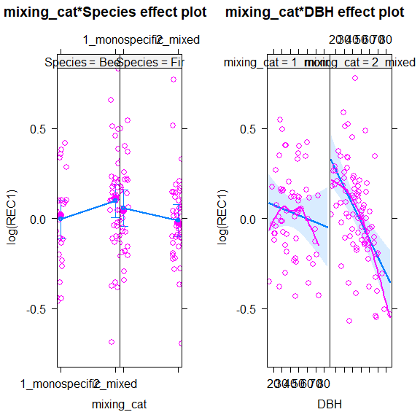
# model check:
fit<- lme_rec
# normally dsitributed
qqnorm(resid(fit))
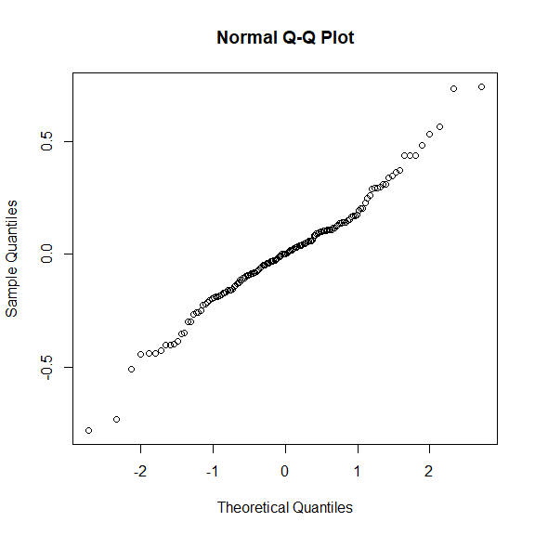
#Checking residuals
plot(fit, resid(., scaled=TRUE) ~ fitted(.) , abline = 0)
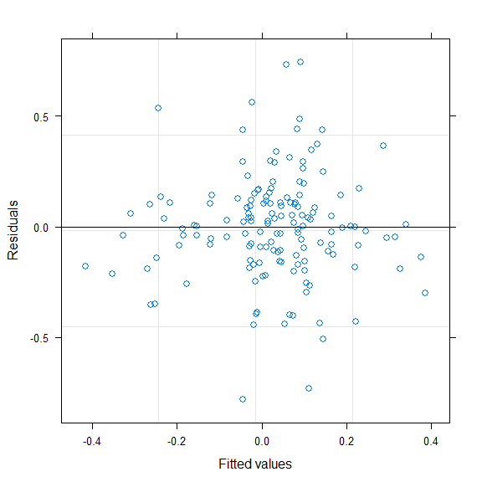
plot(fit, resid(., scaled=TRUE) ~ DBH , abline = 0)
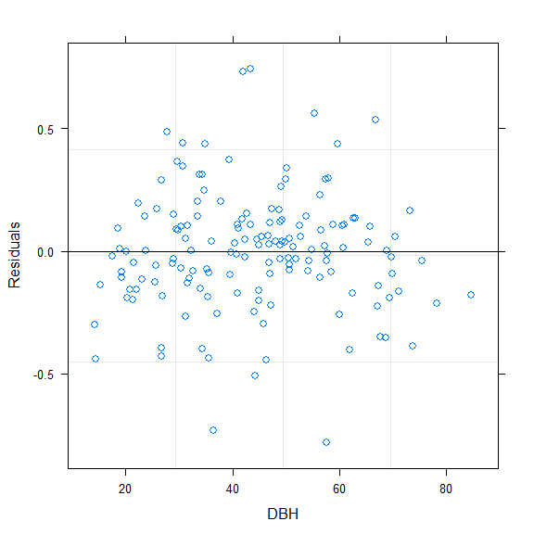
# Growth resilience
lme_resil1 <- lme(log(RESIL1) ~ mixing_cat + Species + scale(DBH) + mixing_cat*Species + mixing_cat*scale(DBH), random= ~1|Site ,method="REML", data=data)
summary(lme_resil1)
## Linear mixed-effects model fit by REML
## Data: data
## AIC BIC logLik
## 90.51609 114.3849 -37.25805
##
## Random effects:
## Formula: ~1 | Site
## (Intercept) Residual
## StdDev: 0.1155198 0.2838736
##
## Fixed effects: log(RESIL1) ~ mixing_cat + Species + scale(DBH) + mixing_cat * Species + mixing_cat * scale(DBH)
## Value Std.Error DF t-value p-value
## (Intercept) -0.22603883 0.08043005 143 -2.8103777 0.0056
## mixing_cat2_mixed 0.03744808 0.07034966 143 0.5323136 0.5953
## SpeciesFir 0.00936700 0.07922250 143 0.1182366 0.9060
## scale(DBH) -0.03177317 0.05067949 143 -0.6269433 0.5317
## mixing_cat2_mixed:SpeciesFir -0.05175838 0.09861609 143 -0.5248472 0.6005
## mixing_cat2_mixed:scale(DBH) -0.13104056 0.05007950 143 -2.6166508 0.0098
## Correlation:
## (Intr) mxn_2_ SpcsFr s(DBH) m_2_:S
## mixing_cat2_mixed -0.524
## SpeciesFir -0.526 0.552
## scale(DBH) 0.262 -0.178 -0.396
## mixing_cat2_mixed:SpeciesFir 0.390 -0.739 -0.751 0.187
## mixing_cat2_mixed:scale(DBH) -0.179 0.244 0.261 -0.658 -0.297
##
## Standardized Within-Group Residuals:
## Min Q1 Med Q3 Max
## -2.6050452 -0.6140755 -0.0446657 0.5989750 2.8653112
##
## Number of Observations: 152
## Number of Groups: 4
r.squaredGLMM(lme_resil1)
## R2m R2c
## [1,] 0.1565167 0.2763533
plot(allEffects(lme_resil1))
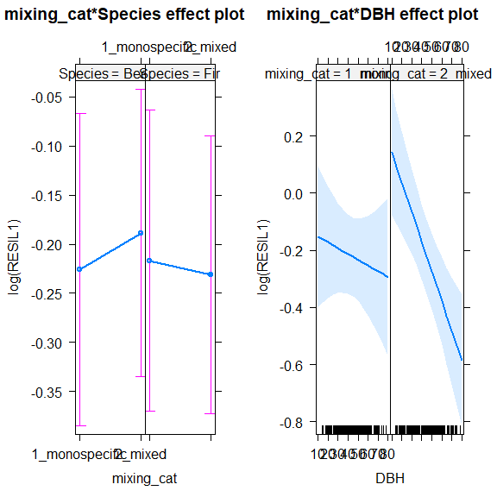
# model check:
qqnorm(resid(lme_resil1))
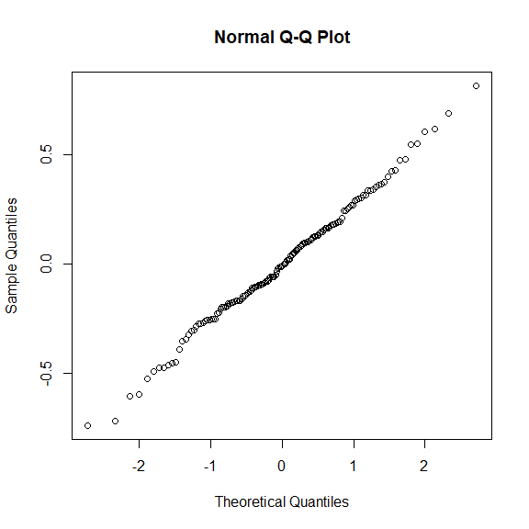
hist(residuals(lme_resil1), breaks = 40)
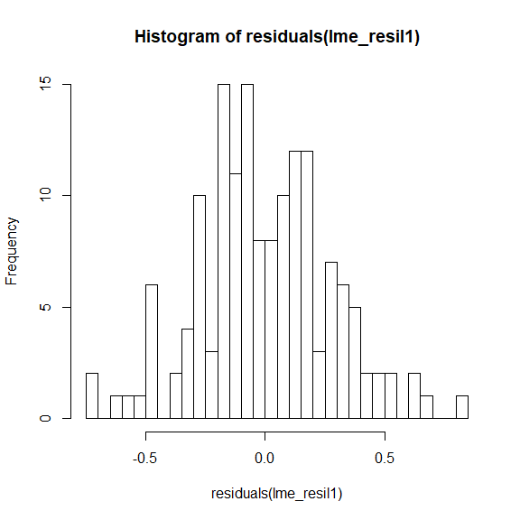
fit<- lme_resil1
#Checking residuals
plot(fit, resid(., scaled=TRUE) ~ fitted(.) , abline = 0)
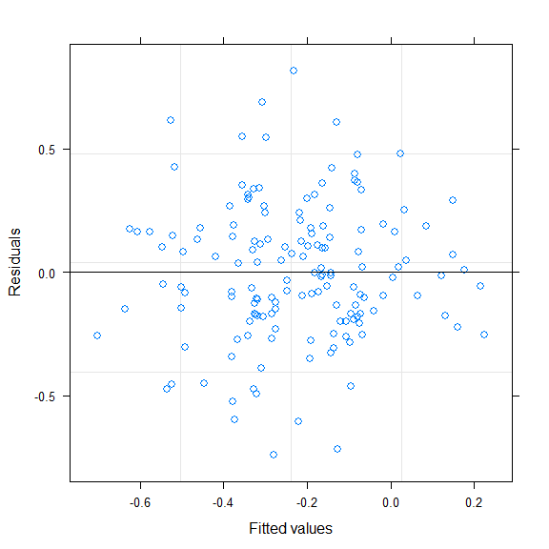
plot(fit, resid(., scaled=TRUE) ~ DBH , abline = 0)
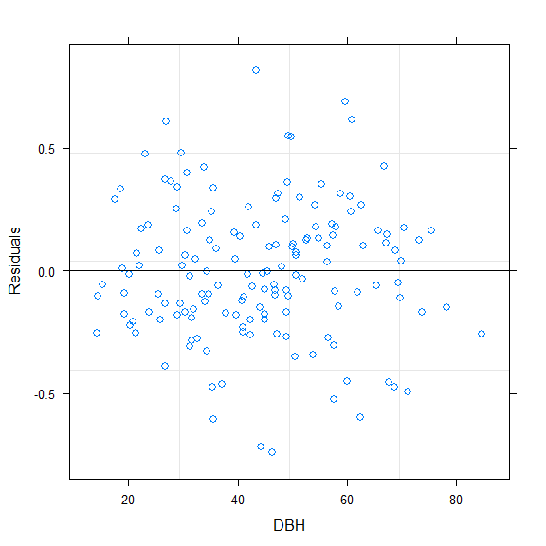
#Resistance of d13C
lme_dry <- lme(log(RES13C) ~ mixing_cat + Species + scale(DBH) + mixing_cat*Species + mixing_cat*scale(DBH), random= ~1|Site ,method="REML", data=data, na.action=na.exclude)
summary(lme_dry)
## Linear mixed-effects model fit by REML
## Data: data
## AIC BIC logLik
## -21.3721 2.330658 18.68605
##
## Random effects:
## Formula: ~1 | Site
## (Intercept) Residual
## StdDev: 0.01889773 0.1956167
##
## Fixed effects: log(RES13C) ~ mixing_cat + Species + scale(DBH) + mixing_cat * Species + mixing_cat * scale(DBH)
## Value Std.Error DF t-value p-value
## (Intercept) -0.16438707 0.03872306 140 -4.245198 0.0000
## mixing_cat2_mixed 0.01322694 0.04827696 140 0.273980 0.7845
## SpeciesFir -0.06736892 0.05325135 140 -1.265112 0.2079
## scale(DBH) 0.03643843 0.02835424 140 1.285114 0.2009
## mixing_cat2_mixed:SpeciesFir 0.01123605 0.06818422 140 0.164790 0.8693
## mixing_cat2_mixed:scale(DBH) 0.00149424 0.03465519 140 0.043117 0.9657
## Correlation:
## (Intr) mxn_2_ SpcsFr s(DBH) m_2_:S
## mixing_cat2_mixed -0.749
## SpeciesFir -0.706 0.559
## scale(DBH) 0.299 -0.221 -0.291
## mixing_cat2_mixed:SpeciesFir 0.545 -0.728 -0.774 0.205
## mixing_cat2_mixed:scale(DBH) -0.230 0.234 0.218 -0.759 -0.273
##
## Standardized Within-Group Residuals:
## Min Q1 Med Q3 Max
## -2.41039807 -0.69110499 -0.04765004 0.75355615 3.42154351
##
## Number of Observations: 149
## Number of Groups: 4
plot(allEffects(lme_dry))
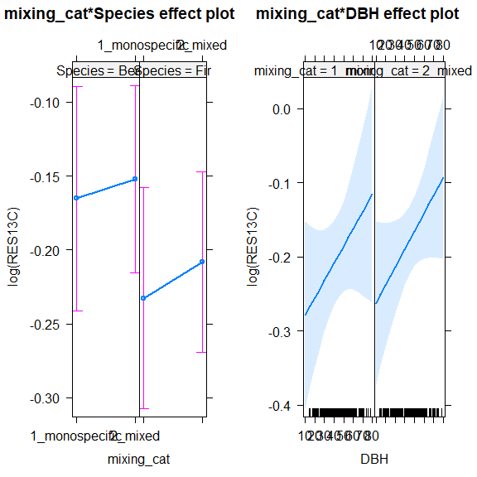
r.squaredGLMM(lme_dry)
## R2m R2c
## [1,] 0.04579245 0.05461545
# model check:
qqnorm(resid(lme_dry))
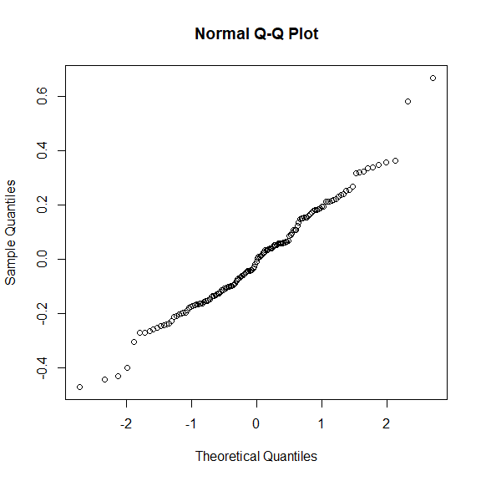
hist(residuals(lme_dry), breaks = 40)
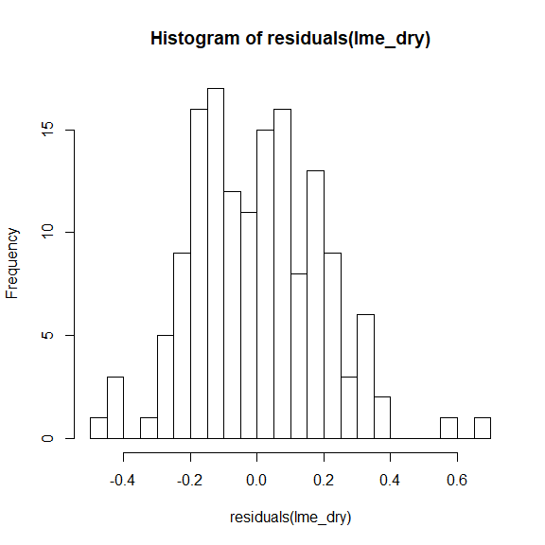
fit<- lme_dry
#Checking residuals
plot(fit, resid(., scaled=TRUE) ~ fitted(.) , abline = 0)
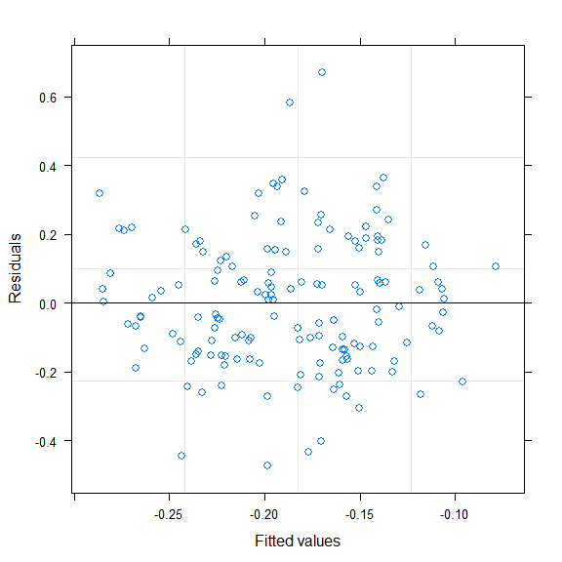
plot(fit, resid(., scaled=TRUE) ~ DBH , abline = 0)
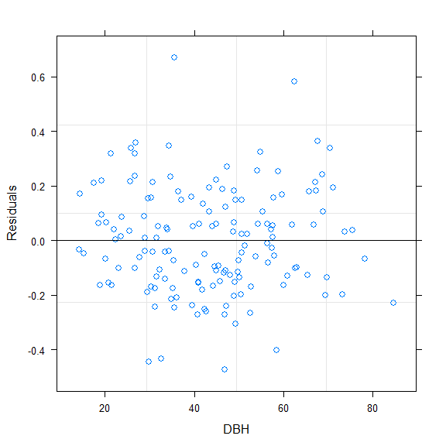
##Recovery of d13C
lme_rec <- lme(REC13C~ mixing_cat + Species + scale(DBH) + mixing_cat*Species + mixing_cat*scale(DBH), random= ~1|Site ,method="REML", data=data, na.action=na.exclude)
summary(lme_rec)
## Linear mixed-effects model fit by REML
## Data: data
## AIC BIC logLik
## -24.41089 -0.7642766 20.20545
##
## Random effects:
## Formula: ~1 | Site
## (Intercept) Residual
## StdDev: 0.1095647 0.1892173
##
## Fixed effects: REC13C ~ mixing_cat + Species + scale(DBH) + mixing_cat * Species + mixing_cat * scale(DBH)
## Value Std.Error DF t-value p-value
## (Intercept) 1.1334541 0.06621449 139 17.117915 0.0000
## mixing_cat2_mixed -0.0063821 0.04672185 139 -0.136598 0.8915
## SpeciesFir 0.0362976 0.05359723 139 0.677228 0.4994
## scale(DBH) 0.0187294 0.03567406 139 0.525015 0.6004
## mixing_cat2_mixed:SpeciesFir -0.0089813 0.06609311 139 -0.135889 0.8921
## mixing_cat2_mixed:scale(DBH) 0.0147135 0.03390862 139 0.433917 0.6650
## Correlation:
## (Intr) mxn_2_ SpcsFr s(DBH) m_2_:S
## mixing_cat2_mixed -0.422
## SpeciesFir -0.417 0.534
## scale(DBH) 0.207 -0.161 -0.391
## mixing_cat2_mixed:SpeciesFir 0.310 -0.726 -0.747 0.170
## mixing_cat2_mixed:scale(DBH) -0.141 0.228 0.238 -0.647 -0.272
##
## Standardized Within-Group Residuals:
## Min Q1 Med Q3 Max
## -2.71543309 -0.66912753 0.07135109 0.70660959 3.71372543
##
## Number of Observations: 148
## Number of Groups: 4
plot(allEffects(lme_rec))
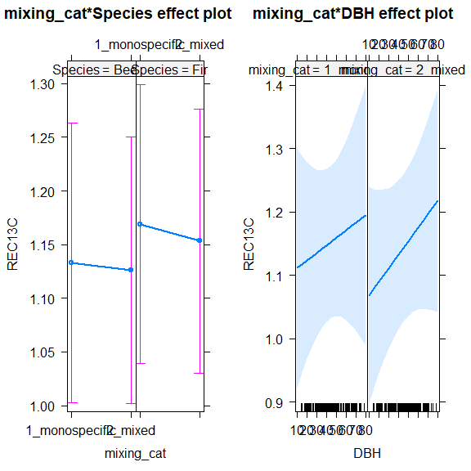
r.squaredGLMM(lme_rec)
## R2m R2c
## [1,] 0.02596952 0.2705471
# model check:
qqnorm(resid(lme_rec))
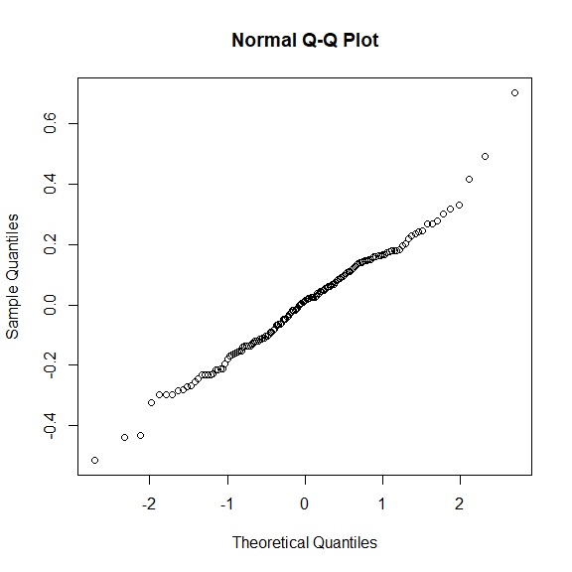
hist(residuals(lme_rec), breaks = 40)
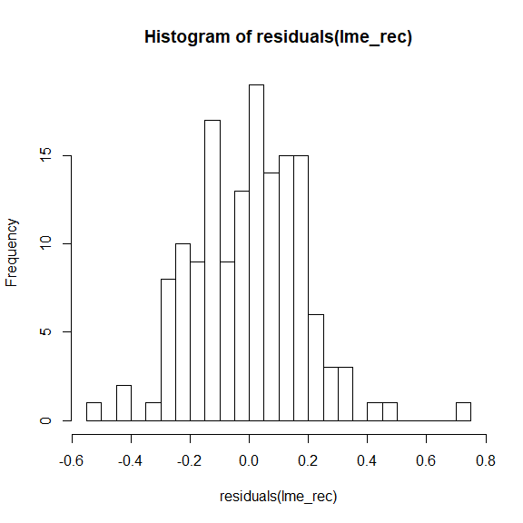
plot(lme_rec, resid(., scaled=TRUE) ~ fitted(.) , abline = 0)
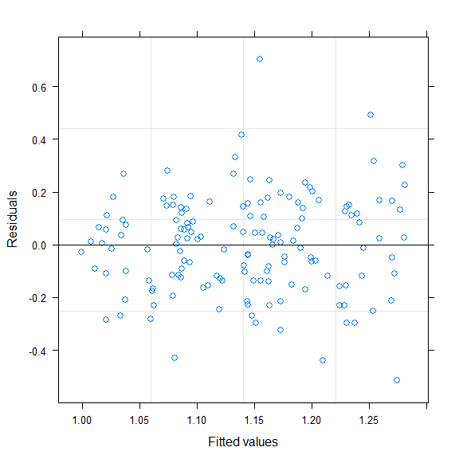
plot(lme_rec, resid(., scaled=TRUE) ~ DBH , abline = 0)
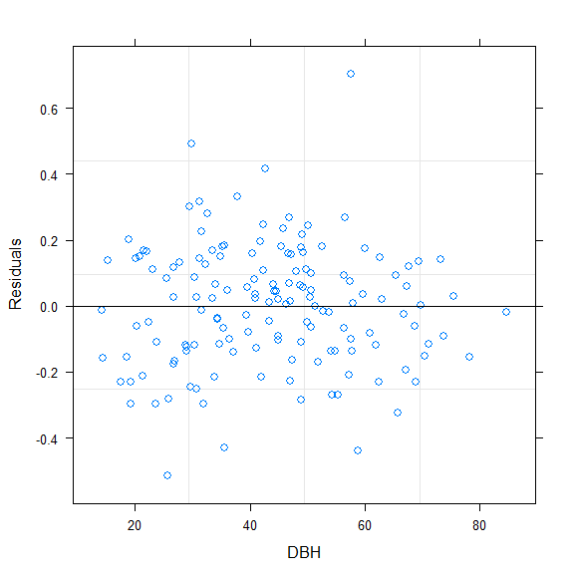
##Resilience of d13C
lme_resil <- lme(log(RESIL13C) ~ mixing_cat + Species + scale(DBH) + mixing_cat*Species + mixing_cat*scale(DBH), random= ~1|Site ,method="REML", data=data, na.action=na.exclude)
summary(lme_resil)
## Linear mixed-effects model fit by REML
## Data: data
## AIC BIC logLik
## -101.6944 -78.04783 58.84722
##
## Random effects:
## Formula: ~1 | Site
## (Intercept) Residual
## StdDev: 1.574819e-05 0.1475823
##
## Fixed effects: log(RESIL13C) ~ mixing_cat + Species + scale(DBH) + mixing_cat * Species + mixing_cat * scale(DBH)
## Value Std.Error DF t-value p-value
## (Intercept) -0.07047820 0.02819188 139 -2.4999472 0.0136
## mixing_cat2_mixed -0.00336966 0.03636088 139 -0.0926727 0.9263
## SpeciesFir -0.00603781 0.03996015 139 -0.1510958 0.8801
## scale(DBH) -0.00879416 0.02043059 139 -0.4304411 0.6675
## mixing_cat2_mixed:SpeciesFir 0.02164073 0.05149003 139 0.4202897 0.6749
## mixing_cat2_mixed:scale(DBH) 0.02535634 0.02610333 139 0.9713832 0.3330
## Correlation:
## (Intr) mxn_2_ SpcsFr s(DBH) m_2_:S
## mixing_cat2_mixed -0.775
## SpeciesFir -0.725 0.562
## scale(DBH) 0.294 -0.228 -0.274
## mixing_cat2_mixed:SpeciesFir 0.563 -0.727 -0.776 0.213
## mixing_cat2_mixed:scale(DBH) -0.230 0.229 0.214 -0.783 -0.269
##
## Standardized Within-Group Residuals:
## Min Q1 Med Q3 Max
## -1.89319145 -0.67962420 0.08099036 0.53708451 3.69461786
##
## Number of Observations: 148
## Number of Groups: 4
plot(allEffects(lme_resil))
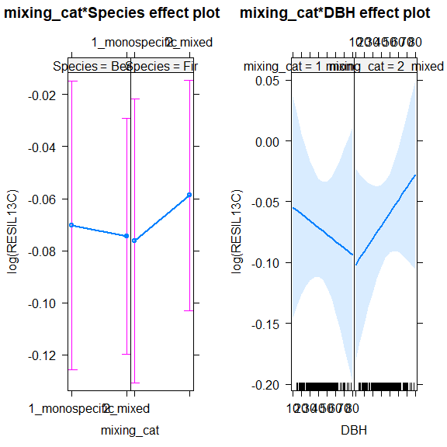
r.squaredGLMM(lme_resil)
## R2m R2c
## [1,] 0.01349563 0.01349564
# model check:
qqnorm(resid(lme_resil))
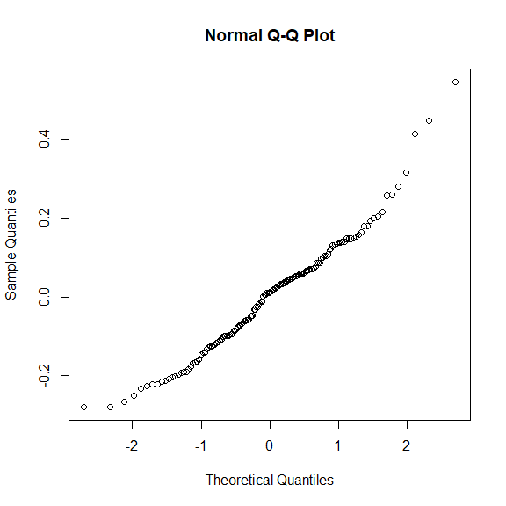
hist(residuals(lme_resil), breaks = 40)
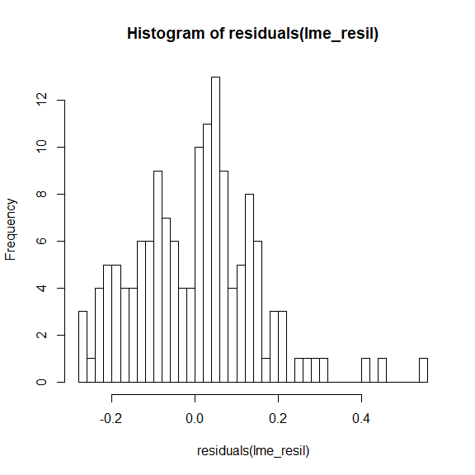
plot(lme_resil, resid(., scaled=TRUE) ~ fitted(.) , abline = 0)
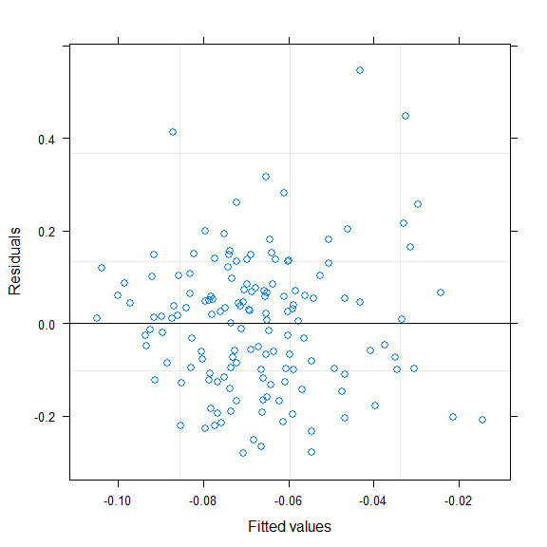
plot(lme_resil, resid(., scaled=TRUE) ~ DBH , abline = 0)
