Supplementary Material 3: NEIGHBOURHOOD ANALYSIS to identify the most important growth-controlling variables for the two species at the tree neighborhood level, we analyzed the effect of admixing on tree growth while accounting for additional confounding factors
Julia Schwarz

load libraries
rm(list=ls(all=TRUE))
set.seed(1234)
library(lme4)
library(lmerTest)
library(effects)
library(tidyr)
library(sciplot)
library(RColorBrewer)
library(psych)
library(MuMIn)
library(dplyr)
library(stringr)
library(ggplot2)
library(qpcR)
library(effects)
library(nlme)
library(geoR)
library(AICcmodavg)
library(piecewiseSEM)
library(emmeans)
library(inlabru)
library(gridExtra)
library(ggsci)
library(car)
library(MASS)
library(rcompanion)
library(flexsurv)
library(ggpubr)
rm(list=ls(all=TRUE))
data <- read.delim("../Data/lastyr.txt")
str(data)
## 'data.frame': 153 obs. of 29 variables:
## $ Tree : Factor w/ 153 levels "CoBu01","CoBu02",..: 1 2 3 4 5 6 7 8 9 10 ...
## $ Site : Factor w/ 4 levels "Conventwald",..: 1 1 1 1 1 1 1 1 1 1 ...
## $ Martonne : num 7.41 7.41 7.41 7.41 7.41 ...
## $ Martonne_new : num 6.76 6.76 6.76 6.76 6.76 6.76 6.76 6.76 6.76 6.76 ...
## $ Soil : Factor w/ 2 levels "Braunerde","Rendzina": 1 1 1 1 1 1 1 1 1 1 ...
## $ Soil.1 : int 1 1 1 1 1 1 1 1 1 1 ...
## $ Species : Factor w/ 2 levels "Beech","Fir": 1 1 1 1 1 1 1 1 1 1 ...
## $ Year : int 2016 2016 2016 2016 2016 2016 2016 2016 2016 2016 ...
## $ DBH : num 71.3 60.9 63 52 59.9 52.9 57.3 51.5 56.3 46 ...
## $ N_nbors : int 6 4 6 4 4 6 7 6 5 5 ...
## $ mean_distance : num 8.53 6.8 7.03 4.95 7.15 ...
## $ nrbydist : num 0.703 0.588 0.853 0.808 0.559 ...
## $ meandistlarger: num 8.1 5.97 9.7 4.5 6.5 ...
## $ nrlarger : int 3 3 2 3 2 3 3 3 4 5 ...
## $ nrbydistlarger: num 0.37 0.503 0.206 0.667 0.308 ...
## $ BAL : num 17.44 13.89 10.29 15.17 7.75 ...
## $ Hegyi_old : num 0.696 0.953 0.96 1.236 0.673 ...
## $ Hegyi : num 0.602 0.787 0.909 0.996 0.543 ...
## $ Beech_prop : num 34.5 11.7 76.3 0 0 ...
## $ Fir_prop : num 65.5 88.3 23.7 100 100 ...
## $ Other_prop : num 0 0 0 0 0 0 0 0 0 0 ...
## $ Admixed_prop : num 65.5 88.3 23.7 100 100 ...
## $ Mixture : Factor w/ 3 levels "1_monospecific",..: 2 3 1 3 3 1 1 1 3 2 ...
## $ mixed : Factor w/ 2 levels "less","more": 2 2 1 2 2 1 1 1 2 1 ...
## $ BAI2016 : num 1485 2433 1187 527 512 ...
## $ BAIsum3 : num 4838 6142 5043 3898 2944 ...
## $ BAIsum5 : num 9630 11587 8513 6848 6630 ...
## $ RelBAI2016 : num 0.895 1.467 0.715 0.318 0.309 ...
## $ RW : num 0.702 1.358 0.639 0.349 0.291 ...
summary(data)
## Tree Site Martonne Martonne_new
## CoBu01 : 1 Conventwald:39 Min. :3.866 Min. :5.130
## CoBu02 : 1 Croatia :41 1st Qu.:6.278 1st Qu.:5.130
## CoBu03 : 1 Freiamt :33 Median :6.769 Median :6.760
## CoBu04 : 1 Hexental :40 Mean :6.179 Mean :6.004
## CoBu05 : 1 3rd Qu.:7.413 3rd Qu.:6.840
## CoBu06 : 1 Max. :7.413 Max. :6.840
## (Other):147
## Soil Soil.1 Species Year DBH
## Braunerde:112 Min. :1.000 Beech:73 Min. :2016 Min. :19.90
## Rendzina : 41 1st Qu.:1.000 Fir :80 1st Qu.:2016 1st Qu.:38.60
## Median :1.000 Median :2016 Median :49.40
## Mean :1.268 Mean :2016 Mean :49.48
## 3rd Qu.:2.000 3rd Qu.:2016 3rd Qu.:60.00
## Max. :2.000 Max. :2016 Max. :88.70
##
## N_nbors mean_distance nrbydist meandistlarger
## Min. : 2.000 Min. : 3.300 Min. :0.2920 Min. : 2.300
## 1st Qu.: 5.000 1st Qu.: 5.200 1st Qu.:0.7660 1st Qu.: 5.276
## Median : 6.000 Median : 6.211 Median :0.9627 Median : 6.617
## Mean : 6.346 Mean : 6.339 Mean :1.0775 Mean : 6.727
## 3rd Qu.: 7.000 3rd Qu.: 7.375 3rd Qu.:1.3032 3rd Qu.: 7.987
## Max. :13.000 Max. :14.600 Max. :2.6190 Max. :13.300
## NA's :35
## nrlarger nrbydistlarger BAL Hegyi_old
## Min. :0.00 Min. :0.09901 Min. : 0.000 Min. :0.2333
## 1st Qu.:1.00 1st Qu.:0.25647 1st Qu.: 2.043 1st Qu.:0.7256
## Median :2.00 Median :0.40678 Median : 4.034 Median :0.9494
## Mean :2.17 Mean :0.45518 Mean : 5.878 Mean :1.0800
## 3rd Qu.:3.00 3rd Qu.:0.60728 3rd Qu.: 9.663 3rd Qu.:1.3272
## Max. :8.00 Max. :1.47806 Max. :21.823 Max. :2.6195
## NA's :35
## Hegyi Beech_prop Fir_prop Other_prop
## Min. :0.2680 Min. : 0.00 Min. : 0.00 Min. : 0.000
## 1st Qu.:0.7499 1st Qu.: 18.49 1st Qu.: 19.15 1st Qu.: 0.000
## Median :0.9800 Median : 48.53 Median : 51.25 Median : 0.000
## Mean :1.0878 Mean : 48.35 Mean : 48.30 Mean : 3.359
## 3rd Qu.:1.3604 3rd Qu.: 76.30 3rd Qu.: 76.68 3rd Qu.: 0.000
## Max. :2.8336 Max. :100.00 Max. :100.00 Max. :40.958
##
## Admixed_prop Mixture mixed BAI2016
## Min. : 0.00 1_monospecific :61 less:86 Min. : 288.5
## 1st Qu.: 18.49 2_mixed :43 more:67 1st Qu.: 1448.6
## Median : 47.13 3_heterospecific:49 Median : 2346.6
## Mean : 47.16 Mean : 2741.1
## 3rd Qu.: 76.08 3rd Qu.: 3635.5
## Max. :100.00 Max. :14123.1
##
## BAIsum3 BAIsum5 RelBAI2016 RW
## Min. : 1033 Min. : 1867 Min. :0.1205 Min. :0.166
## 1st Qu.: 4962 1st Qu.: 8513 1st Qu.:0.6909 1st Qu.:1.071
## Median : 7711 Median :12555 Median :0.9713 Median :1.768
## Mean : 8519 Mean :13887 Mean :1.1452 Mean :1.959
## 3rd Qu.:10791 3rd Qu.:17659 3rd Qu.:1.4749 3rd Qu.:2.566
## Max. :35774 Max. :51292 Max. :5.0029 Max. :6.455
##
data$N_nbors <- as.numeric(data$N_nbors)
data$nrlarger <- as.numeric(data$nrlarger)
data$Year <- as.numeric(data$Year)
data$meanBAI3 <-data$BAIsum3/3
data$meanBAI5 <-data$BAIsum5/5
str(data)
## 'data.frame': 153 obs. of 31 variables:
## $ Tree : Factor w/ 153 levels "CoBu01","CoBu02",..: 1 2 3 4 5 6 7 8 9 10 ...
## $ Site : Factor w/ 4 levels "Conventwald",..: 1 1 1 1 1 1 1 1 1 1 ...
## $ Martonne : num 7.41 7.41 7.41 7.41 7.41 ...
## $ Martonne_new : num 6.76 6.76 6.76 6.76 6.76 6.76 6.76 6.76 6.76 6.76 ...
## $ Soil : Factor w/ 2 levels "Braunerde","Rendzina": 1 1 1 1 1 1 1 1 1 1 ...
## $ Soil.1 : int 1 1 1 1 1 1 1 1 1 1 ...
## $ Species : Factor w/ 2 levels "Beech","Fir": 1 1 1 1 1 1 1 1 1 1 ...
## $ Year : num 2016 2016 2016 2016 2016 ...
## $ DBH : num 71.3 60.9 63 52 59.9 52.9 57.3 51.5 56.3 46 ...
## $ N_nbors : num 6 4 6 4 4 6 7 6 5 5 ...
## $ mean_distance : num 8.53 6.8 7.03 4.95 7.15 ...
## $ nrbydist : num 0.703 0.588 0.853 0.808 0.559 ...
## $ meandistlarger: num 8.1 5.97 9.7 4.5 6.5 ...
## $ nrlarger : num 3 3 2 3 2 3 3 3 4 5 ...
## $ nrbydistlarger: num 0.37 0.503 0.206 0.667 0.308 ...
## $ BAL : num 17.44 13.89 10.29 15.17 7.75 ...
## $ Hegyi_old : num 0.696 0.953 0.96 1.236 0.673 ...
## $ Hegyi : num 0.602 0.787 0.909 0.996 0.543 ...
## $ Beech_prop : num 34.5 11.7 76.3 0 0 ...
## $ Fir_prop : num 65.5 88.3 23.7 100 100 ...
## $ Other_prop : num 0 0 0 0 0 0 0 0 0 0 ...
## $ Admixed_prop : num 65.5 88.3 23.7 100 100 ...
## $ Mixture : Factor w/ 3 levels "1_monospecific",..: 2 3 1 3 3 1 1 1 3 2 ...
## $ mixed : Factor w/ 2 levels "less","more": 2 2 1 2 2 1 1 1 2 1 ...
## $ BAI2016 : num 1485 2433 1187 527 512 ...
## $ BAIsum3 : num 4838 6142 5043 3898 2944 ...
## $ BAIsum5 : num 9630 11587 8513 6848 6630 ...
## $ RelBAI2016 : num 0.895 1.467 0.715 0.318 0.309 ...
## $ RW : num 0.702 1.358 0.639 0.349 0.291 ...
## $ meanBAI3 : num 1613 2047 1681 1299 981 ...
## $ meanBAI5 : num 1926 2317 1703 1370 1326 ...
data$resp <- log(data$meanBAI3)
data$back <- exp(data$resp)
summary(data)
## Tree Site Martonne Martonne_new
## CoBu01 : 1 Conventwald:39 Min. :3.866 Min. :5.130
## CoBu02 : 1 Croatia :41 1st Qu.:6.278 1st Qu.:5.130
## CoBu03 : 1 Freiamt :33 Median :6.769 Median :6.760
## CoBu04 : 1 Hexental :40 Mean :6.179 Mean :6.004
## CoBu05 : 1 3rd Qu.:7.413 3rd Qu.:6.840
## CoBu06 : 1 Max. :7.413 Max. :6.840
## (Other):147
## Soil Soil.1 Species Year DBH
## Braunerde:112 Min. :1.000 Beech:73 Min. :2016 Min. :19.90
## Rendzina : 41 1st Qu.:1.000 Fir :80 1st Qu.:2016 1st Qu.:38.60
## Median :1.000 Median :2016 Median :49.40
## Mean :1.268 Mean :2016 Mean :49.48
## 3rd Qu.:2.000 3rd Qu.:2016 3rd Qu.:60.00
## Max. :2.000 Max. :2016 Max. :88.70
##
## N_nbors mean_distance nrbydist meandistlarger
## Min. : 2.000 Min. : 3.300 Min. :0.2920 Min. : 2.300
## 1st Qu.: 5.000 1st Qu.: 5.200 1st Qu.:0.7660 1st Qu.: 5.276
## Median : 6.000 Median : 6.211 Median :0.9627 Median : 6.617
## Mean : 6.346 Mean : 6.339 Mean :1.0775 Mean : 6.727
## 3rd Qu.: 7.000 3rd Qu.: 7.375 3rd Qu.:1.3032 3rd Qu.: 7.987
## Max. :13.000 Max. :14.600 Max. :2.6190 Max. :13.300
## NA's :35
## nrlarger nrbydistlarger BAL Hegyi_old
## Min. :0.00 Min. :0.09901 Min. : 0.000 Min. :0.2333
## 1st Qu.:1.00 1st Qu.:0.25647 1st Qu.: 2.043 1st Qu.:0.7256
## Median :2.00 Median :0.40678 Median : 4.034 Median :0.9494
## Mean :2.17 Mean :0.45518 Mean : 5.878 Mean :1.0800
## 3rd Qu.:3.00 3rd Qu.:0.60728 3rd Qu.: 9.663 3rd Qu.:1.3272
## Max. :8.00 Max. :1.47806 Max. :21.823 Max. :2.6195
## NA's :35
## Hegyi Beech_prop Fir_prop Other_prop
## Min. :0.2680 Min. : 0.00 Min. : 0.00 Min. : 0.000
## 1st Qu.:0.7499 1st Qu.: 18.49 1st Qu.: 19.15 1st Qu.: 0.000
## Median :0.9800 Median : 48.53 Median : 51.25 Median : 0.000
## Mean :1.0878 Mean : 48.35 Mean : 48.30 Mean : 3.359
## 3rd Qu.:1.3604 3rd Qu.: 76.30 3rd Qu.: 76.68 3rd Qu.: 0.000
## Max. :2.8336 Max. :100.00 Max. :100.00 Max. :40.958
##
## Admixed_prop Mixture mixed BAI2016
## Min. : 0.00 1_monospecific :61 less:86 Min. : 288.5
## 1st Qu.: 18.49 2_mixed :43 more:67 1st Qu.: 1448.6
## Median : 47.13 3_heterospecific:49 Median : 2346.6
## Mean : 47.16 Mean : 2741.1
## 3rd Qu.: 76.08 3rd Qu.: 3635.5
## Max. :100.00 Max. :14123.1
##
## BAIsum3 BAIsum5 RelBAI2016 RW
## Min. : 1033 Min. : 1867 Min. :0.1205 Min. :0.166
## 1st Qu.: 4962 1st Qu.: 8513 1st Qu.:0.6909 1st Qu.:1.071
## Median : 7711 Median :12555 Median :0.9713 Median :1.768
## Mean : 8519 Mean :13887 Mean :1.1452 Mean :1.959
## 3rd Qu.:10791 3rd Qu.:17659 3rd Qu.:1.4749 3rd Qu.:2.566
## Max. :35774 Max. :51292 Max. :5.0029 Max. :6.455
##
## meanBAI3 meanBAI5 resp back
## Min. : 344.4 Min. : 373.4 Min. :5.842 Min. : 344.4
## 1st Qu.: 1653.9 1st Qu.: 1702.6 1st Qu.:7.411 1st Qu.: 1653.9
## Median : 2570.4 Median : 2511.0 Median :7.852 Median : 2570.4
## Mean : 2839.7 Mean : 2777.4 Mean :7.794 Mean : 2839.7
## 3rd Qu.: 3597.1 3rd Qu.: 3531.8 3rd Qu.:8.188 3rd Qu.: 3597.1
## Max. :11924.6 Max. :10258.4 Max. :9.386 Max. :11924.6
##
#Collinearity analysis: VIF : https://hlplab.wordpress.com/2011/02/24/diagnosing-collinearity-in-lme4/
vif.mer <- function (fit) {
## adapted from rms::vif
v <- vcov(fit)
nam <- names(fixef(fit))
## exclude intercepts
ns <- sum(1 * (nam == "Intercept" | nam == "(Intercept)"))
if (ns > 0) {
v <- v[-(1:ns), -(1:ns), drop = FALSE]
nam <- nam[-(1:ns)]
}
d <- diag(v)^0.5
v <- diag(solve(v/(d %o% d)))
names(v) <- nam
v
}

Response variables: BAI or mean BAI of last 3 years (2014-16) or mean BAI of last 5 years (2011-16)
##pre-correlation analysis for the predictors
resp= c(which(names(data)=="BAI2016"), which(names(data)=="meanBAI3"), which(names(data)=="meanBAI5"))
oldpar <- par(mfrow = c(3,2))
for (i in resp){
hist(log(data[,i]), main = colnames(data)[i], breaks = 30)
}
par(oldpar)
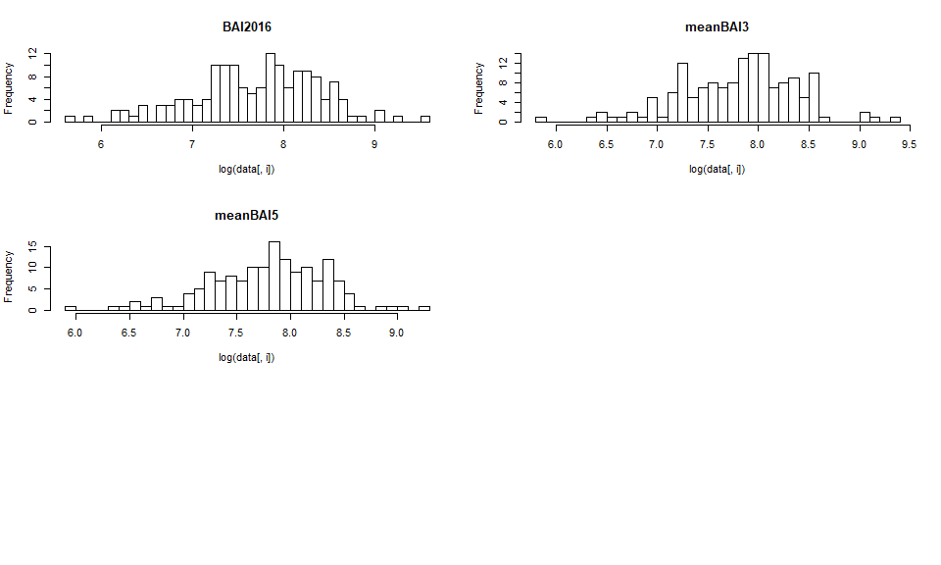
pairs(log(data[resp]), lower.panel = panel.smooth, diag.panel = panel.hist, upper.panel = panel.cor)
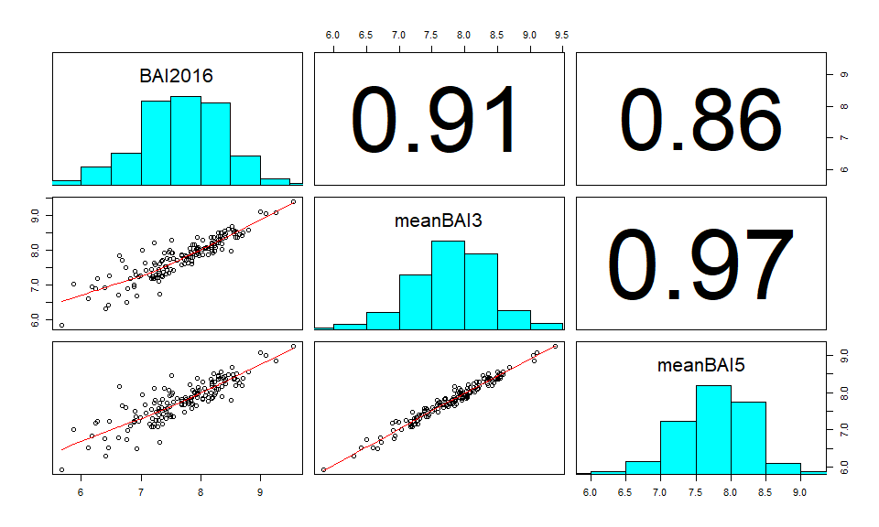
# we use only one as high correlation
attach(data)
## The following object is masked _by_ .GlobalEnv:
##
## resp
hist(log(meanBAI3), breaks = 40) #looks good
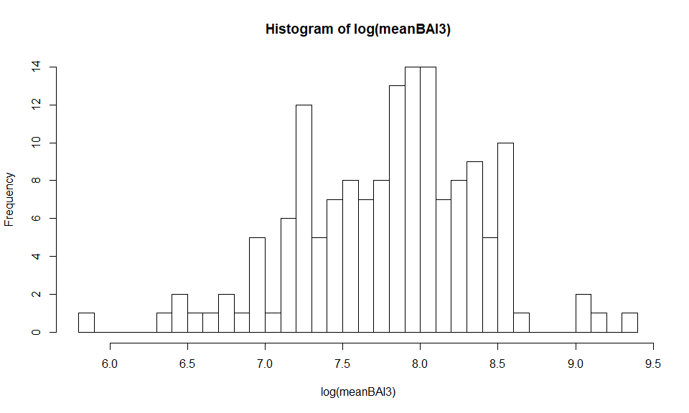
qqnorm(log(meanBAI3))# yes
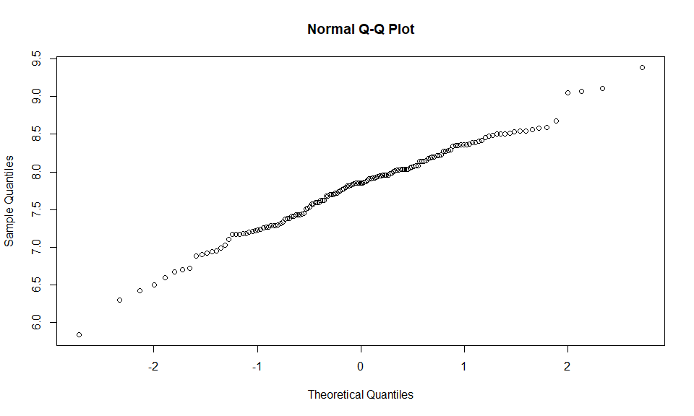

Before modelling we have to reduce collinearity among predictors by doing precorrelation anaylos
finalPred2016 = resp= c(which(names(data)=="Admixed_prop"),
which(names(data)=="Hegyi"),
which(names(data)=="BAL"),
which(names(data)=="DBH"),
which(names(data)=="Martonne_new"))
pairs(data[,finalPred2016], lower.panel = panel.smooth, diag.panel = panel.hist, upper.panel = panel.cor)
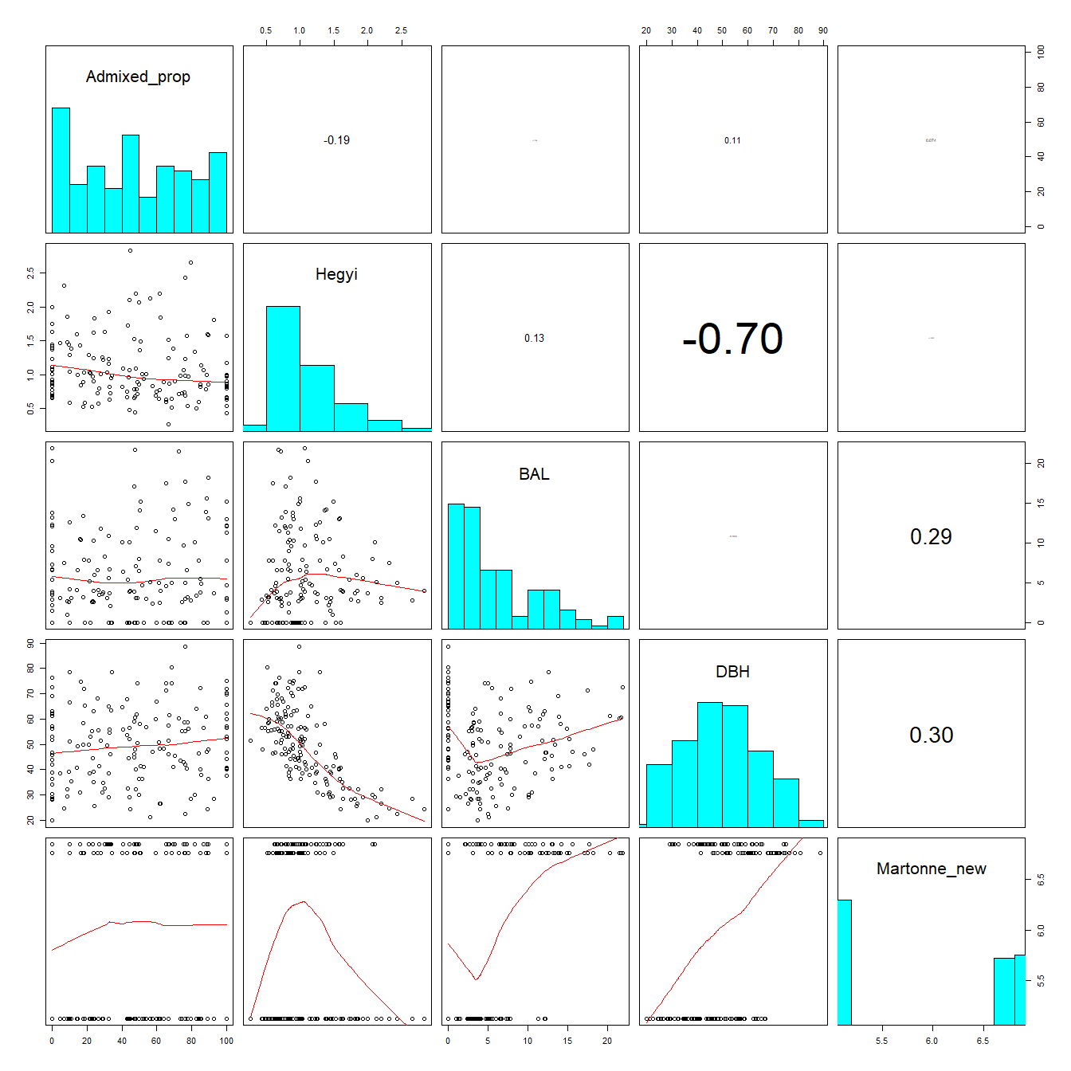
# looks fine
#Random effect structure selection: For comparing random structures via AIC keep fixed effects constant and use REML!!! AIC is a good option to use, see also Zuur et al.2009, We should use full model with as many interactions as possible.
lme_r1 <- lme(log(meanBAI3) ~ scale(Admixed_prop) + scale(Hegyi) + scale(BAL) + scale(DBH) + scale(Martonne_new) + Species + scale(Admixed_prop)*Species + scale(Admixed_prop)*scale(DBH)+ scale(Admixed_prop)*scale(Hegyi) +scale(Admixed_prop)*scale(BAL)+scale(Admixed_prop)*scale(Martonne_new)
,random= ~1|Site , data=data)
lme_r2 <- lme(log(meanBAI3)~ scale(Admixed_prop) + scale(Hegyi) + scale(BAL) + scale(DBH) + scale(Martonne_new) + Species + scale(Admixed_prop)*Species + scale(Admixed_prop)*scale(DBH)+ scale(Admixed_prop)*scale(Hegyi) +scale(Admixed_prop)*scale(BAL)+scale(Admixed_prop)*scale(Martonne_new)
,random= ~1|Site/Tree , data=data, )
lme_r3 <- lme(log(meanBAI3) ~scale(Admixed_prop) + scale(Hegyi) + scale(BAL) + scale(DBH) + scale(Martonne_new) + Species + scale(Admixed_prop)*Species + scale(Admixed_prop)*scale(DBH)+ scale(Admixed_prop)*scale(Hegyi) +scale(Admixed_prop)*scale(BAL)+scale(Admixed_prop)*scale(Martonne_new)
,random= ~1|Species/Site/Tree , data=data)
lme_r4 <- lme(log(meanBAI3) ~scale(Admixed_prop) + scale(Hegyi) + scale(BAL) + scale(DBH) + scale(Martonne_new) + Species + scale(Admixed_prop)*Species + scale(Admixed_prop)*scale(DBH)+ scale(Admixed_prop)*scale(Hegyi) +scale(Admixed_prop)*scale(BAL)+scale(Admixed_prop)*scale(Martonne_new)
,random= ~1|Species/Site , data=data)
aictab(mget(str_subset(ls(), "lme_r")))# sites!!!
## Warning in aictab.AIClme(mget(str_subset(ls(), "lme_r"))):
## Model selection for fixed effects is only appropriate with method=ML:
## REML (default) should only be used to select random effects for a constant set of fixed effects
##
## Model selection based on AICc:
##
## K AICc Delta_AICc AICcWt Cum.Wt Res.LL
## lme_r1 14 234.44 0.00 0.77 0.77 -101.70
## lme_r2 15 236.90 2.46 0.22 0.99 -101.70
## lme_r4 15 244.61 10.17 0.00 1.00 -105.55
## lme_r3 16 247.11 12.67 0.00 1.00 -105.55
summary(lme_r1)
## Linear mixed-effects model fit by REML
## Data: data
## AIC BIC logLik
## 231.3934 272.676 -101.6967
##
## Random effects:
## Formula: ~1 | Site
## (Intercept) Residual
## StdDev: 0.3442674 0.4038346
##
## Fixed effects: log(meanBAI3) ~ scale(Admixed_prop) + scale(Hegyi) + scale(BAL) + scale(DBH) + scale(Martonne_new) + Species + scale(Admixed_prop) * Species + scale(Admixed_prop) * scale(DBH) + scale(Admixed_prop) * scale(Hegyi) + scale(Admixed_prop) * scale(BAL) + scale(Admixed_prop) * scale(Martonne_new)
## Value Std.Error DF t-value
## (Intercept) 7.730547 0.18163474 139 42.56095
## scale(Admixed_prop) 0.026890 0.05704710 139 0.47137
## scale(Hegyi) -0.155606 0.05965785 139 -2.60831
## scale(BAL) -0.065318 0.05169171 139 -1.26361
## scale(DBH) 0.351012 0.07206333 139 4.87088
## scale(Martonne_new) -0.291207 0.18066306 2 -1.61188
## SpeciesFir 0.159464 0.08940888 139 1.78354
## scale(Admixed_prop):SpeciesFir 0.070199 0.08949689 139 0.78437
## scale(Admixed_prop):scale(DBH) 0.137776 0.06512736 139 2.11549
## scale(Admixed_prop):scale(Hegyi) 0.198990 0.06157935 139 3.23144
## scale(Admixed_prop):scale(BAL) 0.068966 0.04095012 139 1.68414
## scale(Admixed_prop):scale(Martonne_new) 0.002508 0.04394349 139 0.05707
## p-value
## (Intercept) 0.0000
## scale(Admixed_prop) 0.6381
## scale(Hegyi) 0.0101
## scale(BAL) 0.2085
## scale(DBH) 0.0000
## scale(Martonne_new) 0.2483
## SpeciesFir 0.0767
## scale(Admixed_prop):SpeciesFir 0.4342
## scale(Admixed_prop):scale(DBH) 0.0362
## scale(Admixed_prop):scale(Hegyi) 0.0015
## scale(Admixed_prop):scale(BAL) 0.0944
## scale(Admixed_prop):scale(Martonne_new) 0.9546
## Correlation:
## (Intr) sc(A_) scl(H) s(BAL) s(DBH)
## scale(Admixed_prop) 0.039
## scale(Hegyi) 0.056 -0.063
## scale(BAL) -0.087 -0.261 -0.137
## scale(DBH) 0.099 -0.171 0.557 0.217
## scale(Martonne_new) 0.035 0.031 -0.008 -0.170 -0.172
## SpeciesFir -0.257 -0.135 -0.267 0.353 -0.381
## scale(Admixed_prop):SpeciesFir -0.043 -0.810 0.097 0.320 0.188
## scale(Admixed_prop):scale(DBH) -0.038 0.296 -0.123 0.271 -0.006
## scale(Admixed_prop):scale(Hegyi) -0.019 0.221 -0.229 0.237 -0.062
## scale(Admixed_prop):scale(BAL) -0.076 -0.371 0.113 0.112 0.157
## scale(Admixed_prop):scale(Martonne_new) 0.006 -0.099 -0.064 -0.112 -0.153
## sc(M_) SpcsFr s(A_):S s(A_):(D
## scale(Admixed_prop)
## scale(Hegyi)
## scale(BAL)
## scale(DBH)
## scale(Martonne_new)
## SpeciesFir 0.018
## scale(Admixed_prop):SpeciesFir -0.044 0.151
## scale(Admixed_prop):scale(DBH) -0.064 0.176 -0.374
## scale(Admixed_prop):scale(Hegyi) -0.064 0.170 -0.236 0.763
## scale(Admixed_prop):scale(BAL) -0.015 0.298 0.410 -0.042
## scale(Admixed_prop):scale(Martonne_new) 0.045 -0.063 0.175 -0.544
## s(A_):(H s(A_):(B
## scale(Admixed_prop)
## scale(Hegyi)
## scale(BAL)
## scale(DBH)
## scale(Martonne_new)
## SpeciesFir
## scale(Admixed_prop):SpeciesFir
## scale(Admixed_prop):scale(DBH)
## scale(Admixed_prop):scale(Hegyi)
## scale(Admixed_prop):scale(BAL) -0.043
## scale(Admixed_prop):scale(Martonne_new) -0.308 -0.257
##
## Standardized Within-Group Residuals:
## Min Q1 Med Q3 Max
## -2.69742406 -0.67795313 -0.08993041 0.71315404 2.08442327
##
## Number of Observations: 153
## Number of Groups: 4
#Checking residuals
plot(lme_r1)
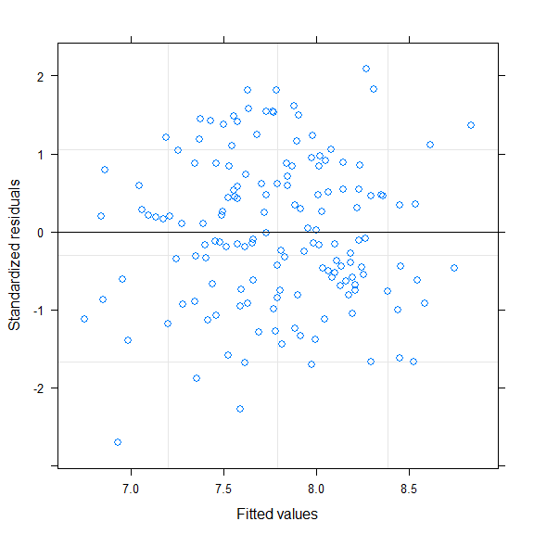
# that looks quite good
qqnorm(resid(lme_r1))# good
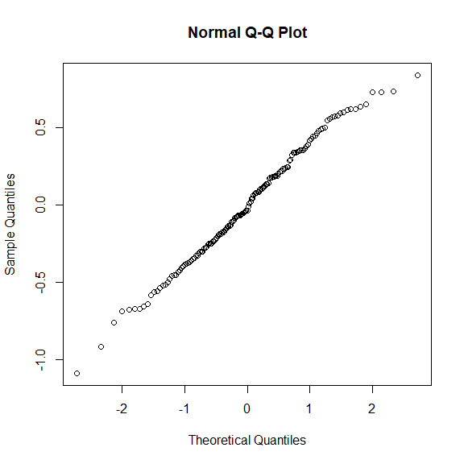
shapiro.test(resid(lme_r1))# good
##
## Shapiro-Wilk normality test
##
## data: resid(lme_r1)
## W = 0.99093, p-value = 0.4361
op <- par(mfrow = c(2, 3), mar = c(4, 4, 3, 2))
plot(data$DBH,resid(lme_r1,type="pearson")) #ok
plot(data$Hegyi,resid(lme_r1,type="pearson")) #quite ok
plot(data$nrlarger,resid(lme_r1,type="pearson")) # naja
plot(data$Admixed_prop,resid(lme_r1,type="pearson")) # naja
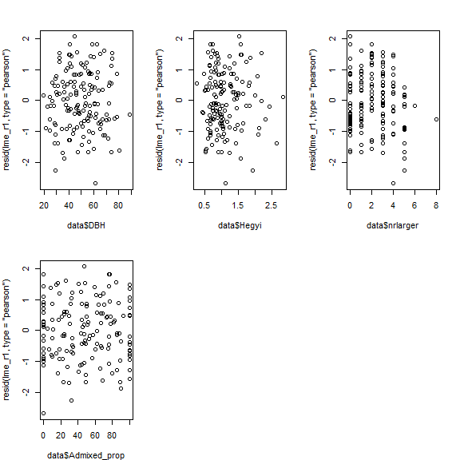
#Variance structure selection with lme: We tested different methods of incorporating heterogeneity into the model (variance structures). AR not needed as no repeated measureas (Pinheiro and Bates, 2000; Zuur et al., 2009). To address heteroscedasticity of the predictor variables we tested either a constant variance structure per group (varIdent) an exponential (varExp) or power (varPower) variance function for continuous predictor variables (Pinheiro et al., 2018).
lme_r1 <- lme(log(meanBAI3) ~ scale(Admixed_prop) + scale(Hegyi) + scale(BAL) + scale(DBH) + scale(Martonne_new) + Species + scale(Admixed_prop)*Species + scale(Admixed_prop)*scale(DBH)+ scale(Admixed_prop)*scale(Hegyi) +scale(Admixed_prop)*scale(BAL)+scale(Admixed_prop)*scale(Martonne_new)
,random= ~1|Site , data=data)
lme_v1 <- lme_r1
plot(lme_v1)
lme_v2 <- lme(log(meanBAI3) ~ scale(Admixed_prop) + scale(Hegyi) + scale(BAL) + scale(DBH) + scale(Martonne_new) + Species + scale(Admixed_prop)*Species + scale(Admixed_prop)*scale(DBH)+ scale(Admixed_prop)*scale(Hegyi) +scale(Admixed_prop)*scale(BAL)+scale(Admixed_prop)*scale(Martonne_new)
,random= ~1|Site
,weights = varExp( form = ~ Hegyi)
, data=data)
plot(lme_v2)
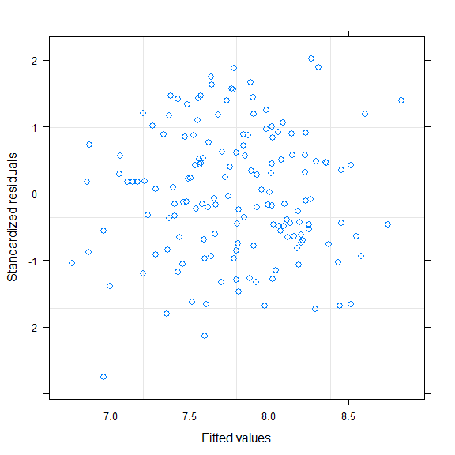
lme_v4 <- lme(log(meanBAI3) ~ scale(Admixed_prop) + scale(Hegyi) + scale(BAL) + scale(DBH) + scale(Martonne_new) + Species + scale(Admixed_prop)*Species + scale(Admixed_prop)*scale(DBH)+ scale(Admixed_prop)*scale(Hegyi) +scale(Admixed_prop)*scale(BAL)+scale(Admixed_prop)*scale(Martonne_new)
,random= ~1|Site
,weights = varExp( form = ~ DBH)
, data=data)
plot(lme_v4)
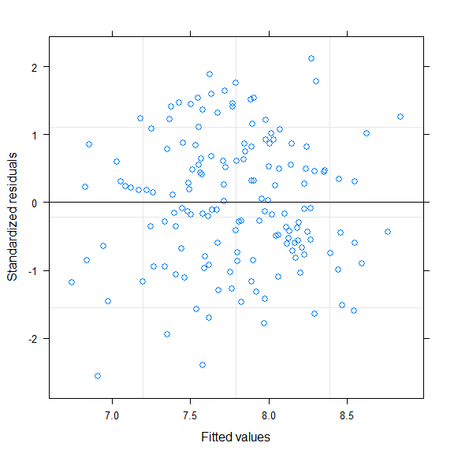
lme_v5 <- lme(log(meanBAI3) ~ scale(Admixed_prop) + scale(Hegyi) + scale(BAL) + scale(DBH) + scale(Martonne_new) + Species + scale(Admixed_prop)*Species + scale(Admixed_prop)*scale(DBH)+ scale(Admixed_prop)*scale(Hegyi) +scale(Admixed_prop)*scale(BAL)+scale(Admixed_prop)*scale(Martonne_new)
,random= ~1|Site
,weights = varPower( form = ~ DBH)
,data=data)
plot(lme_v5)
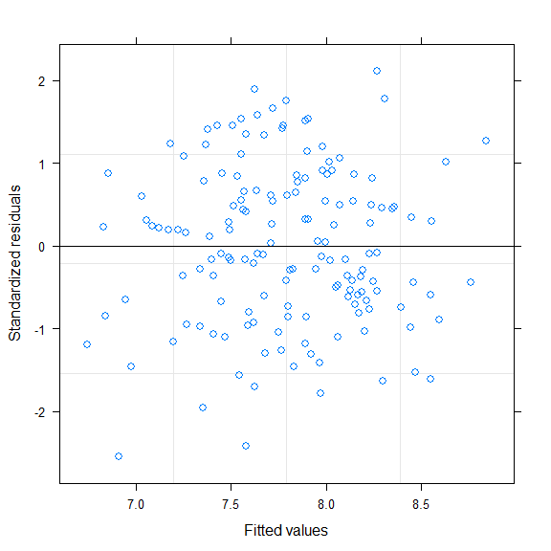
lme_v8 <- lme(log(meanBAI3) ~ scale(Admixed_prop) + scale(Hegyi) + scale(BAL) + scale(DBH) + scale(Martonne_new) + Species + scale(Admixed_prop)*Species + scale(Admixed_prop)*scale(DBH)+ scale(Admixed_prop)*scale(Hegyi) +scale(Admixed_prop)*scale(BAL)+scale(Admixed_prop)*scale(Martonne_new)
,random= ~1|Site
,weights = varExp( form = ~ BAL)
,data=data, na.action=na.exclude)
plot(lme_v8)
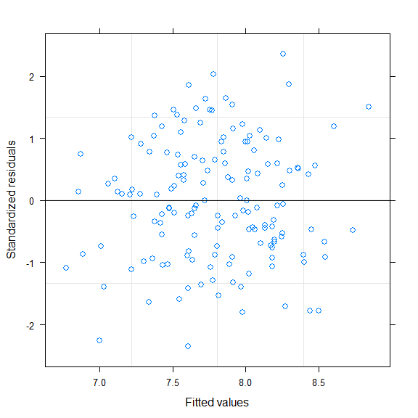
aictab(mget(str_subset(ls(), "lme_v")))# aictab: no adjustement of varaince structure needed
## Warning in aictab.AIClme(mget(str_subset(ls(), "lme_v"))):
## Model selection for fixed effects is only appropriate with method=ML:
## REML (default) should only be used to select random effects for a constant set of fixed effects
##
## Model selection based on AICc:
##
## K AICc Delta_AICc AICcWt Cum.Wt Res.LL
## lme_v1 14 234.44 0.00 0.33 0.33 -101.70
## lme_v8 15 234.57 0.13 0.31 0.64 -100.53
## lme_v5 15 236.33 1.89 0.13 0.76 -101.41
## lme_v4 15 236.42 1.98 0.12 0.89 -101.46
## lme_v2 15 236.54 2.10 0.11 1.00 -101.52
summary(lme_v1)# same as lme_r1
## Linear mixed-effects model fit by REML
## Data: data
## AIC BIC logLik
## 231.3934 272.676 -101.6967
##
## Random effects:
## Formula: ~1 | Site
## (Intercept) Residual
## StdDev: 0.3442674 0.4038346
##
## Fixed effects: log(meanBAI3) ~ scale(Admixed_prop) + scale(Hegyi) + scale(BAL) + scale(DBH) + scale(Martonne_new) + Species + scale(Admixed_prop) * Species + scale(Admixed_prop) * scale(DBH) + scale(Admixed_prop) * scale(Hegyi) + scale(Admixed_prop) * scale(BAL) + scale(Admixed_prop) * scale(Martonne_new)
## Value Std.Error DF t-value
## (Intercept) 7.730547 0.18163474 139 42.56095
## scale(Admixed_prop) 0.026890 0.05704710 139 0.47137
## scale(Hegyi) -0.155606 0.05965785 139 -2.60831
## scale(BAL) -0.065318 0.05169171 139 -1.26361
## scale(DBH) 0.351012 0.07206333 139 4.87088
## scale(Martonne_new) -0.291207 0.18066306 2 -1.61188
## SpeciesFir 0.159464 0.08940888 139 1.78354
## scale(Admixed_prop):SpeciesFir 0.070199 0.08949689 139 0.78437
## scale(Admixed_prop):scale(DBH) 0.137776 0.06512736 139 2.11549
## scale(Admixed_prop):scale(Hegyi) 0.198990 0.06157935 139 3.23144
## scale(Admixed_prop):scale(BAL) 0.068966 0.04095012 139 1.68414
## scale(Admixed_prop):scale(Martonne_new) 0.002508 0.04394349 139 0.05707
## p-value
## (Intercept) 0.0000
## scale(Admixed_prop) 0.6381
## scale(Hegyi) 0.0101
## scale(BAL) 0.2085
## scale(DBH) 0.0000
## scale(Martonne_new) 0.2483
## SpeciesFir 0.0767
## scale(Admixed_prop):SpeciesFir 0.4342
## scale(Admixed_prop):scale(DBH) 0.0362
## scale(Admixed_prop):scale(Hegyi) 0.0015
## scale(Admixed_prop):scale(BAL) 0.0944
## scale(Admixed_prop):scale(Martonne_new) 0.9546
## Correlation:
## (Intr) sc(A_) scl(H) s(BAL) s(DBH)
## scale(Admixed_prop) 0.039
## scale(Hegyi) 0.056 -0.063
## scale(BAL) -0.087 -0.261 -0.137
## scale(DBH) 0.099 -0.171 0.557 0.217
## scale(Martonne_new) 0.035 0.031 -0.008 -0.170 -0.172
## SpeciesFir -0.257 -0.135 -0.267 0.353 -0.381
## scale(Admixed_prop):SpeciesFir -0.043 -0.810 0.097 0.320 0.188
## scale(Admixed_prop):scale(DBH) -0.038 0.296 -0.123 0.271 -0.006
## scale(Admixed_prop):scale(Hegyi) -0.019 0.221 -0.229 0.237 -0.062
## scale(Admixed_prop):scale(BAL) -0.076 -0.371 0.113 0.112 0.157
## scale(Admixed_prop):scale(Martonne_new) 0.006 -0.099 -0.064 -0.112 -0.153
## sc(M_) SpcsFr s(A_):S s(A_):(D
## scale(Admixed_prop)
## scale(Hegyi)
## scale(BAL)
## scale(DBH)
## scale(Martonne_new)
## SpeciesFir 0.018
## scale(Admixed_prop):SpeciesFir -0.044 0.151
## scale(Admixed_prop):scale(DBH) -0.064 0.176 -0.374
## scale(Admixed_prop):scale(Hegyi) -0.064 0.170 -0.236 0.763
## scale(Admixed_prop):scale(BAL) -0.015 0.298 0.410 -0.042
## scale(Admixed_prop):scale(Martonne_new) 0.045 -0.063 0.175 -0.544
## s(A_):(H s(A_):(B
## scale(Admixed_prop)
## scale(Hegyi)
## scale(BAL)
## scale(DBH)
## scale(Martonne_new)
## SpeciesFir
## scale(Admixed_prop):SpeciesFir
## scale(Admixed_prop):scale(DBH)
## scale(Admixed_prop):scale(Hegyi)
## scale(Admixed_prop):scale(BAL) -0.043
## scale(Admixed_prop):scale(Martonne_new) -0.308 -0.257
##
## Standardized Within-Group Residuals:
## Min Q1 Med Q3 Max
## -2.69742406 -0.67795313 -0.08993041 0.71315404 2.08442327
##
## Number of Observations: 153
## Number of Groups: 4
plot(lme_v1)
# Final random structure
lme_rv <- lme_v1
summary(lme_rv)
## Linear mixed-effects model fit by REML
## Data: data
## AIC BIC logLik
## 231.3934 272.676 -101.6967
##
## Random effects:
## Formula: ~1 | Site
## (Intercept) Residual
## StdDev: 0.3442674 0.4038346
##
## Fixed effects: log(meanBAI3) ~ scale(Admixed_prop) + scale(Hegyi) + scale(BAL) + scale(DBH) + scale(Martonne_new) + Species + scale(Admixed_prop) * Species + scale(Admixed_prop) * scale(DBH) + scale(Admixed_prop) * scale(Hegyi) + scale(Admixed_prop) * scale(BAL) + scale(Admixed_prop) * scale(Martonne_new)
## Value Std.Error DF t-value
## (Intercept) 7.730547 0.18163474 139 42.56095
## scale(Admixed_prop) 0.026890 0.05704710 139 0.47137
## scale(Hegyi) -0.155606 0.05965785 139 -2.60831
## scale(BAL) -0.065318 0.05169171 139 -1.26361
## scale(DBH) 0.351012 0.07206333 139 4.87088
## scale(Martonne_new) -0.291207 0.18066306 2 -1.61188
## SpeciesFir 0.159464 0.08940888 139 1.78354
## scale(Admixed_prop):SpeciesFir 0.070199 0.08949689 139 0.78437
## scale(Admixed_prop):scale(DBH) 0.137776 0.06512736 139 2.11549
## scale(Admixed_prop):scale(Hegyi) 0.198990 0.06157935 139 3.23144
## scale(Admixed_prop):scale(BAL) 0.068966 0.04095012 139 1.68414
## scale(Admixed_prop):scale(Martonne_new) 0.002508 0.04394349 139 0.05707
## p-value
## (Intercept) 0.0000
## scale(Admixed_prop) 0.6381
## scale(Hegyi) 0.0101
## scale(BAL) 0.2085
## scale(DBH) 0.0000
## scale(Martonne_new) 0.2483
## SpeciesFir 0.0767
## scale(Admixed_prop):SpeciesFir 0.4342
## scale(Admixed_prop):scale(DBH) 0.0362
## scale(Admixed_prop):scale(Hegyi) 0.0015
## scale(Admixed_prop):scale(BAL) 0.0944
## scale(Admixed_prop):scale(Martonne_new) 0.9546
## Correlation:
## (Intr) sc(A_) scl(H) s(BAL) s(DBH)
## scale(Admixed_prop) 0.039
## scale(Hegyi) 0.056 -0.063
## scale(BAL) -0.087 -0.261 -0.137
## scale(DBH) 0.099 -0.171 0.557 0.217
## scale(Martonne_new) 0.035 0.031 -0.008 -0.170 -0.172
## SpeciesFir -0.257 -0.135 -0.267 0.353 -0.381
## scale(Admixed_prop):SpeciesFir -0.043 -0.810 0.097 0.320 0.188
## scale(Admixed_prop):scale(DBH) -0.038 0.296 -0.123 0.271 -0.006
## scale(Admixed_prop):scale(Hegyi) -0.019 0.221 -0.229 0.237 -0.062
## scale(Admixed_prop):scale(BAL) -0.076 -0.371 0.113 0.112 0.157
## scale(Admixed_prop):scale(Martonne_new) 0.006 -0.099 -0.064 -0.112 -0.153
## sc(M_) SpcsFr s(A_):S s(A_):(D
## scale(Admixed_prop)
## scale(Hegyi)
## scale(BAL)
## scale(DBH)
## scale(Martonne_new)
## SpeciesFir 0.018
## scale(Admixed_prop):SpeciesFir -0.044 0.151
## scale(Admixed_prop):scale(DBH) -0.064 0.176 -0.374
## scale(Admixed_prop):scale(Hegyi) -0.064 0.170 -0.236 0.763
## scale(Admixed_prop):scale(BAL) -0.015 0.298 0.410 -0.042
## scale(Admixed_prop):scale(Martonne_new) 0.045 -0.063 0.175 -0.544
## s(A_):(H s(A_):(B
## scale(Admixed_prop)
## scale(Hegyi)
## scale(BAL)
## scale(DBH)
## scale(Martonne_new)
## SpeciesFir
## scale(Admixed_prop):SpeciesFir
## scale(Admixed_prop):scale(DBH)
## scale(Admixed_prop):scale(Hegyi)
## scale(Admixed_prop):scale(BAL) -0.043
## scale(Admixed_prop):scale(Martonne_new) -0.308 -0.257
##
## Standardized Within-Group Residuals:
## Min Q1 Med Q3 Max
## -2.69742406 -0.67795313 -0.08993041 0.71315404 2.08442327
##
## Number of Observations: 153
## Number of Groups: 4
# model check:
plot(lme_rv) #looks good
qqnorm(resid(lme_rv))
##checking predictors
op <- par(mfrow = c(2, 3), mar = c(4, 4, 3, 2))
plot(data$DBH,resid(lme_rv,type="pearson"))
plot(data$Hegyi,resid(lme_rv,type="pearson"))
plot(data$BAL,resid(lme_rv,type="pearson"))
plot(data$Admixed_prop,resid(lme_rv,type="pearson"))
# seems all ok
par(op)
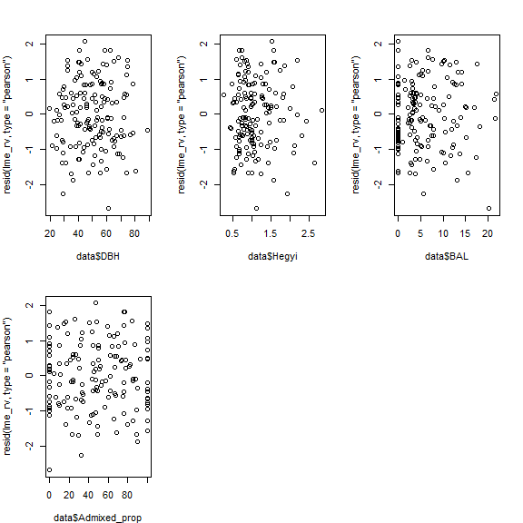
#Fixed effects selection based on likelihood ratio tests using anova()
#best full model
lme_v1 <- lme(log(meanBAI3) ~ scale(Admixed_prop) + scale(Hegyi) + scale(BAL) + scale(DBH) + scale(Martonne_new) + Species + scale(Admixed_prop)*Species + scale(Admixed_prop)*scale(DBH)+ scale(Admixed_prop)*scale(Hegyi) +scale(Admixed_prop)*scale(BAL)+scale(Admixed_prop)*scale(Martonne_new)
,random= ~1|Site , data=data, method="ML")
lme_f0 <-lme_v1
summary(lme_f0)
## Linear mixed-effects model fit by maximum likelihood
## Data: data
## AIC BIC logLik
## 184.8334 227.2595 -78.41669
##
## Random effects:
## Formula: ~1 | Site
## (Intercept) Residual
## StdDev: 0.2175692 0.3907217
##
## Fixed effects: log(meanBAI3) ~ scale(Admixed_prop) + scale(Hegyi) + scale(BAL) + scale(DBH) + scale(Martonne_new) + Species + scale(Admixed_prop) * Species + scale(Admixed_prop) * scale(DBH) + scale(Admixed_prop) * scale(Hegyi) + scale(Admixed_prop) * scale(BAL) + scale(Admixed_prop) * scale(Martonne_new)
## Value Std.Error DF t-value
## (Intercept) 7.726272 0.12731863 139 60.68454
## scale(Admixed_prop) 0.028656 0.05747569 139 0.49858
## scale(Hegyi) -0.147207 0.05959186 139 -2.47025
## scale(BAL) -0.075688 0.05160712 139 -1.46662
## scale(DBH) 0.335678 0.07176328 139 4.67758
## scale(Martonne_new) -0.276611 0.12530337 2 -2.20753
## SpeciesFir 0.164986 0.09001963 139 1.83278
## scale(Admixed_prop):SpeciesFir 0.066430 0.09016113 139 0.73680
## scale(Admixed_prop):scale(DBH) 0.135478 0.06561878 139 2.06462
## scale(Admixed_prop):scale(Hegyi) 0.195753 0.06198898 139 3.15787
## scale(Admixed_prop):scale(BAL) 0.069736 0.04125395 139 1.69041
## scale(Admixed_prop):scale(Martonne_new) 0.004532 0.04426474 139 0.10239
## p-value
## (Intercept) 0.0000
## scale(Admixed_prop) 0.6189
## scale(Hegyi) 0.0147
## scale(BAL) 0.1447
## scale(DBH) 0.0000
## scale(Martonne_new) 0.1580
## SpeciesFir 0.0690
## scale(Admixed_prop):SpeciesFir 0.4625
## scale(Admixed_prop):scale(DBH) 0.0408
## scale(Admixed_prop):scale(Hegyi) 0.0019
## scale(Admixed_prop):scale(BAL) 0.0932
## scale(Admixed_prop):scale(Martonne_new) 0.9186
## Correlation:
## (Intr) sc(A_) scl(H) s(BAL) s(DBH)
## scale(Admixed_prop) 0.057
## scale(Hegyi) 0.083 -0.064
## scale(BAL) -0.130 -0.260 -0.129
## scale(DBH) 0.141 -0.169 0.577 0.201
## scale(Martonne_new) 0.024 0.043 -0.019 -0.239 -0.241
## SpeciesFir -0.369 -0.136 -0.272 0.363 -0.379
## scale(Admixed_prop):SpeciesFir -0.062 -0.810 0.099 0.319 0.186
## scale(Admixed_prop):scale(DBH) -0.055 0.297 -0.121 0.271 -0.009
## scale(Admixed_prop):scale(Hegyi) -0.028 0.221 -0.224 0.236 -0.066
## scale(Admixed_prop):scale(BAL) -0.109 -0.372 0.115 0.115 0.162
## scale(Admixed_prop):scale(Martonne_new) 0.009 -0.100 -0.069 -0.109 -0.152
## sc(M_) SpcsFr s(A_):S s(A_):(D
## scale(Admixed_prop)
## scale(Hegyi)
## scale(BAL)
## scale(DBH)
## scale(Martonne_new)
## SpeciesFir 0.023
## scale(Admixed_prop):SpeciesFir -0.061 0.152
## scale(Admixed_prop):scale(DBH) -0.091 0.177 -0.375
## scale(Admixed_prop):scale(Hegyi) -0.090 0.172 -0.237 0.763
## scale(Admixed_prop):scale(BAL) -0.024 0.297 0.411 -0.042
## scale(Admixed_prop):scale(Martonne_new) 0.063 -0.065 0.176 -0.543
## s(A_):(H s(A_):(B
## scale(Admixed_prop)
## scale(Hegyi)
## scale(BAL)
## scale(DBH)
## scale(Martonne_new)
## SpeciesFir
## scale(Admixed_prop):SpeciesFir
## scale(Admixed_prop):scale(DBH)
## scale(Admixed_prop):scale(Hegyi)
## scale(Admixed_prop):scale(BAL) -0.044
## scale(Admixed_prop):scale(Martonne_new) -0.307 -0.257
##
## Standardized Within-Group Residuals:
## Min Q1 Med Q3 Max
## -2.78269666 -0.69489230 -0.07780347 0.69787944 2.20653033
##
## Number of Observations: 153
## Number of Groups: 4
max(vif.mer(lme_f0))# 3.9 too high
## [1] 3.933407
#drop term with highest P-value: species* admixed_prop
lme_f1 <- lme(log(meanBAI3) ~ scale(Admixed_prop) + scale(Hegyi) + scale(BAL) + scale(DBH) + scale(Martonne_new) + Species + scale(Admixed_prop)*scale(DBH)+ scale(Admixed_prop)*scale(Hegyi) +scale(Admixed_prop)*scale(BAL)+scale(Admixed_prop)*scale(Martonne_new)
,random= ~1|Site , data=data, method="ML")
summary(lme_f1)
## Linear mixed-effects model fit by maximum likelihood
## Data: data
## AIC BIC logLik
## 183.4185 222.8142 -78.70924
##
## Random effects:
## Formula: ~1 | Site
## (Intercept) Residual
## StdDev: 0.2128957 0.3916976
##
## Fixed effects: log(meanBAI3) ~ scale(Admixed_prop) + scale(Hegyi) + scale(BAL) + scale(DBH) + scale(Martonne_new) + Species + scale(Admixed_prop) * scale(DBH) + scale(Admixed_prop) * scale(Hegyi) + scale(Admixed_prop) * scale(BAL) + scale(Admixed_prop) * scale(Martonne_new)
## Value Std.Error DF t-value
## (Intercept) 7.731728 0.12452619 140 62.08917
## scale(Admixed_prop) 0.062954 0.03365228 140 1.87073
## scale(Hegyi) -0.150921 0.05919255 140 -2.54966
## scale(BAL) -0.088556 0.04882058 140 -1.81391
## scale(DBH) 0.324753 0.07037946 140 4.61432
## scale(Martonne_new) -0.269893 0.12244779 2 -2.20415
## SpeciesFir 0.155355 0.08887078 140 1.74810
## scale(Admixed_prop):scale(DBH) 0.153335 0.06077661 140 2.52293
## scale(Admixed_prop):scale(Hegyi) 0.206282 0.06015586 140 3.42913
## scale(Admixed_prop):scale(BAL) 0.057359 0.03756915 140 1.52675
## scale(Admixed_prop):scale(Martonne_new) -0.001024 0.04352786 140 -0.02353
## p-value
## (Intercept) 0.0000
## scale(Admixed_prop) 0.0635
## scale(Hegyi) 0.0119
## scale(BAL) 0.0718
## scale(DBH) 0.0000
## scale(Martonne_new) 0.1583
## SpeciesFir 0.0826
## scale(Admixed_prop):scale(DBH) 0.0128
## scale(Admixed_prop):scale(Hegyi) 0.0008
## scale(Admixed_prop):scale(BAL) 0.1291
## scale(Admixed_prop):scale(Martonne_new) 0.9813
## Correlation:
## (Intr) sc(A_) scl(H) s(BAL) s(DBH)
## scale(Admixed_prop) 0.012
## scale(Hegyi) 0.092 0.028
## scale(BAL) -0.119 -0.003 -0.170
## scale(DBH) 0.158 -0.032 0.573 0.151
## scale(Martonne_new) 0.020 -0.011 -0.014 -0.236 -0.238
## SpeciesFir -0.372 -0.022 -0.293 0.337 -0.419
## scale(Admixed_prop):scale(DBH) -0.087 -0.012 -0.090 0.445 0.066
## scale(Admixed_prop):scale(Hegyi) -0.045 0.052 -0.207 0.338 -0.024
## scale(Admixed_prop):scale(BAL) -0.093 -0.073 0.082 -0.018 0.096
## scale(Admixed_prop):scale(Martonne_new) 0.021 0.074 -0.089 -0.177 -0.190
## sc(M_) SpcsFr s(A_):(D s(A_):(H
## scale(Admixed_prop)
## scale(Hegyi)
## scale(BAL)
## scale(DBH)
## scale(Martonne_new)
## SpeciesFir 0.033
## scale(Admixed_prop):scale(DBH) -0.125 0.255
## scale(Admixed_prop):scale(Hegyi) -0.110 0.216 0.748
## scale(Admixed_prop):scale(BAL) 0.001 0.261 0.132 0.061
## scale(Admixed_prop):scale(Martonne_new) 0.077 -0.094 -0.523 -0.277
## s(A_):(B
## scale(Admixed_prop)
## scale(Hegyi)
## scale(BAL)
## scale(DBH)
## scale(Martonne_new)
## SpeciesFir
## scale(Admixed_prop):scale(DBH)
## scale(Admixed_prop):scale(Hegyi)
## scale(Admixed_prop):scale(BAL)
## scale(Admixed_prop):scale(Martonne_new) -0.367
##
## Standardized Within-Group Residuals:
## Min Q1 Med Q3 Max
## -2.88578571 -0.68003191 -0.01993937 0.62699635 2.20584845
##
## Number of Observations: 153
## Number of Groups: 4
anova(lme_f0,lme_f1) #decreases AIC although not sig better as null
## Model df AIC BIC logLik Test L.Ratio p-value
## lme_f0 1 14 184.8334 227.2595 -78.41669
## lme_f1 2 13 183.4185 222.8142 -78.70924 1 vs 2 0.5851089 0.4443
#drop next term: martonne * admix interaction
lme_f2 <- lme(log(meanBAI3) ~ scale(Admixed_prop) + scale(Hegyi) + scale(BAL) + scale(DBH) + scale(Martonne_new) + Species + scale(Admixed_prop)*scale(DBH)+ scale(Admixed_prop)*scale(Hegyi) +scale(Admixed_prop)*scale(BAL)
,random= ~1|Site
,data=data, method="ML")
summary(lme_f2)
## Linear mixed-effects model fit by maximum likelihood
## Data: data
## AIC BIC logLik
## 181.4191 217.7843 -78.70954
##
## Random effects:
## Formula: ~1 | Site
## (Intercept) Residual
## StdDev: 0.2127117 0.3917067
##
## Fixed effects: log(meanBAI3) ~ scale(Admixed_prop) + scale(Hegyi) + scale(BAL) + scale(DBH) + scale(Martonne_new) + Species + scale(Admixed_prop) * scale(DBH) + scale(Admixed_prop) * scale(Hegyi) + scale(Admixed_prop) * scale(BAL)
## Value Std.Error DF t-value p-value
## (Intercept) 7.731776 0.12397931 141 62.36344 0.0000
## scale(Admixed_prop) 0.063012 0.03344283 141 1.88418 0.0616
## scale(Hegyi) -0.151019 0.05875295 141 -2.57041 0.0112
## scale(BAL) -0.088785 0.04788180 141 -1.85426 0.0658
## scale(DBH) 0.324399 0.06885198 141 4.71154 0.0000
## scale(Martonne_new) -0.269633 0.12157197 2 -2.21789 0.1568
## SpeciesFir 0.155177 0.08816942 141 1.75998 0.0806
## scale(Admixed_prop):scale(DBH) 0.152583 0.05161713 141 2.95604 0.0037
## scale(Admixed_prop):scale(Hegyi) 0.205882 0.05760251 141 3.57418 0.0005
## scale(Admixed_prop):scale(BAL) 0.057041 0.03482466 141 1.63794 0.1037
## Correlation:
## (Intr) sc(A_) scl(H) s(BAL) s(DBH) sc(M_)
## scale(Admixed_prop) 0.011
## scale(Hegyi) 0.094 0.035
## scale(BAL) -0.117 0.010 -0.189
## scale(DBH) 0.165 -0.019 0.569 0.121
## scale(Martonne_new) 0.018 -0.017 -0.007 -0.227 -0.229
## SpeciesFir -0.372 -0.015 -0.303 0.327 -0.447 0.040
## scale(Admixed_prop):scale(DBH) -0.089 0.031 -0.161 0.420 -0.040 -0.100
## scale(Admixed_prop):scale(Hegyi) -0.041 0.075 -0.242 0.306 -0.081 -0.093
## scale(Admixed_prop):scale(BAL) -0.092 -0.049 0.053 -0.091 0.029 0.032
## SpcsFr s(A_):(D s(A_):(H
## scale(Admixed_prop)
## scale(Hegyi)
## scale(BAL)
## scale(DBH)
## scale(Martonne_new)
## SpeciesFir
## scale(Admixed_prop):scale(DBH) 0.243
## scale(Admixed_prop):scale(Hegyi) 0.199 0.737
## scale(Admixed_prop):scale(BAL) 0.244 -0.076 -0.046
##
## Standardized Within-Group Residuals:
## Min Q1 Med Q3 Max
## -2.88580430 -0.68286539 -0.02037989 0.62857664 2.20675445
##
## Number of Observations: 153
## Number of Groups: 4
anova(lme_f0,lme_f2,lme_f1)# decreases AIC although not sig better as null
## Model df AIC BIC logLik Test L.Ratio p-value
## lme_f0 1 14 184.8334 227.2595 -78.41669
## lme_f2 2 12 181.4191 217.7843 -78.70954 1 vs 2 0.5857019 0.7461
## lme_f1 3 13 183.4185 222.8142 -78.70924 2 vs 3 0.0005930 0.9806
#drop next term: martonne
lme_f3 <- lme(log(meanBAI3) ~ scale(Admixed_prop) + scale(Hegyi) + scale(BAL) + scale(DBH)+ Species + scale(Admixed_prop)*scale(DBH)+ scale(Admixed_prop)*scale(Hegyi) +scale(Admixed_prop)*scale(BAL)
,random= ~1|Site
,data=data, method="ML")
summary(lme_f3)
## Linear mixed-effects model fit by maximum likelihood
## Data: data
## AIC BIC logLik
## 182.9862 216.321 -80.49311
##
## Random effects:
## Formula: ~1 | Site
## (Intercept) Residual
## StdDev: 0.3488999 0.3914701
##
## Fixed effects: log(meanBAI3) ~ scale(Admixed_prop) + scale(Hegyi) + scale(BAL) + scale(DBH) + Species + scale(Admixed_prop) * scale(DBH) + scale(Admixed_prop) * scale(Hegyi) + scale(Admixed_prop) * scale(BAL)
## Value Std.Error DF t-value p-value
## (Intercept) 7.746729 0.18865843 141 41.06219 0.0000
## scale(Admixed_prop) 0.062798 0.03331020 141 1.88524 0.0615
## scale(Hegyi) -0.161085 0.05916867 141 -2.72247 0.0073
## scale(BAL) -0.089524 0.04760040 141 -1.88073 0.0621
## scale(DBH) 0.324052 0.06863147 141 4.72163 0.0000
## SpeciesFir 0.151640 0.08791636 141 1.72482 0.0868
## scale(Admixed_prop):scale(DBH) 0.149264 0.05130824 141 2.90916 0.0042
## scale(Admixed_prop):scale(Hegyi) 0.203849 0.05732958 141 3.55574 0.0005
## scale(Admixed_prop):scale(BAL) 0.055758 0.03472980 141 1.60548 0.1106
## Correlation:
## (Intr) sc(A_) scl(H) s(BAL) s(DBH) SpcsFr
## scale(Admixed_prop) 0.007
## scale(Hegyi) 0.059 0.032
## scale(BAL) -0.069 0.009 -0.199
## scale(DBH) 0.116 -0.021 0.553 0.120
## SpeciesFir -0.245 -0.015 -0.296 0.323 -0.451
## scale(Admixed_prop):scale(DBH) -0.056 0.031 -0.162 0.414 -0.047 0.244
## scale(Admixed_prop):scale(Hegyi) -0.024 0.075 -0.247 0.301 -0.087 0.199
## scale(Admixed_prop):scale(BAL) -0.062 -0.048 0.054 -0.095 0.023 0.246
## s(A_):(D s(A_):(H
## scale(Admixed_prop)
## scale(Hegyi)
## scale(BAL)
## scale(DBH)
## SpeciesFir
## scale(Admixed_prop):scale(DBH)
## scale(Admixed_prop):scale(Hegyi) 0.736
## scale(Admixed_prop):scale(BAL) -0.075 -0.045
##
## Standardized Within-Group Residuals:
## Min Q1 Med Q3 Max
## -2.88369701 -0.68037467 -0.03314333 0.60071907 2.19271023
##
## Number of Observations: 153
## Number of Groups: 4
anova(lme_f0,lme_f2,lme_f3, lme_f1)# NO keep Martonne: increases AIC and model worse at p=0.05
## Model df AIC BIC logLik Test L.Ratio p-value
## lme_f0 1 14 184.8334 227.2595 -78.41669
## lme_f2 2 12 181.4191 217.7843 -78.70954 1 vs 2 0.585702 0.7461
## lme_f3 3 11 182.9862 216.3210 -80.49311 2 vs 3 3.567135 0.0589
## lme_f1 4 13 183.4185 222.8142 -78.70924 3 vs 4 3.567728 0.1680
#alternative drop BAL * admix prop
lme_f4 <- lme(log(meanBAI3) ~ scale(Admixed_prop) + scale(Hegyi) + scale(BAL) + scale(DBH) + scale(Martonne_new) + Species + scale(Admixed_prop)*scale(DBH)+ scale(Admixed_prop)*scale(Hegyi) ,random= ~1|Site
,data=data, method="ML")
summary(lme_f4)
## Linear mixed-effects model fit by maximum likelihood
## Data: data
## AIC BIC logLik
## 182.2465 215.5814 -80.12327
##
## Random effects:
## Formula: ~1 | Site
## (Intercept) Residual
## StdDev: 0.2267826 0.3948078
##
## Fixed effects: log(meanBAI3) ~ scale(Admixed_prop) + scale(Hegyi) + scale(BAL) + scale(DBH) + scale(Martonne_new) + Species + scale(Admixed_prop) * scale(DBH) + scale(Admixed_prop) * scale(Hegyi)
## Value Std.Error DF t-value p-value
## (Intercept) 7.751179 0.12973612 142 59.74573 0.0000
## scale(Admixed_prop) 0.065727 0.03355107 142 1.95902 0.0521
## scale(Hegyi) -0.157669 0.05902966 142 -2.67101 0.0084
## scale(BAL) -0.080052 0.04796318 142 -1.66903 0.0973
## scale(DBH) 0.323730 0.06926729 142 4.67363 0.0000
## scale(Martonne_new) -0.278434 0.12794409 2 -2.17621 0.1615
## SpeciesFir 0.118973 0.08589052 142 1.38517 0.1682
## scale(Admixed_prop):scale(DBH) 0.159210 0.05169823 142 3.07960 0.0025
## scale(Admixed_prop):scale(Hegyi) 0.210693 0.05780654 142 3.64479 0.0004
## Correlation:
## (Intr) sc(A_) scl(H) s(BAL) s(DBH) sc(M_)
## scale(Admixed_prop) 0.006
## scale(Hegyi) 0.095 0.037
## scale(BAL) -0.121 0.006 -0.186
## scale(DBH) 0.161 -0.017 0.565 0.127
## scale(Martonne_new) 0.023 -0.015 -0.007 -0.216 -0.220
## SpeciesFir -0.346 -0.004 -0.326 0.360 -0.469 0.032
## scale(Admixed_prop):scale(DBH) -0.092 0.028 -0.158 0.415 -0.037 -0.094
## scale(Admixed_prop):scale(Hegyi) -0.043 0.073 -0.241 0.303 -0.079 -0.088
## SpcsFr s(A_):(D
## scale(Admixed_prop)
## scale(Hegyi)
## scale(BAL)
## scale(DBH)
## scale(Martonne_new)
## SpeciesFir
## scale(Admixed_prop):scale(DBH) 0.270
## scale(Admixed_prop):scale(Hegyi) 0.217 0.736
##
## Standardized Within-Group Residuals:
## Min Q1 Med Q3 Max
## -3.31816496 -0.66945150 0.02929204 0.68065863 2.22363959
##
## Number of Observations: 153
## Number of Groups: 4
anova(lme_f0, lme_f2,lme_f4, lme_f1) # increases AIC but gets not worse
## Model df AIC BIC logLik Test L.Ratio p-value
## lme_f0 1 14 184.8334 227.2595 -78.41669
## lme_f2 2 12 181.4191 217.7843 -78.70954 1 vs 2 0.5857019 0.7461
## lme_f4 3 11 182.2465 215.5814 -80.12327 2 vs 3 2.8274599 0.0927
## lme_f1 4 13 183.4185 222.8142 -78.70924 3 vs 4 2.8280528 0.2432
# drop also BAL?
lme_f5<- lme(log(meanBAI3) ~ scale(Admixed_prop) + scale(Hegyi) + scale(DBH) + scale(Martonne_new) + Species + scale(Admixed_prop)*scale(DBH)+ scale(Admixed_prop)*scale(Hegyi) ,random= ~1|Site
,data=data, method="ML")
summary(lme_f5)
## Linear mixed-effects model fit by maximum likelihood
## Data: data
## AIC BIC logLik
## 183.0242 213.3286 -81.5121
##
## Random effects:
## Formula: ~1 | Site
## (Intercept) Residual
## StdDev: 0.2664943 0.3968891
##
## Fixed effects: log(meanBAI3) ~ scale(Admixed_prop) + scale(Hegyi) + scale(DBH) + scale(Martonne_new) + Species + scale(Admixed_prop) * scale(DBH) + scale(Admixed_prop) * scale(Hegyi)
## Value Std.Error DF t-value p-value
## (Intercept) 7.728450 0.14727556 143 52.47612 0.0000
## scale(Admixed_prop) 0.066110 0.03361336 143 1.96678 0.0511
## scale(Hegyi) -0.179064 0.05830838 143 -3.07099 0.0026
## scale(DBH) 0.344735 0.06909773 143 4.98909 0.0000
## scale(Martonne_new) -0.328658 0.14397386 2 -2.28276 0.1499
## SpeciesFir 0.165126 0.08043494 143 2.05291 0.0419
## scale(Admixed_prop):scale(DBH) 0.193742 0.04712556 143 4.11119 0.0001
## scale(Admixed_prop):scale(Hegyi) 0.239610 0.05520843 143 4.34011 0.0000
## Correlation:
## (Intr) sc(A_) scl(H) s(DBH) sc(M_) SpcsFr
## scale(Admixed_prop) 0.006
## scale(Hegyi) 0.064 0.038
## scale(DBH) 0.158 -0.018 0.598
## scale(Martonne_new) 0.008 -0.012 -0.041 -0.175
## SpeciesFir -0.287 -0.006 -0.279 -0.558 0.106
## scale(Admixed_prop):scale(DBH) -0.041 0.028 -0.089 -0.102 -0.003 0.143
## scale(Admixed_prop):scale(Hegyi) -0.006 0.075 -0.198 -0.126 -0.021 0.122
## s(A_):(D
## scale(Admixed_prop)
## scale(Hegyi)
## scale(DBH)
## scale(Martonne_new)
## SpeciesFir
## scale(Admixed_prop):scale(DBH)
## scale(Admixed_prop):scale(Hegyi) 0.704
##
## Standardized Within-Group Residuals:
## Min Q1 Med Q3 Max
## -3.60047272 -0.65519119 -0.02144695 0.69156824 2.20235398
##
## Number of Observations: 153
## Number of Groups: 4
anova(lme_f0, lme_f2,lme_f5, lme_f1)# increases AIC but not worse sig
## Model df AIC BIC logLik Test L.Ratio p-value
## lme_f0 1 14 184.8334 227.2595 -78.41669
## lme_f2 2 12 181.4191 217.7843 -78.70954 1 vs 2 0.585702 0.7461
## lme_f5 3 10 183.0242 213.3286 -81.51210 2 vs 3 5.605123 0.0607
## lme_f1 4 13 183.4185 222.8142 -78.70924 3 vs 4 5.605716 0.1325
anova(lme_f2,lme_f5)
## Model df AIC BIC logLik Test L.Ratio p-value
## lme_f2 1 12 181.4191 217.7843 -78.70954
## lme_f5 2 10 183.0242 213.3286 -81.51210 1 vs 2 5.605123 0.0607
# check again if dropping last significant term martonne
lme_f6<- lme(log(meanBAI3) ~ scale(Admixed_prop) + scale(Hegyi) + scale(DBH) + Species + scale(Admixed_prop)*scale(DBH)+ scale(Admixed_prop)*scale(Hegyi) ,random= ~1|Site
,data=data, method="ML")
summary(lme_f6)
## Linear mixed-effects model fit by maximum likelihood
## Data: data
## AIC BIC logLik
## 184.5486 211.8225 -83.27429
##
## Random effects:
## Formula: ~1 | Site
## (Intercept) Residual
## StdDev: 0.4273144 0.396735
##
## Fixed effects: log(meanBAI3) ~ scale(Admixed_prop) + scale(Hegyi) + scale(DBH) + Species + scale(Admixed_prop) * scale(DBH) + scale(Admixed_prop) * scale(Hegyi)
## Value Std.Error DF t-value p-value
## (Intercept) 7.744986 0.22540068 143 34.36097 0.0000
## scale(Admixed_prop) 0.065842 0.03348843 143 1.96611 0.0512
## scale(Hegyi) -0.187094 0.05844544 143 -3.20118 0.0017
## scale(DBH) 0.344593 0.06887702 143 5.00302 0.0000
## SpeciesFir 0.163458 0.08020853 143 2.03792 0.0434
## scale(Admixed_prop):scale(DBH) 0.191193 0.04697503 143 4.07011 0.0001
## scale(Admixed_prop):scale(Hegyi) 0.237969 0.05503089 143 4.32428 0.0000
## Correlation:
## (Intr) sc(A_) scl(H) s(DBH) SpcsFr
## scale(Admixed_prop) 0.004
## scale(Hegyi) 0.041 0.035
## scale(DBH) 0.108 -0.020 0.589
## SpeciesFir -0.190 -0.005 -0.271 -0.559
## scale(Admixed_prop):scale(DBH) -0.027 0.028 -0.087 -0.106 0.146
## scale(Admixed_prop):scale(Hegyi) -0.004 0.076 -0.200 -0.129 0.123
## s(A_):(D
## scale(Admixed_prop)
## scale(Hegyi)
## scale(DBH)
## SpeciesFir
## scale(Admixed_prop):scale(DBH)
## scale(Admixed_prop):scale(Hegyi) 0.704
##
## Standardized Within-Group Residuals:
## Min Q1 Med Q3 Max
## -3.593445459 -0.660654453 0.001167001 0.719843657 2.192002393
##
## Number of Observations: 153
## Number of Groups: 4
anova(lme_f0, lme_f2,lme_f6, lme_f5, lme_f1)# gets sig worse, keep martonne
## Model df AIC BIC logLik Test L.Ratio p-value
## lme_f0 1 14 184.8334 227.2595 -78.41669
## lme_f2 2 12 181.4191 217.7843 -78.70954 1 vs 2 0.585702 0.7461
## lme_f6 3 9 184.5486 211.8225 -83.27429 2 vs 3 9.129507 0.0276
## lme_f5 4 10 183.0242 213.3286 -81.51210 3 vs 4 3.524383 0.0605
## lme_f1 5 13 183.4185 222.8142 -78.70924 4 vs 5 5.605716 0.1325
lme_final <- lme_f5
summary(lme_final)
## Linear mixed-effects model fit by maximum likelihood
## Data: data
## AIC BIC logLik
## 183.0242 213.3286 -81.5121
##
## Random effects:
## Formula: ~1 | Site
## (Intercept) Residual
## StdDev: 0.2664943 0.3968891
##
## Fixed effects: log(meanBAI3) ~ scale(Admixed_prop) + scale(Hegyi) + scale(DBH) + scale(Martonne_new) + Species + scale(Admixed_prop) * scale(DBH) + scale(Admixed_prop) * scale(Hegyi)
## Value Std.Error DF t-value p-value
## (Intercept) 7.728450 0.14727556 143 52.47612 0.0000
## scale(Admixed_prop) 0.066110 0.03361336 143 1.96678 0.0511
## scale(Hegyi) -0.179064 0.05830838 143 -3.07099 0.0026
## scale(DBH) 0.344735 0.06909773 143 4.98909 0.0000
## scale(Martonne_new) -0.328658 0.14397386 2 -2.28276 0.1499
## SpeciesFir 0.165126 0.08043494 143 2.05291 0.0419
## scale(Admixed_prop):scale(DBH) 0.193742 0.04712556 143 4.11119 0.0001
## scale(Admixed_prop):scale(Hegyi) 0.239610 0.05520843 143 4.34011 0.0000
## Correlation:
## (Intr) sc(A_) scl(H) s(DBH) sc(M_) SpcsFr
## scale(Admixed_prop) 0.006
## scale(Hegyi) 0.064 0.038
## scale(DBH) 0.158 -0.018 0.598
## scale(Martonne_new) 0.008 -0.012 -0.041 -0.175
## SpeciesFir -0.287 -0.006 -0.279 -0.558 0.106
## scale(Admixed_prop):scale(DBH) -0.041 0.028 -0.089 -0.102 -0.003 0.143
## scale(Admixed_prop):scale(Hegyi) -0.006 0.075 -0.198 -0.126 -0.021 0.122
## s(A_):(D
## scale(Admixed_prop)
## scale(Hegyi)
## scale(DBH)
## scale(Martonne_new)
## SpeciesFir
## scale(Admixed_prop):scale(DBH)
## scale(Admixed_prop):scale(Hegyi) 0.704
##
## Standardized Within-Group Residuals:
## Min Q1 Med Q3 Max
## -3.60047272 -0.65519119 -0.02144695 0.69156824 2.20235398
##
## Number of Observations: 153
## Number of Groups: 4
max(vif.mer(lme_final))
## [1] 2.167718
lme_final <- lme(log(meanBAI3) ~ scale(Admixed_prop) + scale(Hegyi) + scale(DBH) + scale(Martonne_new) + Species + scale(Admixed_prop)*scale(DBH)+ scale(Admixed_prop)*scale(Hegyi) ,random= ~1|Site
,data=data, method="REML")
summary(lme_final)
## Linear mixed-effects model fit by REML
## Data: data
## AIC BIC logLik
## 212.0874 241.8548 -96.04371
##
## Random effects:
## Formula: ~1 | Site
## (Intercept) Residual
## StdDev: 0.4000565 0.4047882
##
## Fixed effects: log(meanBAI3) ~ scale(Admixed_prop) + scale(Hegyi) + scale(DBH) + scale(Martonne_new) + Species + scale(Admixed_prop) * scale(DBH) + scale(Admixed_prop) * scale(Hegyi)
## Value Std.Error DF t-value p-value
## (Intercept) 7.734006 0.20733103 143 37.30270 0.0000
## scale(Admixed_prop) 0.066223 0.03337791 143 1.98405 0.0492
## scale(Hegyi) -0.184152 0.05822242 143 -3.16290 0.0019
## scale(DBH) 0.354954 0.06903446 143 5.14170 0.0000
## scale(Martonne_new) -0.335368 0.20523666 2 -1.63406 0.2439
## SpeciesFir 0.156300 0.08010327 143 1.95123 0.0530
## scale(Admixed_prop):scale(DBH) 0.191599 0.04681564 143 4.09263 0.0001
## scale(Admixed_prop):scale(Hegyi) 0.239123 0.05484852 143 4.35971 0.0000
## Correlation:
## (Intr) sc(A_) scl(H) s(DBH) sc(M_) SpcsFr
## scale(Admixed_prop) 0.004
## scale(Hegyi) 0.044 0.036
## scale(DBH) 0.113 -0.019 0.589
## scale(Martonne_new) 0.027 -0.009 -0.027 -0.123
## SpeciesFir -0.203 -0.006 -0.273 -0.562 0.076
## scale(Admixed_prop):scale(DBH) -0.030 0.028 -0.087 -0.105 -0.002 0.145
## scale(Admixed_prop):scale(Hegyi) -0.004 0.076 -0.199 -0.127 -0.014 0.122
## s(A_):(D
## scale(Admixed_prop)
## scale(Hegyi)
## scale(DBH)
## scale(Martonne_new)
## SpeciesFir
## scale(Admixed_prop):scale(DBH)
## scale(Admixed_prop):scale(Hegyi) 0.704
##
## Standardized Within-Group Residuals:
## Min Q1 Med Q3 Max
## -3.4969022096 -0.6647776526 -0.0002223488 0.7210892616 2.1185847484
##
## Number of Observations: 153
## Number of Groups: 4
r.squaredGLMM(lme_final)
## Warning: 'r.squaredGLMM' now calculates a revised statistic. See the help
## page.
## R2m R2c
## [1,] 0.4542337 0.7239084
plot(allEffects(lme_final))
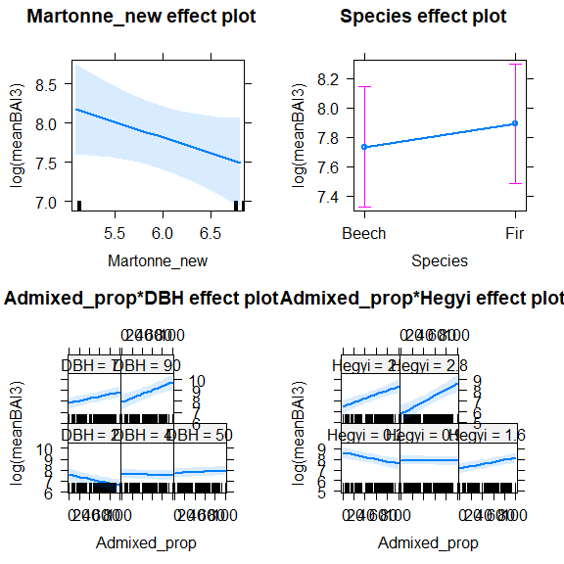
# model check:
plot(lme_final) #looks good
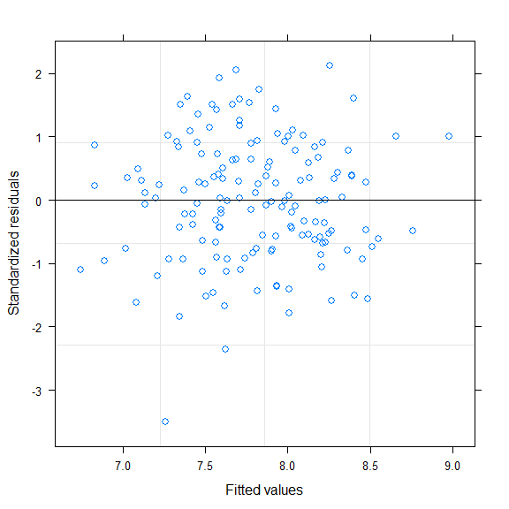
qqnorm(resid(lme_final))
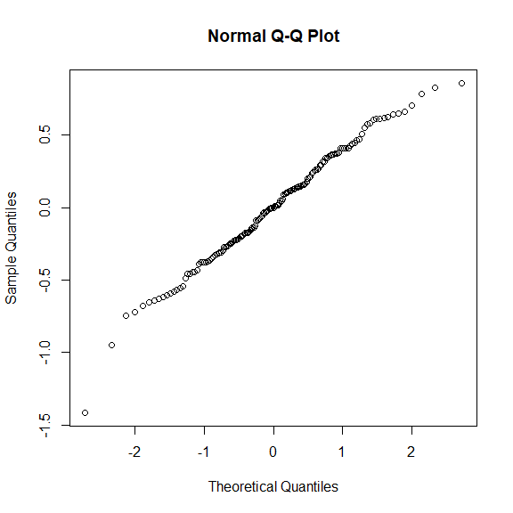
##checking predictors
op <- par(mfrow = c(2, 3), mar = c(4, 4, 3, 2))
plot(data$DBH,resid(lme_final,type="pearson"))
plot(data$Hegyi,resid(lme_final,type="pearson"))
plot(data$Martonne,resid(lme_final,type="pearson"))
plot(data$Admixed_prop,resid(lme_final,type="pearson"))
# seems all ok
par(op)
