Supplementary Material 2: Temporal analysis to test for the overall effect of mixing on growth complementarity of the two species over time (testing H1)
Julia Schwarz

load libraries
rm(list=ls(all=TRUE))
set.seed(1234)
library(lme4)
library(lmerTest)
library(effects)
library(tidyr)
library(sciplot)
library(RColorBrewer)
library(psych)
library(MuMIn)
library(dplyr)
library(stringr)
library(ggplot2)
library(qpcR)
library(effects)
library(nlme)
library(geoR)
library(AICcmodavg)
library(piecewiseSEM)
library(emmeans)
library(inlabru)
library(gridExtra)
library(ggsci)
library(car)
library(MASS)
library(rcompanion)
library(flexsurv)
library(ggpubr)
#Collinearity analysis: VIF : https://hlplab.wordpress.com/2011/02/24/diagnosing-collinearity-in-lme4/
vif.mer <- function (fit) {
## adapted from rms::vif
v <- vcov(fit)
nam <- names(fixef(fit))
## exclude intercepts
ns <- sum(1 * (nam == "Intercept" | nam == "(Intercept)"))
if (ns > 0) {
v <- v[-(1:ns), -(1:ns), drop = FALSE]
nam <- nam[-(1:ns)]
}
d <- diag(v)^0.5
v <- diag(solve(v/(d %o% d)))
names(v) <- nam
v
}

LMMs with only Year and Species plus their interaction as fixed effects.
##To reduce the temporal autocorrelation of samples from subsequent years or periods we used the first order auto-regressive covariance structure (AR1) which introduces smaller correlations with increasing time difference between sampling dates (Zuur et al., 2009; Pinheiro et al., 2018).
comp <- read.delim("../Data/comp_bai.txt")
attach(comp)
summary(comp)
## Tree Site Species Year mix
## CoBu01 : 17 Conventwald:408 Beech:731 Min. :2000 mixed:1564
## CoBu02 : 17 Croatia :459 Fir :833 1st Qu.:2004
## CoBu04 : 17 Freiamt :272 Median :2008
## CoBu05 : 17 Hexental :425 Mean :2008
## CoBu09 : 17 3rd Qu.:2012
## CoBu10 : 17 Max. :2016
## (Other):1462
## RingWidth BAI mean.BAI.conspecific Complementarity
## Min. :0.2885 Min. : 313.7 Min. :1275 Min. :-87.278
## 1st Qu.:1.3529 1st Qu.: 1656.5 1st Qu.:2144 1st Qu.:-31.660
## Median :2.0208 Median : 2554.8 Median :2562 Median : -3.229
## Mean :2.2310 Mean : 2905.8 Mean :2706 Mean : 10.169
## 3rd Qu.:2.8960 3rd Qu.: 3784.3 3rd Qu.:2978 3rd Qu.: 34.830
## Max. :8.5395 Max. :14534.2 Max. :5768 Max. :489.359
##
qqnorm(Complementarity)
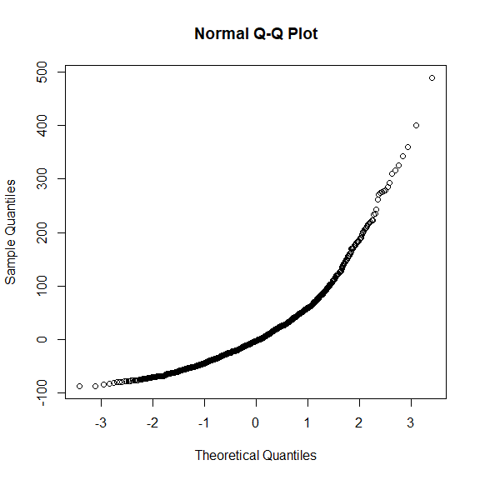
hist(Complementarity)
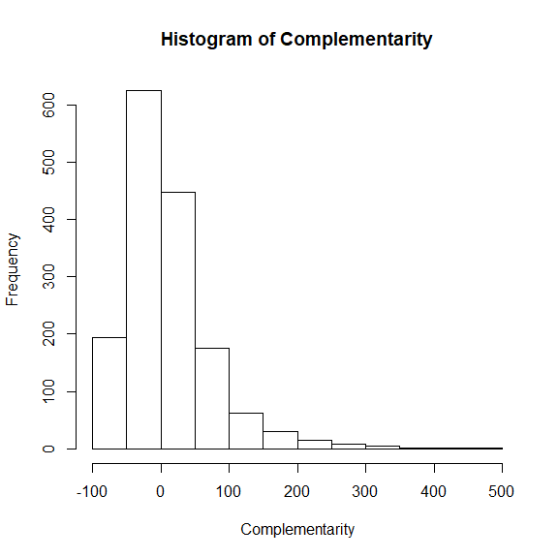
#normal transformations failed, final Boxcox
comp$compl <- comp$Complementarity+87.3 # box-cox works only with non-zero values
summary(comp)
## Tree Site Species Year mix
## CoBu01 : 17 Conventwald:408 Beech:731 Min. :2000 mixed:1564
## CoBu02 : 17 Croatia :459 Fir :833 1st Qu.:2004
## CoBu04 : 17 Freiamt :272 Median :2008
## CoBu05 : 17 Hexental :425 Mean :2008
## CoBu09 : 17 3rd Qu.:2012
## CoBu10 : 17 Max. :2016
## (Other):1462
## RingWidth BAI mean.BAI.conspecific Complementarity
## Min. :0.2885 Min. : 313.7 Min. :1275 Min. :-87.278
## 1st Qu.:1.3529 1st Qu.: 1656.5 1st Qu.:2144 1st Qu.:-31.660
## Median :2.0208 Median : 2554.8 Median :2562 Median : -3.229
## Mean :2.2310 Mean : 2905.8 Mean :2706 Mean : 10.169
## 3rd Qu.:2.8960 3rd Qu.: 3784.3 3rd Qu.:2978 3rd Qu.: 34.830
## Max. :8.5395 Max. :14534.2 Max. :5768 Max. :489.359
##
## compl
## Min. : 0.0217
## 1st Qu.: 55.6400
## Median : 84.0707
## Mean : 97.4688
## 3rd Qu.:122.1299
## Max. :576.6588
##
ccomp <-boxcoxfit(comp$compl)
ccomp
## Fitted parameters:
## lambda beta sigmasq
## 0.2997571 9.2909251 6.0352179
##
## Convergence code returned by optim: 0
comp$complbox <- ((comp$compl)^ccomp$lambda-1)/ccomp$lambda
qqnorm(comp$complbox)# goodish
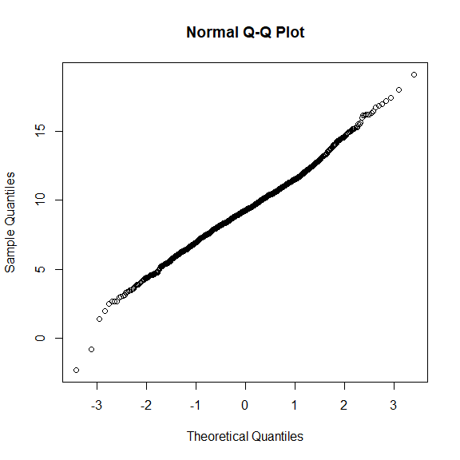
summary(comp)
## Tree Site Species Year mix
## CoBu01 : 17 Conventwald:408 Beech:731 Min. :2000 mixed:1564
## CoBu02 : 17 Croatia :459 Fir :833 1st Qu.:2004
## CoBu04 : 17 Freiamt :272 Median :2008
## CoBu05 : 17 Hexental :425 Mean :2008
## CoBu09 : 17 3rd Qu.:2012
## CoBu10 : 17 Max. :2016
## (Other):1462
## RingWidth BAI mean.BAI.conspecific Complementarity
## Min. :0.2885 Min. : 313.7 Min. :1275 Min. :-87.278
## 1st Qu.:1.3529 1st Qu.: 1656.5 1st Qu.:2144 1st Qu.:-31.660
## Median :2.0208 Median : 2554.8 Median :2562 Median : -3.229
## Mean :2.2310 Mean : 2905.8 Mean :2706 Mean : 10.169
## 3rd Qu.:2.8960 3rd Qu.: 3784.3 3rd Qu.:2978 3rd Qu.: 34.830
## Max. :8.5395 Max. :14534.2 Max. :5768 Max. :489.359
##
## compl complbox
## Min. : 0.0217 Min. :-2.277
## 1st Qu.: 55.6400 1st Qu.: 7.792
## Median : 84.0707 Median : 9.258
## Mean : 97.4688 Mean : 9.291
## 3rd Qu.:122.1299 3rd Qu.:10.749
## Max. :576.6588 Max. :19.094
##
# testing for random structure: Site or trees nested in sites
fitr1 <- lme(complbox ~ scale(Year) + Species + scale(Year)* Species
,random= ~1|Site/Tree , data=comp, correlation = corAR1())
fitr2 <- lme(complbox ~ scale(Year) + Species + scale(Year)* Species
,random= ~1|Site , data=comp, correlation = corAR1())
aictab(mget(str_subset(ls(), "fitr")))# trees nested sites!!
## Warning in aictab.AIClme(mget(str_subset(ls(), "fitr"))):
## Model selection for fixed effects is only appropriate with method=ML:
## REML (default) should only be used to select random effects for a constant set of fixed effects
##
## Model selection based on AICc:
##
## K AICc Delta_AICc AICcWt Cum.Wt Res.LL
## fitr1 8 5506.41 0.00 1 1 -2745.16
## fitr2 7 6287.74 781.33 0 1 -3136.83
fit <- lme(complbox ~ scale(Year) + Species + scale(Year)* Species
,random= ~1|Site/Tree , data=comp, correlation = corAR1())
summary(fit)
## Linear mixed-effects model fit by REML
## Data: comp
## AIC BIC logLik
## 5506.318 5549.137 -2745.159
##
## Random effects:
## Formula: ~1 | Site
## (Intercept)
## StdDev: 0.0007343646
##
## Formula: ~1 | Tree %in% Site
## (Intercept) Residual
## StdDev: 2.022308 1.371228
##
## Correlation Structure: AR(1)
## Formula: ~1 | Site/Tree
## Parameter estimate(s):
## Phi
## 0.367328
## Fixed effects: complbox ~ scale(Year) + Species + scale(Year) * Species
## Value Std.Error DF t-value p-value
## (Intercept) 8.898965 0.3167395 1470 28.095530 0.0000
## scale(Year) 0.148115 0.0500413 1470 2.959843 0.0031
## SpeciesFir 0.753101 0.4340087 87 1.735221 0.0862
## scale(Year):SpeciesFir -0.044233 0.0686517 1470 -0.644311 0.5195
## Correlation:
## (Intr) scl(Y) SpcsFr
## scale(Year) -0.010
## SpeciesFir -0.730 0.007
## scale(Year):SpeciesFir 0.007 -0.729 -0.010
##
## Standardized Within-Group Residuals:
## Min Q1 Med Q3 Max
## -4.88487834 -0.53499688 -0.01029198 0.53510507 5.15221565
##
## Number of Observations: 1564
## Number of Groups:
## Site Tree %in% Site
## 4 92
max(vif.mer(fit))
## [1] 2.133753
r.squaredGLMM(fit)
## Warning: 'r.squaredGLMM' now calculates a revised statistic. See the help
## page.
## R2m R2c
## [1,] 0.02566862 0.6931319
plot(allEffects(fit, partial.residuals=T))
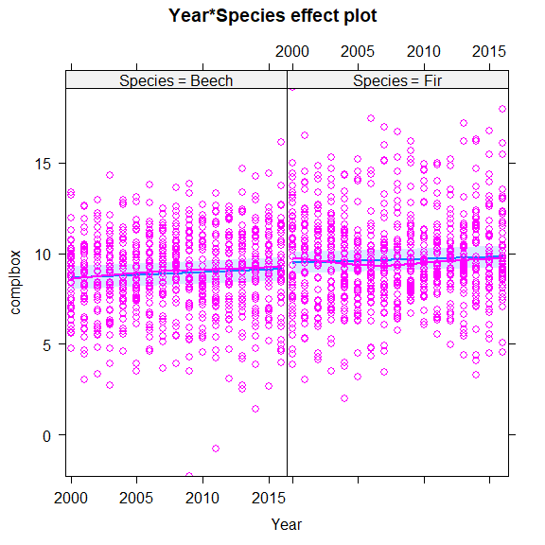
#Checking residuals
plot(fit)
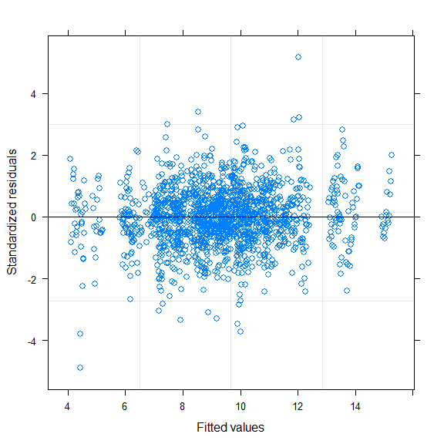
# that looks good
qqnorm(residuals(fit))
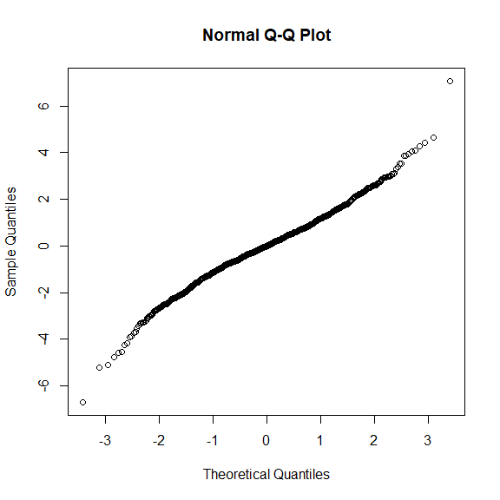
hist(residuals(fit), breaks = 50)
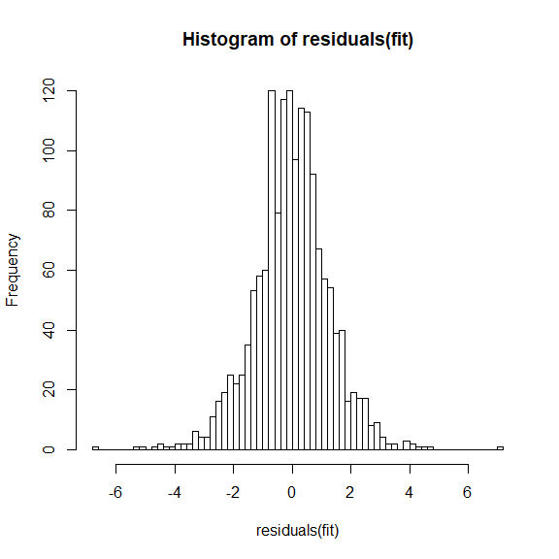
plot(fit, resid(., scaled=TRUE) ~ fitted(.) , abline = 0)
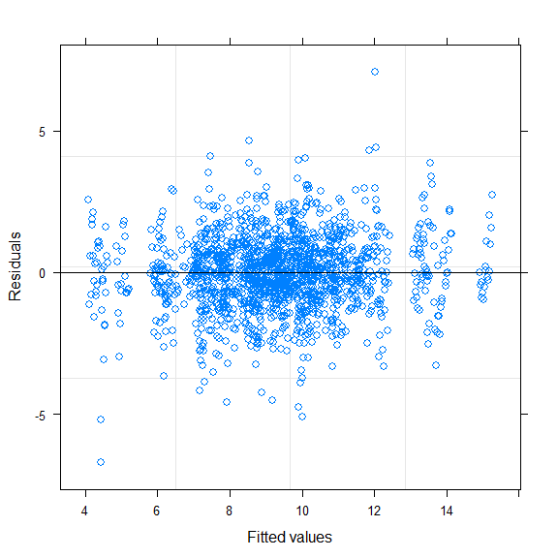
plot(fit, resid(., scaled=TRUE) ~ Year , abline = 0)
