Supplementary Material

Supplementary Figures and Table

Supplementary Figures
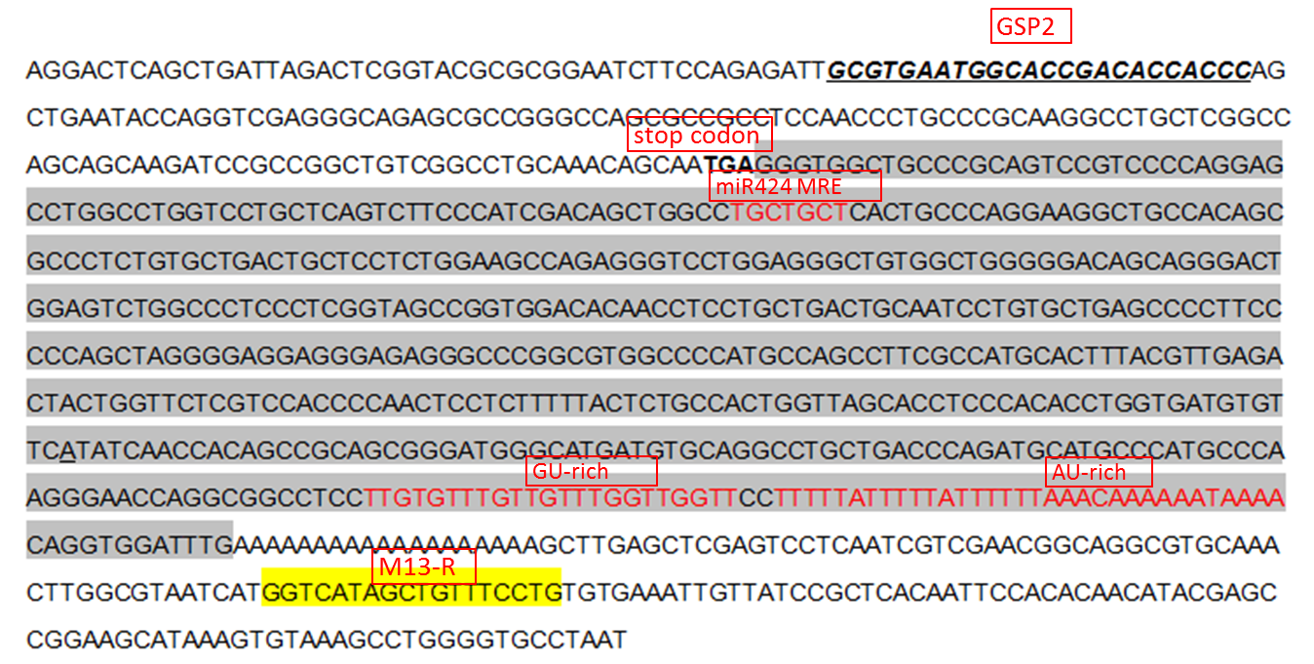
Supplementary Figure 1. 3’ untranslated region sequence of the bovine STK11 gene. The gray shadow showes the untranslated region of STK11 gene in bovine fat tissues. The translational end site (TGA) is shown in blood letters. The miR-424-STK11-MRE, GU-rich and AU-rich sequence are shown in red letters, and primer sequences are underlined with the respective names shown below the line. (For interpretation of the references to colour in this figure legend, the reader is referred to the Web version of this article.)
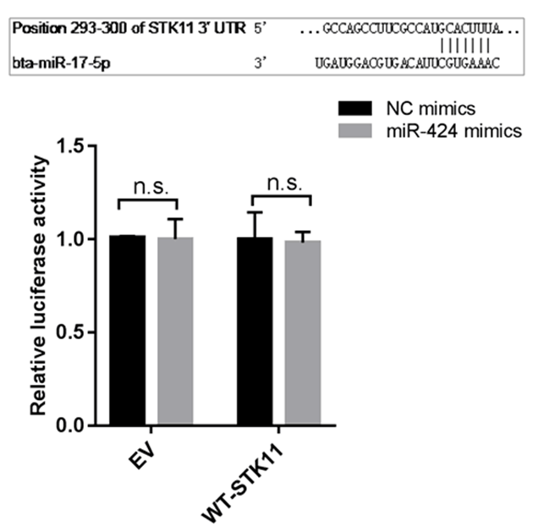
Supplementary Figure 2. STK11 is a not direct target of miR-424. (Top) Schematic representation of the sequence of mature miR-17. The putative binding sites were located in the 3' UTR of bovine STK11 gene. (Bottom) Relative luciferase activity was measured in HEK293A cells co-transfected with the psi-Check2 empty vector (EV) or STK11 3' UTR-WT reporter plasmids along with NC mimics or miR-424 mimics. Renilla luciferase activity was normalized to firefly luciferase.

Supplementary Table
Supplementary Table1. Primers sequence information
Name | Forward Primer (5’-3’) | Reversed Primer (5’-3’)
Primer sequences used for real-time PCR
bta-miR-424-5p | CAGCAGCAATTCATGTTTTGA | provided by the kit
RPS18 | CAGCACACCAAGACCACAG | ACACAAAGCCCACACATTATTTC
STK11 | AGTCACGCTCTACAACATCAC | CTGTATGGAGAACCGCTTGG
GAPDH | ACACCCTCAAGATTGTCAGC | GTCATAAGTCCCTCCACGAT
CEBPα | ATCTGCGAACACGAGACG | CCAGGAACTCGTCGTTGAA
CEBPβ | TTCCTCTCCGACCTCTTCTC | CCAGACTCACGTAGCCGTACT
PPARγ | TGAAGAGCCTTCCAACTCCC | GTCCTCCGGAAGAAACCCTTG
FABP4 | TGAGATTTCCTTCAAATTGGG | CTTGTACCAGAGCACCTTCATC
Primer sequences used for 3’RACE
3'RACE QT | CCAGTGAGCAGAGTGACGAGGACTCGAGCTCAAGCTTTTTTTTTTTTTTTTT
3'RACE QO | CCAGTGAGCAGAGTGACG
3'RACE QI | GAGGACTCGAGCTCAAGC
STK11 GSP1 | CCGGCCAAGCGGTTCTCCATACAGC
STK11 GSP2 | GCGTGAATGGCACCGACACCACCC
Primer sequences used for vector construction
F-FL (XhoI/NotI) | C^TCGAGGTCCTGCTCAGTCTTCCCAT | GC^GGCCGCTCAAATCCACCTGTTTTAT
F-MRE (XhoI/NotI) | C^TCGAGGTCCTGCTCAGTCTTCCCAT | GC^GGCCGCGAACACATCACCAGGTGTG
F-ΔMRE (XhoI/NotI) | C^TCGAGCACACCTGGTGATGTGTTC | GC^GGCCGCTCAAATCCACCTGTTTTAT

