Supplementary materials
Supplementary figure 1| The macroscopic and microscopic characterization of selected actinobacteria strains.

Strain T1LA3 Strain S51 Strain S62
Gram Stain GLM agar
20 μm
20 μm
20 μm

Supplementary figure 2| Plant growth promoting characterization of endophytic actinobacterial strains associated with tea.

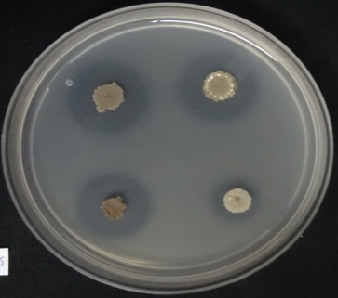
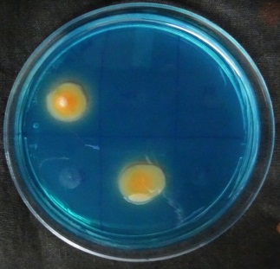
IAA production
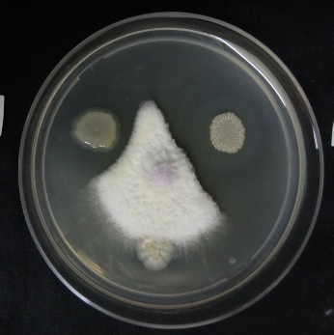
Phosphate solubilization
Siderophore production
Antifungal activity
HiCarbohydrate test production
Supplementary figure 3| (a) 18 family chitinase gene amplification (size: 400-500 bp) with GA1F/GA1R, (b) PKS-I gene amplification (size: 1200-1400 bp) with K1F/M6R, (c) NRPS amplification (size: 700 - 800 bp) with A3F/A7R.

100 bp SA1 SA2 CJRA1 SA21 S62 SA13 CRRA1 SA8 S43 SA27 SA12
1 kb ladder SA8
100 bp ladder SA8
(a)
(c)
(b)

500 bp

700 bp
2000 bp
1000 bp

Supplementary figure 4| In vivo plant growth promotion experiment. (a) Nursery plant growth promotion experiment, (b) Inoculated tea plant (Clone TV1) with strain T1LA3 vs control.

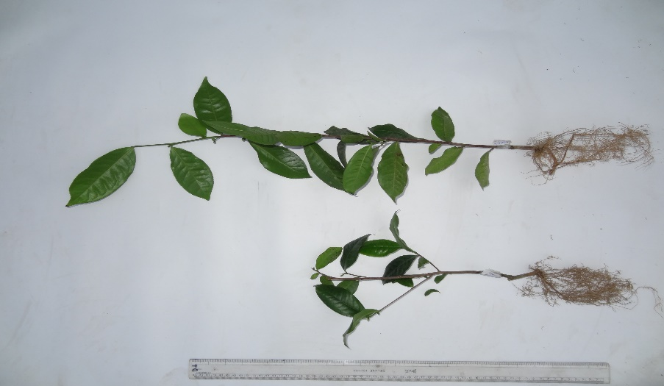
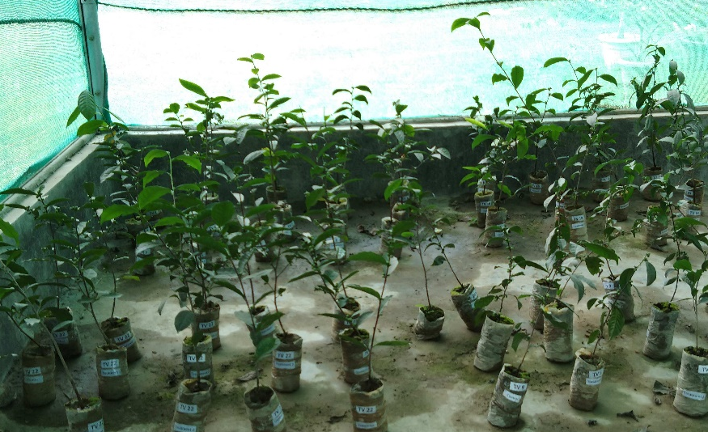
(b)
Control
Treated
(a)
Supplementary figure 5| Fold change analysis of tea clones TV1, TV9, TV18 and TV22 treated with endophytic actinobacterial strains.
 | Fold Change | log2(FC)
Root dry weight | 2.7143 | 1.4406
No. of leaves | 2.2459 | 1.1673
Shoot dry weight | 2.1743 | 1.1206
Root fresh weight | 1.9872 | 0.99072
Shoot Fresh weight | 1.5976 | 0.67591
Shoot height | 1.5803 | 0.66021
Root length | 1.5738 | 0.65425
Tea clone TV1
- Treatment 1 (Strain SA1)
- Treatment 2 (Strain T1LA3)
 | Fold Change | log2(FC)
Root dry weight | 6.2198 | 2.6369
Root fresh weight | 3.3504 | 1.7443
Shoot dry weight | 2.6514 | 1.4067
No. of leaves | 2.3443 | 1.2291
Shoot Fresh weight | 1.9538 | 0.96626
Shoot height | 1.8523 | 0.88932
Root length | 1.3393 | 0.42149
- Treatment 3 (Strain SA14)
 | Fold Change | log2(FC)
Root dry weight | 3.4505 | 1.7868
Root fresh weight | 1.9145 | 0.93699
Shoot dry weight | 1.8991 | 0.9253
No. of leaves | 1.6393 | 0.71312
Shoot height | 1.5772 | 0.65739
Shoot Fresh weight | 1.4777 | 0.56339
Root length | 1.3255 | 0.40656
- Treatment 4 (SA1+T1LA3+SA14)
 | Fold Change | log2(FC)
Root dry weight | 4.0549 | 2.0197
Root fresh weight | 2.5513 | 1.3512
Shoot dry weight | 1.7339 | 0.79406
No. of leaves | 1.5902 | 0.66918
Shoot Fresh weight | 1.4914 | 0.5767
Root length | 1.4552 | 0.54119
Shoot height | 1.1662 | 0.22176

Tea clone TV9
(e)Treatment 1 (Strain SA1)
 | Fold Change | log2(FC)
Root length | 1.7653 | 0.81991
Root dry weight | 1.7121 | 0.77578
No. of leaves | 1.64 | 0.7137
Shoot dry weight | 1.5755 | 0.65578
Shoot height | 1.4196 | 0.50553
Shoot Fresh weight | 1.2558 | 0.32857
Root fresh weight | 1.2135 | 0.27922
(f)Treatment 2 (Strain T1LA3)
 | Fold Change | log2(FC)
Root dry weight | 2.5303 | 1.3393
Root length | 1.9026 | 0.92799
No. of leaves | 1.72 | 0.78241
Root fresh weight | 1.4948 | 0.57994
Shoot dry weight | 1.2925 | 0.37011
Shoot height | 1.2226 | 0.28995
Shoot Fresh weight | 1.13 | 0.1763
(g) Treatment 3 (Strain SA14)
 | Fold Change | log2(FC)
Root length | 1.6292 | 0.70418
No. of leaves | 1.48 | 0.5656
Root dry weight | 1.2803 | 0.35649
Shoot height | 1.1499 | 0.20153
Root fresh weight | 1.0651 | 0.090995

(h) Treatment 4 (SA1+T1LA3+SA14)
 | Fold Change | log2(FC)
Root length | 1.7653 | 0.81991
Root dry weight | 1.7121 | 0.77578
No. of leaves | 1.64 | 0.7137
Shoot dry weight | 1.5755 | 0.65578
Shoot height | 1.4196 | 0.50553
Shoot Fresh weight | 1.2558 | 0.32857
Root fresh weight | 1.2135 | 0.27922

Tea clone TV 18
(i) Treatment 1 (Strain SA1)
 | Fold Change | log2(FC)
Root dry weight | 1.6305 | 0.70532
Root length | 1.6128 | 0.68952
No. of leaves | 1.5946 | 0.67319
Shoot dry weight | 1.5171 | 0.60133
Shoot height | 1.4645 | 0.55041
Root fresh weight | 1.3728 | 0.45708
Shoot Fresh weight | 1.3528 | 0.43594
(j) Treatment 2 (Strain T1LA3)
 | Fold Change | log2(FC)
Root dry weight | 2.0373 | 1.0267
Root fresh weight | 1.5878 | 0.66704
Root length | 1.5348 | 0.61808
Shoot height | 1.5015 | 0.58645
Shoot dry weight | 1.4639 | 0.5498
Shoot Fresh weight | 1.3165 | 0.39668
No. of leaves | 1.1532 | 0.20558
 | Fold Change | log2(FC)
Shoot dry weight | 1.8384 | 0.87845
Root length | 1.6517 | 0.72396
Root dry weight | 1.6136 | 0.69025
Shoot Fresh weight | 1.572 | 0.65259
Shoot height | 1.5401 | 0.62305
No. of leaves | 1.3964 | 0.48171
Root fresh weight | 1.3638 | 0.44763
(k) Treatment 3 (Strain SA14)
(l) Treatment 4 (SA1+T1LA3+SA14)
 | Fold Change | log2(FC)
Root dry weight | 1.7695 | 0.82333
Root length | 1.7591 | 0.81488
Shoot height | 1.4666 | 0.55244
Root fresh weight | 1.4462 | 0.5323
No. of leaves | 1.4414 | 0.52751
Shoot dry weight | 1.3897 | 0.47481
Shoot Fresh weight | 1.1271 | 0.17263

Tea clone TV 22
(m) Treatment 1 (Strain SA1)
 | Fold Change | log2(FC)
No. of leaves | 1.5789 | 0.65896
Root dry weight | 1.4429 | 0.52893
Root length | 1.2918 | 0.36935
Shoot dry weight | 1.2888 | 0.36601
Shoot height | 1.2777 | 0.35357
Root fresh weight | 1.265 | 0.33909
Shoot Fresh weight | 1.2134 | 0.27905
(n) Treatment 2 (Strain T1LA3)
 | Fold Change | log2(FC)
Root dry weight | 1.6629 | 0.73366
Root length | 1.4964 | 0.58147
Root fresh weight | 1.3966 | 0.4819
No. of leaves | 1.3947 | 0.47999
Shoot height | 1.2856 | 0.36248
Shoot dry weight | 1.1813 | 0.24033
Shoot Fresh weight | 1.1339 | 0.18134
(o) Treatment 3 (Strain SA14)
 | Fold Change | log2(FC)
Root length | 1.931 | 0.94934
Root dry weight | 1.5971 | 0.67549
Root fresh weight | 1.3573 | 0.4407
Shoot dry weight | 1.3149 | 0.39495
No. of leaves | 1.2895 | 0.36678
Shoot Fresh weight | 1.2327 | 0.30181
Shoot height | 1.0837 | 0.11598

(p) Treatment 4 (SA1+T1LA3+SA14)
 | Fold Change | log2(FC)
Root dry weight | 2.0343 | 1.0245
Root fresh weight | 1.6188 | 0.69493
No. of leaves | 1.3947 | 0.47999
Root length | 1.339 | 0.42114
Shoot height | 1.237 | 0.30683
Shoot dry weight | 1.169 | 0.22524
Shoot Fresh weight | 1.1249 | 0.16974
Note: In all figures the red dots represent parameters above the threshold and Important features selected by fold change analysis with threshold 1. The values are on log scale, so that both up-regulated and down regulated parameters can be plotted in a symmetrical way

Supplementary table 1| Solubilization of inorganic phosphate in liquid Pikovskaya’s medium with different initial values of pH for endophytic actinobacteria isolates obtained from Camellia spp., after 6 days of incubation at 28 °C

Sl. No. | Isolate code | pH 6.0 | pH 7.0 | pH 8.0
1 | SA1 | 47.0 ± 6.0 | 104.6 ± 10.7 | 49.0 ± 11.0
2 | SA14 | 149.1 ± 9.4 | 223.3 ± 14.3 | 86.8 ± 7.3
3 | S85 | 118.3 ± 17.3 | 164.0 ± 14.0 | 92.6 ± 8.4

Supplementary table 2| Soil chemical parameters
- Tea clone TV1
Soil Parameters | Control | SA1 | T1LA3 | SA14 | SA1+T1LA3+SA14
Potassium (as K), % by mass | 0.032 | 0.027 | 0.021 | 0.033 | 0.029
Organic Matter, % by mass | 0.55 | 0.46 | 0.46 | 0.55 | 0.55
Total Phosphorus (as P), % by mass | 0.065 | 0.19 | 0.017 | 0.029 | 0.029
Available Phosphorus (as P), % by mass | 0.021 | 0.026 | 0.009 | 0.007 | 0.007
Total Nitrogen (as N), % by mass | 0.08 | 0.028 | 0.1 | 0.09 | 0.09
Available Nitrogen (as N), % by mass | 0.011 | 0.01 | 0.02 | 0.016 | 0.014
Sulphur (as So₄), % by mass | 0.096 | 0.15 | 0.073 | 0.6 | 0.21
Calcium (as Ca) * % by mass | ND (DL=0.001) | ND (DL=0.001) | ND (DL=0.001) | ND (DL=0.001) | ND (DL=0.001)
Magnesium (as Mg) *, % by mass | 0.14 | 0.3 | 0.11 | 0.12 | 0.1
Water Holding Capacity*, % by mass | 48.18 | 39.75 | 40.33 | 45.9 | 38.33
Manganese (as Mn) *, mg/kg | 159.28 | 141.97 | 163.59 | 149.57 | 140.5
Iron (as Fe) *, mg/kg | 64.6 | 61.15 | 72.45 | 69.07 | 64.29
Copper (as Cu) *, mg/kg | 2.57 | 2.92 | 2.87 | 2.96 | 2.69
Zinc (as Zn) *, mg/kg | 16.04 | 17.89 | 19.12 | 16.28 | 16.41
Molybdenum (as Mo) *, mg/kg | 1.23 | ND (DL=0.25) | ND (DL=0.25) | ND (DL=0.25) | ND (DL=0.25)
Boron (as B) *, mg/kg | 1.59 | 12.86 | 1.23 | 1.15 | 1.13

- Tea clone TV9
Soil parameters | Control | SA1 | T1LA3 | SA14 | SA1+T1LA3+SA14
Potassium (as K), % by mass | 0.044 | 0.044 | 0.047 | 0.051 | 0.055
Organic Matter, % by mass | 0.91 | 0.55 | 0.68 | 0.9 | 0.92
Total Phosphorus (as P), % by mass | 0.031 | 0.12 | 0.037 | 0.044 | 0.039
Available Phosphorus (as P), % by mass | 0.011 | 0.036 | 0.008 | 0.006 | 0.009
Total Nitrogen (as N), % by mass | 0.16 | 0.05 | 0.17 | 0.15 | 0.16
Available Nitrogen (as N), % by mass | 0.036 | ND(DL=0.001) | 0.022 | 0.062 | 0.071
Sulphur (as So₄), % by mass | 0.18 | 0.21 | 0.29 | 0.48 | 0.31
Calcium (as Ca)* % by mass | ND (DL=0.001) | ND (DL=0.001) | ND (DL=0.001) | ND (DL=0.001) | ND (DL=0.001)
Magnesium (as Mg)*, % by mass | 0.13 | 0.13 | 0.14 | 0.13 | 0.12
Water Holding Capacity*, % by mass | 42.18 | 39.32 | 48.18 | 45.55 | 46.3
Manganese (as Mn)*, mg/kg | 97.01 | 119.36 | 4.61 | 6.16 | 10.16
Iron (as Fe)*, mg/kg | 64.68 | 61.34 | 2.38 | 3.2 | 7.11
Copper (as Cu)*, mg/kg | 3.29 | 2.65 | ND(DL=1.0) | ND(DL=1.0) | ND(DL=1.0)
Zinc (as Zn)*, mg/kg | 19.04 | 16.52 | ND(DL=1.0) | ND (DL=1.0) | ND (DL=1.0)
Molybdenum (as Mo)*, mg/kg | ND (DL=0.25) | ND (DL=0.25) | ND (DL=0.25) | ND (DL=0.25) | ND (DL=0.25)
Boron (as B)*, mg/kg | 1.86 | ND(DL=1.0) | ND(DL=1.0) | ND (DL=0.25) | ND (DL=0.25)

- Tea clone TV18
Soil parameters | Control | SA1 | T1LA3 | SA14 | SA1+T1LA3+SA14
Potassium (as K), % by mass | 0.017 | 0.021 | 0.02 | 0.02 | 0.031
Organic Matter, % by mass | 0.46 | 0.69 | 0.42 | 0.43 | 0.42
Total Phosphorus (as P), % by mass | 0.017 | 0.03 | 0.14 | 0.16 | 0.12
Available Phosphorus (as P), % by mass | 0.008 | ND(DL=0.001) | 0.03 | 0.029 | 0.037
Total Nitrogen (as N), % by mass | 0.11 | 0.14 | 0.15 | 0.15 | 0.11
Available Nitrogen (as N), % by mass | 0.036 | 0.042 | 0.05 | 0.06 | 0.061
Sulphur (as So₄), % by mass | 0.1 | 0.065 | 0.091 | 0.096 | 0.13
Calcium (as Ca)* % by mass | ND (DL=0.001) | ND (DL=0.001) | ND (DL=0.001) | ND (DL=0.001) | ND (DL=0.001)
Magnesium (as Mg)*, % by mass | 0.14 | 0.14 | 0.11 | 0.13 | 0.12
Water Holding Capacity*, % by mass | 44.52 | 44.49 | 41.92 | 43.97 | 45.32
Manganese (as Mn)*, mg/kg | 4 | 6.47 | ND (DL=1.0) | ND (DL=1.0) | ND (DL=1.0)
Iron (as Fe)*, mg/kg | ND(DL=5.0) | ND(DL=5.0) | ND(DL=5.0) | ND(DL=5.0) | ND(DL=5.0)
Copper (as Cu)*, mg/kg | ND(DL=1.0) | ND(DL=1.0) | ND(DL=1.0) | ND(DL=1.0) | ND(DL=1.0)
Zinc (as Zn)*, mg/kg | ND(DL=1.0) | ND(DL=1.0) | ND(DL=1.0) | ND(DL=1.0) | ND(DL=1.0)
Molybdenum (as Mo)*, mg/kg | ND (DL=0.25) | ND (DL=0.25) | ND (DL=0.25) | ND (DL=0.25) | ND (DL=0.25)
Boron (as B)*, mg/kg | ND(DL=1.0) | ND(DL=1.0) | ND(DL=1.0) | ND(DL=1.0) | ND(DL=1.0)

- Tea clone TV22
Soil parameters | Control | SA1 | T1LA3 | SA14 | SA1+T1LA3+SA14
Potassium (as K), % by mass | 0.04 | 0.02 | 0.022 | 0.02 | 0.043
Organic Matter, % by mass | 0.69 | 0.51 | 0.63 | 0.61 | 0.74
Total Phosphorus (as P), % by mass | 0.16 | 0.18 | 0.038 | 0.097 | 0.03
Available Phosphorus (as P), % by mass | 0.024 | 0.029 | 0.009 | 0.03 | 0.007
Total Nitrogen (as N), % by mass | 0.16 | 0.15 | 0.13 | 0.12 | 0.17
Available Nitrogen (as N), % by mass | 0.07 | 0.08 | 0.07 | 0.08 | 0.06
Sulphur (as So₄), % by mass | 0.085 | 0.068 | 0.22 | 0.076 | 0.18
Calcium (as Ca)* % by mass | ND (DL=0.001) | ND (DL=0.001) | ND (DL=0.001) | ND (DL=0.001) | ND (DL=0.001)
Magnesium (as Mg)*, % by mass | 0.11 | 0.13 | 0.03 | 0.14 | 0.14
Water Holding Capacity*, % by mass | 42.41 | 42.43 | 39.95 | 42.79 | 43.76
Manganese (as Mn)*, mg/kg | ND (DL=1.0) | 3.11 | 3.71 | 1.5 | 1.56
Iron (as Fe)*, mg/kg | ND(DL=5.0) | ND(DL=5.0) | ND(DL=5.0) | ND(DL=5.0) | ND(DL=5.0)
Copper (as Cu)*, mg/kg | ND(DL=1.0) | ND(DL=1.0) | ND(DL=1.0) | ND(DL=1.0) | ND(DL=1.0)
Zinc (as Zn)*, mg/kg | ND(DL=1.0) | ND(DL=1.0) | ND(DL=1.0) | ND(DL=1.0) | ND(DL=1.0)
Molybdenum (as Mo)*, mg/kg | ND (DL=0.25) | ND (DL=0.25) | ND (DL=0.25) | ND (DL=0.25) | ND (DL=0.25)
Boron (as B)*, mg/kg | ND(DL=1.0) | ND(DL=1.0) | ND(DL=1.0) | ND(DL=1.0) | ND(DL=1.0)

