**Chemotherapeutic nanoparticle-based liposomes enhance the efficiency of mild microwave ablation in hepatocellular carcinoma therapy**

Songsong Wu1,2, Dongyun Zhang 1, Jie Yu1, Jianping Dou1, Xin Li1, Mengjuan Mu1, Ping Liang1*

Authors affiliation

1. Department of Interventional Ultrasound, Chinese PLA General Hospital, 28 Fuxing Road, Beijing 100853, China.

2. Department of Ultrasonography, Fujian Provincial Hospital, Shengli Clinical Medical College of Fujian Medical University, Fuzhou 350001, China

*Contact information:

Ping Liang, M.D., Ph.D., Department of Interventional Ultrasound, Chinese PLA General Hospital, 28 Fuxing Road, Beijing 100853, China. Fax: +86-10-68161218; E-mail: liangping301@hotmail.com.

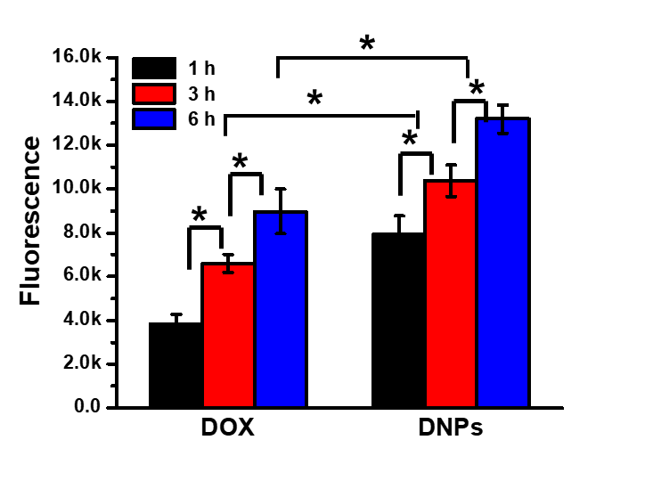

Supporting S1: Intracellular DOX fluorescence of Huh7 cells treated with DNPs by flow cytometry.

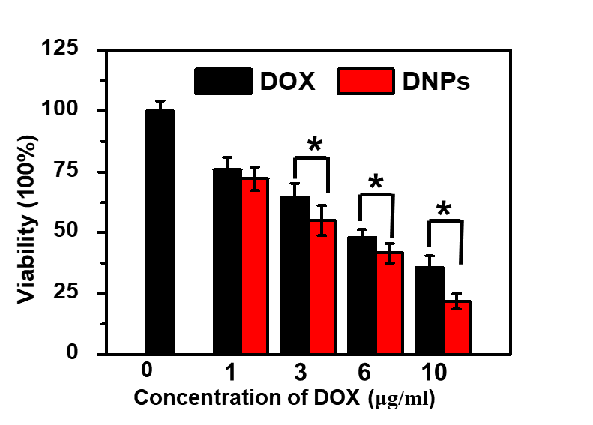

Supporting S2: Cell survival of Huh7 cells treated with DOX and DNPs.



Supporting S3: Survival of cells treated with MWA followed DOX and DNPs incubation.