: Description of type of statistical distributions considered
In order to perform an uncertainty analysis via Monte Carlo simulations, assumptions on how the input variables to the system model are statistically distributed must be made. As several types of distributions (normal, log-normal, beta, min-extreme, yes-no) are considered in this study, the following paragraphs aim to help the reader better understand them.
The first is the well-known normal distribution, which forms a symmetric bell curve around its mean as shown in Figure 10(a). This distribution is widely used for well-characterised systems due to the Central Limit Theorem, which states that sums of independent random variables tend to become normally distributed even if the original variables are not normally distributed.
A closely related distribution is the log-normal distribution shown in Figure 10(b). In this case, the logarithm of the parameter is normally distributed. Compared to a normal distribution, the log-normal distribution is quite skewed, having a short left tail and long right tail. This means that obtaining an extremely small result would be very unlikely, while an extremely high result would be somewhat likely.
The beta distribution, which is commonly used to model bounded random variables, is also considered. For the set of parameters considered in this study, the beta distribution has a negative excess kurtosis, meaning that it does not have proper tails extending to the left or right as shown in Figure 10(c).
The last continuous probability distribution considered is the min-extreme distribution. Compared to a normal distribution, this is skewed in such a way that it has a longer left tail and shorter right tail as shown in Figure 10(d). In other words, compared to a normal distribution, a min-extreme distribution increases the chance of extremely low outcomes and decreases the chance of extremely high outcomes.
Finally, a "yes-no" distribution, also known as a binary distribution or Bernoulli distribution, is also used in one of the cases. As shown in Figure 10(e), this is the simplest discrete distribution, having only two possible outcomes with probabilities $p$ and $1-p$.
For each uncertain parameter considered in this study, Table 4 lists the specific type of distributions employed, its statistical characteristics, and any relevant additional defining parameters (location, minimum, maximum, etc.) in comments.

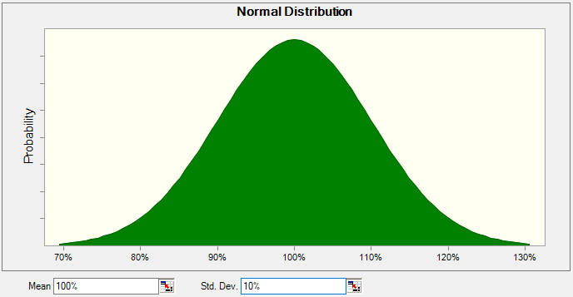 | 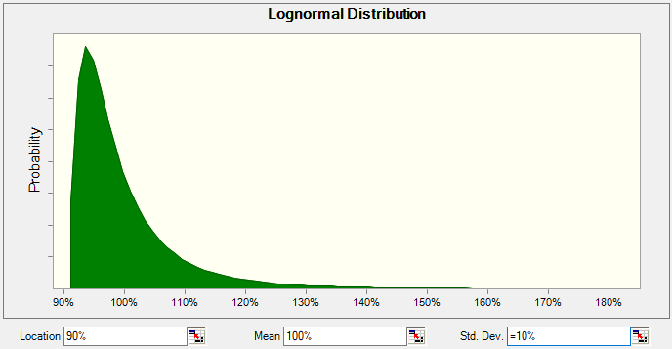
(a) Normal distribution | (b) Log-normal distribution
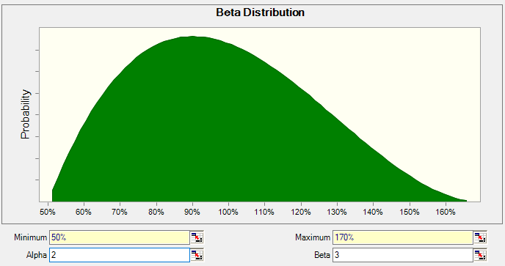 | 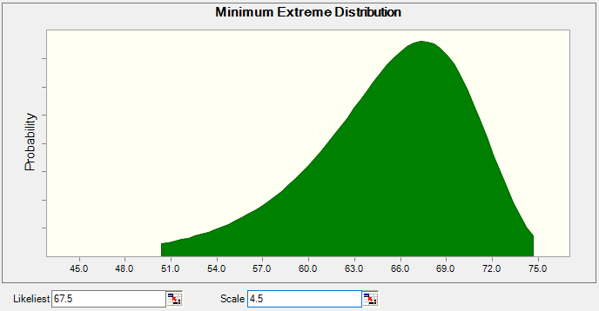
(c) Beta distribution | (d) Min-extreme distribution
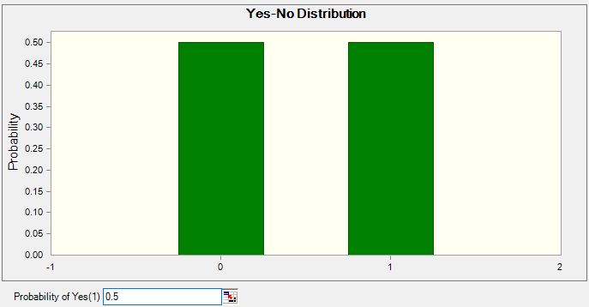
(e) "Yes-No" distribution
Figure 10: Illustration of the probability distributions considered in the present study and their associated defining parameters: (a) Normal distribution (b) Log-normal distribution (c) Beta distribution (d) Min-extreme distribution (e) "Yes-No" distribution.

: CO₂ avoidance cost and share of avoided emissions of the WtE plant with CO₂ capture for different installed capacity factor
Figure 11: CO₂ avoidance cost breakdown and share of avoided emissions for MEA-based CO₂ capture depending on the installed capacity factor.

Figure 12: CO₂ avoidance cost breakdown and share of avoided emissions for advanced solvent-based CO₂ capture depending on the installed capacity factor.

Figure 13: CO₂ avoidance cost breakdown and share of avoided emissions for membrane-based CO₂ capture depending on the installed capacity factor.

: Annual CO₂ flows evolution in different sections of chain D (transport and storage)

Figure 14: Annual CO₂ flows evolution in the different section of chain D: CO₂ imported via ship, imported CO₂ injected in the EOR storage, and excess imported CO₂ injected in the EOR storage.

