Figure S1. Cytotoxicity test of Ferulic acid (FA) in H9c2 cells.
H9c2 cells were treated with different dosages of FA for 24h, then cell viability were monitored by the CCK-8 assay. Data are expressed as mean ± SEM (n = 6). *P < 0.05 vs. the control group.

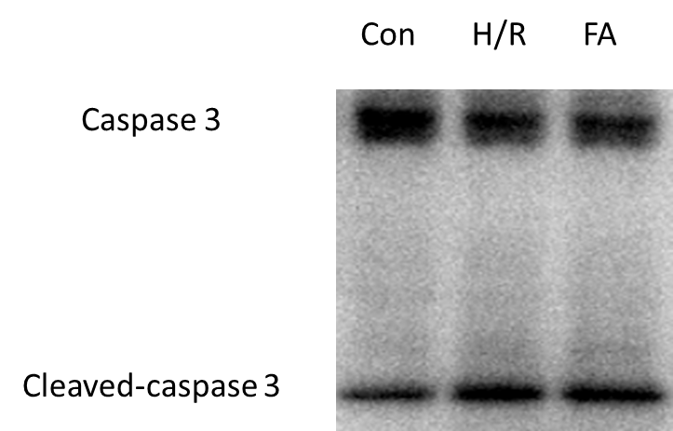

Figure S2. The entire get of caspase3 and cleaved-caspase3.

