Supplementary Information

iRSVPred: A web server for artificial intelligence based prediction of major basmati paddy seed varieties

Arun Sharma#, Deepshikha Satish#, Sushmita Sharma, Dinesh Gupta*

Translational Bioinformatics Group, International Centre for Genetic Engineering and Biotechnology, Aruna Asaf Ali Marg, New Delhi, India

*To whom the correspondence should be addressed

Dr. Dinesh Gupta,
Group Leader, Translational Bioinformatics Group,
International Centre for Genetic Engineering and Biotechnology,
Aruna Asaf Ali Marg, New Delhi, India.
Pin- 110067
Email: dinesh@icgeb.res.in
Phone: 011 2674 1358 (403)

#Equal contribution

Table S1: The export of Basmati rice from India during the last three years:

2016-17 |  |  | 2017-18 |  |  | 2018-19
Qty-MTs | Val-₹ cr | Val-$ m | Qty-MTs | Val-₹ cr | Val-$ m | Qty-MTs | Val-₹ cr | Val-$ m
39,85,195 | 21,513 | 3,217 | 40,56,759 | 26,870 | 4,169 | 44,14,562 | 32,804.19 | 4,722.46
Source: The Directorate General of Commercial Intelligence and Statistics (DGCI & S), Kolkata, under the Ministry of Commerce, Government of India

Table S2: Primary basmati quality characteristics
Source of table 3: The Department of Agriculture, Cooperation and Farmers’ welfare, Govt. of India
** The grain sample for analyses will necessarily have to be 'aged' for three months under protected conditions at normal room temperature as milled kernel.
* As per standardized protocol (Directorate of Rice Research, Hyderabad)'

S. No. | Parameter** | Value
1 | Minimum average precooked milled rice length (mm) | 6.61
2 | Average precooked milled rice breadth (mm) | <=2.00
3 | Minimum length/breadth ratio of precooked milled rice (L/B Ratio) | 3.50
4 | Minimum average cooked rice length (mm) | 12.00
5 | Minimum cooked rice length/precooked rice length ratio or Minimum elongation ratio | 1.70
6 | Average volume expansion ratio | >3.50
7 | Aroma | Present (Qualitative Sensory Analysis as Panel Test*)
8 | Texture of cooked grain for high integrity (without bursting the surface), non-stickiness, tenderness, good taste and good mouth feel | Present (Qualitative Sensory Analysis as Panel Test*)

Table S3: Specification of apparatus.

S. No. | Specifications | Detail
1 | Dimension of Apparatus | 20cm * 33.5 cm (Breadth * Height)
2 | Background | White
3 | Height from sample | 11 cm
4 | Area of sample well | 8.5cm*8.5cm*1cm
5 | Light Used | 2 Light-emiting diode bulb of power 4 Watt each was used. Light emitted by each bulb was crystal white of luminous flux 370 lumen. Bulbs were positioned diagonally opposite in order to cancel the shadow effect.
Table S4: List of 32 basmati varieties notifies by Govt. of India. (Varieties used in iRSVPred are highlighted in bold letters)

S. No. | Variety | Notification No. & Date
1 | Basmati 217 | 4045 – 24.09.1969 361 (E) – 30.06.1973
2 | Punjab Basmati 1 (Bauni Basmati) | 596 (E) - 13.08.1984
3 | Basmati 386 | 647 (E) – 09.09.1997
4 | Punjab Basmati 2 | 1708 (E) – 26.07.2012
5 | Punjab Basmati 3 | 3540(E) - 24.11.2016
6 | Basmati 370 | 361 (E) – 30.06.1973786 – 02.02.1976
7 | Haryana Basmati 1 | 793 (E) - 22.11.1991
8 | Taraori Basmati (HBC 19) | 1(E) – 01.01.1996
9 | Type 3 (Dehraduni Basmati) | 13 – 19.12.1978
10 | Pant Basmati 1 (IET 21665) | 112(E)- 13.01.2016
11 | Pant Basmati 2 (IET 21953) | 112(E) - 13.01.2016
12 | Kasturi | 615 (E) - 06.11.1989
13 | Mahi Sugandha | 408 (E) - 04.05.1995
14 | Basmati CSR 30  After amendment | 1134(E) – 25.11.2001  2126 (E) – 10.09.2012
15 | Malviya Basmati Dhan 10-9 (IET 21669) | 2817 (E) – 19.09.2013
16 | Ranbir Basmati | 1 (E) - 01.01.1996
17 | Basmati 564 | 268 (E) – 28.01.2015
18 | Pusa Basmati 1 | 615 (E) - 06.11.1989
19 | Improved Pusa Basmati 1 (Pusa 1460) | 1178 (E) – 20.07.2007
20 | Pusa Basmati 1121  After amendment | 1566 (E) – 05.11.2005  2547 (E) - 29.10.2008
21 | Pusa Basmati 1509 (IET 21960) | 2817 (E) – 19.09.2013
22 | Pusa Basmati 6 (Pusa 1401) | 733 (E) – 01.04.2010
23 | Pusa Basmati 1609 | 2680(E)- 01.10.2015
24 | Pusa Basmati 1637 | 3540(E) - 24.11.2016
25 | Pusa Basmati 1728 | 3540(E) - 24.11.2016
26 | Vallabh Basmati 22 | 2187 (E) – 27.08.2009
27 | Vallabh Basmati 21 (IET 19493) | 2817 (E) – 19.09.2013
28 | Vallabh Basmati 23 | 268 (E) – 28.01.2015
29 | Vallabh Basmati 24 | 268 (E) – 28.01.2015
30 | Pusa Basmati 1718 | 2805(E) - 25.08.2017
31 | Punjab Basmati 4 | 1379 (E) – 27.03.2018
32 | Punjab Basmati 5 | 1379 (E) – 27.03.2018

Table S5: Full- form of the abbreviations of Augmentations used in iRSVPred

Sr. No. | Augmentation abbreviations | Full Form
1 | Aug1 | HSV(Hue, Saturation, and Value)
2 | Aug2 | Gamma Correction
3 | Aug3 | LAB(L* for the lightness from black to white, A* from green to red, and B* from blue to yellow)
4 | Aug4 | Crop 0.5
5 | Aug5 | Crop 0.7
6 | Aug6 | Crop 0.9
7 | Aug7 | Drop out 5 %
8 | Aug8 | Drop out 10 %
9 | Aug9 | Drop out 15 %
10 | Aug10 | Elastic Deformation
11 | Aug11 | Equalize Histogram
12 | Aug12 | Flip Horizontal
13 | Aug13 | Flip Vertical
14 | Aug14 | Flip Horizontal followed by vertical
15 | Aug15 | Invert
16 | Aug16 | Shearing
17 | Aug17 | Sharpen
18 | Aug18 | Rotate 45 degree
19 | Aug19 | Rotate 60 degree
20 | Aug20 | Rotate 90 degree
21 | Aug21 | Rotate 120 degree
22 | Aug22 | Rotate 140 degree
23 | Aug23 | Rotate 160 degree
24 | Aug24 | Resize
25 | Aug25 | Raise Red
26 | Aug26 | Raise Hue
27 | Aug27 | Raise Green
28 | Aug28 | Raise Blue
29 | Aug29 | Median Blur

Table S6: Training and internal validation-set accuracies accompanied with validation loss values for paddy seeds variety prediction models developed using original images and different types of augmented images.

Sr. No. | Model Type | No. of training set images | No. of internal validation set images | Training  Accuracy (%) | Validation Accuracy (%) | Validation Loss
1 | Original images Model | 2055 | 513 | 99.20 | 88.30 | 0.31
2 | Original + Crop 0.5 images Model | 4109 | 1027 | 100.00 | 86.30 | 0.496
3 | Original + Crop 0.7 images Model | 4109 | 1027 | 99.20 | 87.10 | 0.345
4 | Original + Crop 0.9 images Model | 4109 | 1027 | 95.70 | 85.90 | 0.486
5 | Original + Dropout 0.05 images Model | 4109 | 1027 | 100.00 | 94.10 | 0.154
6 | Original + Dropout 0.10 images Model | 4109 | 1027 | 100.00 | 87.90 | 0.349
7 | Original + Dropout 0.15 images Model | 4109 | 1027 | 100.00 | 91.00 | 0.23
8 | Original + Elastic Deform images Model | 4109 | 1027 | 100.00 | 96.10 | 0.084
9 | Original + Equalize Histogram images Model | 4109 | 1027 | 100.00 | 87.90 | 0.385
10 | Original + Flip horizontal images Model | 4109 | 1027 | 99.60 | 90.60 | 0.307
11 | Original + Flip vertical images Model | 4109 | 1027 | 99.60 | 92.60 | 0.255
12 | Original + Flip both images Model | 4109 | 1027 | 99.60 | 89.50 | 0.287
13 | Original + Gamma correction images Model | 4109 | 1027 | 99.60 | 98.00 | 0.079
14 | Original + HSV images Model | 4109 | 1027 | 96.50 | 92.60 | 0.229
15 | Original + Invert images Model | 4109 | 1027 | 100.00 | 89.80 | 0.253
16 | Original + LAB images Model | 4109 | 1027 | 99.20 | 88.30 | 0.38
17 | Original + Median blur images Model | 4109 | 1027 | 99.60 | 95.70 | 0.135
18 | Original + Raise blue images Model | 4109 | 1027 | 100.00 | 96.90 | 0.13
19 | Original + Raise green images Model | 4109 | 1027 | 100.00 | 98.40 | 0.055
20 | Original + Raise hue images Model | 4109 | 1027 | 100.00 | 97.30 | 0.147
21 | Original + Raise red images Model | 4109 | 1027 | 100.00 | 98.00 | 0.079
22 | Original + Resize images Model | 4109 | 1027 | 100.00 | 98.40 | 0.069
23 | Original + Rotate 45º images Model | 4109 | 1027 | 98.40 | 93.00 | 0.241
24 | Original + Rotate 60º images Model | 4109 | 1027 | 98.80 | 89.50 | 0.275
25 | Original + Rotate 90º images Model | 4109 | 1027 | 98.00 | 90.20 | 0.272
26 | Original + Rotate 120º images Model | 4109 | 1027 | 98.80 | 91.40 | 0.287
27 | Original + Rotate 140º images Model | 4109 | 1027 | 98.40 | 86.70 | 0.434
28 | Original + Rotate 160º images Model | 4109 | 1027 | 98.00 | 92.60 | 0.204
29 | Original + Sharpen images Model | 4109 | 1027 | 100.00 | 92.60 | 0.203
30 | Original + Shearing images Model | 4109 | 1027 | 100.00 | 91.00 | 0.266
31 | Multiple augmentation Model  (251 Epochs) | 61632 | 15408 | 98.0 | 93.4 | 0.239
32 | Multiple augmentation Model  (502 Epochs) | 61632 | 15408 | 100.0 | 97.7 | 0.155

Table S7: Number of original images generated

S. No. | Variety | Number of Images taken
1 | Basmati 370 | 250
2 | Type 3 (Dehraduni Basmati) | 250
3 | Pusa Basmati 1 | 250
4 | Pusa Basmati 1121 | 250
5 | Pusa Basmati 6 (Pusa 1401) | 250
6 | Basmati CSR 30 | 250
7 | Pusa Basmati 1509 (IET 21960) | 250
8 | Pusa Basmati 1637 | 250
9 | Pusa Basmati 1728 | 250
10 | Pusa Basmati 1718 | 250
11 | Mix varieties (1121 plus 1509) | 250
12 | Other seeds and related entities | 460
 | Total Images | 3210
Table S8: External validation set (containing all augmentation types for each variety) accuracies on multiple augmentation model (251 and 502 epochs).

Sr. No. | Variety / Other seeds and related entities | No. of images used for validation | Multiple augmentation Model  (251 Epochs)  Accuracy (%) | Multiple augmentation Model  (502 Epochs)  Accuracy (%)
1 | 1121 | 1500 | 61.4 | 68.53
2 | 1509 | 1500 | 85.33 | 88.2
3 | 1637 | 1500 | 59.07 | 77.47
4 | 1718 | 1500 | 38.07 | 64.47
5 | 1728 | 1500 | 64.73 | 55.6
6 | BAS-370 | 1500 | 89.87 | 96.13
7 | CSR-30 | 1500 | 87.53 | 65.67
8 | DHBT-3 | 1500 | 83.73 | 95.4
9 | PB-1 | 1500 | 78.27 | 83.47
10 | PB-6 | 1500 | 69.87 | 59.53
11 | Other seeds and related entities | 4260 | 99.51 | 99.27

Table S9: External validation-set (original images) accuracies on paddy seeds variety prediction multiple augmentation model (251 and 502 epochs).

Sr. No. | Variety / Other seeds and related entities | No. of images used for validation | Multiple augmentation Model  (251 Epochs)  Accuracy (%) | Multiple augmentation Model  (502 Epochs)  Accuracy (%)
1 | 1121 | 50 | 74 | 72
2 | 1509 | 50 | 92 | 92
3 | 1637 | 50 | 76 | 84
4 | 1718 | 50 | 26 | 62
5 | 1728 | 50 | 86 | 74
6 | BAS-370 | 50 | 98 | 100
7 | CSR-30 | 50 | 86 | 64
8 | DHBT-3 | 50 | 72 | 98
9 | PB-1 | 50 | 86 | 90
10 | PB-6 | 50 | 80 | 64
11 | Other seeds and related entities | 142 | 100 | 100

Table S10.1: External validation-set (original and augmented images) accuracies on paddy seeds variety prediction multiple augmentation model (251 epochs).

Sr. No. | Variety / Other seeds and related entities | No. of images used for validation | Aug1 | Aug2 | Aug3 | Aug4 | Aug5 | Aug6 | Aug7 | Aug8 | Aug9 | Aug10 | Aug11 | Aug12 | Aug13 | Aug14 | Aug15
1 | 1121 | 100 | 73 | 65 | 78 | 63 | 71 | 70 | 55 | 64 | 49 | 81 | 46 | 68 | 71 | 68 | 71
2 | 1509 | 100 | 85 | 84 | 76 | 90 | 85 | 85 | 80 | 93 | 91 | 95 | 75 | 94 | 93 | 93 | 64
3 | 1637 | 100 | 68 | 48 | 45 | 68 | 75 | 72 | 48 | 51 | 51 | 46 | 39 | 75 | 77 | 75 | 68
4 | 1718 | 100 | 25 | 22 | 15 | 32 | 35 | 27 | 20 | 28 | 22 | 27 | 22 | 32 | 44 | 35 | 62
5 | 1728 | 100 | 73 | 67 | 58 | 78 | 82 | 87 | 67 | 64 | 59 | 53 | 60 | 86 | 84 | 86 | 57
6 | BAS-370 | 100 | 96 | 90 | 90 | 95 | 96 | 96 | 99 | 99 | 99 | 99 | 82 | 92 | 97 | 84 | 90
7 | CSR-30 | 100 | 87 | 92 | 79 | 85 | 88 | 91 | 84 | 86 | 90 | 85 | 85 | 90 | 90 | 89 | 79
8 | DHBT-3 | 100 | 84 | 78 | 74 | 80 | 80 | 76 | 78 | 82 | 85 | 80 | 54 | 81 | 83 | 82 | 85
9 | PB-1 | 100 | 91 | 69 | 70 | 80 | 77 | 81 | 82 | 70 | 72 | 77 | 64 | 85 | 86 | 89 | 84
10 | PB-6 | 100 | 70 | 60 | 59 | 72 | 75 | 80 | 84 | 81 | 73 | 66 | 61 | 77 | 82 | 75 | 62
11 | Other seeds and related entities | 284 | 100 | 99.65 | 98.59 | 100 | 100 | 100 | 99.65 | 98.94 | 98.59 | 100 | 98.94 | 99.3 | 100 | 100 | 99.65

Table S10.2: External validation-set (original and augmented images) accuracies on paddy seeds variety prediction multiple augmentation model (251 epochs).

Sr. No. | Variety / Other seeds and related entities | No. of images used for validation | Aug16 | Aug17 | Aug18 | Aug19 | Aug20 | Aug21 | Aug22 | Aug23 | Aug24 | Aug25 | Aug26 | Aug27 | Aug28 | Aug29
1 | 1121 | 100 | 64 | 59 | 68 | 70 | 61 | 69 | 71 | 76 | 74 | 64 | 79 | 79 | 49 | 81
2 | 1509 | 100 | 91 | 85 | 94 | 95 | 92 | 95 | 95 | 95 | 93 | 89 | 92 | 93 | 81 | 95
3 | 1637 | 100 | 83 | 58 | 84 | 85 | 79 | 83 | 84 | 83 | 71 | 80 | 77 | 77 | 40 | 60
4 | 1718 | 100 | 40 | 22 | 43 | 46 | 40 | 43 | 37 | 39 | 23 | 46 | 32 | 28 | 15 | 33
5 | 1728 | 100 | 80 | 76 | 86 | 84 | 88 | 84 | 82 | 90 | 87 | 86 | 75 | 78 | 57 | 61
6 | BAS-370 | 100 | 99 | 75 | 98 | 99 | 97 | 98 | 99 | 98 | 99 | 71 | 89 | 96 | 99 | 99
7 | CSR-30 | 100 | 92 | 84 | 91 | 93 | 89 | 92 | 93 | 93 | 90 | 80 | 78 | 83 | 85 | 74
8 | DHBT-3 | 100 | 85 | 68 | 86 | 86 | 83 | 86 | 86 | 83 | 71 | 60 | 64 | 66 | 77 | 81
9 | PB-1 | 100 | 82 | 86 | 86 | 91 | 81 | 85 | 88 | 89 | 87 | 84 | 93 | 92 | 81 | 76
10 | PB-6 | 100 | 80 | 80 | 80 | 78 | 76 | 80 | 79 | 79 | 82 | 75 | 77 | 79 | 73 | 73
11 | Other seeds and related entities | 284 | 100 | 100 | 100 | 100 | 100 | 100 | 100 | 100 | 100 | 100 | 100 | 99.65 | 99.65 | 100

Table S11.1: External validation-set (original and augmented images) accuracies on paddy seeds variety prediction multiple augmentation model (502 epochs).

Sr. No. | Variety / Other seeds and related entities | No. of images used for validation | Aug1 | Aug2 | Aug3 | Aug4 | Aug5 | Aug6 | Aug7 | Aug8 | Aug9 | Aug10 | Aug11 | Aug12 | Aug13 | Aug14 | Aug15
1 | 1121 | 100 | 67 | 64 | 65 | 50 | 68 | 68 | 71 | 69 | 66 | 75 | 57 | 79 | 76 | 75 | 67
2 | 1509 | 100 | 89 | 78 | 79 | 84 | 89 | 91 | 91 | 90 | 91 | 95 | 73 | 95 | 93 | 95 | 76
3 | 1637 | 100 | 86 | 74 | 77 | 76 | 86 | 85 | 72 | 69 | 72 | 57 | 68 | 86 | 91 | 86 | 77
4 | 1718 | 100 | 59 | 68 | 61 | 70 | 65 | 61 | 55 | 57 | 49 | 58 | 57 | 64 | 73 | 62 | 51
5 | 1728 | 100 | 60 | 51 | 56 | 69 | 71 | 75 | 62 | 65 | 70 | 44 | 56 | 74 | 72 | 71 | 51
6 | BAS-370 | 100 | 98 | 99 | 94 | 100 | 100 | 100 | 100 | 99 | 98 | 100 | 85 | 98 | 100 | 100 | 94
7 | CSR-30 | 100 | 70 | 63 | 62 | 60 | 68 | 63 | 59 | 58 | 63 | 60 | 46 | 65 | 67 | 72 | 64
8 | DHBT-3 | 100 | 97 | 94 | 96 | 99 | 98 | 98 | 99 | 99 | 99 | 95 | 77 | 99 | 99 | 99 | 95
9 | PB-1 | 100 | 86 | 90 | 90 | 78 | 80 | 86 | 86 | 80 | 80 | 82 | 75 | 88 | 93 | 90 | 79
10 | PB-6 | 100 | 58 | 47 | 56 | 54 | 58 | 60 | 66 | 63 | 60 | 58 | 51 | 63 | 66 | 67 | 54
11 | Other seeds and related entities | 284 | 99.3 | 99.65 | 99.3 | 100 | 100 | 98.94 | 98.94 | 98.24 | 99.3 | 99.65 | 99.65 | 99.3 | 100 | 99.65 | 98.94
Table S11.2: External validation-set (original and augmented images) accuracies on paddy seeds variety prediction multiple augmentation model (502 epochs).

Sr. No. | Variety / Other seeds and related entities | No. of images used for validation | Aug16 | Aug17 | Aug18 | Aug19 | Aug20 | Aug21 | Aug22 | Aug23 | Aug24 | Aug25 | Aug26 | Aug27 | Aug28 | Aug29
1 | 1121 | 100 | 69 | 61 | 73 | 79 | 81 | 78 | 77 | 76 | 72 | 66 | 78 | 77 | 60 | 72
2 | 1509 | 100 | 95 | 86 | 95 | 94 | 95 | 95 | 95 | 95 | 95 | 85 | 93 | 93 | 91 | 95
3 | 1637 | 100 | 87 | 80 | 90 | 87 | 91 | 91 | 92 | 91 | 85 | 84 | 86 | 85 | 58 | 69
4 | 1718 | 100 | 68 | 52 | 76 | 73 | 69 | 69 | 73 | 72 | 61 | 76 | 59 | 59 | 47 | 71
5 | 1728 | 100 | 65 | 63 | 72 | 65 | 65 | 73 | 71 | 65 | 73 | 71 | 68 | 69 | 54 | 49
6 | BAS-370 | 100 | 100 | 86 | 100 | 100 | 100 | 100 | 100 | 100 | 100 | 91 | 100 | 100 | 100 | 100
7 | CSR-30 | 100 | 75 | 55 | 77 | 80 | 69 | 79 | 77 | 78 | 63 | 51 | 59 | 61 | 57 | 60
8 | DHBT-3 | 100 | 99 | 98 | 99 | 99 | 99 | 99 | 99 | 99 | 97 | 92 | 91 | 94 | 96 | 99
9 | PB-1 | 100 | 90 | 88 | 92 | 91 | 90 | 89 | 87 | 94 | 88 | 80 | 94 | 91 | 84 | 91
10 | PB-6 | 100 | 66 | 61 | 67 | 64 | 66 | 66 | 66 | 65 | 65 | 63 | 64 | 64 | 67 | 64
11 | Other seeds and related entities | 284 | 100 | 99.3 | 100 | 99.65 | 99.65 | 100 | 100 | 100 | 100 | 99.65 | 100 | 100 | 100 | 100

Table S12.1: External validation-set (augmented images only) accuracies on paddy seeds variety prediction multiple augmentation model (251 epochs).

Sr. No. | Variety / Other seeds and related entities | No. of images used for validation | Aug1 | Aug2 | Aug3 | Aug4 | Aug5 | Aug6 | Aug7 | Aug8 | Aug9 | Aug10 | Aug11 | Aug12 | Aug13 | Aug14 | Aug15
1 | 1121 | 50 | 72 | 56 | 82 | 52 | 68 | 66 | 36 | 54 | 24 | 88 | 18 | 62 | 68 | 62 | 68
2 | 1509 | 50 | 78 | 76 | 60 | 88 | 78 | 78 | 68 | 94 | 90 | 98 | 58 | 96 | 94 | 94 | 36
3 | 1637 | 50 | 60 | 20 | 14 | 60 | 74 | 68 | 20 | 26 | 26 | 16 | 2 | 74 | 78 | 74 | 60
4 | 1718 | 50 | 24 | 18 | 4 | 38 | 44 | 28 | 14 | 30 | 18 | 28 | 18 | 38 | 62 | 44 | 98
5 | 1728 | 50 | 60 | 48 | 30 | 70 | 78 | 88 | 48 | 42 | 32 | 20 | 34 | 86 | 82 | 86 | 28
6 | BAS-370 | 50 | 94 | 82 | 82 | 92 | 94 | 94 | 100 | 100 | 100 | 100 | 66 | 86 | 96 | 70 | 82
7 | CSR-30 | 50 | 88 | 98 | 72 | 84 | 90 | 96 | 82 | 86 | 94 | 84 | 84 | 94 | 94 | 92 | 72
8 | DHBT-3 | 50 | 96 | 84 | 76 | 88 | 88 | 80 | 84 | 92 | 98 | 88 | 36 | 90 | 94 | 92 | 98
9 | PB-1 | 50 | 96 | 52 | 54 | 74 | 68 | 76 | 78 | 54 | 58 | 68 | 42 | 84 | 86 | 92 | 82
10 | PB-6 | 50 | 60 | 40 | 38 | 64 | 70 | 80 | 88 | 82 | 66 | 52 | 42 | 74 | 84 | 70 | 44
11 | Other seeds and related entities | 142 | 100 | 99.3 | 97.18 | 100 | 100 | 100 | 99.3 | 97.89 | 97.18 | 100 | 97.89 | 98.59 | 100 | 100 | 99.3

Table S12.2: External validation-set (augmented images only) accuracies on paddy seeds variety prediction multiple augmentation model (251 epochs).

Sr. No. | Variety / Other seeds and related entities | No. of images used for validation | Aug16 | Aug17 | Aug18 | Aug19 | Aug20 | Aug21 | Aug22 | Aug23 | Aug24 | Aug25 | Aug26 | Aug27 | Aug28 | Aug29
1 | 1121 | 50 | 54 | 44 | 62 | 66 | 48 | 64 | 68 | 78 | 74 | 54 | 84 | 84 | 24 | 88
2 | 1509 | 50 | 90 | 78 | 96 | 98 | 92 | 98 | 98 | 98 | 94 | 86 | 92 | 94 | 70 | 98
3 | 1637 | 50 | 90 | 40 | 92 | 94 | 82 | 90 | 92 | 90 | 66 | 84 | 78 | 78 | 4 | 44
4 | 1718 | 50 | 54 | 18 | 60 | 66 | 54 | 60 | 48 | 52 | 20 | 66 | 38 | 30 | 4 | 40
5 | 1728 | 50 | 74 | 66 | 86 | 82 | 90 | 82 | 78 | 94 | 88 | 86 | 64 | 70 | 28 | 36
6 | BAS-370 | 50 | 100 | 52 | 98 | 100 | 96 | 98 | 100 | 98 | 100 | 44 | 80 | 94 | 100 | 100
7 | CSR-30 | 50 | 98 | 82 | 96 | 100 | 92 | 98 | 100 | 100 | 94 | 74 | 70 | 80 | 84 | 62
8 | DHBT-3 | 50 | 98 | 64 | 100 | 100 | 94 | 100 | 100 | 94 | 70 | 48 | 56 | 60 | 82 | 90
9 | PB-1 | 50 | 78 | 86 | 86 | 96 | 76 | 84 | 90 | 92 | 88 | 82 | 100 | 98 | 76 | 66
10 | PB-6 | 50 | 80 | 80 | 80 | 76 | 72 | 80 | 78 | 78 | 84 | 70 | 74 | 78 | 66 | 66
11 | Other seeds and related entities | 142 | 100 | 100 | 100 | 100 | 100 | 100 | 100 | 100 | 100 | 100 | 100 | 99.3 | 99.3 | 100

Table S13.1: External validation-set (augmented images only) accuracies on paddy seeds variety prediction multiple augmentation model (502 epochs).

Sr. No. | Variety / Other seeds and related entities | No. of images used for validation | Aug1 | Aug2 | Aug3 | Aug4 | Aug5 | Aug6 | Aug7 | Aug8 | Aug9 | Aug10 | Aug11 | Aug12 | Aug13 | Aug14 | Aug15
1 | 1121 | 50 | 62 | 56 | 58 | 28 | 64 | 64 | 70 | 66 | 60 | 78 | 42 | 86 | 80 | 78 | 62
2 | 1509 | 50 | 86 | 64 | 66 | 76 | 86 | 90 | 90 | 88 | 90 | 98 | 54 | 98 | 94 | 98 | 60
3 | 1637 | 50 | 88 | 64 | 70 | 68 | 88 | 86 | 60 | 54 | 60 | 30 | 52 | 88 | 98 | 88 | 70
4 | 1718 | 50 | 56 | 74 | 60 | 78 | 68 | 60 | 48 | 52 | 36 | 54 | 52 | 66 | 84 | 62 | 40
5 | 1728 | 50 | 46 | 28 | 38 | 64 | 68 | 76 | 50 | 56 | 66 | 14 | 38 | 74 | 70 | 68 | 28
6 | BAS-370 | 50 | 96 | 98 | 88 | 100 | 100 | 100 | 100 | 98 | 96 | 100 | 70 | 96 | 100 | 100 | 88
7 | CSR-30 | 50 | 76 | 62 | 60 | 56 | 72 | 62 | 54 | 52 | 62 | 56 | 28 | 66 | 70 | 80 | 64
8 | DHBT-3 | 50 | 96 | 90 | 94 | 100 | 98 | 98 | 100 | 100 | 100 | 92 | 56 | 100 | 100 | 100 | 92
9 | PB-1 | 50 | 82 | 90 | 90 | 66 | 70 | 82 | 82 | 70 | 70 | 74 | 60 | 86 | 96 | 90 | 68
10 | PB-6 | 50 | 52 | 30 | 48 | 44 | 52 | 56 | 68 | 62 | 56 | 52 | 38 | 62 | 68 | 70 | 44
11 | Other seeds and related entities | 142 | 98.59 | 99.3 | 98.59 | 100 | 100 | 97.89 | 97.89 | 96.48 | 98.59 | 99.3 | 99.3 | 98.59 | 100 | 99.3 | 97.89

Table S13.2: External validation-set (augmented images only) accuracies on paddy seeds variety prediction multiple augmentation model (502 epochs).

Sr. No. | Variety / Other seeds and related entities | No. of images used for validation | Aug16 | Aug17 | Aug18 | Aug19 | Aug20 | Aug21 | Aug22 | Aug23 | Aug24 | Aug25 | Aug26 | Aug27 | Aug28 | Aug29
1 | 1121 | 50 | 66 | 50 | 74 | 86 | 90 | 84 | 82 | 80 | 72 | 60 | 84 | 82 | 48 | 72
2 | 1509 | 50 | 98 | 80 | 98 | 96 | 98 | 98 | 98 | 98 | 98 | 78 | 94 | 94 | 90 | 98
3 | 1637 | 50 | 90 | 76 | 96 | 90 | 98 | 98 | 100 | 98 | 86 | 84 | 88 | 86 | 32 | 54
4 | 1718 | 50 | 74 | 42 | 90 | 84 | 76 | 76 | 84 | 82 | 60 | 90 | 56 | 56 | 32 | 80
5 | 1728 | 50 | 56 | 52 | 70 | 56 | 56 | 72 | 68 | 56 | 72 | 68 | 62 | 64 | 34 | 24
6 | BAS-370 | 50 | 100 | 72 | 100 | 100 | 100 | 100 | 100 | 100 | 100 | 82 | 100 | 100 | 100 | 100
7 | CSR-30 | 50 | 86 | 46 | 90 | 96 | 74 | 94 | 90 | 92 | 62 | 38 | 54 | 58 | 50 | 56
8 | DHBT-3 | 50 | 100 | 98 | 100 | 100 | 100 | 100 | 100 | 100 | 96 | 86 | 84 | 90 | 94 | 100
9 | PB-1 | 50 | 90 | 86 | 94 | 92 | 90 | 88 | 84 | 98 | 86 | 70 | 98 | 92 | 78 | 92
10 | PB-6 | 50 | 68 | 58 | 70 | 64 | 68 | 68 | 68 | 66 | 66 | 62 | 64 | 64 | 70 | 64
11 | Other seeds and related entities | 142 | 100 | 98.59 | 100 | 99.3 | 99.3 | 100 | 100 | 100 | 100 | 99.3 | 100 | 100 | 100 | 100

Supplementary Figures

Figure S1: Figure depicting the export statistics for basmati rice, from Pakistan. Source: REAP (Rice Export Association of Pakistan).

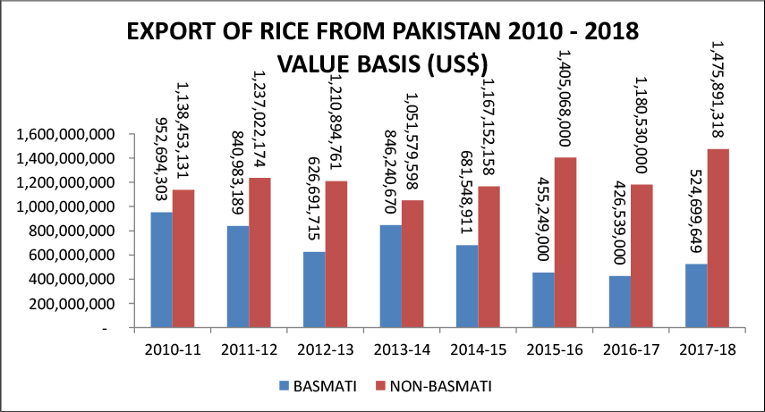

Figure S2: Figure depicting the export statistics for basmati rice, top 30 countries are shown. Source: Data from APEDA, 2019.

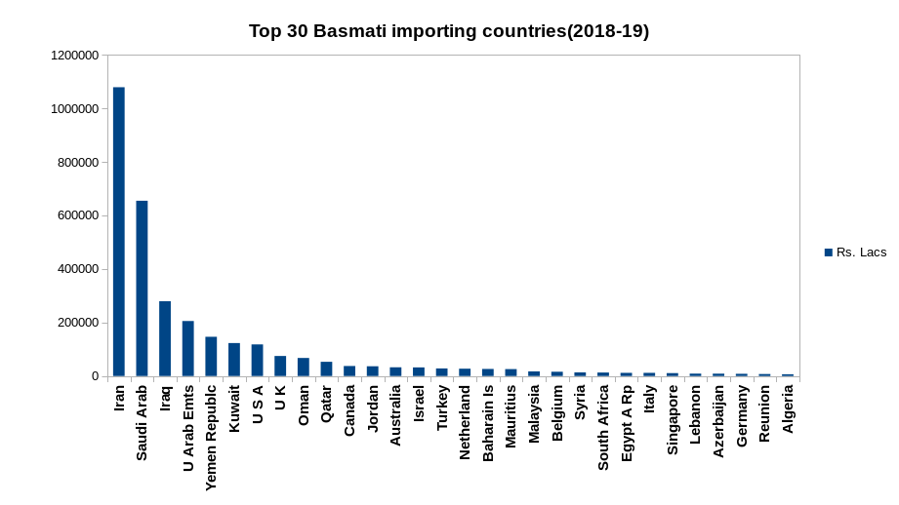
Figure S3.1: Number of original images used in model generation.

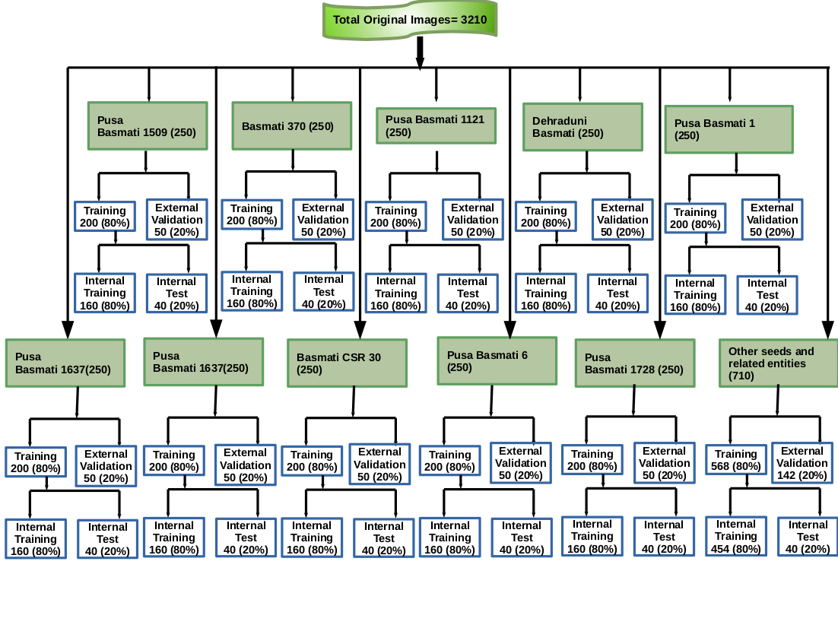

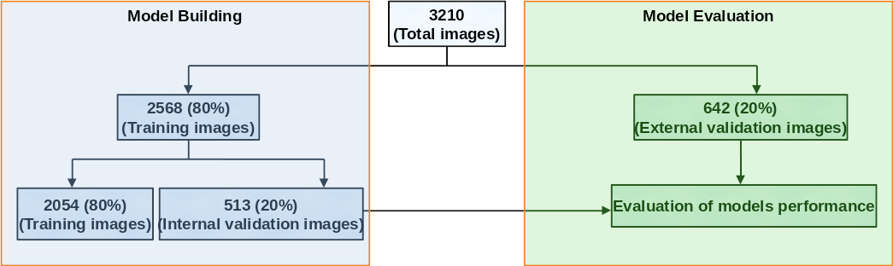
Figure S3.2: Distribution of number of original images used in model generation.
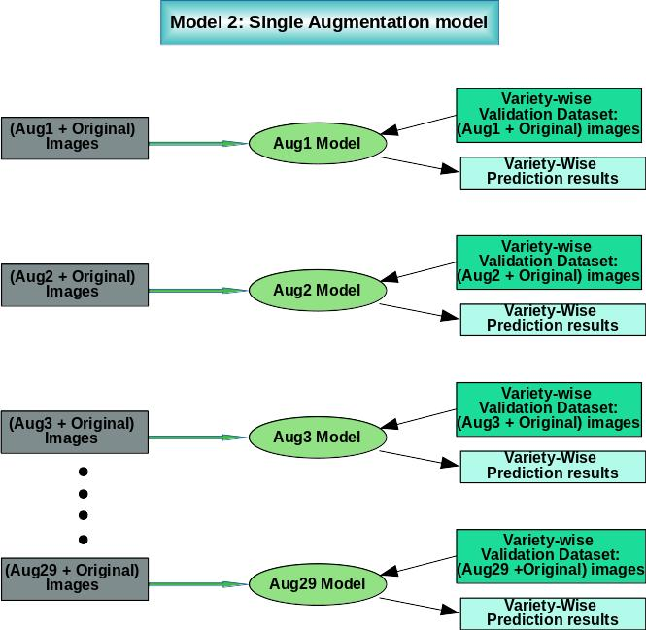
Figure S4: Single augmentation and original images based prediction models (29 different types of models).
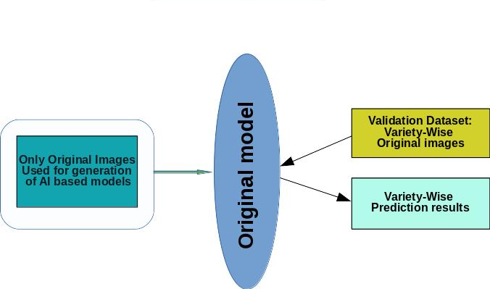
Figure S5: For development of this model only original images were used. Validation dataset for this model also comprised of original images only.

Figure S6: Multiple augmentation model (251 and 502 epochs) tested on external validation set containing all augmentation types for each variety.

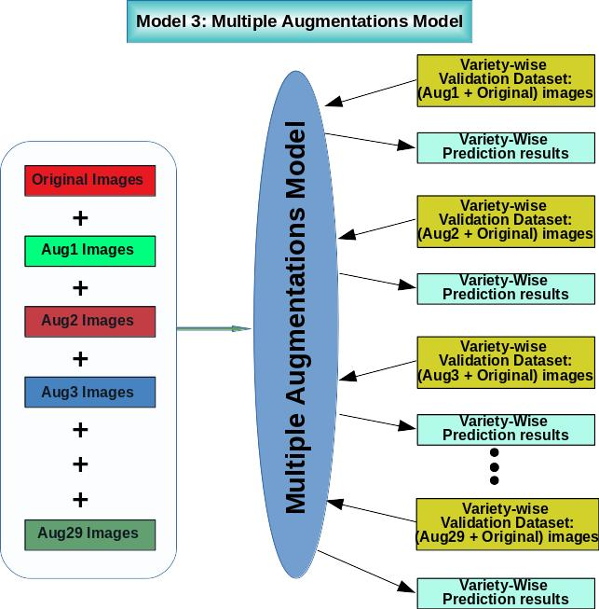

Figure S7: Other seeds and related entities dataset preparation.

Other seeds and related
entities dataset

Figure S8: Flow chart representing number of images used in model generation and as validation test set.

