Supplementary Material
Table 1 The primers were used for polarity effect in this study
Primers | Sequences | Function
2040-F | ATGTACCCACTTATCAAAAA | To amplify the HAPS_2040 gene (1008 bp)
2040-R | CTAAATAGAAATTTTCCTAACC
2042-F | ATGCACTCCTCTATTCCTTTAT | To amplify the HAPS_2042 gene (192 bp)
2042-R | TCATTTCATATTCCCAACTAAAGC
2044-F | ATGATTATCCCTTGGCAAG | To amplify the HAPS_2044 gene (225 bp)
2044-R | TTACAAATTCCCTAAGAAAG
2045-F | ATGACAGAACCTGTTATC | To amplify the HAPS_2045 gene (606 bp)
2045-R | CTAGTAGAACAATGGCTTAATC

A

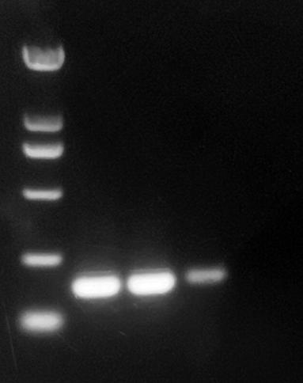
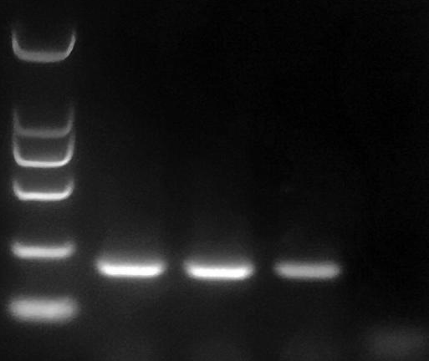
2000bp
1000bp
750bp
500bp
250bp
100bp
M 1 2 3 N
HAPS_2040
2000bp
1000bp
750bp
500bp
250bp
100bp
M 1 2 3 N
HAPS_2042
2000bp
1000bp
750bp
500bp
250bp
100bp
M 1 2 3 N
HAPS_2044
M 1 2 3 N
2000bp
1000bp
750bp
500bp
250bp
100bp
HAPS_2045
B

Figure 1. Verification the expression of the neighbor genes of the crp gene. (A) Distribution diagram of upstream and downstream of crp gene. (B) RT-PCR identification of the HAPS_2040, HAPS_2042, HAPS_2044 and HAPS_2045 from cDNAs of wild type and crp mutant strain. M: DL 2000 Mark, 1 and 2 represented cDNA genomes of the wild type and crp mutant, 3 represented genomes DNA (gDNA) of the wild type which was the positive control, N represented negative control.

