Supplementary Material

Nitrogen and phosphorus co-doped porous carbon for high-performance supercapacitors
Jiaming Zhou¹, Shewen Ye¹, Qinqin Zeng¹, Hui Yang¹, Jiahao Chen¹, Ziting Guo¹, Honghui Jiang^{1,}*, Karthikeyan Rajan^{1,}*
¹School of Materials Science and Engineering, Jiangxi University of Science and Technology, Ganzhou, China
* Correspondence:
Corresponding Author
jhonghui@163.com; karthikeyan148@gmail.com

Electrochemical measurements
For the three-electrode system, the specific capacitance of GCD was calculated according to the following equation (1):
$$\begin{aligned}{\text{C}}_{\text{s}}^{\text{*}}\text{=}\frac{\text{I×}\text{t}}{\text{m×}\text{V}}\#\left(\text{1}\right)\end{aligned}$$
For the two-electrode system, the specific capacitance of GCD was calculated according to the following equation (2):
$$\begin{aligned}{\text{C}}_{\text{s}}\text{=}\frac{\text{2×I×}\text{t}}{\text{m×}\text{V}}\#\left(\text{2}\right)\end{aligned}$$
Where I (A) is the discharge current, m (g) is the mass of the active materials in a single electrode and ΔV (V) is potential window. The energy density (E, Wh/kg) and power density (P, W/kg) was calculated according to the following equations:
$$\begin{aligned}\text{E}\text{=}\frac{{\text{C}}_{\text{s}}\text{×}{\text{V}}^{\text{2}}}{\text{2×}\text{3.6}}\#\left(\text{3}\right)\end{aligned}$$
$$\begin{aligned}\text{P}\text{=}\frac{\text{3600×}\text{E}}{\text{t}}\#\left(\text{4}\right)\end{aligned}$$
Where C_{s} (F/g) is the specific capacitance of a two electrode device, ΔV (V) is potential window and Δt is the discharge time (s).

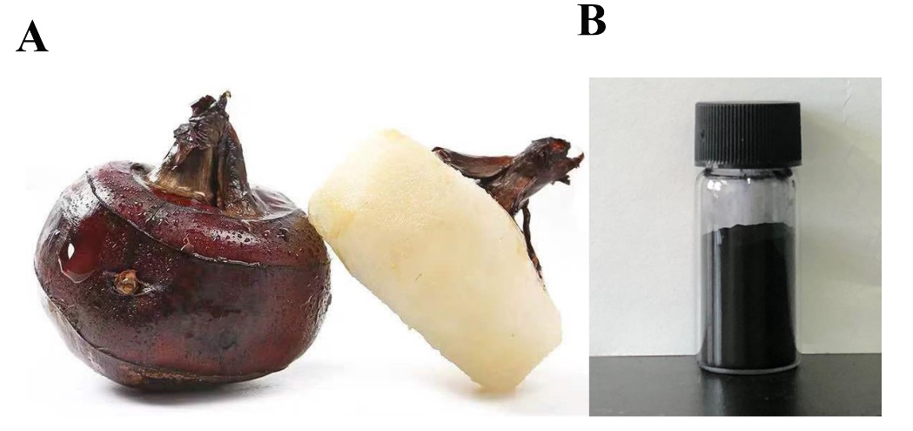

FIGURE. S1 optical images of ED before (A) and after (B) carbonization

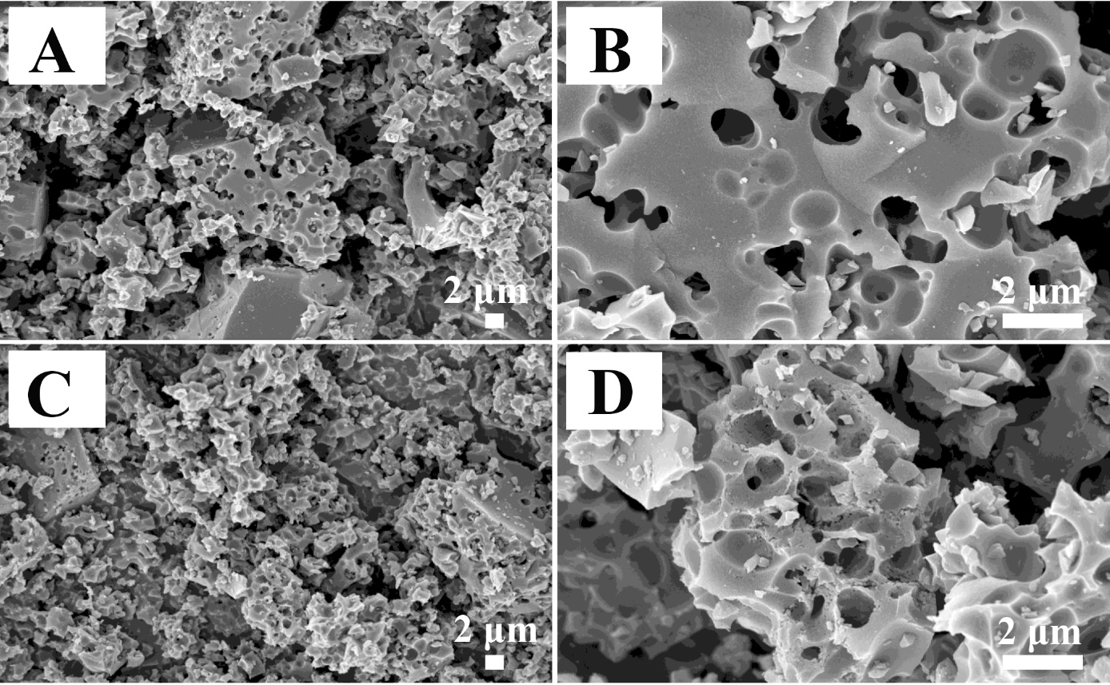
FIGURE. S2 (A, B) SEM images of NPC-1. (C,D) SEM images of NPC-2

FIGURE. S3 O_{1s} XPS spectra for NPC-3

FIGURE. S4 (A) CV curves of NPC-3 at different scanning rates; (B) Nyquist plot of NPCs

Table.S1. different types of N in PCs according to the XPS results
Samples | Pyridine-N  (%) | Quaternary-N  (%) | Pyrrolic-N  (%)
NPC-1 | 36.5 | 32.1 | 31.3
NPC-2 | 32.9 | 24.7 | 42.4
NPC-3 | 37.2 | 17.4 | 45.4

Table.S2. Comparison of BET, relative atomic concentrations of the N and P and electrochemical performance of carbon materials derived from biomass precursors
Biomass precursor | S _{BET}  (m² g⁻¹) | N content  (at%) | P content  (at%) | Cs  (F g⁻¹) | Measurement  condition | Ref
Fish scale | 1134.20 | 5.74 | 32.1 | 332 | 6 M KOH  1 A/g | (Wang et al., 2015)
Elaeocarpus tectorius shell | 860.00 | 0 | 8.10 | 201 | 1 M H₂SO₄  1 A/g | (Nirosha et al., 2020)
Silkworm Cocoon | 1247.60 | 3.56 | 1.63 | 317 | 1 M H₂SO₄  1 A/g | (Wang et al., 2019)
Shrimp shell | 725.60 | 3.34 | 1.77 | 206 | 6 M KOH  0.1 A/g | (Qu et al., 2015)
Shiitake | 2335.00 | 1.10 | 1.60 | 283 | 6 M KOH  0.5 A/g | (Cao et al., 2016)
Silkworm excrement | 2258.00 | 2.15 | 0.26 | 401 | 6 M KOH  0.5 A/g | (Lei et al., 2018)
Eleocharis dulcis | 2454.00 | 0.95 | 0.18 | 340 | 6 M KOH  1 A/g | This work

References
Cao, H., Chen, Z., Chen, Q., Yang, C., Hou, L., Rehan, M., et al. (2016). A shiitake-derived nitrogen/oxygen/phosphorus co-doped carbon framework with hierarchical tri-modal porosity for high-performance electrochemical capacitors. RSC Advances 6(85), 81527-81533. doi: 10.1039/c6ra13689c.
Lei, S., Chen, L., Zhou, W., Deng, P., Liu, Y., Fei, L., et al. (2018). Tetra-heteroatom self-doped carbon nanosheets derived from silkworm excrement for high-performance supercapacitors. J. Power Sources 379, 74-83. doi: 10.1016/j.jpowsour.2018.01.032.
Nirosha, B., Selvakumar, R., Jeyanthi, J., and Vairam, S. (2020). Elaeocarpus tectorius derived phosphorus-doped carbon as an electrode material for an asymmetric supercapacitor. New J. Chem. 44(1), 181-193. doi: 10.1039/c9nj04813h.
Qu, J., Geng, C., Lv, S., Shao, G., Ma, S., and Wu, M. (2015). Nitrogen, oxygen and phosphorus decorated porous carbons derived from shrimp shells for supercapacitors. Electrochim. Acta 176, 982-988. doi: 10.1016/j.electacta.2015.07.094.
Wang, J., Shen, L., Xu, Y., Dou, H., and Zhang, X. (2015). Lamellar-structured biomass-derived phosphorus- and nitrogen-co-doped porous carbon for high-performance supercapacitors. New J. Chem. 39(12), 9497-9503. doi: 10.1039/c5nj02080h.
Wang, Y., Zhang, M., Dai, Y., Wang, H.-Q., Zhang, H., Wang, Q., et al. (2019). Nitrogen and phosphorus co-doped silkworm-cocoon-based self-activated porous carbon for high performance supercapacitors. J. Power Sources 438. doi: 10.1016/j.jpowsour.2019.227045.

