Supplementary Materials
Additional Results
Mean and standard deviations of RTs within the stimulation parameter sets of interest across titration sessions were as follows:
- Lower-middle contacts, low V (optimal): mean=0.582s, sd=0.182s
- Both middle contacts, high V: mean=0.592s, sd=0.182s
- Lower-middle contacts, high V: mean=0.599s, sd=0.151s
- DBS-OFF: mean=0.633s, sd=0.182s

Results comparing correct RTs in the incongruent condition during stimulation with optimal stimulation parameter values (low V, ventral-medial contacts) to either set of suboptimal parameter values were not statistically significant:
- Lower-middle contacts, low V (optimal) vs. both middle contacts, high V: chisq(1)=2.276, p=0.131
- Lower-middle contacts, low V (optimal) vs. lower-middle contacts, high V: chisq(1)=1.164, p=0.281

Results comparing correct RTs in the congruent condition during stimulation with optimal parameter values to either set of suboptimal parameter values were also not significant:
- Lower-middle contacts, low V (optimal) vs. both middle contacts, high V: chisq(1)=0.327, p=0.567
- Lower-middle contacts, low V (optimal) vs. lower-middle contacts, high V: chisq(1)=0.167, p=0.682

Results comparing correct RTs in the neutral condition during stimulation for each parameter set to DBS-OFF were not significant:
- Lower-middle contacts, low V (optimal) vs. DBS-OFF: chisq(1)=1.972, p=0.160
- Both middle contacts, high V vs. DBS-OFF: chisq(1)=0.166, p=0.684
- Lower-middle contacts, high V vs. DBS-OFF: chisq(1)=0.359, p=0.543

Long-term results were presented as rate of weight loss, calculated by dividing the total weight change by the total number of days that each set of stimulation parameters were active. As each set of parameters were active for very different amounts of time (129, 675, and 108 days), our rate calculations may have been biased by duration-dependent changes in stimulation efficacy. In a follow-up analysis, we therefore considered weight loss only within the initial period of active stimulation in an effort to standardize these long-term durations. Although durations were not exactly equal because we did not collect weight data on every day of the study, we find that the results presented in the main manuscript are maintained:
- Lower-middle contacts, low V: 47.8 lbs lost in 129 days
- Both middle contacts, high V: 22.2 lbs lost in 119 days
- Lower-middle contacts, high V: 1.6 lbs lost in 108 days

For the main analyses, voltages were assigned to “low” and “high” groups relative to 5V. To demonstrate that our results are maintained beyond these specific group designations, we ran follow-up analyses with three voltage groups, each covering an equal range of 2.67V: low (2.00 to 4.67V), medium (4.67 to 7.33V), and high (7.33 to 10.00V). Using the same linear mixed effects regression analysis described in the manuscript, we identified a significant flanker RT effect for only one set of stimulation parameters: bilateral lower-middle contacts with medium V in the left hemisphere (L) and low V in the right hemisphere (R; chisq(1)=6.350, p=0.012). Applying these group delineations to the long-term weight loss data, we found that the same set of parameters that yielded a significant acute task effect also yielded the fastest rate of weight loss in the long term:
- Lower-middle contacts, L medium V, R low V: 45.8 lbs lost in 121 days
Another set of parameters yielded the same amount of weight loss, but over a much longer period of time:
- Both middle contacts, L high V, R high V: 45.8 lbs lost in 611 days
Other results were as follows:
- Lower-middle contacts, L low V, R low V: 2.0 lbs lost in 8 days
- Lower-middle contacts, L medium V, R medium V: 5.7 lbs gained in 14 days
- Lower-middle contacts, L high V, R high V: 7.3 lbs lost in 94 days
- Both middle contacts, L medium V, R medium V: 1.2 lbs lost in 64 days

Supplementary Figure 1: Orientation of implanted leads. Postoperative anterior-posterior (A) and lateral (B) x-ray images. Fusions of coronal (C) and left hemisphere sagittal (D) pre-op T1 anatomical MRI (3T) and 1-month post-op CT images showing lead placement.

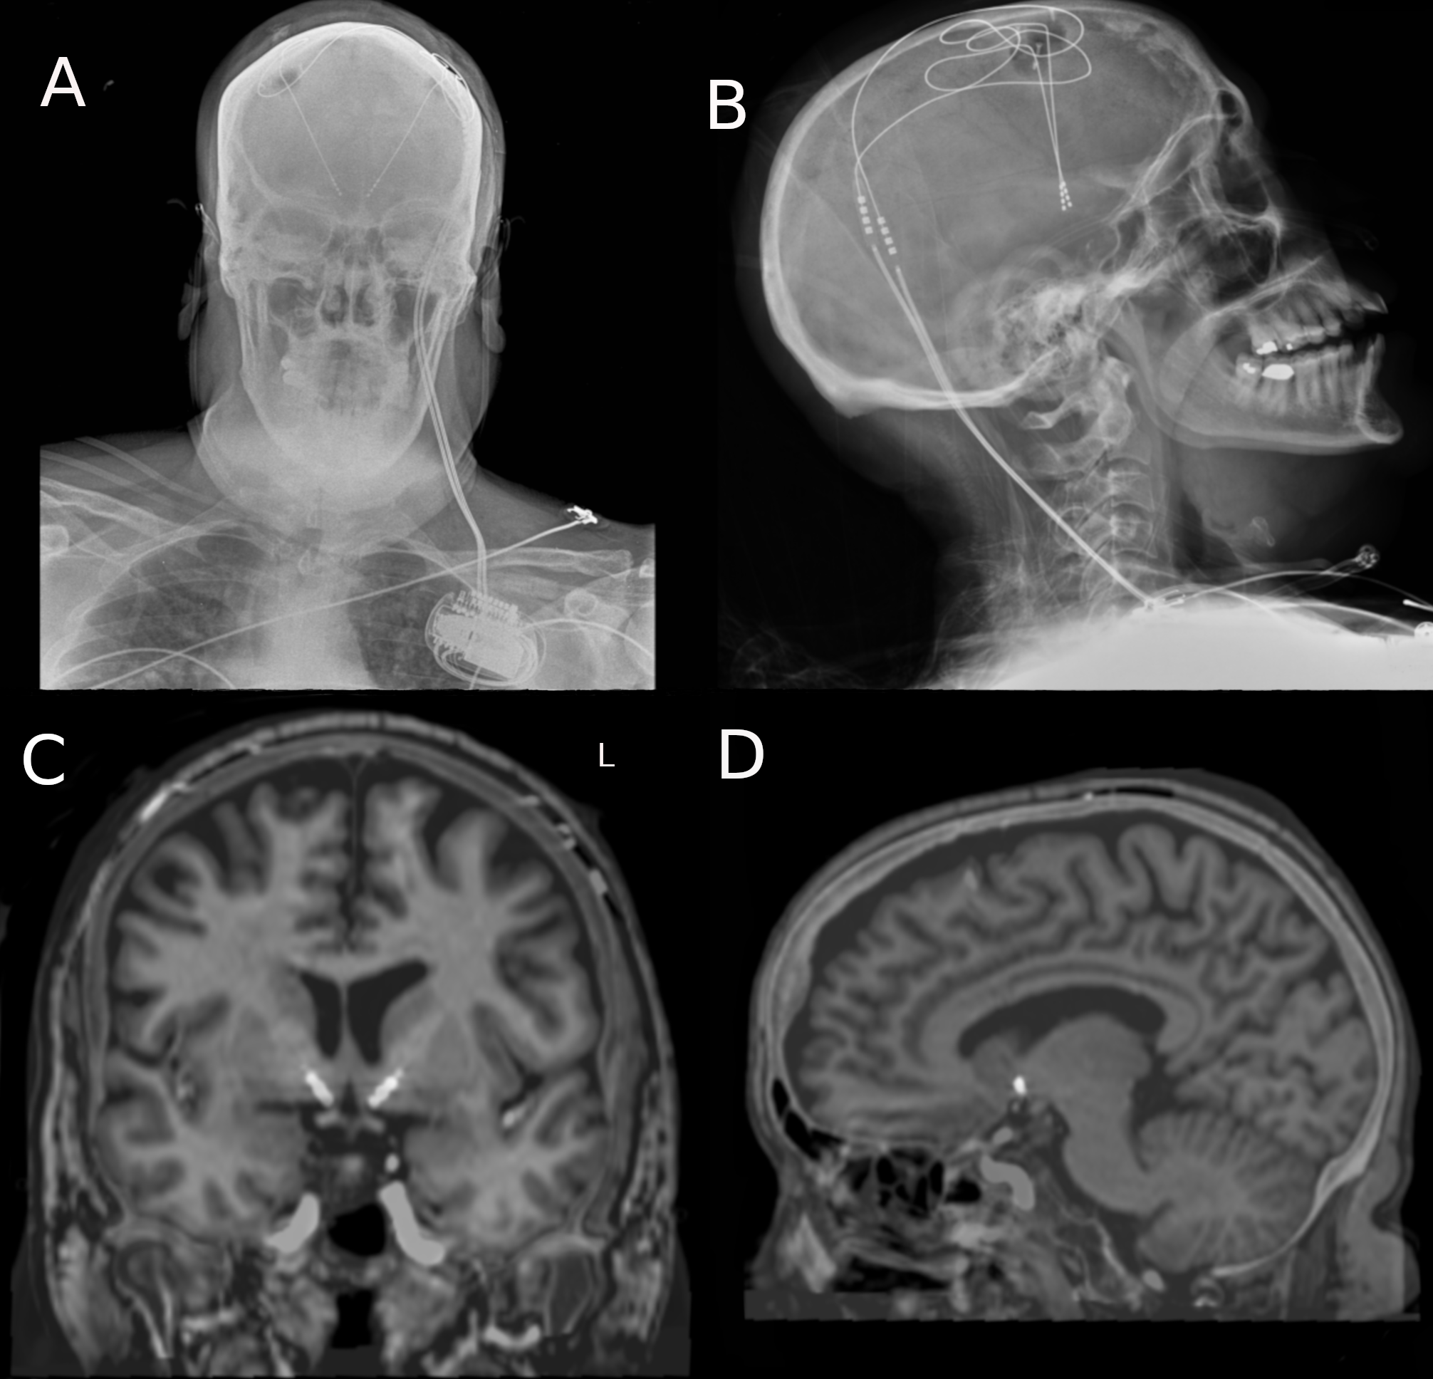

Supplementary Table 1: Contact locations. All coordinates are reported relative to the midcommisural point (MCP). X=medial-lateral, Y=anterior-posterior, Z=rostral-caudal.

Contact | Left |  |  | Right
 | X | Y | Z | X | Y | Z
0 | -6.51mm | 15.51mm | -5.22mm | 7.36mm | 13.60mm | -5.36mm
1 | -7.70mm | 16.30mm | -2.52mm | 8.76mm | 14.79mm | -2.98mm
2 | -8.87mm | 17.07mm | -0.13mm | 10.15mm | 15.97mm | -0.60mm
3 | -10.04mm | 17.85mm | 2.78mm | 11.54mm | 17.15mm | 1.78mm

Supplementary Table 2: Clusters associated with optimal settings (bilateral lower middle contacts, low amplitudes) with center of mass coordinates in MNI space.

Cluster# | Voxel# | CMx | Cmy | CMz
31 | 13751 | 148 | 297 | 206
1 | 11428 | 218 | 143 | 70
34 | 10058 | 149 | 154 | 212
44 | 2573 | 203 | 145 | 244
28 | 1608 | 148 | 210 | 169
37 | 825 | 206 | 174 | 187
51 | 502 | 117 | 285 | 232
11 | 458 | 189 | 182 | 128

Supplementary Table 3: Clusters associated with suboptimal settings (bilateral lower middle contacts, high amplitudes ) with center of mass coordinates in MNI space.

Cluster# | Voxel# | CMx | Cmy | CMz
5 | 29739 | 212 | 157 | 70
199 | 23211 | 149 | 284 | 201
215 | 7701 | 144 | 149 | 232
276 | 3792 | 157 | 240 | 257
106 | 3642 | 166 | 364 | 131
238 | 2657 | 196 | 345 | 221
44 | 1417 | 157 | 301 | 83
294 | 1118 | 203 | 143 | 250
112 | 846 | 185 | 187 | 136
102 | 818 | 220 | 233 | 145
256 | 813 | 184 | 233 | 201
85 | 753 | 152 | 248 | 120
189 | 720 | 227 | 274 | 160
197 | 700 | 140 | 200 | 172
303 | 677 | 236 | 274 | 240
223 | 607 | 205 | 171 | 185
48 | 598 | 197 | 290 | 82
233 | 503 | 232 | 322 | 194
51 | 492 | 186 | 115 | 91
128 | 440 | 189 | 211 | 129
307 | 429 | 149 | 220 | 252
4 | 426 | 200 | 164 | 67
113 | 409 | 207 | 242 | 126
45 | 378 | 225 | 91 | 87
153 | 350 | 164 | 316 | 139
83 | 339 | 198 | 255 | 112
295 | 317 | 125 | 283 | 224
288 | 284 | 165 | 225 | 213
171 | 279 | 143 | 242 | 151

Supplementary Table 4: Clusters associated with suboptimal settings (both bilateral middle contacts, high amplitudes) with center of mass coordinates in MNI space.

Cluster# | Voxel# | CMx | Cmy | CMz
109 | 28303 | 158 | 310 | 189
151 | 25432 | 172 | 151 | 222
8 | 24806 | 218 | 152 | 71
61 | 1439 | 156 | 233 | 125
254 | 992 | 157 | 238 | 253
98 | 884 | 120 | 263 | 132
242 | 665 | 120 | 285 | 230
218 | 636 | 175 | 198 | 200
227 | 634 | 134 | 321 | 207
82 | 586 | 137 | 219 | 126
217 | 335 | 208 | 99 | 204
179 | 298 | 213 | 118 | 182
127 | 297 | 118 | 182 | 151
222 | 292 | 186 | 234 | 198
183 | 260 | 134 | 196 | 177

Supplementary Table 5: Clusters from the general linear t-test between stimulation parameters associated with ‘improvement’ and ‘no change’ with center of mass coordinates in MNI space.

Cluster# | Voxel# | CMx | Cmy | CMz
85 | 7326 | 193 | 345 | 189
138 | 3973 | 183 | 270 | 198
68 | 1961 | 172 | 325 | 126
149 | 1660 | 157 | 238 | 259
1 | 1577 | 216 | 158 | 65
133 | 1180 | 164 | 170 | 199
63 | 636 | 172 | 388 | 114
134 | 546 | 233 | 319 | 192
113 | 519 | 226 | 273 | 159
156 | 482 | 160 | 284 | 250
141 | 359 | 166 | 278 | 210
140 | 342 | 181 | 233 | 202

Supplementary Table 6: Clusters from the general linear t-test between stimulation parameters associated with ‘improvement’ and ‘worsening’ with center of mass coordinates in MNI space.

Cluster# | Voxel# | CMx | Cmy | CMz
63 | 5458 | 160 | 154 | 211
1 | 5410 | 221 | 154 | 70
70 | 428 | 171 | 271 | 195
86 | 417 | 153 | 300 | 233
57 | 363 | 95 | 294 | 188
110 | 334 | 193 | 139 | 265

