Supplementary Material

A fluorescent and colorimetric chemosensor for Hg²⁺ based on rhodamine 6G with a two-step reaction mechanism
Cui-Bing Bai^{1,2}, Wei-Gang Wang¹, Jie Zhang¹, Chang Wang^{1,2}, Rui Qiao^{1,2*}, Biao Wei^{1,2}, Lin Zhang^{1,2}, Shui-Sheng Chen^{1,2}, Song Yang^{1,2}
¹School of Chemistry and Materials Engineering, Fuyang Normal University, Fuyang, Anhui Province, China
²Anhui Province Key Laboratory for Degradation and Monitoring of Pollution of the Environment, Fuyang, Anhui Province, China
*Corresponding Author
Rui Qiao, qiaorui@mail.ipc.ac.cn Tel: +86-558-2595626; Fax: +86-558-2596249

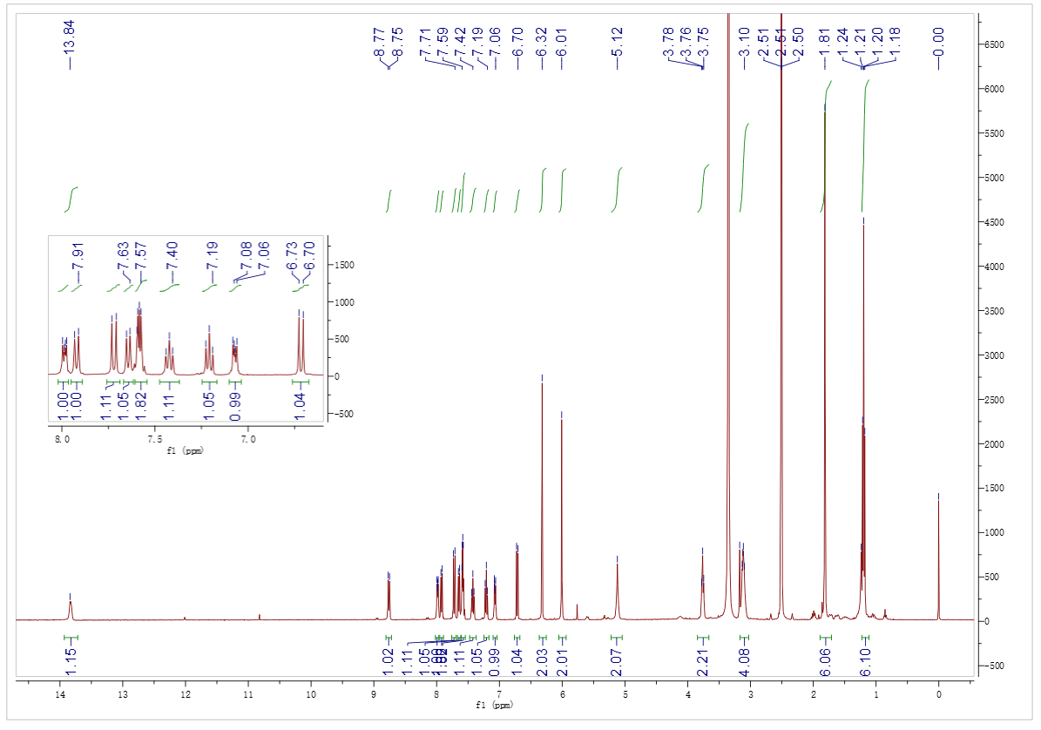
Figure S1. ¹H NMR spectra of compound L

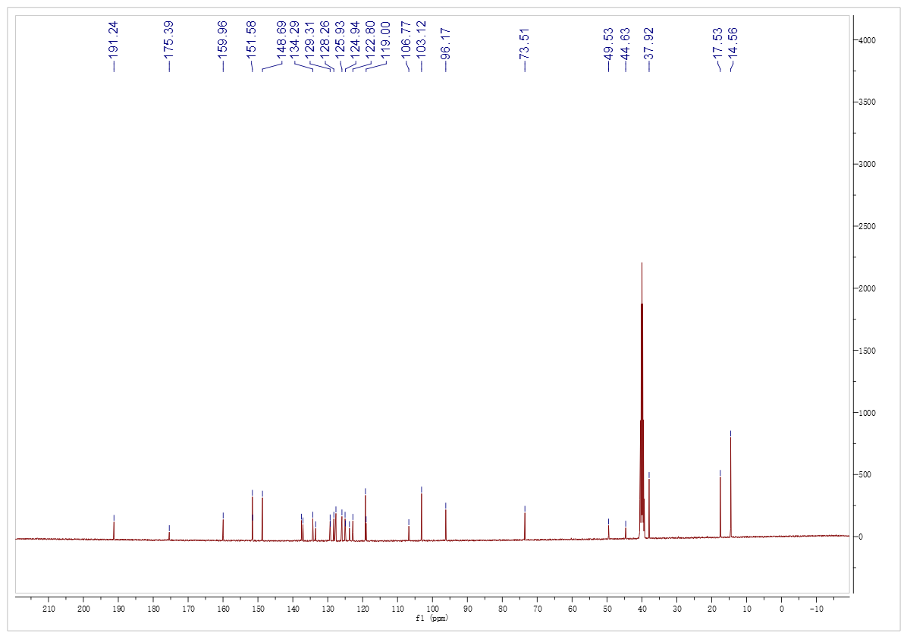
Figure S2. ¹³C NMR spectra of compound L

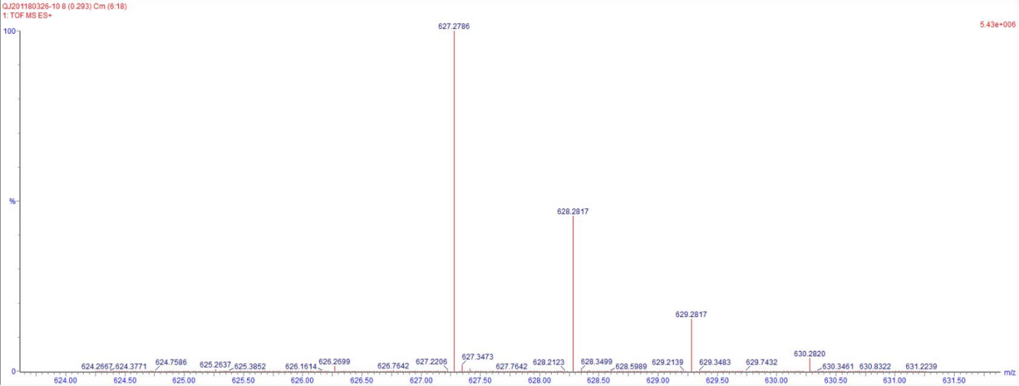
Figure S3. ESI-MS spectrum of L

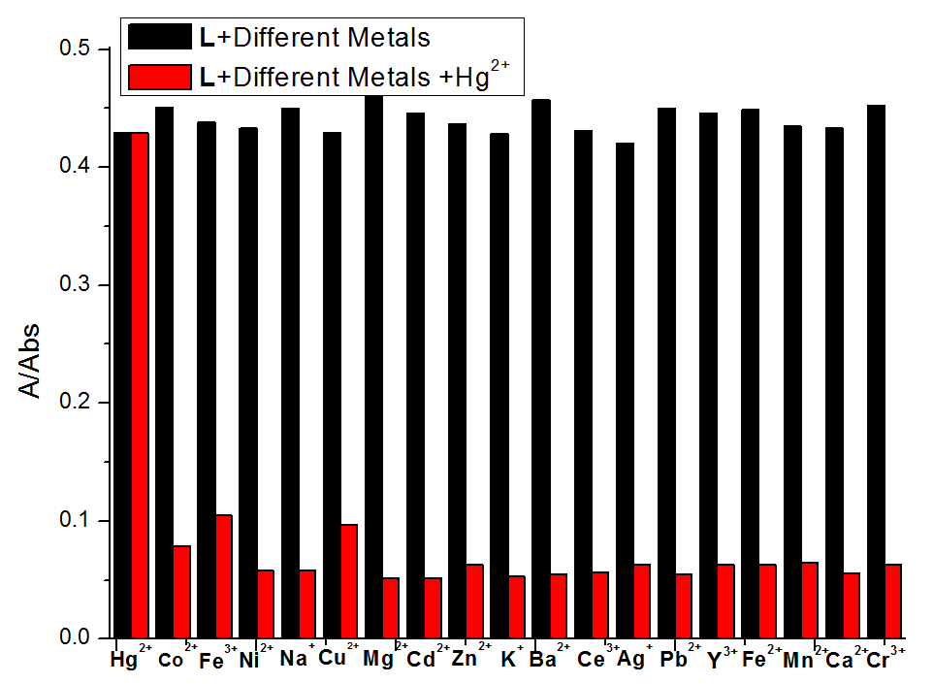
Figure S4. Absorption response of L (1×10⁻⁵ M) in HEPES buffer (10 mM, pH 7.4)/CH₃CN (40:60, V/V) upon addition of respective metal ions, at 526 nm, followed by addition of Hg²⁺.

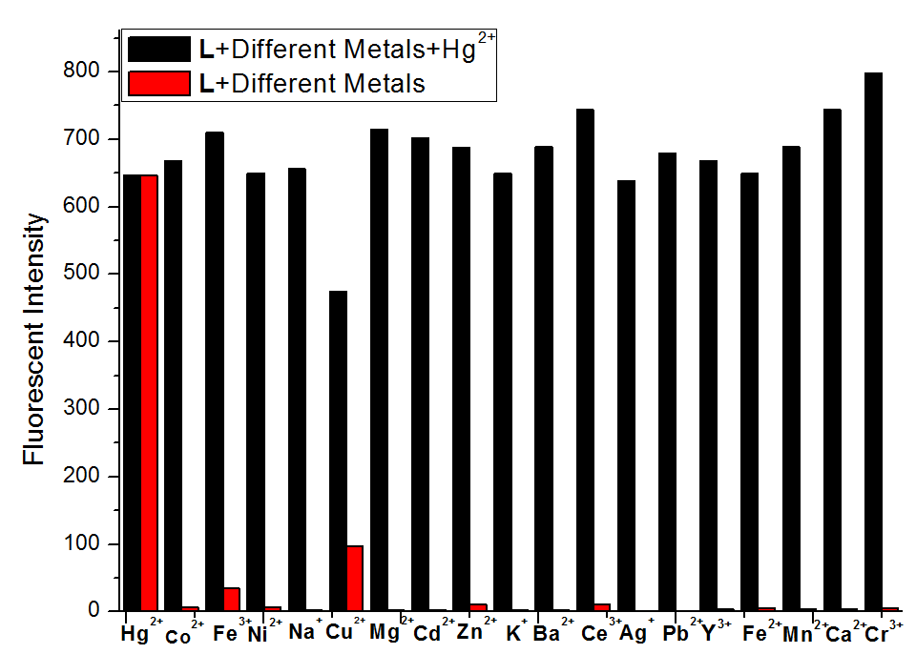
Figure S5. Competitive selectivity of L (1.0×10⁻⁵ M) towards Cu²⁺ in the presence of other metal ions in HEPES buffer (10 mM, pH 7.4)/CH₃CN (40:60, V/V), λ_{ex} = 526 nm, fluorescent intensity at 550 nm.

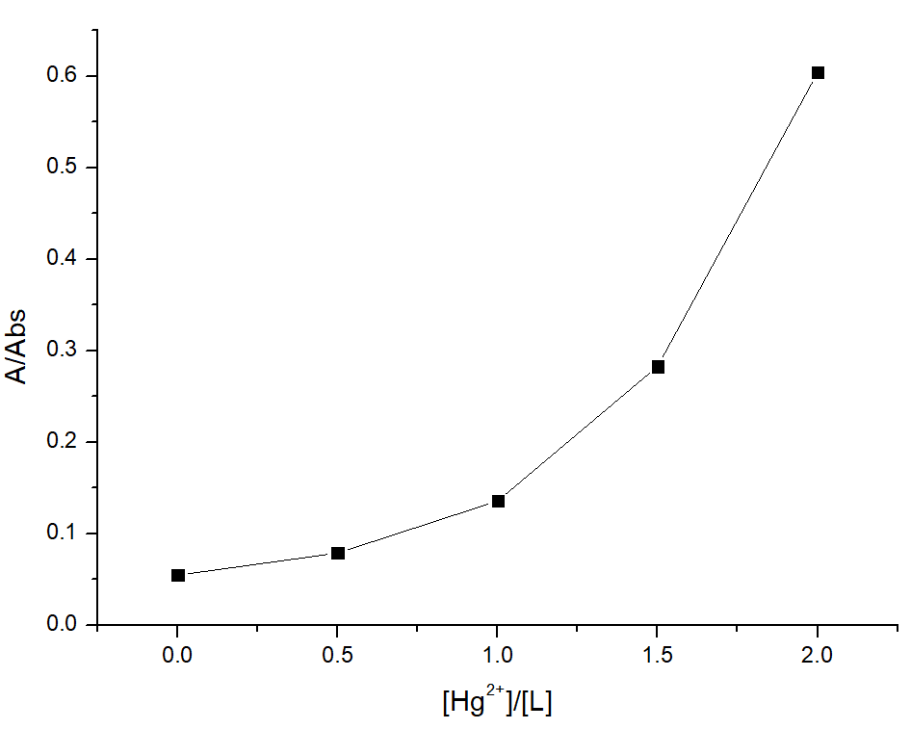
Figure S6. Absorption response of L (1×10⁻⁵ M) in HEPES buffer (10 mM, pH 7.4)/CH₃CN (40:60, V/V), at 526 nm, followed by addition of Hg²⁺. [Hg²⁺]/[L]=0, 0.5, 1, 1.5, 2 were separately tested.

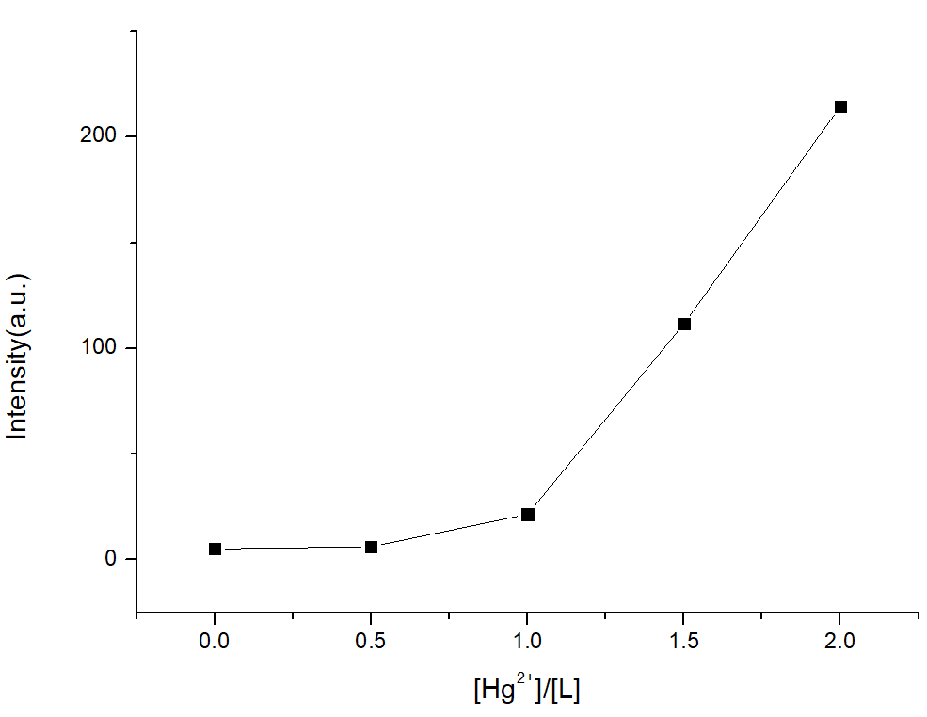
Figure S7. Fluorescence spectra of L (1×10⁻⁵ M) in HEPES buffer (10 mM, pH 7.4)/CH₃CN (40:60, V/V), at 550 nm, followed by addition of Hg²⁺. [Hg²⁺]/[L]=0, 0.5, 1, 1.5, 2 were separately tested.

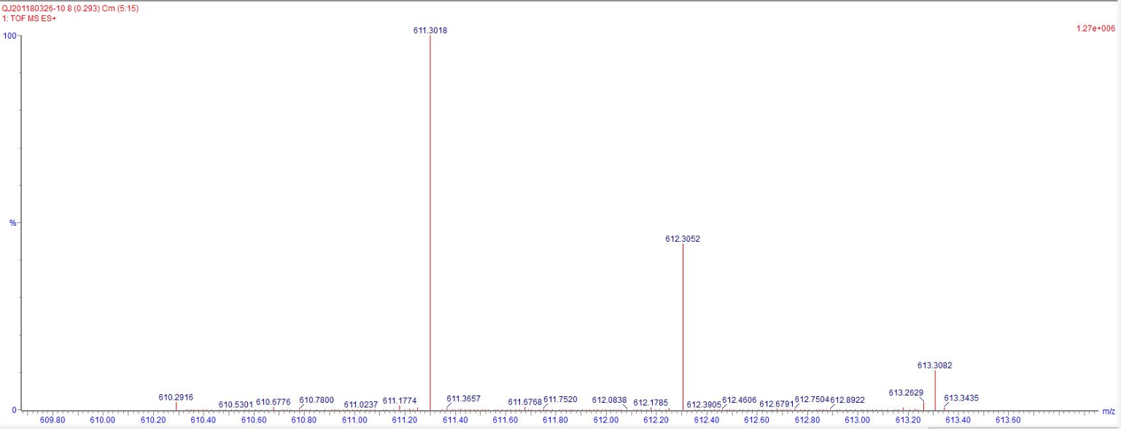
Figure S8. ESI-MS spectrum of LO

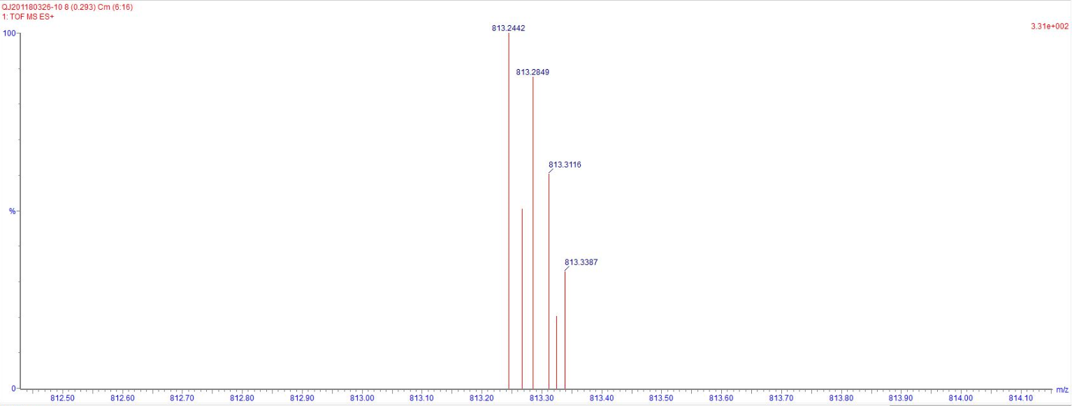
Figure S9. ESI-MS spectrum of LO-Hg²⁺

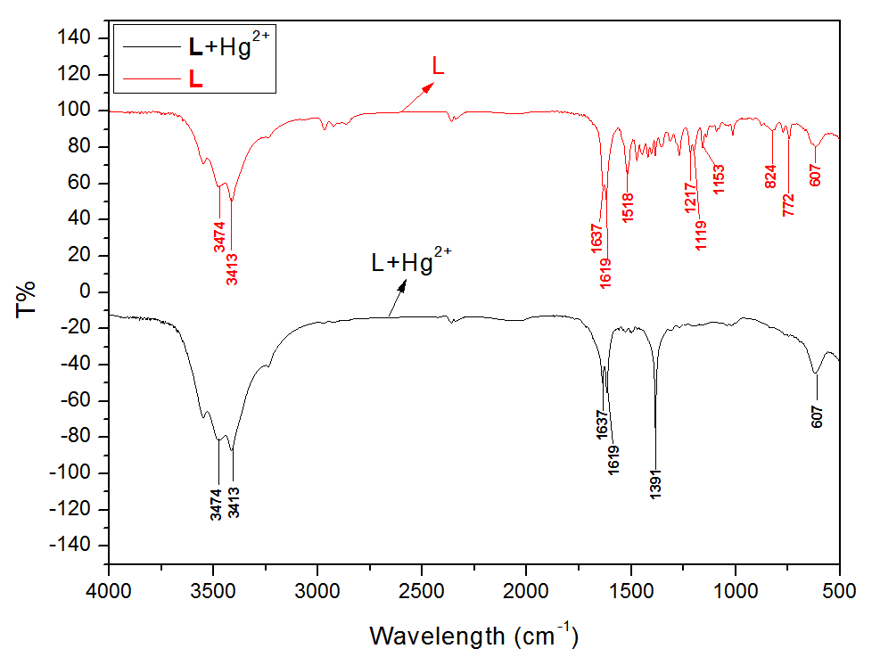
Figure S10. FTIR spectra of compound L and L−Hg²⁺

(a)
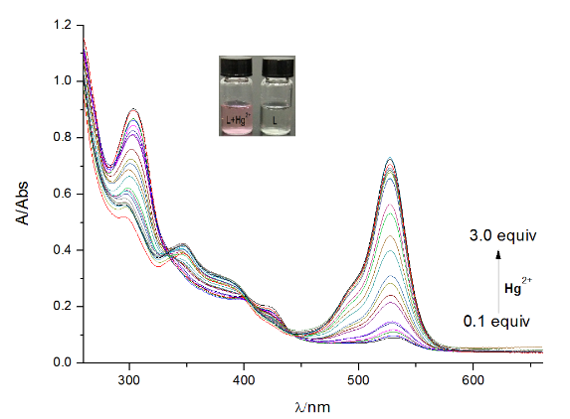
(b)
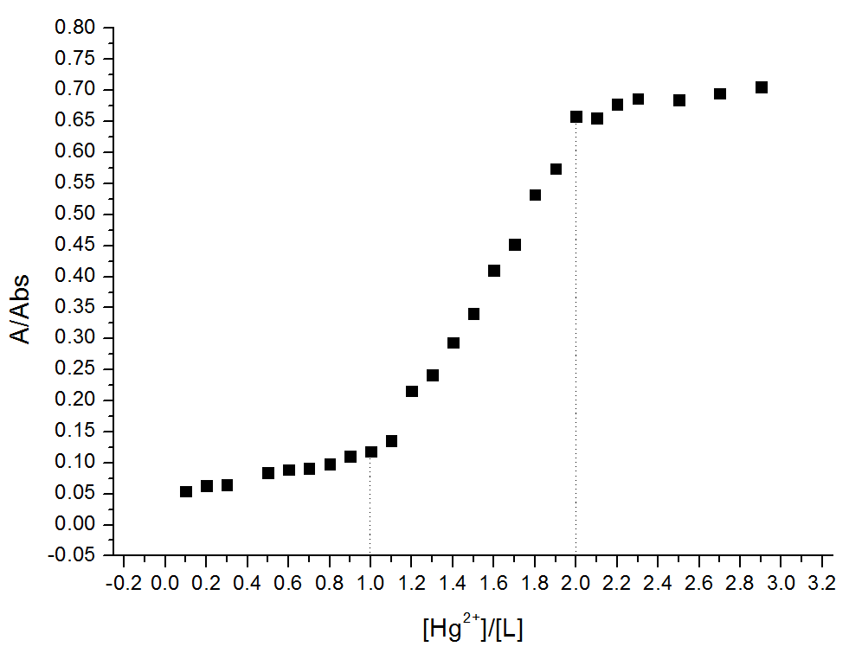
Figure S11. (a) Absorption spectra of L (1.0×10⁻⁵ M) in the presence of different concentration of Hg²⁺ (0-3.0 equiv.) in HEPES buffer (10 mM, pH 7.4)/CH₃CN (40:60, V/V). (b) A plot of absorption depending on the concentration of Hg²⁺ in the range from 0.1 to 3.0 equiv, at 526 nm.

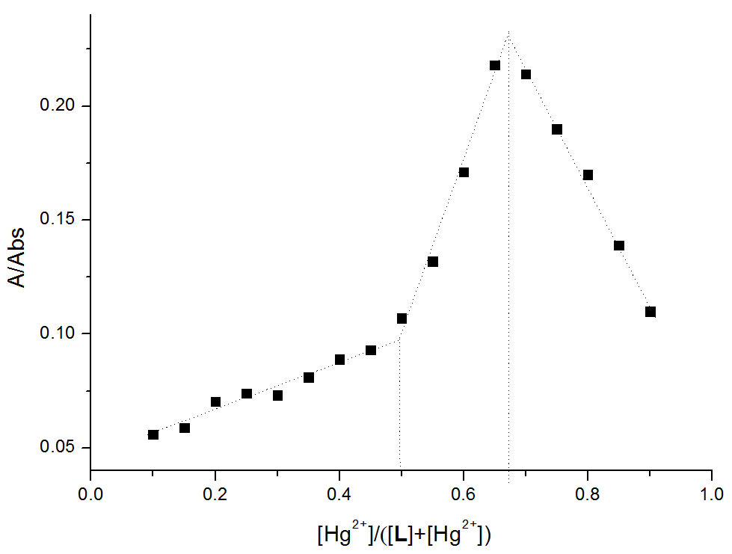
Figure S12. Absorption of chemosensors L in the presence of Hg²⁺ with different mole ratios of [Hg²⁺]/ ([Hg²⁺+L]) at the constant total concentration ([Hg²⁺] + [L] = 2.0×10⁻⁵ M) in HEPES buffer (10 mM, pH 7.4)/CH₃CN (40:60, V/V). (b) Job’ plot for determination of the binding stoichiometry of chemosensors L with Hg²⁺, λ= 526 nm.

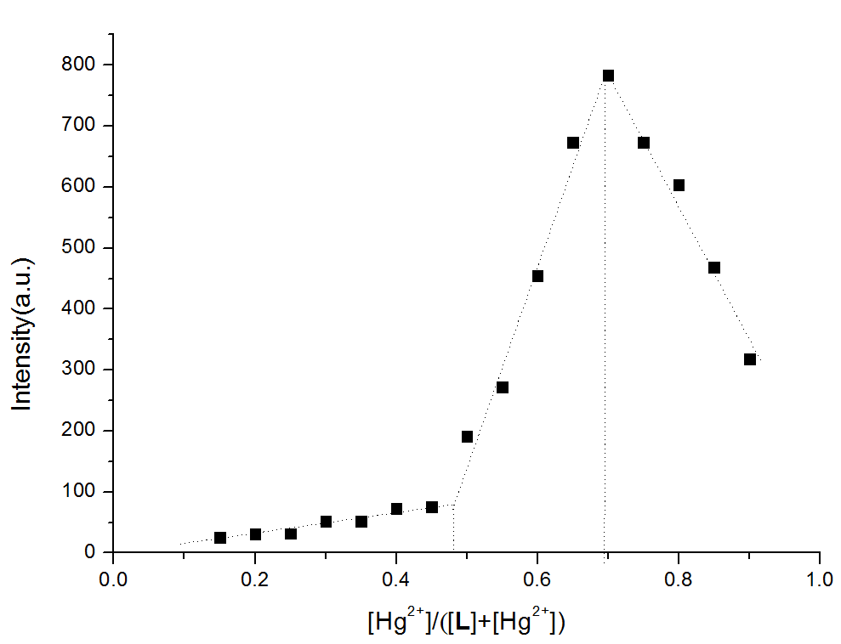
Figure S13. (a) Fluorescence spectra of chemosensor L in the presence of Hg²⁺ with different mole ratios of [Hg²⁺]/ ([Hg²⁺+L]) at the constant total concentration ([Hg²⁺]+[L]= 2.0×10⁻⁵ M) in HEPES buffer (10 mM, pH 7.4)/CH₃CN (40:60, V/V), λ_{ex}= 526 nm, at 550 nm.. (b) Job’ plot for determination of the binding stoichiometry of chemosensors L with Hg²⁺.
.

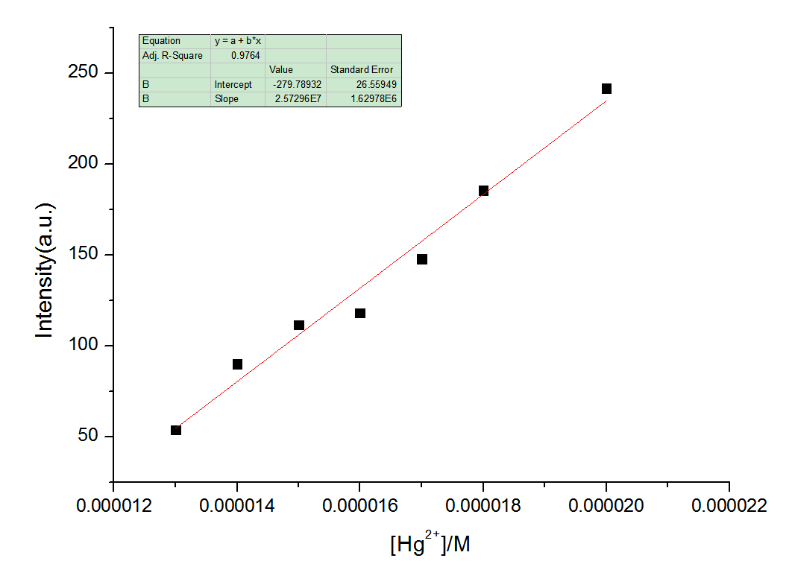
Figure S14. Plot of the intensity at 550 nm for a mixture of the sensor L (1×10⁻⁵ M) and Hg²⁺ in HEPES buffer (10 mM, pH 7.4)/CH₃CN (40:60, V/V), λ_{ex}= 526 nm.
S = 2.57296× 10⁷ δ =$\sqrt{\frac{\sum{(}F_{0 }– F_{1})^{2}}{N-1}}$ = 0.01036 (N = 20) K = 3
LOD = K × δ / S = 0.012 × 10⁻⁷ M
F₀ is the fluorescence intensity of L; F₁ is the average of the F₀.

Table S1. Fluorescence life time and quantum yield
Probes | Fluorescence Life Time | Fluorescence quantum yield
L-Hg²⁺ | 4.290913×10⁻⁹ S | 49.86 %

