Fig. S1 The Statistics on the number of genes in different expression levels with FPKM >1. G6,G18: G. lozoyensis grown with glucose as carbon source taken at 6 and 18 days; F6,F18: G. lozoyensis grown with fructose as carbon source taken at 6 and 18 days.

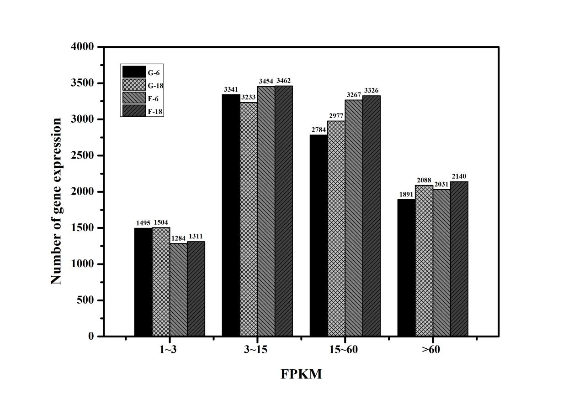

Fig. S2 KEGG pathway enrichment analysis of the differentially expressed genes (DEG) with a FDR of ≦0.05.X axis represents number of DEG. Y axis represents the name of the KEGG metabolic pathway. (A) G6 VS F6; (B ) G18 VS F18. G6,G18: G. lozoyensis grown with glucose as carbon source taken at 6 and 18 days; F6,F18: G. lozoyensis grown with fructose as carbon source taken at 6 and 18 days.

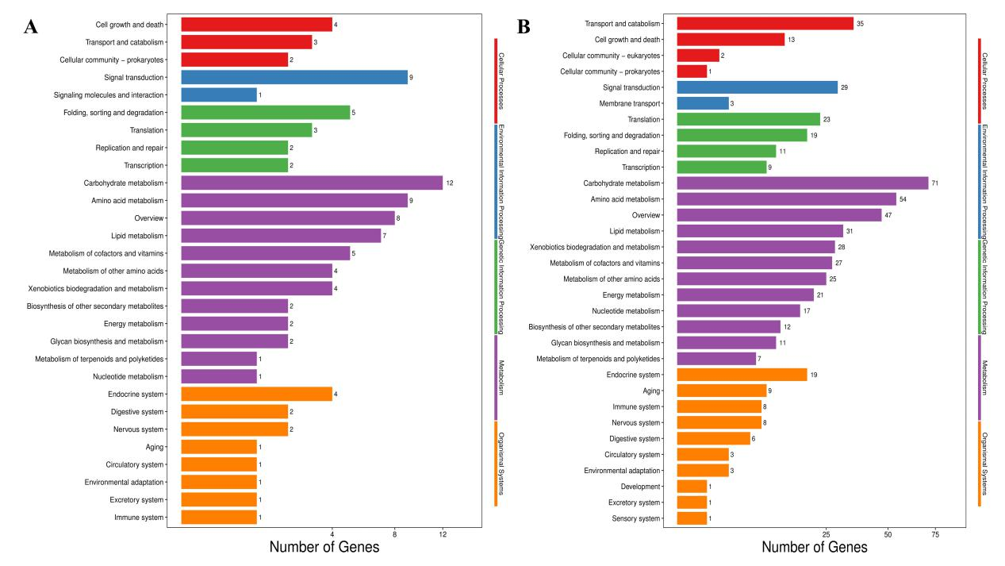

Fig. S3 Validation of the gene expression profiles of the PFK, G6PD, CS, ACL, CTH, FabG, GLPKS4 and GL ligase genes by quantitative real-time PCR (qRT-PCR). The results were normalized to the 18S rRNA. G6,G18: G. lozoyensis grown with glucose as carbon source taken at 6 and 18 days; F6,F18: G. lozoyensis grown with fructose as carbon source taken at 6 and 18 days. The data were presented as the averages of three parallel samples, and the error bars indicate the standard deviation (SD) from the means of triplicates

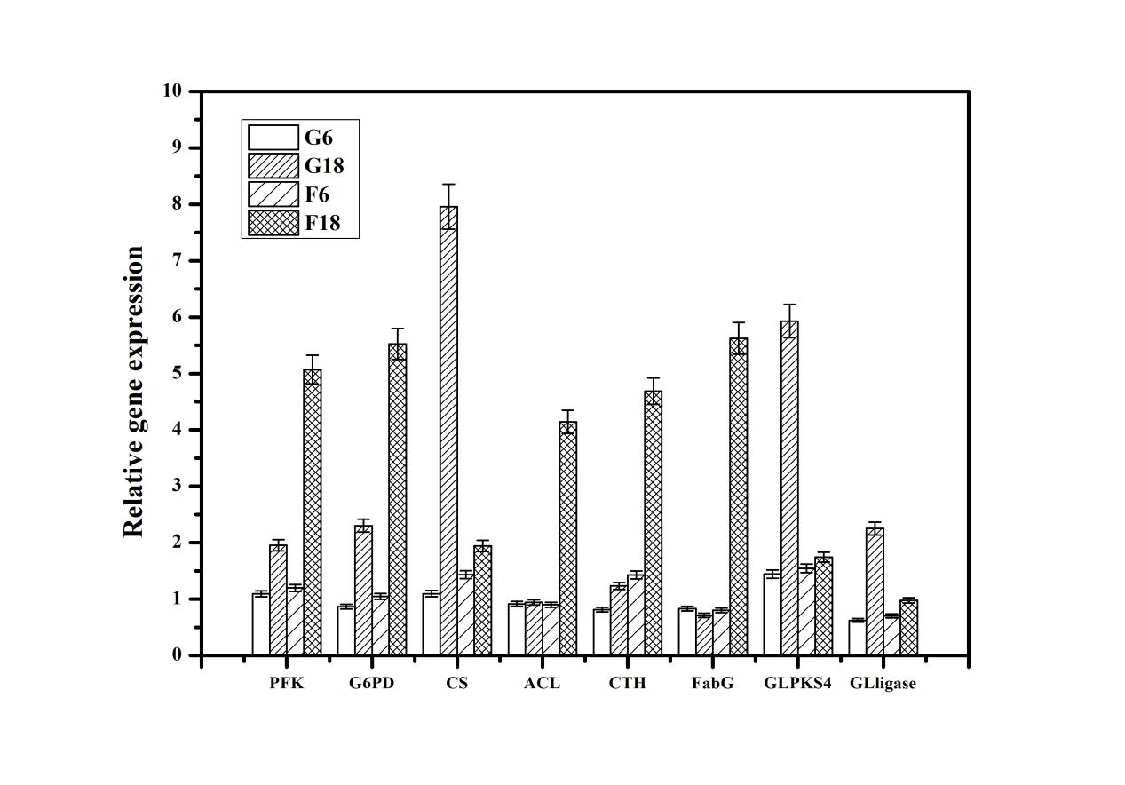

Table S1 Primers used for quantitative real-time PCR (qRT-PCR).

Gene name | Gene ID | Primer sequence (5-3’)
G6PD | GLAREA_00837 | - ACCGTGATTGTCGTTCT  R-TCAGGTGCTGGGAGAC
PFK | GLAREA_02833 | F-GTGGCTGGCTTTCCG  R-GACCCAACTAGACCAACAATA
CS | GLAREA_01577 | - ACTATCATCCCTTCCTACA  R-GAACAGAACCTTCCCAT
CTH | GLAREA_05647 | - CCAGTGGGCATTTACG  R-GCCTTTGCGACTTGTG
FabG | GLAREA_10581 | F-ATGGCACCAGCAGC  R-CCACGACCAATACCG
GLPKS4 | GLAREA_10034 | - TCGTGGGTATGGGG  R-TGCGTTGCTGAGGAT
ACL | GLAREA_01672 | F-GCCGCTACACTGCTC  R-CATCTGCTGCCTTGAC
GL ligase | GLAREA_10043 | F-GATAAGGGACATCAGACAC  R-GAGCAGACAGCGACAA
18S rRNA | endogenous control gene | F-CAGAGGACCCCAAACT  R-AGAGCCCAAGACCCA

Table S2 Summary of draft reads of samples by Illumina sequencing. The Q20 percentage is the proportion of nucleotides with quality values larger than or equal to 20; the Q30 percentage is the proportion of nucleotides with quality values larger than or equal to 30; the GC percentage is the proportion of guanidine and cytosine nucleotides among total nucleotides.

Sample | Clean reads pairs | Clean bases | Length | Q20(%) | Q30(%) | GC(%)
G6 | 22,548,440 | 6,764,532,000 | 150;150 | 97.4;96.2 | 93.1;90.5 | 49.9;49.9
G18 | 26,003,945 | 7,801,183,500 | 150;150 | 97.4;96.5 | 93.1;91.0 | 49.6;49.5
F6 | 20,752,119 | 6,225,635,700 | 150;150 | 97.4;96.4 | 93.1;90.8 | 49.8;49.8
F18 | 23,508,815 | 7,052,644,500 | 150;150 | 97.3;96.1 | 93.0;90.2 | 49.4;49.4

Table. S3 Reference gene comparison with total clean reads

Sample | Total clean read pairs | Total mapped reads | Uniq mapped reads | Multiple mapped reads
G6 | 22,548,440 | 18,638,772(82.66%) | 7,767,243(34.45%) | 10,871,529(48.21%)
G18 | 26,003,945 | 21,686,398(83.40%) | 7,991,125(30.73%) | 13,695,273(52.67%)
F6 | 20,752,119 | 17,202,526(82.90%) | 6,398,242(30.83%) | 10,804,284(52.06%)
F18 | 23,508,815 | 19,350,971(82.31%) | 6,894,133(29.33%) | 12,456,838(52.99%)

Table. S4 The gene list mentioned in this paper. G6,G18: G. lozoyensis grown with glucose as carbon source taken at 6 and 18 days; F6,F18: G. lozoyensis grown with fructose as carbon source taken at 6 and 18 days.

Gene | Gene ID | Pathway | FPKM
 |  |  | G6 | F6 | G18 | F18
GPI | GLAREA12579 | Glycolysis |  |  | 45.22 | 857.71
PFK | GLAREA02833 | Glycolysis |  |  | 25.63 | 178.45
ALDO | GLAREA11809 | Glycolysis |  |  | 121.28 | 1264.30
G6PD | GLAREA00837 | PPP |  |  | 51.92 | 322.28
PGD | GLAREA03380 | PPP |  |  | 80.12 | 1012.23
PDH | GLAREA12506 | TCA |  |  | 85.72 | 463.10
ACL | GLAREA01672 | TCA |  |  | 69.24 | 1687.28
CS | GLAREA01577 | TCA |  |  | 749.50 | 51.35
SDH | GLAREA04970 | TCA |  |  | 953.36 | 184.25
KHX | XLOC001041 | Fructose and mannose metabolism |  |  | 40.51 | 2306.32
SDS | GLAREA07335 | Glycine, serine and threonine metabolism | 35.21 | 125.37 | 69.51 | 280.45
CBS | GLAREA07800 | Glycine, serine and threonine metabolism | 23.55 | 60.42 | 57.92 | 285.76
CTH | GLAREA05647 | Cysteine and methionine metabolism | 20.56 | 81.73 | 149.02 | 2415.28
CD | GLAREA00252 | Cysteine and methionine metabolism | 19.15 | 45.26 | 100.35 | 321.54
metC | GLAREA04056 | Cysteine and methionine metabolism | 55.22 | 115.86 | 33.15 | 13786.20
IDO | GLAREA03347 | Tryptophan metabolism |  |  | 25.44 | 333.47
KMO | GLAREA04299 | Tryptophan metabolism |  |  | 28.54 | 407.50
kynU | GLAREA11410 | Tryptophan metabolism |  |  | 90.15 | 290.56
HAAO | GLAREA05397 | Tryptophan metabolism |  |  | 54.60 | 1023.91
atoB | GLAREA04174 | Tryptophan metabolism |  |  | 41.77 | 493.59
TDC | GLAREA08319 | Phenylalanine metabolism |  |  | 32.81 | 337.60
TAT | GLAREA00731 | Tyrosine metabolism |  |  | 42.13 | 194.61
HPD | GLAREA03832 | Tyrosine metabolism |  |  | 16.30 | 584.39
hmgA | GLAREA00182 | Tyrosine metabolism |  |  | 73.28 | 348.04
ACC | GLAREA00402 | Fatty acid synthesis | 60.23 | 838.93
FabG | GLAREA10581 | Fatty acid synthesis | 32.11 | 726.57 | 66.32 | 18209.48
FAS1 | GLAREA08410 | Fatty acid synthesis | 17.58 | 348.33 | 102.47 | 28115.10
GLPKS4 | GLAREA10034 | Pneumocandin B₀ biosynthesis |  |  | 305.70 | 26.43
GLNRPS4 | GLAREA10035 | Pneumocandin B₀ biosynthesis |  |  | 127.86 | 31.88
GLligase | GLAREA10043 | Pneumocandin B₀ biosynthesis |  |  | 104.76 | 18.52
GLHYD | GLAREA10032 | Pneumocandin B₀ biosynthesis |  |  | 161.74 | 35.20
GLOXY1 | GLAREA10033 | Pneumocandin B₀ biosynthesis |  |  | 351.33 | 112.41
GLOXY2 | GLAREA10041 | Pneumocandin B₀ biosynthesis |  |  | 263.52 | 60.70
GLP450-1 | GLAREA10030 | Pneumocandin B₀ biosynthesis |  |  | 138.89 | 47.96
GLP450-2 | GLAREA10031 | Pneumocandin B₀ biosynthesis |  |  | 235.26 | 58.57

