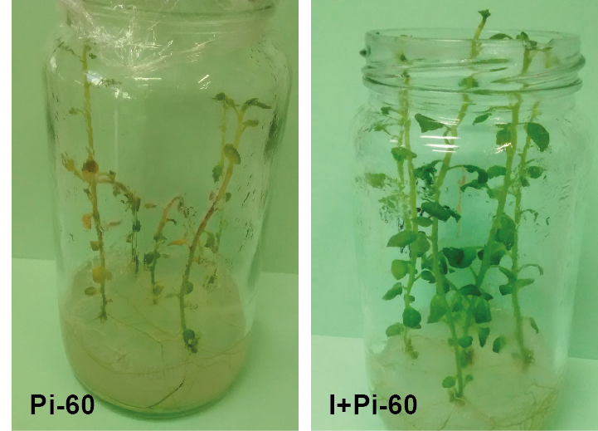
Figure S2. Methylobacterium sp. 2A protected potato plants against P. infestans. In vitro four-weeks-old potato plants inoculated or not with Methylobacterium sp. 2A, were infected with P. infestans isolate Pi-60; 10-µl droplets of zoospore suspension were pipetted on three leaves per plant. Five days later, P. infestans aggressiveness was observed. Left panel: control plants (Pi-60); right panel: Methylobacterium sp. 2A-inoculated plants (I+Pi-60).

