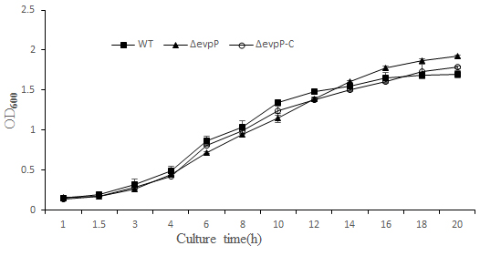
FIGURE S1 Comparison of cell growth in WT, ΔevpP and ΔevpP -C. All experiments were performed in triplicate.

