Supplementary Material

Table S1: Search Strategies
Medline-PubMed
((("pembrolizumab"[ALL] OR "pembrolizumab"[Supplementary Concept] OR "keytruda "[ALL] OR "lambrolizumab"[ALL] OR "MK-3475"[ALL] OR "MK3475"[ALL] OR "MK 3475"[ALL] OR "SCH-900475"[ALL] OR "SCH900475"[ALL] OR "SCH 900475"[ALL] OR "nivolumab"[ALL] OR "nivolumab"[Supplementary Concept] OR "opdivo"[ALL] OR "BMS-936558"[ALL] OR "BMS936558"[ALL] OR "BMS 936558"[ALL] OR "ONO-4538"[ALL] OR "ONO4538"[ALL] OR "ONO 4538"[ALL] OR "MDX-1106"[ALL] OR "MDX1106"[ALL] OR "MDX 1106"[ALL] OR "immune checkpoint inhibitor*"[ALL] OR "anti-PD-1"[ALL] OR "anti-PD1"[ALL] OR "anti-PD 1"[ALL] OR "pd1 inhibitor*"[ALL] OR "pd 1 inhibitor*"[ALL] OR "pd 1 inhibitor nivolumab"[ALL] OR "programmed cell death 1 receptor/antagonists and inhibitors"[MeSH Terms] OR "programmed cell death 1 receptor/antagonists and inhibitors"[ALL] OR "programmed cell death 1 receptor antagonist*"[ALL] OR "programmed cell death 1 receptor inhibitor*"[ALL] OR "Ipilimumab"[ALL] OR "Ipilimumab "[Supplementary Concept] OR "MDX-010"[ALL] OR "MDX010"[ALL] OR "MDX 010"[ALL] OR "MDX-CTLA-4"[ALL] OR "MDX-CTLA4"[ALL] OR "BMS-734016"[ALL] OR "BMS734016"[ALL] OR "BMS 734016"[ALL] OR "Yervoy"[ALL] OR "anti CTLA4"[ALL] OR "anti CTLA-4"[ALL] OR "cytotoxic T-lymphocyte-associated protein-4"[ALL] OR "anti-cytotoxic T-lymphocyte-associated antigen-4"[ALL] OR "MOAB CTLA-4"[ALL] OR "monoclonal antibody CTLA-4"[ALL] OR "monoclonal antibody CTLA4"[ALL]))) AND (("melanoma"[MeSH]) OR "malignant melanoma*"[ALL] OR "melanoma*"[ALL] OR "advanced melanoma*"[ALL] OR "unresectable melanoma*"[ALL]))
Cochrane Library-Trial
#1 MeSH descriptor: [Melanoma] explode all trees
#2 Melanoma
#3 malignant melanoma
#4 advanced melanoma
#5 unresectable melanoma
#6 #1 OR #2 OR #3 OR #4 OR #5
#7 MeSH descriptor: [Ipilimumab] explode all trees
#8 Ipilimumab
#9 Anti-CTLA-4 MAb
#10 Anti CTLA 4 MAb
#11 MDX-CTLA-4
#12 MDX CTLA 4
#13 MDX-010
#14 MDX 010
#15 MDX010
#16 Yervoy
#17 BMS-734016
#18 BMS 734016
#19 anti CTLA4
#20 anti CTLA-4
#21 cytotoxic T-lymphocyte-associated protein-4
#22 anti-cytotoxic T-lymphocyte-associated antigen-4
#23 monoclonal antibody CTLA-4
#24 monoclonal antibody CTLA 4
#25 monoclonal antibody CTLA4
#26 #7 OR #8 OR #9 OR #10 OR #11 OR #12 OR #13 OR #14 OR #15 OR #16 OR #17 OR #18 OR #19 OR #20 OR #21 OR #22 OR #23 OR #24 OR #25
#27 pembrolizumab
#28 keytruda
#29 lambrolizumab
#30 MK-3475
#31 MK3475
#32 MK 3475
#33 SCH-900475
#34 SCH900475
#35 SCH 900475
#36 nivolumab
#37 opdivo
#38 BMS-936558
#39 BMS936558
#40 BMS 936558
#41 ONO-4538
#42 ONO4538
#43 ONO 4538
#44 MDX-1106
#45 MDX1106
#46 MDX 1106
#47 immune checkpoint inhibitor*
#48 anti-PD-1
#49 anti-PD1
#50 anti-PD 1
#51 programmed cell death 1 receptor antagonists
#52 programmed cell death 1 receptor inhibitors
#53 programmed cell death-1 receptor antagonists
#54 programmed cell death-1 receptor inhibitors
#55 #27 OR #28 OR #29 OR #30 OR #31 OR #32 OR #33 OR #34 OR #35 OR #36 OR #37 OR #38 OR #39 OR #40 OR #41 OR #42 OR #43 OR #44 OR #45 OR #46 OR #47 OR #48 OR #49 OR #50 OR #51 OR #52 OR #53 OR #54
#56 #26 OR # 55
#57 #6 AND #56
#7 OR #8 OR #9 OR #10 OR #11 OR #12 OR #13 OR #14 OR #15 OR #16 OR #17 OR #18 OR #19 OR #20 OR #21 OR #22 OR #23 OR #24 OR #25 OR #26 OR #27 OR #28 OR #29 OR #30 OR #31 OR #32 OR #33 OR #34 OR #35 OR #36 OR #37 OR #38 OR #39 OR #40 OR #41 OR #42 OR #43 OR #44 OR #45 OR #46 OR #47 OR #48 OR #49 OR #50 OR #51 OR #52 OR #53 OR #54 OR #55 OR #56 OR #57

Embase
#1 'melanoma'/exp
#2 'advanced melanoma'/exp
#3 'advanced melanoma'
#4 'melanoma'
#5 'malignant melanoma*' OR 'unresectable melanoma*'
#6 #1 OR #2 OR #3 OR #4 OR #5
#7 'pembrolizumab'/exp
#8 pembrolizumab
#9 keytruda
#10 'lambrolizumab'/exp
#11 'lambrolizumab'
#12 'mk-3475' OR 'mk3475' OR 'mk 3475' OR 'sch-900475' OR 'sch900475' OR 'sch 900475'
#13 'nivolumab'/exp
#14 'nivolumab'
#15 opdivo
#16 'bms-936558' OR 'bms936558' OR 'bms 936558' OR 'ono-4538' OR 'ono4538' OR 'ono 4538' OR 'mdx-1106' OR 'mdx1106' OR 'mdx 1106'
#17 'immune checkpoint inhibitor*'
#18 'anti-pd-1' OR 'anti-pd1' OR 'anti-pd 1' OR 'pd1 inhibitor*' OR 'pd 1 inhibitor*' OR 'pd-1 inhibitor'
#19 'programmed cell death 1 receptor antagonist*'
#20 'programmed cell death-1 receptor antagonist*'
#21 'programmed cell death-1 receptor inhibitor*'
#22 'programmed cell death 1 receptor inhibitor*'
#23 'ipilimumab'/exp
#24 'ipilimumab'
#25 yervoy
#26 'mdx-010' OR 'mdx010' OR 'mdx 010' OR 'mdx-ctla-4' OR 'mdx-ctla4' OR 'bms-734016' OR 'bms734016' OR 'bms 734016'
#27 'anti ctla4' OR 'anti ctla-4' OR 'cytotoxic t-lymphocyte-associated protein-4' OR 'anti-cytotoxic t-lymphocyte-associated antigen-4'OR 'moab ctla-4' OR 'monoclonal antibody ctla-4' OR 'monoclonal antibody ctla4'
#28 #7 OR #8 OR #9 OR #10 OR #11 OR #12 OR #13 OR #14 OR #15 OR #16 OR #17 OR #18 OR #19 OR #20 OR #21 OR #22 OR #23 OR #24 OR #25 OR #26 OR #27
#29 #6 AND #28

Table S 2. Quality assessment of non-randomized studies using Newcastle‐Ottawa quality scale for cohort studies
Study | Selection |  |  |  | Comparability |  | Outcome assessment |  |  | Total NOS assessment
 | Representativeness of the exposed cohort | Selection of the non-exposed cohort | Ascertainment of exposure | Outcome of interest was not present at start of study | Controls for the most important factors | Controls for additional factor | Assessment of outcome | Enough follow-up for outcomes to occur | Adequacy of follow up of cohorts
Callahan, 2017 | * | NA | * | * | NA | NA | Open-label | * | * | 5
Day, 2010 | * | NA | * | * | NA | NA | Open-label | * | * | 5
Downey, 2007 | * | * | * | * | NA | NA | Open-label | * | * | 6
Goldberg,2016  Goldberg, | * | NA | * | * | NA | NA | Open-label | * | * | 5
Haag, 2018 | * | NA | * | * | NA | NA | Open-label | * | * | 5
Long, 2017 | * | NA | * | * | NA | NA | Open-label | * | * | 5
Margolin, 2012 | * | NA | * | * | NA | NA | Open-label | * | * | 5
Marker, 2006 | * | NA | * | * | NA | NA | Open-label | * | * | 5
Tawbi, 2018 | * | NA | * | * | NA | NA | Open-label | * | * | 5
Topalian, 2014 | * | NA | * | * | NA | NA | Open-label | * | * | 5
Weber, 2008 | * | NA | * | * | NA | NA | Open-label | * | * | 5
Weber, 2013 | * | NA | * | * | NA | NA | Open-label | * | * | 5
Yamazaki, 2015 | * | NA | * | * | NA | NA | Open-label | * | * | 5
Yamazaki, 2017 (JapicCTI-142533) | * | NA | * | * | NA | NA | Open-label | * | * | 5
Yamazaki, 2017 (KEYNOTE-041) | * | NA | * | * | NA | NA | Open-label | * | * | 5
Zimmer, 2015 | * | NA | * | * | NA | NA | Open-label | * | * | 5
NOS, Newcastle‐Ottawa quality scale; one “*” means one point
Figure S 1: Funnel plot of incidence of all-grade overall potential irAEs in ipilimumab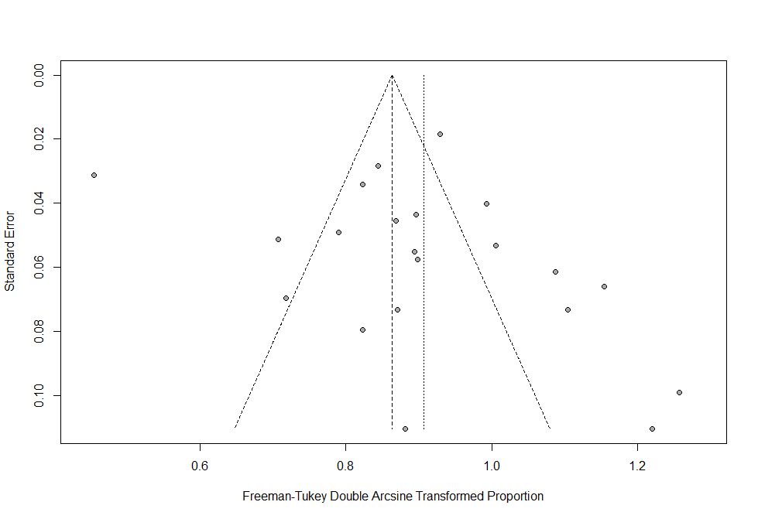

Egger’s test: p-value 0.31
Figure S 2: Funnel plot of incidence of grade≥3 overall potential irAEs in ipilimumab
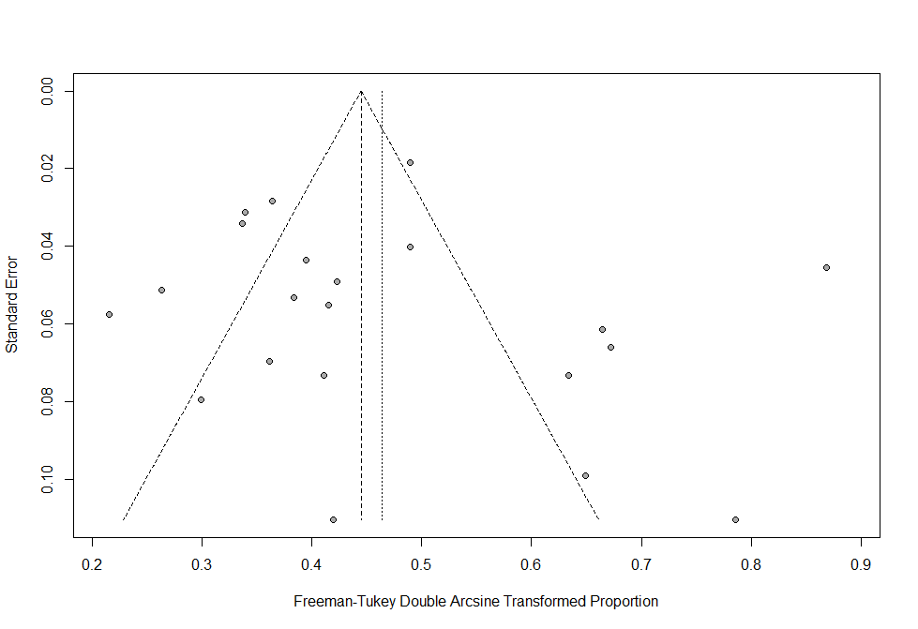
Egger’s test: p-value 0.59

Figure S 3: Funnel plot of incidence of all-grade overall potential irAEs in ipilimumab (FDA approved dose)
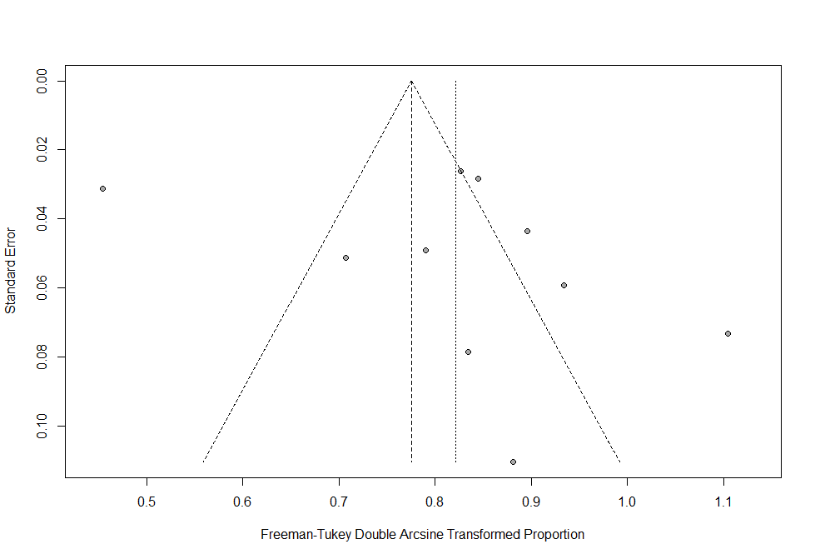
Egger’s test: p-value 0.39
Figure S 4: Funnel plot of incidence of grade≥3 overall potential irAEs in ipilimumab (FDA approved dose)
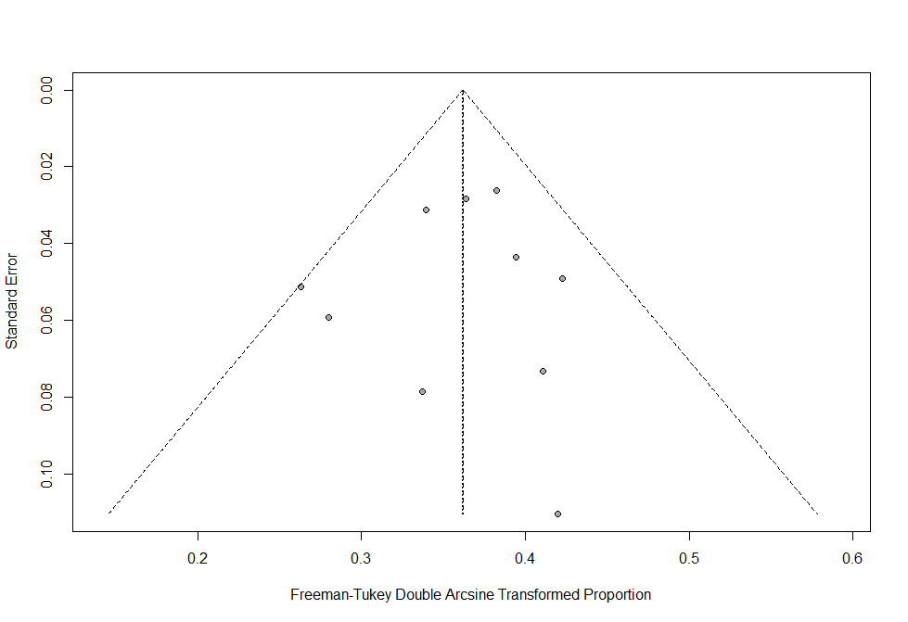
Egger’s test: p-value 0.82
Figure S 5: Funnel plot of incidence of all-grade overall potential irAEs in nivolumab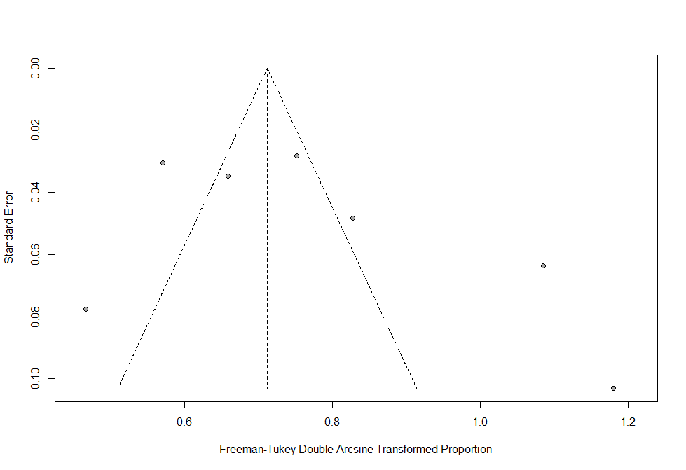
Egger’s test: p-value 0.27
Figure S 6: Funnel plot of incidence of grade≥3 overall potential irAEs in nivolumab
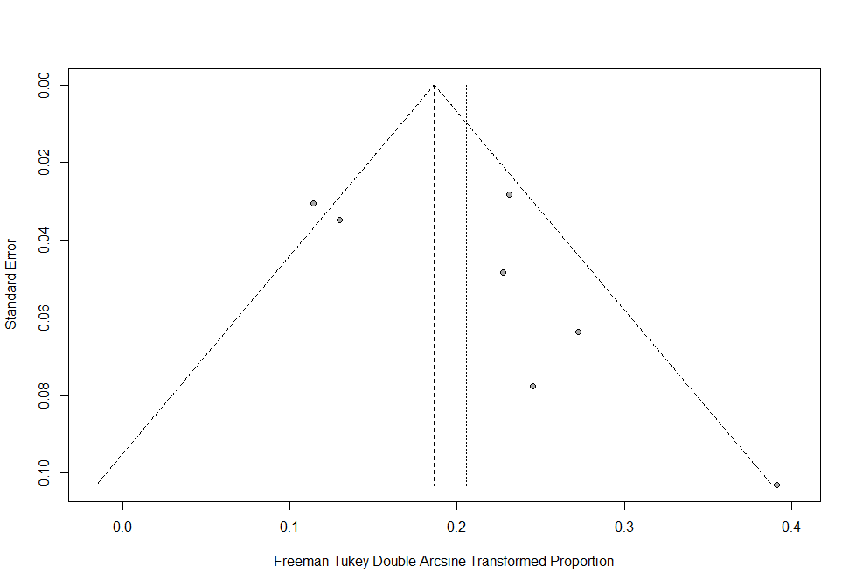
Egger’s test: p-value 0.16

Figure S 7: Funnel plot of incidence of all-grade overall potential irAEs in nivolumab (FDA approved dose)
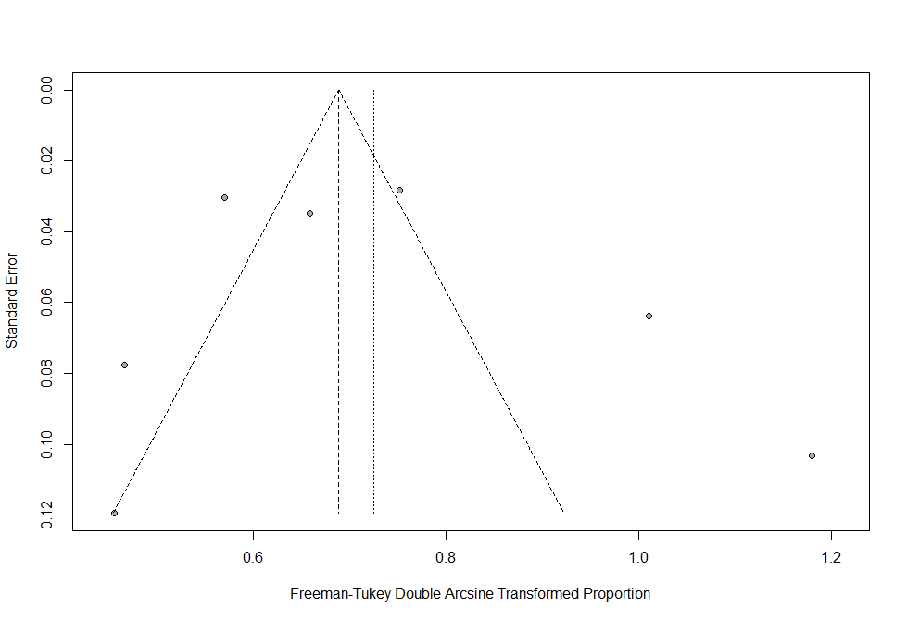
Egger’s test: p-value 0.62
Figure S 8: Funnel plot of incidence of grade≥3 overall potential irAEs in nivolumab (FDA approved dose)
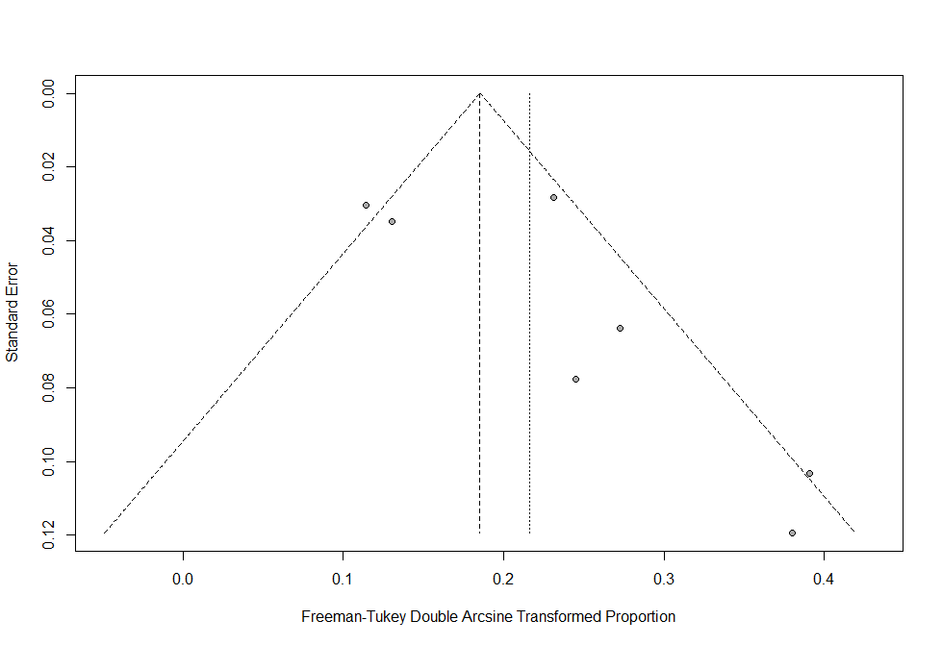
Egger’s test: p-value 0.12

Figure S 9: Funnel plot of incidence of all-grade overall potential irAEs in pembrolizumab
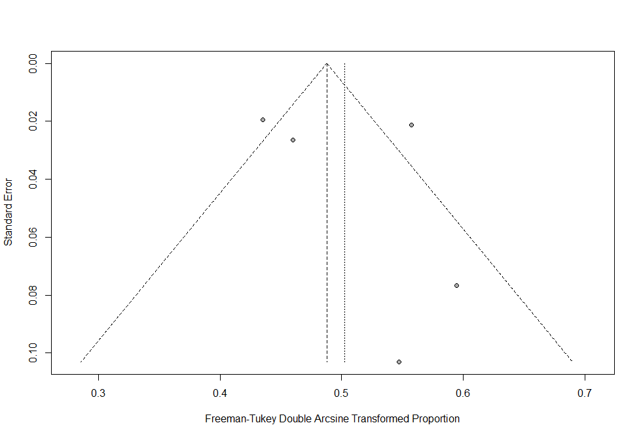
Egger’s test: p-value 0.62
Figure S 10: Funnel plot of incidence of grade≥3 overall potential irAEs in Pembrolizumab
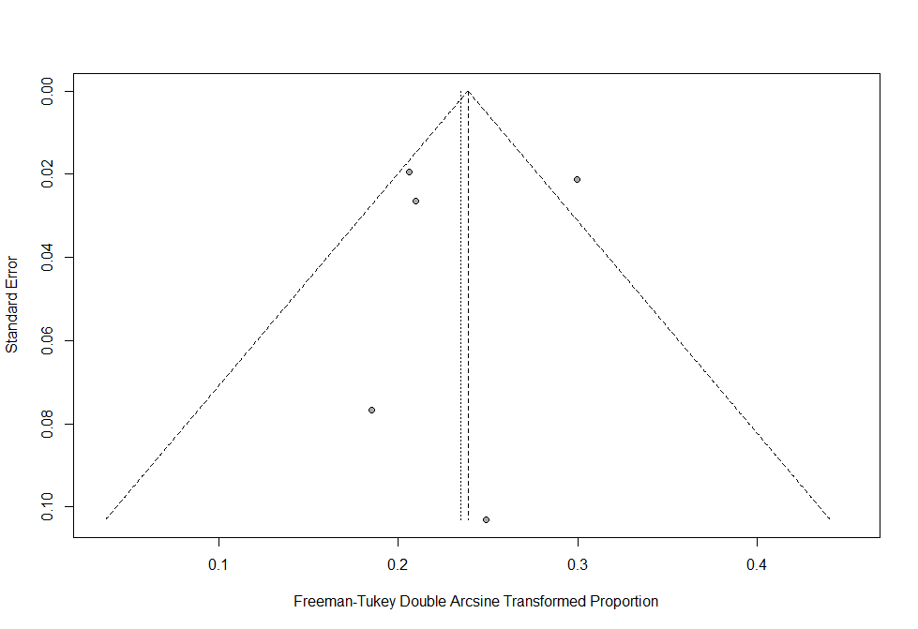
Egger’s test: p-value 0.83

Figure S 11: Funnel plot of incidence of all-grade overall potential irAEs in pembrolizumab (FDA approved dose)
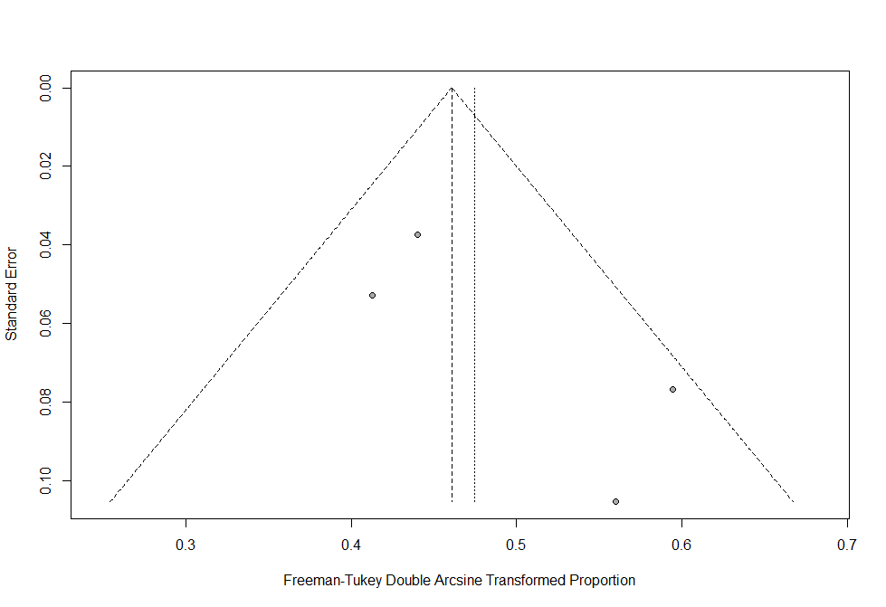
Egger’s test: p-value 0.23
Figure S 12: Funnel plot of incidence of grade≥3 overall potential irAEs in pembrolizumab (FDA approved dose)
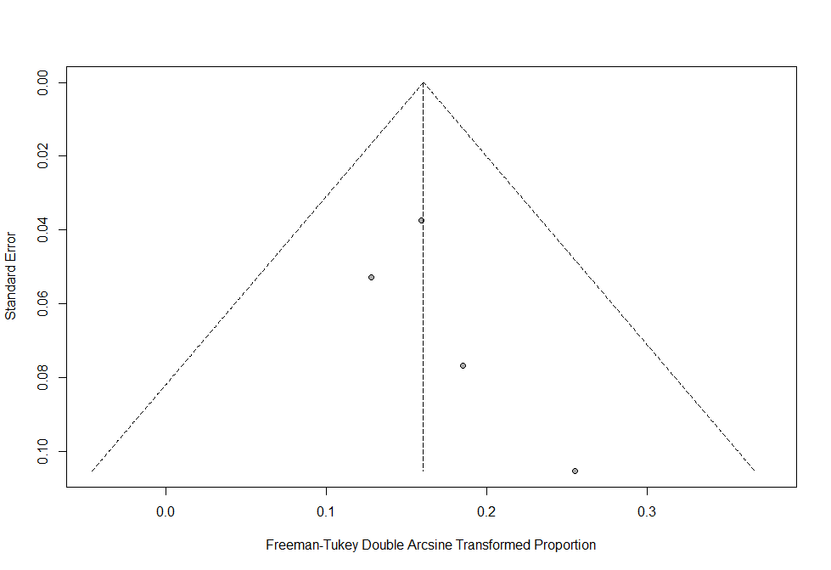
Egger’s test: p-value 0.31
Figure S 13: Funnel plot of incidence of all-grade overall potential irAEs in nivolumab and ipilimumab combination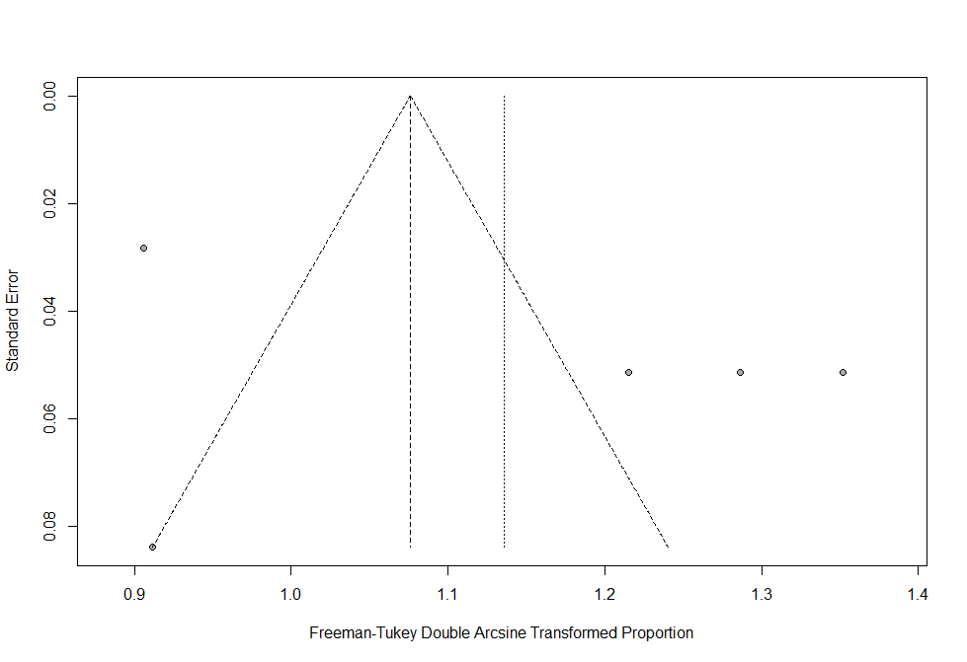
Egger’s test: p-value 0.32
Figure S 14: Funnel plot of incidence of grade≥3 overall potential irAEs in Overall nivolumab and ipilimumab combination 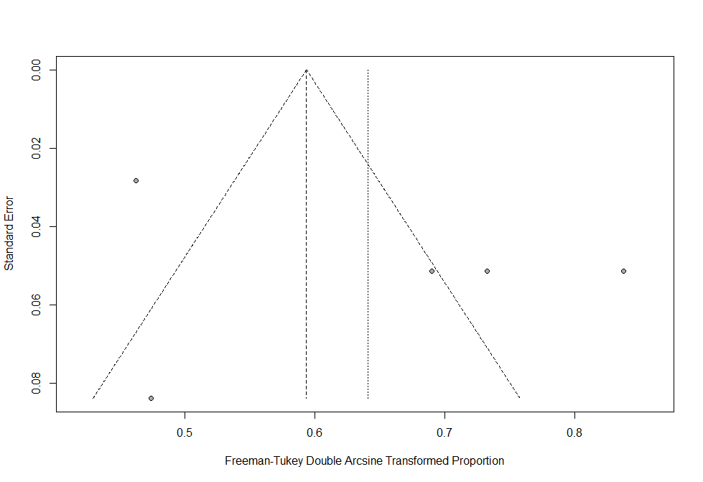
Egger’s test: p-value 0.32

Figure S 15: Funnel plot of incidence of all-grade overall potential irAEs in nivolumab and ipilimumab combination (FDA approved dose)
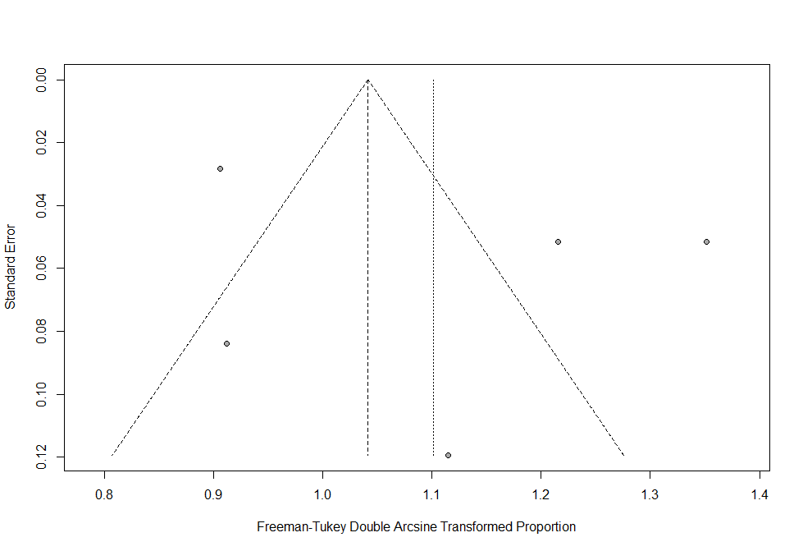
Egger’s test: p-value 0.46
Figure S 16: Funnel plot of incidence of grade≥3 overall potential irAEs in Overall nivolumab and ipilimumab combination (FDA approved dose)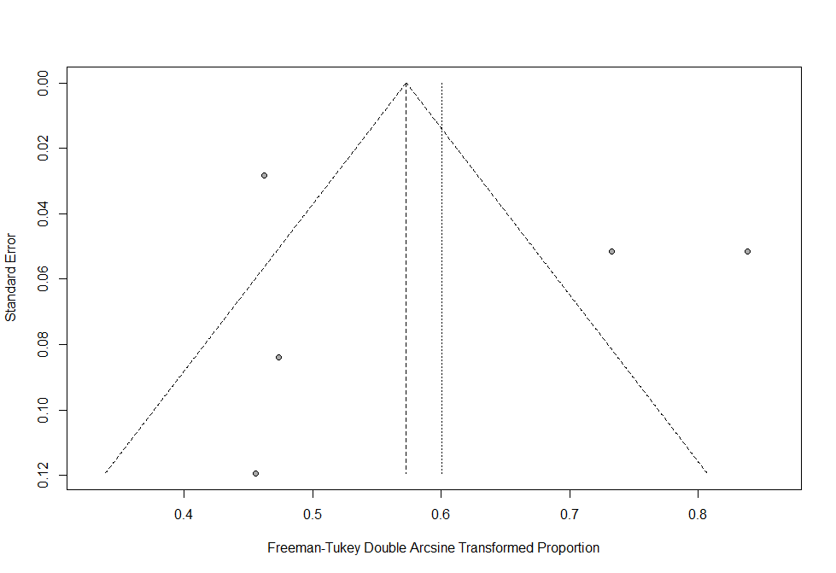
Egger’s test: p-value 0.62

Figure S 17: Forest plot of the incidence of all-grade colitis in the sequential of ipilimumab followed by nivolumab therapy
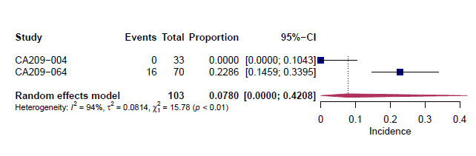

Figure S 18: Forest plot of the incidence of all-grade elevated alanine aminotransferase (ALT) in the sequential of ipilimumab followed by nivolumab therapy

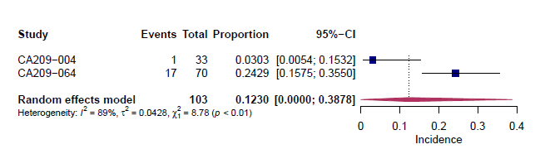

Figure S 19: Forest plot of the incidence of all-grade elevated amylase in the sequential of ipilimumab followed by nivolumab therapy
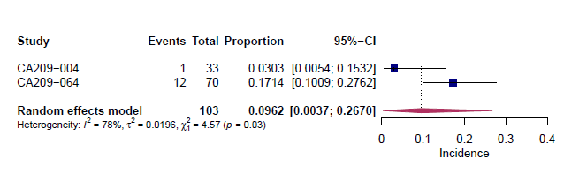

Figure S 20: Forest plot of the incidence of all-grade elevated aspartate aminotransferase (AST) in the sequential of ipilimumab followed by nivolumab therapy
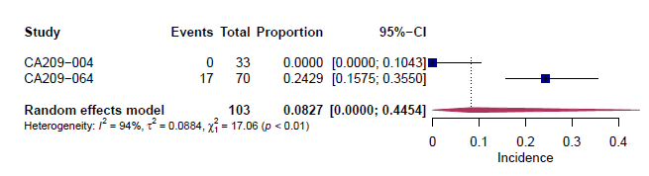

Figure S 21: Forest plot of the incidence of all-grade elevated lipase in the sequential of ipilimumab followed by nivolumab therapy
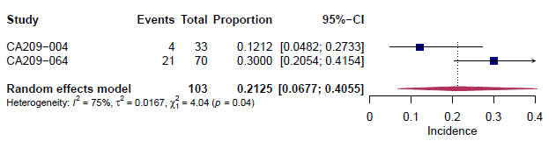

Figure S 22: Forest plot of the incidence of all-grade pruritus in the sequential of ipilimumab followed by nivolumab therapy
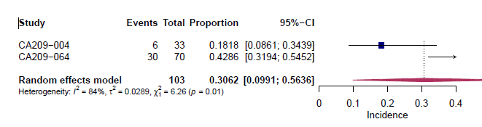

Figure S 23: Forest plot of the incidence of all-grade rash in the sequential of ipilimumab followed by nivolumab therapy
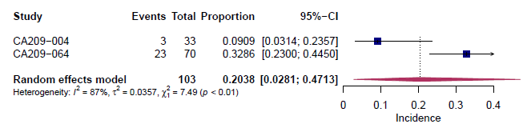

Figure S 24: Forest plot of the incidence of all-grade vitiligo in the sequential of ipilimumab followed by nivolumab therapy
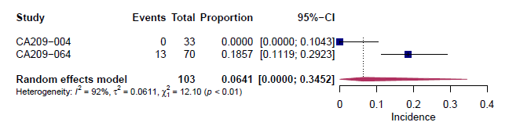

Figure S 25: Forest plot of the incidence of all-grade diarrhea in the sequential of ipilimumab followed by nivolumab therapy
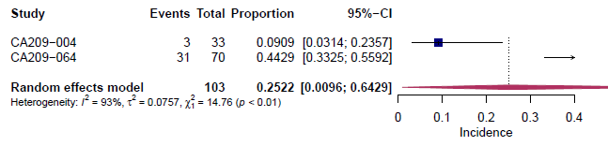

Figure S 26: Forest plot of the incidence of all-grade hypothyrodism in the sequential of ipilimumab followed by nivolumab therapy
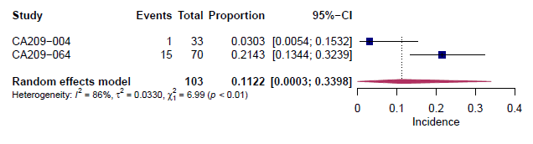

Figure S 27: Forest plot of the incidence of all-grade hepatitis in nivolumab monotherapy
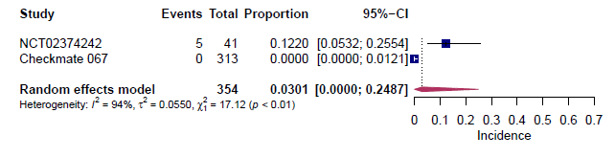

Figure S 28: Forest plot of the incidence of grade≥3 hepatitis in nivolumab monotherapy
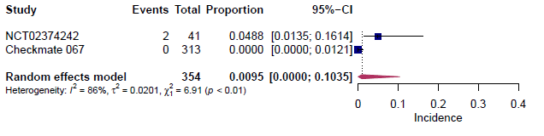

Figure S 29: Forest plot of the incidence of grade≥3 lymphopenia in nivolumab monotherapy
A: main analysis
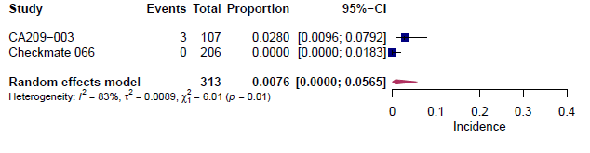
B: FDA approved dose analysis

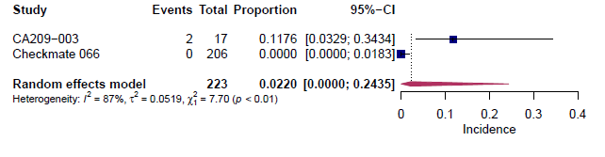

Figure S 30: Forest plot of the incidence of all-grade muscle spasms in nivolumab monotherapy
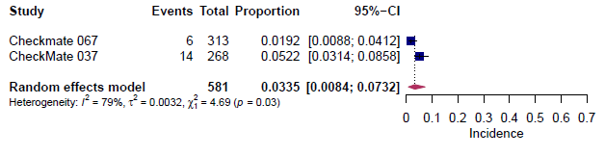

Figure S 31: Forest plot of the incidence of all-grade skin hypopigmentation in ipilimumab and nivolumab concomitant therapy
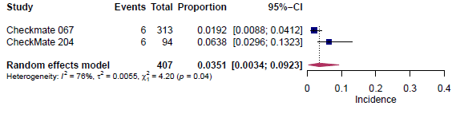

Figure S 32: Forest plot of the incidence of all-grade overall incidence of irAEs in ipilimumab monotherapy by prior treatment experience
A: main analysis
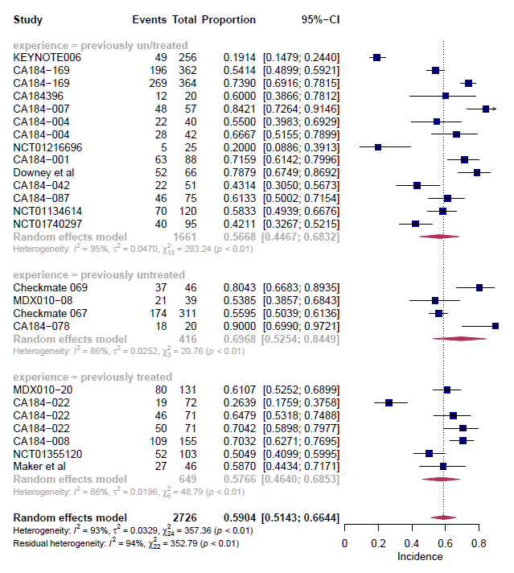

B: FDA approved dose analysis
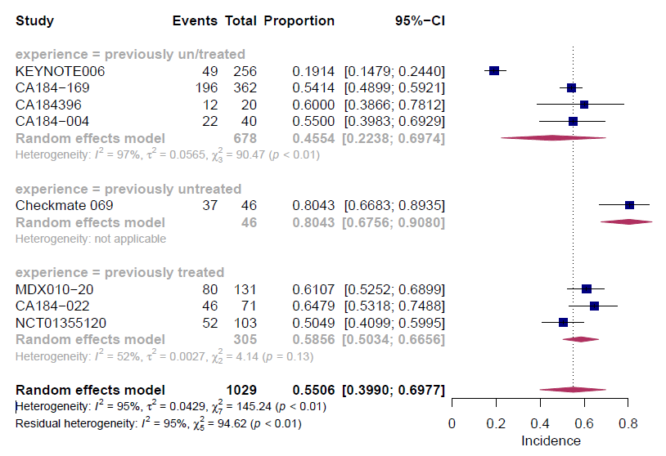

Figure S 33: Forest plot of the incidence of all-grade overall incidence of irAEs in nivolumab monotherapy by prior treatment experience
A: main analysis
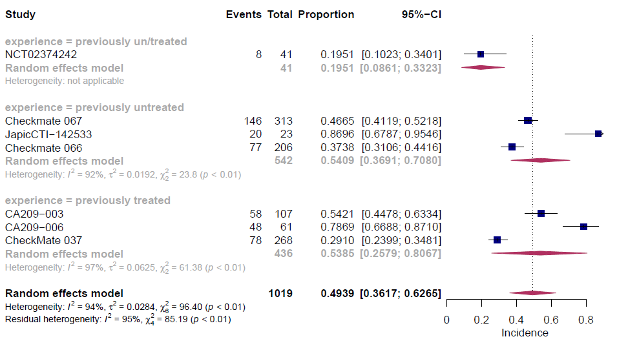
B: FDA approved dose analysis
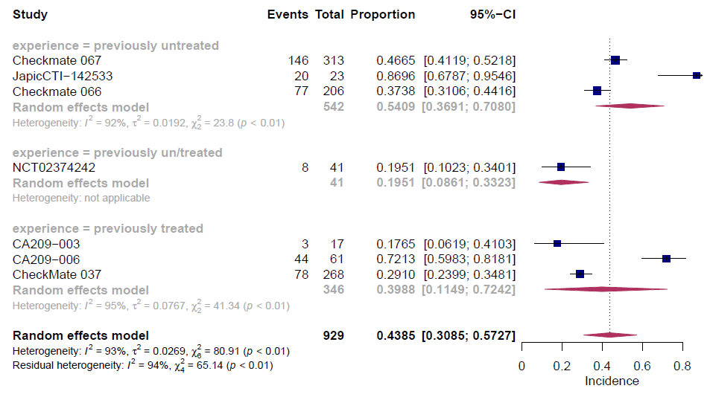

Figure S 34: Forest plot of the incidence of all-grade overall incidence of irAEs in ipilimumab and nivolumab combination therapy by prior treatment experience
A: main analysis
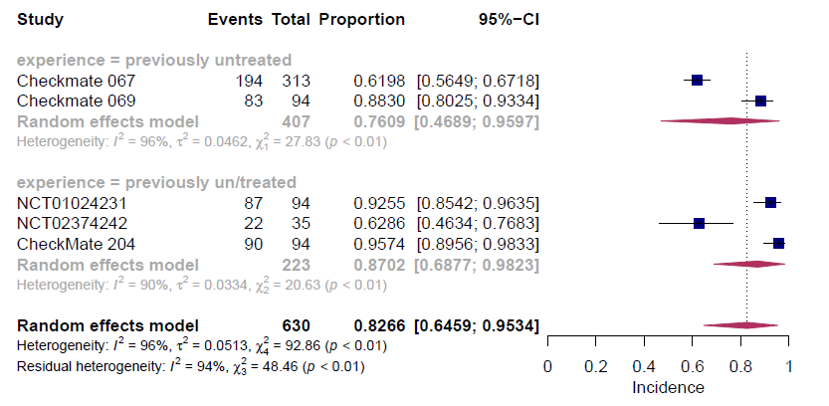

B: FDA approved dose analysis
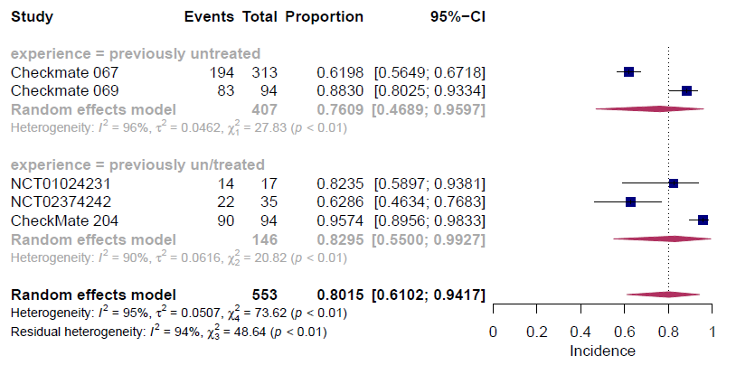

Figure S 35: Forest plot of the incidence of grade≥3 overall incidence of irAEs in ipilimumab and nivolumab combination therapy by prior treatment experience
A: main analysis
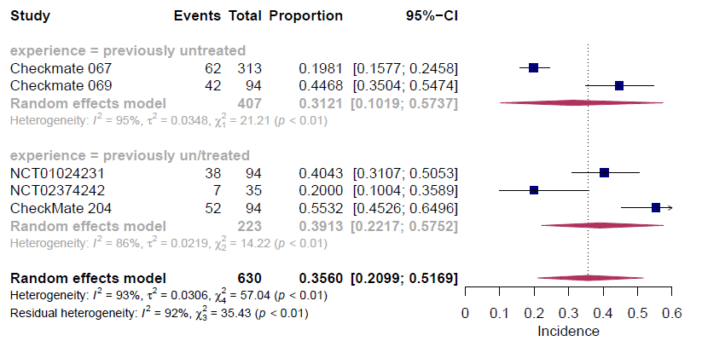

B: FDA approved dose analysis
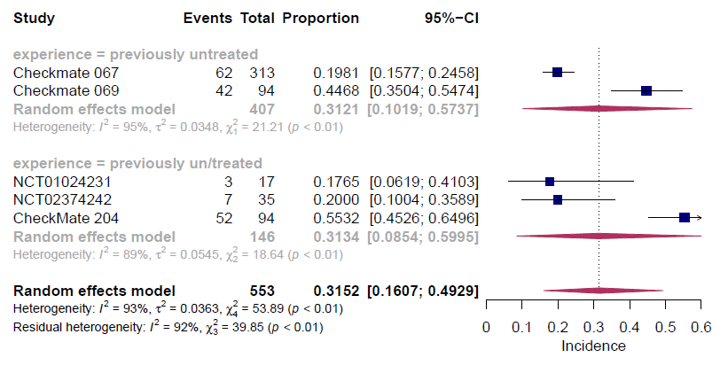

Figure S 36: Forest plot of the incidence of all-grade elevated amylase in ipilimumab monotherapy by prior treatment experience
A: main analysis
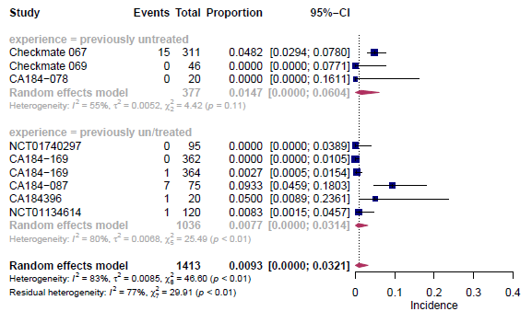
B: FDA approved dose analysis
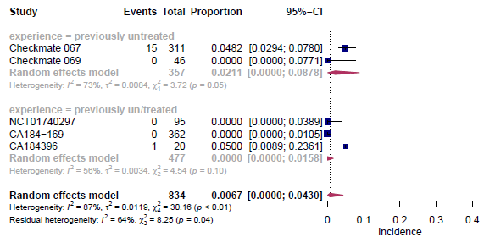

Figure S 37: Forest plot of the incidence of all-grade arthralgia in ipilimumab monotherapy by prior treatment experience
A: main analysis
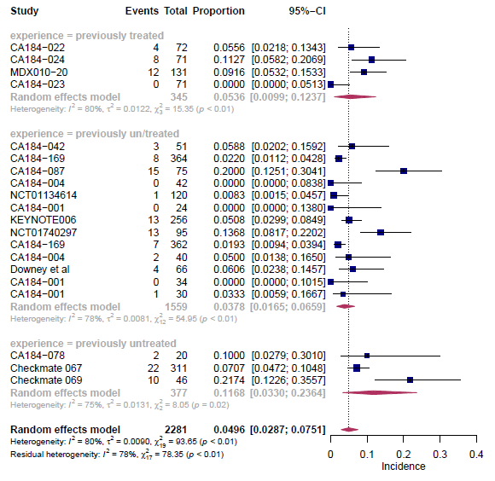
B: FDA approved dose analysis
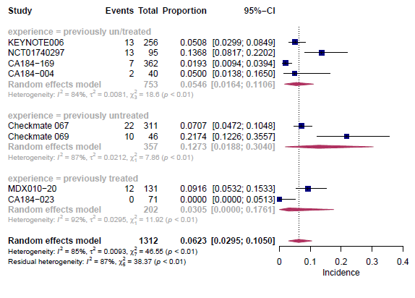

Figure S 38: Forest plot of the incidence of all-grade dermatitis in ipilimumab monotherapy by prior treatment experience
A: main analysis
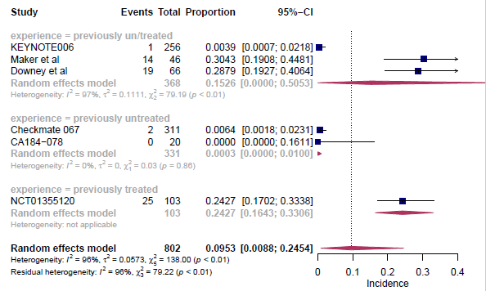
B: FDA approved dose analysis
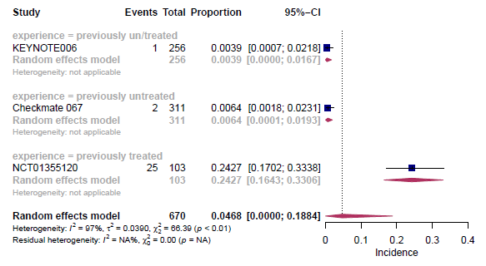

Figure S 39: Forest plot of the incidence of all-grade hyperglycemia in ipilimumab monotherapy by prior treatment experience
A: main analysis
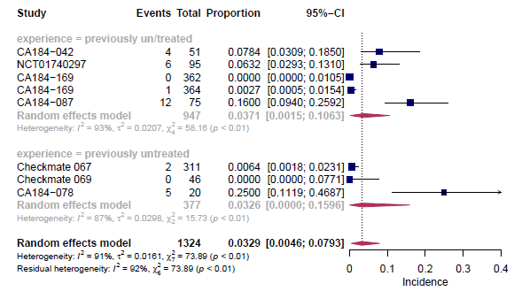
B: FDA approved dose analysis
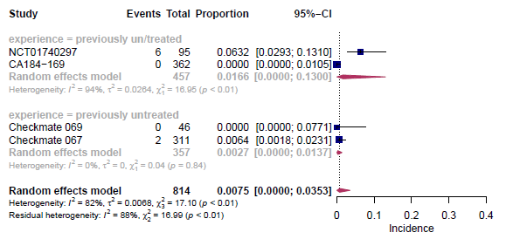

Figure S 40: Forest plot of the incidence of all-grade elevated lipase in ipilimumab monotherapy by prior treatment experience
A: main analysis
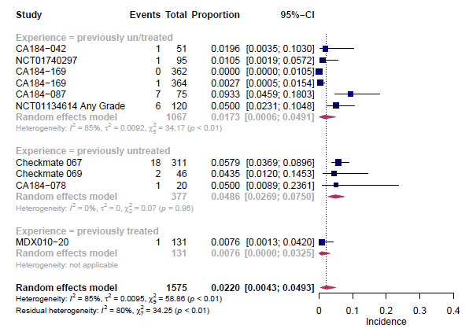
B: FDA approved dose analysis
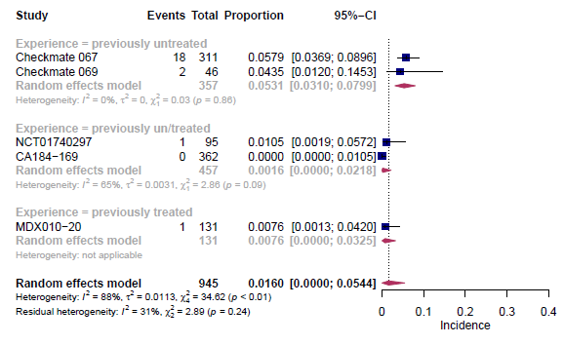

Figure S 41: Forest plot of the incidence of grade≥3 elevated lipase in ipilimumab monotherapy by prior treatment experience
A: main analysis
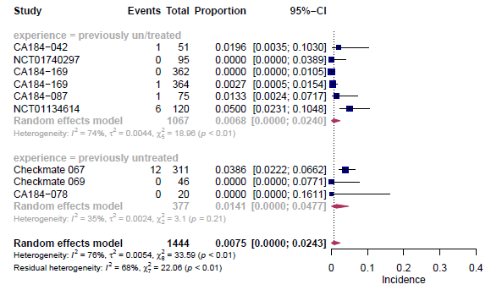
B: FDA approved dose analysis
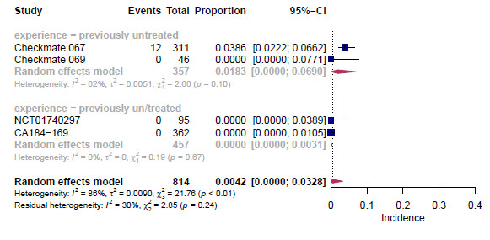

Figure S 42: Forest plot of the incidence of all-grade pruritus in ipilimumab monotherapy by prior treatment experience
A: main analysis
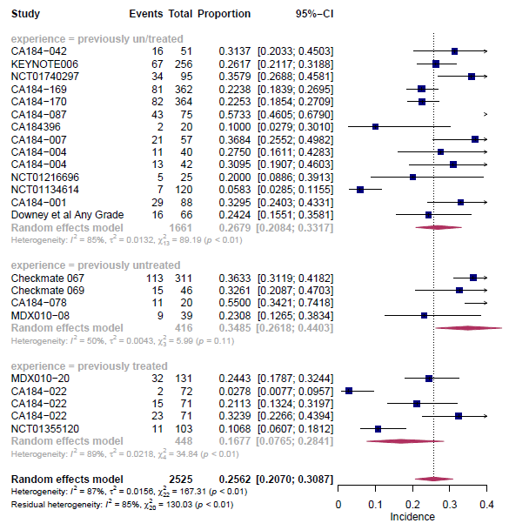
B: FDA approved dose analysis
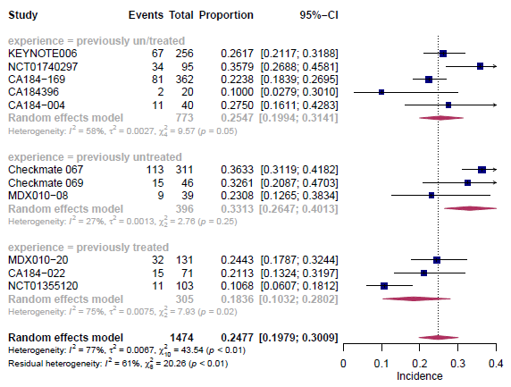

Figure S 43: Forest plot of the incidence of all-grade rash maculopapular in ipilimumab monotherapy by prior treatment experience
A: main analysis
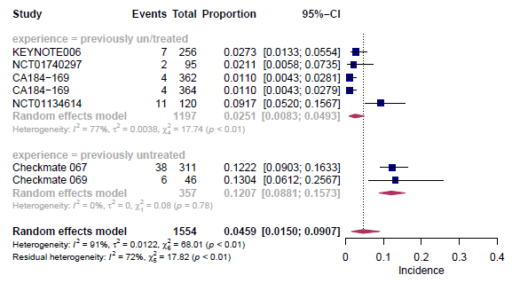
B: FDA approved dose analysis
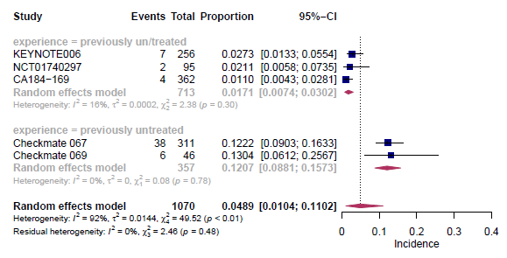

Figure S 44: Forest plot of the incidence of all-grade elevated blood alkaline phosphatase in nivolumab monotherapy by prior treatment experience
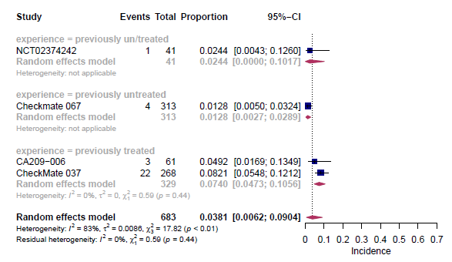

Figure S 45: Forest plot of the incidence of all-grade alopecia in nivolumab monotherapy by prior treatment experience
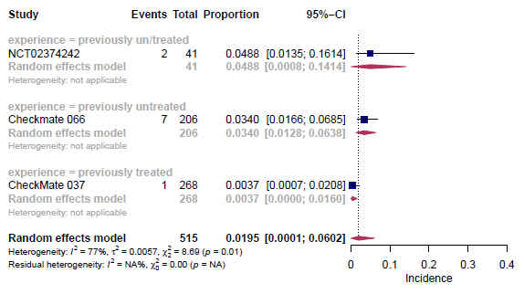

Figure S 46: Forest plot of the incidence of all-grade diarrhea in nivolumab monotherapy by prior treatment experience
A: main analysis
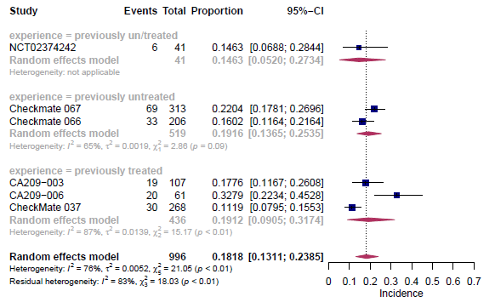
B: FDA approved dose analysis
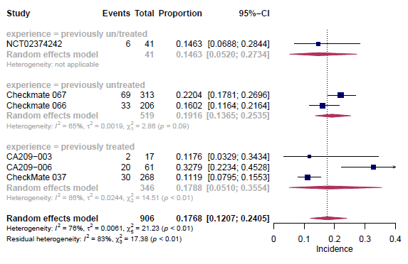

Figure S 47: Forest plot of the incidence of all-grade elevated lipase in nivolumab monotherapy by prior treatment experience
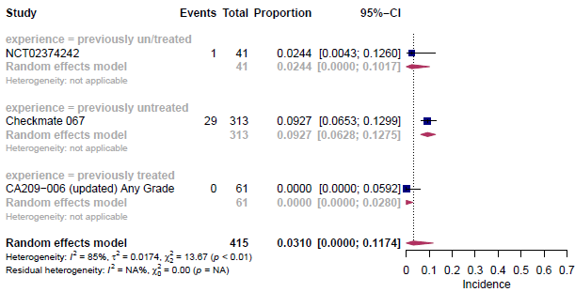

Figure S 48: Forest plot of the incidence of all-grade pruritus in nivolumab monotherapy by prior treatment experience
A: main analysis
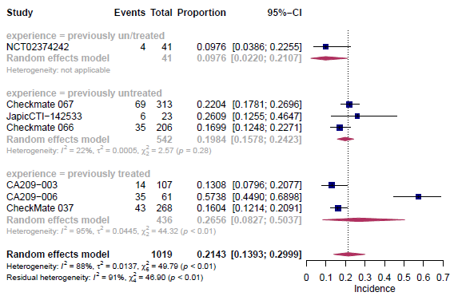
B: FDA approved dose analysis
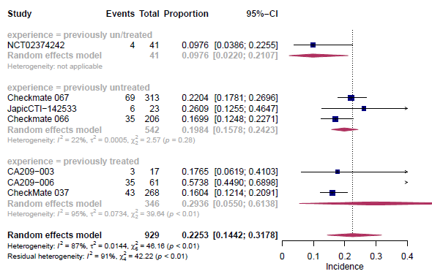

Figure S 49: Forest plot of the incidence of all-grade rash in nivolumab monotherapy by prior treatment experience
A: main analysis
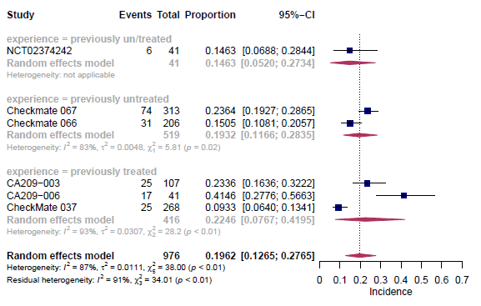
B: FDA approved dose analysis
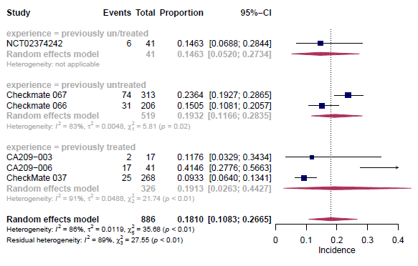

Figure S 50: Forest plot of the incidence of all-grade maculopapular rash in nivolumab monotherapy by prior treatment experience
A: main analysis
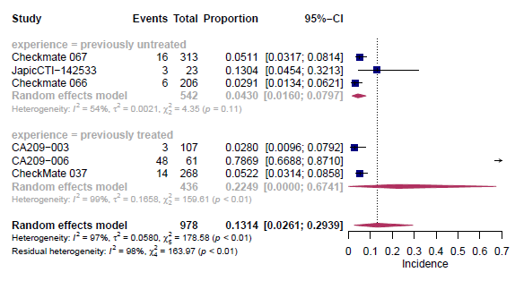
B: FDA approved dose analysis
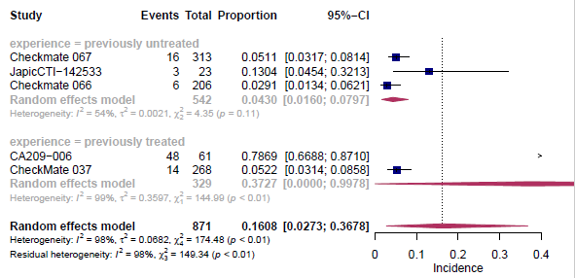

Figure S 51: Forest plot of the incidence of all-grade elevated aspartate aminotransferase (AST) in ipilimumab and nivolumab combination therapy by prior treatment experience
A: main analysis
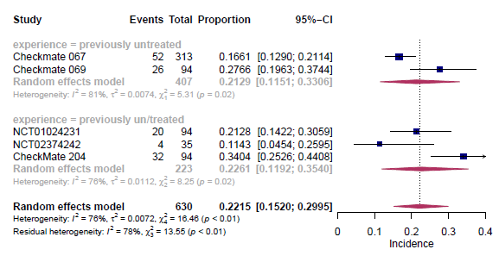
B: FDA approved dose analysis
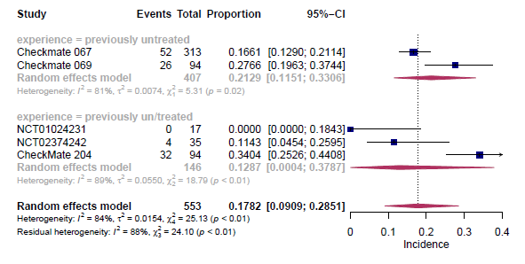

Figure S 52: Forest plot of the incidence of all-grade hepatitis in ipilimumab and nivolumab combination therapy by prior treatment experience
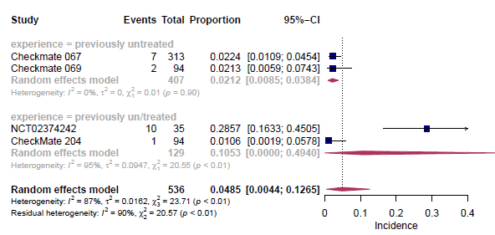

Figure S 53: Forest plot of the incidence of all-grade myalgia in ipilimumab and nivolumab combination therapy by prior treatment experience
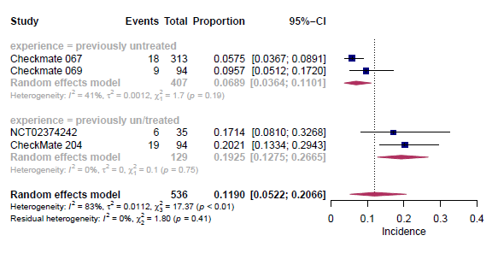

Figure S 54: Forest plot of the incidence of all-grade rash in ipilimumab and nivolumab combination therapy by prior treatment experience
A: main analysis
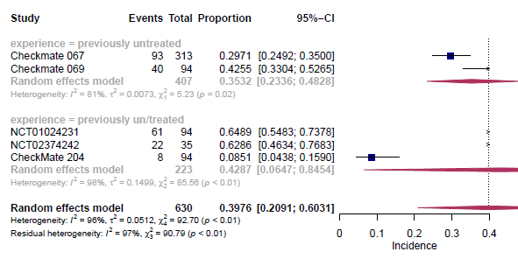
B: FDA approved dose analysis
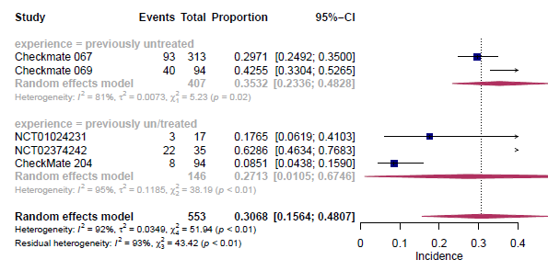

Figure S 55: Forest plot of the incidence of all-grade maculopapular rash in ipilimumab and nivolumab combination therapy by prior treatment experience
A: main analysis
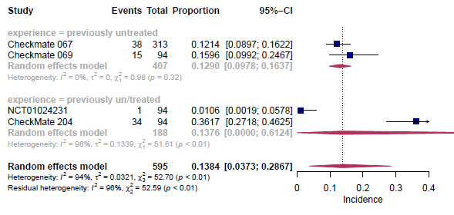
B: FDA approved dose analysis
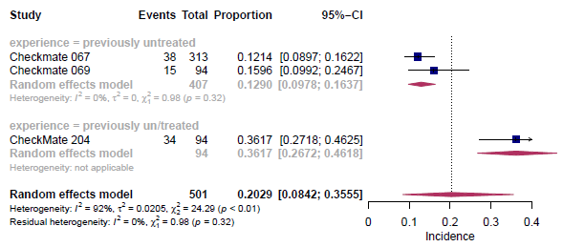

Figure S 56: Forest plot of the incidence of grade≥3 diabetes mellites in ipilimumab (FDA dose) monotherapy by prior treatment experience
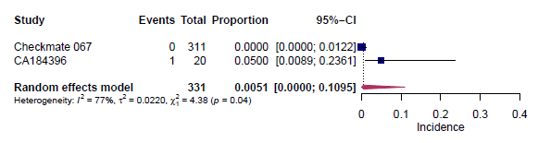

Figure S 57: Forest plot of the incidence of all-grade lymphopenia in nivolumab (FDA dose) monotherapy by prior treatment experience
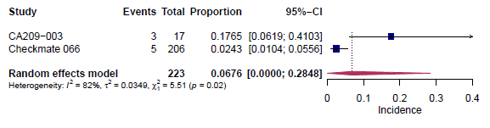

Figure S 58: Forest plot of the incidence of all-grade photosensitivity in nivolumab (FDA dose) monotherapy by prior treatment experience
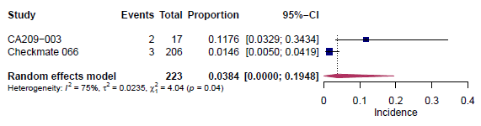

Figure S 59: Forest plot of the incidence of all-grade erythema in ipilimumab and nivolumab (FDA dose) combination therapy by prior treatment experience
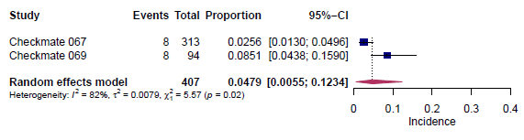

Figure S 60: Forest plot of the incidence of all-grade hyperthyroidism in ipilimumab (FDA dose) monotherapy by prior treatment experience
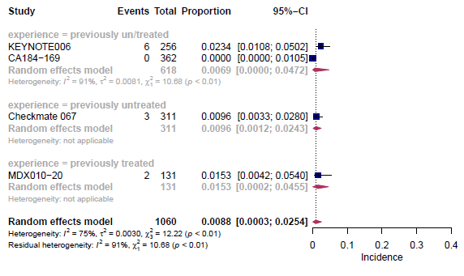

Figure S 61: Forest plot of the incidence of all-grade myalgia in ipilimumab (FDA dose) monotherapy by prior treatment experience
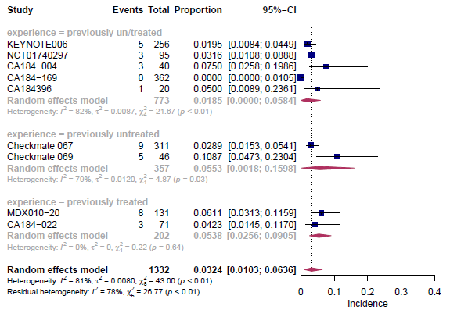

Figure S 62: Forest plot of the incidence of all-grade elevated alanine aminotransferase (ALT) in ipilimumab and nivolumab (FDA dose) combination therapy by prior treatment experience
