Supplementary Material

Supplementary Figures
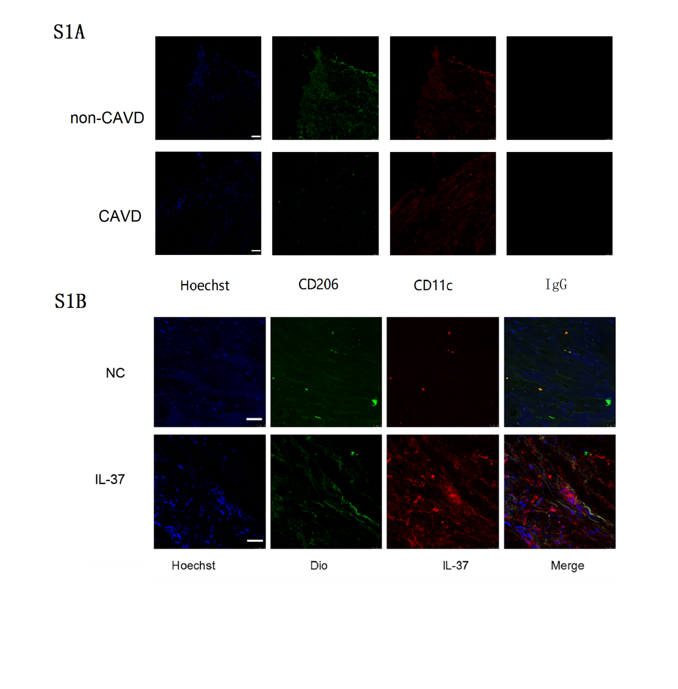

Supplementary Figure 1. Calcified aortic valves show more M1 infiltration than M2 while non-calcified aortic valves show the opposite. (A) Representative images show that there are less CD11c+ cells (M1 macrophages) than CD206+ cells (M2 macrophages) accumulation in non-calcified aortic valves, while calcified aortic valves show more CD11c+ cells (M1 macrophages) than CD206+ cells . (B) IL-37 staining in non-calcified aortic valves indicates that IL-37 locates both intracellularly and extracellularly. IF, Immunofluorescence; IgG: isotype control,NC, negative control; Dio, 3,3′-dioctadecyloxacarbocyanine perchlorate; scale bar, 25μm.

Supplementary Figure 2. Calcified aortic valve tissues show more M1 macrophage infiltration and less IL-37 expression. (A) Representative images show that there are more M1 macrophage infiltration and less CD206 expression in calcified aortic valve; scale bar, 100μm. HE, hematoxylin-eosin; IHC, Immunohistochemistry. (B) Representative western blots show the expression of iNOS (M1 marker), CD206 (M2 marker) and IL-37 in non-calcified and calcified aortic valves; n=3. (C) Densitometric data show the expression of iNOS , CD206 , IL-37 in non-calcified and calcified aortic valve tissues; *P < 0.05, **P < 0.01.

Supplementary Figure 3. Recombinant human IL-37 inhibits NF-κB activation induced by LPS and IFN-γ co-treatment. (A-B) Representative western blots and densitometric data show that IL-37 inhibits NF-κB phosphorylation at different time points; n=3; ***P < 0.001.

