Supplementary Material

Supplementary Figures
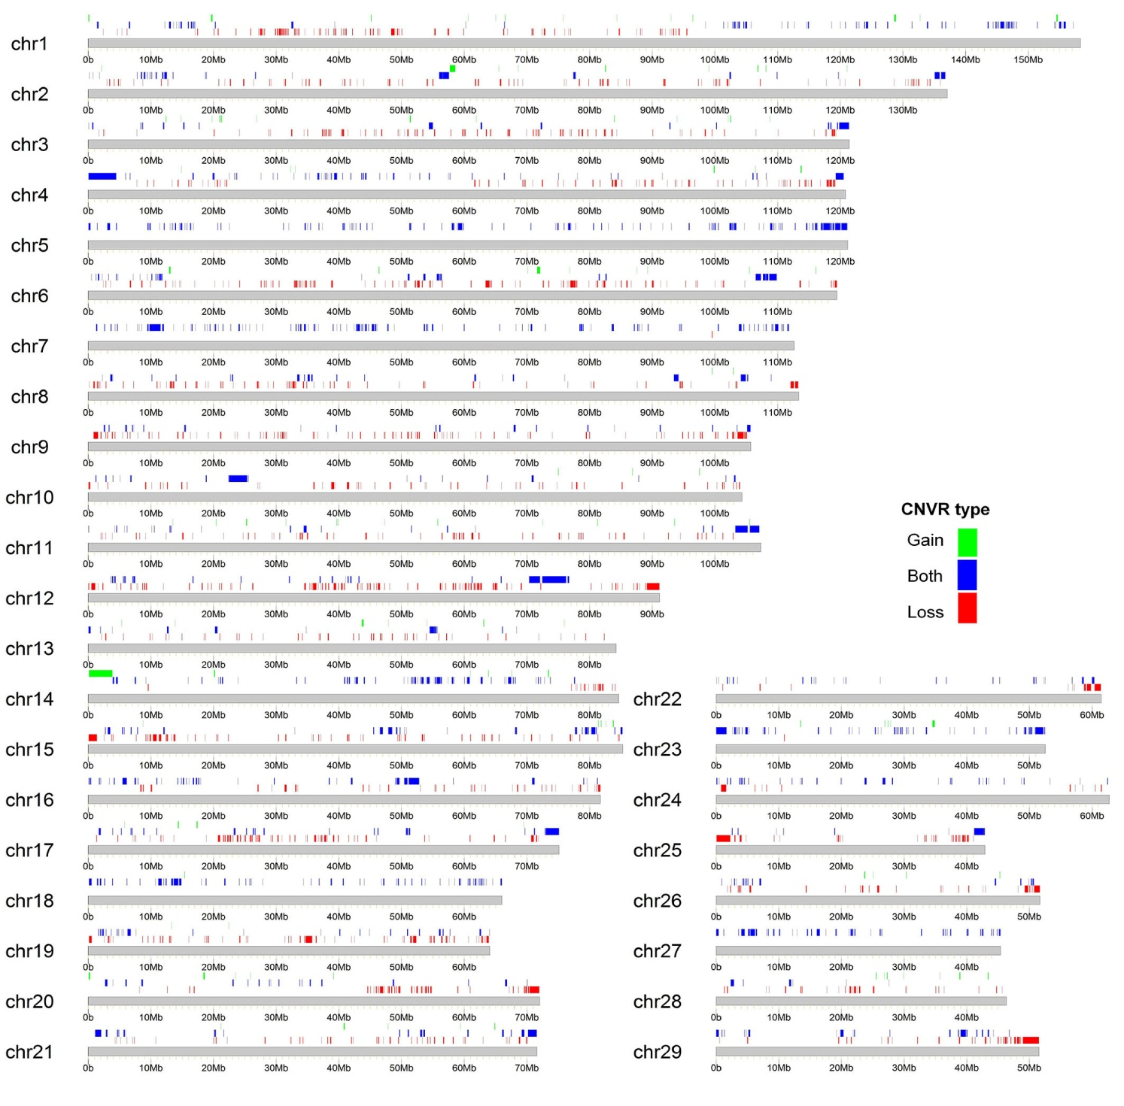
Figure S1. Genomic distribution of CNVRs in 318 Chinese indigenous cattle.

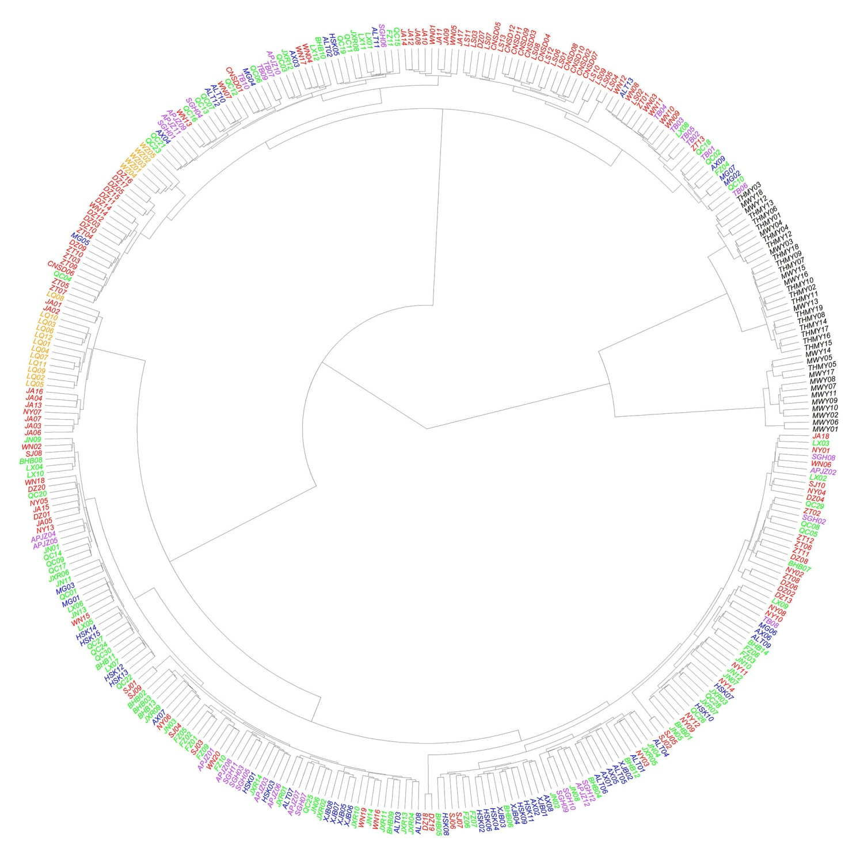
Figure S2. Neighbor-joining clustering map of 318 Chinese indigenous cattle and 37 yaks.
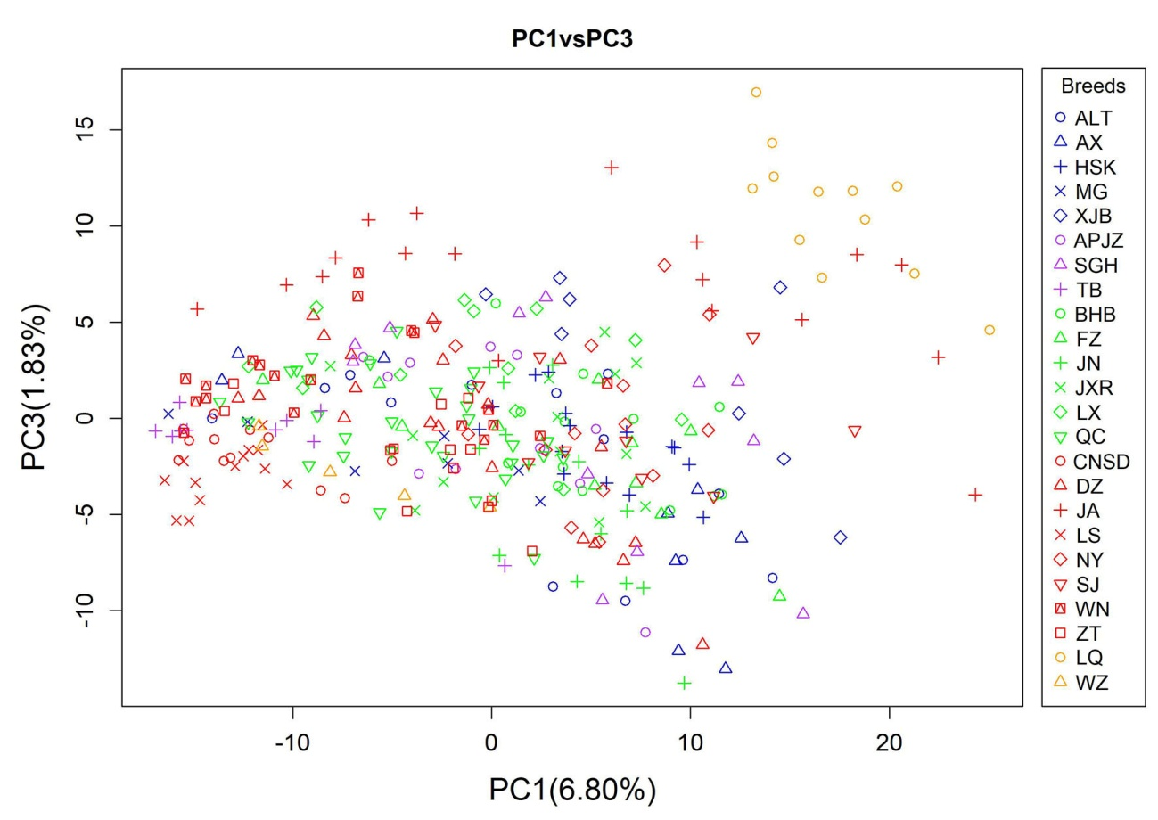
Figure S3. Principal component analysis (PCA) based on CNVs of animals assessed, with colors and shapes representing specific breeds. PC3 described 1.97% of the total variation, separated LQ and partial JA from other cattle breeds.
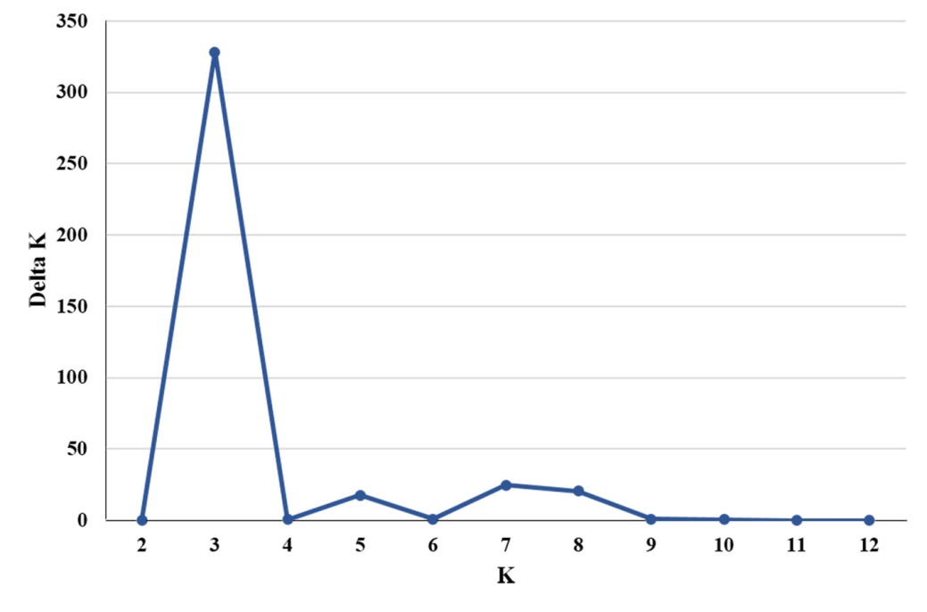
Figure S4. DeltaK values for K=2 to K=12. The DetaK value of K=3 is the largest. Accordingly, the best K value is the number of three.

