Figure S1. Western blot exhibiting specificity of anti-DivIVA_{Ef} and anti-EF1025 antibody for DivIVA_{Ef} and EF1025. An E. faecalis whole cell lysate was probed with anti-DivIVA_{Ef} (Lanes 1-4), and anti-EF1025 (Lanes 5-8). A protein ladder confirmed the presence of protein bands of sizes corresponding to DivIVA_{Ef} (40 kDa) or EF1025 (27 kDa).
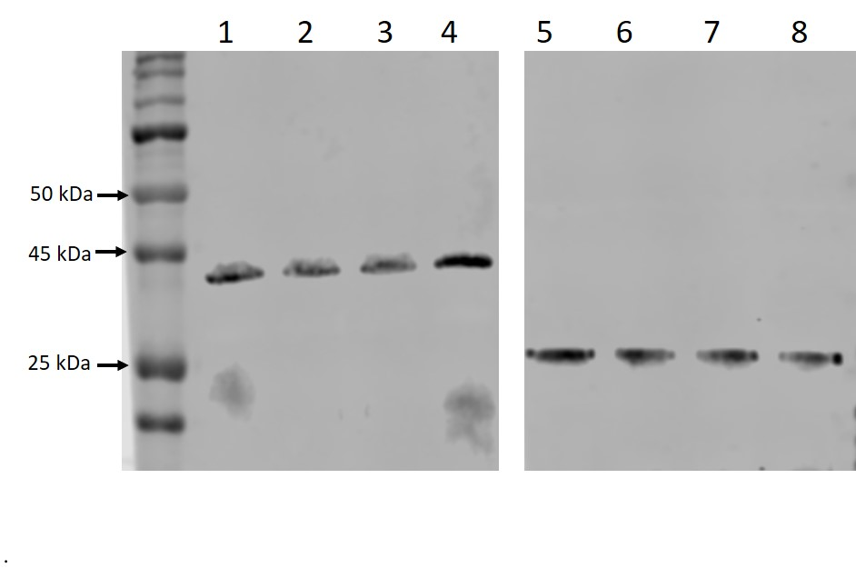

Figure S2. Light scattering (LS) data and measured molar mass for EF1025 (under denaturing conditions). Separated by SEC and detected using the μDAWN and UT-rEX (red) detected with the Wyatt TREOS and Optilab T-rEX (blue). The plot shows the chromatograms as a function of elution time. The average molecular weight calculated was 222 kDa for the complex. Black line shows aggregation profile of the protein.

Figure S3. EF1025CBS12 interacts with DivIVA_{Ef} in GST pull-down assay. Shown is a Western blot probed with an anti-6xHis EF1025 monoclonal antibody. Lane 1: Protein Ladder; Lane 2: GST bound beads; Lane 3: GST-DivIVA_{Ef} bound beads; Lane 5: E. faecalis extracts representing 10% input of EF1025CBS12.
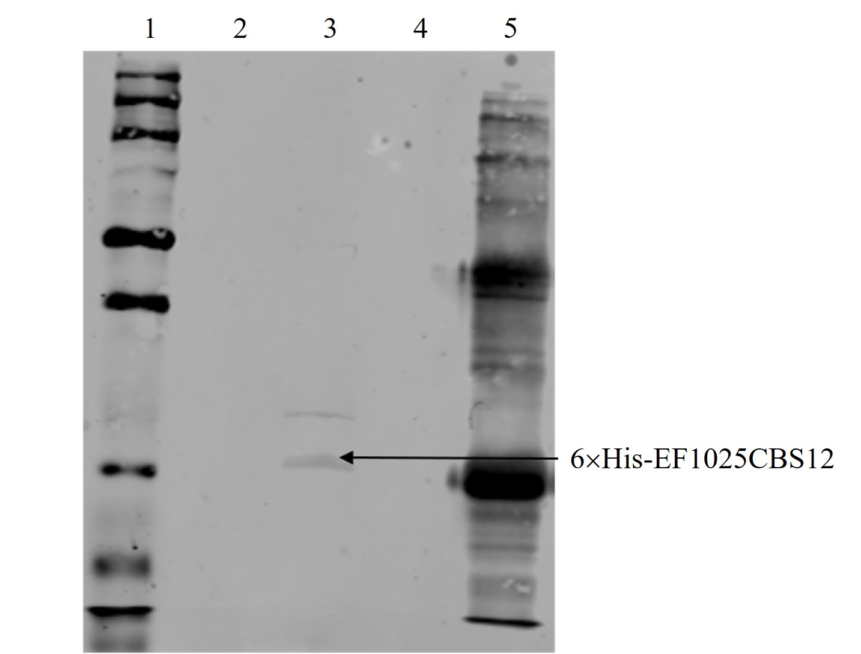

Figure S4. Confirmation of Kan^{R} cassette insertion in EF1025 in E faecalis MJ26. (A) Schematic presentation of genomic insertional inactivation of EF1025 in E. faecalis. A kan^{R} cassette was inserted at the nt151 position of mljd1. Arrows indicated primers used for PCR amplification to confirm Kan^{R} insertion in the E. faecalis genomic DNA, (B) PCR confirmation of insertional mutation. PCR was performed on E. faecalis MJ26 genomic DNA using primer pairs Mut-F/Kan-R (Lane 1- 1300 bp), Kan-F/Kan-R (Lane 2- 930 bp), Pro-F/Kan-R (Lane 3- 1500 bp), Kan-F/CBSDPR (Lane 4- 1409 bp) and CBSDPF/CBSDPR (Lane 5- 1560 bp and 630 bp). M: 1kb plus DNA ladder. Presence of wild type EF1025 was due to the presence of co-transformed plasmid pMSPEF1025-Pro (Lane 5). Lane 6: cropped lane from same gel with amplified wild type EF1025.
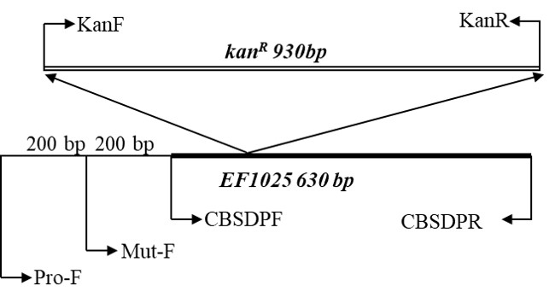
A.

B. 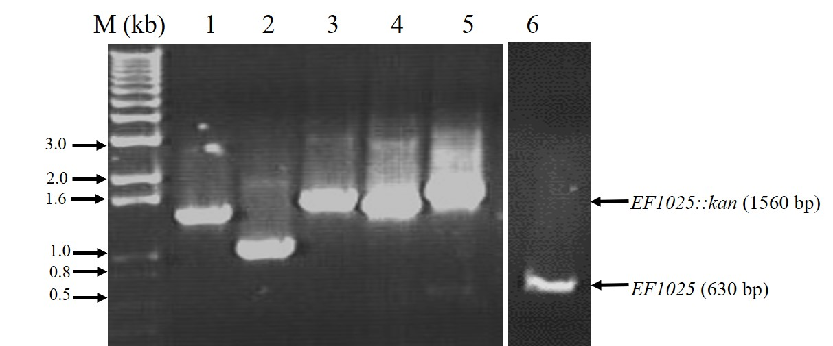

Figure S5. E. faecalis MJ26 and MK12 grew slower than E. faecalis JH2-2 cells. Viability curve of E. faecalis MJ26 cells. Growth was measured by OD at 600nm. E. faecalis MJ26 cells were subcultured on BHI containing appropriate antibiotics. Samples were withdrawn for plating every 2 hours. X- axis: Viable counts (CFU/ml), Y- axis- time (hours). X marked line- E. faecalis MK12; Open triangle line- E. faecalis JH2-2; Closed triangle line- E. faecalis MJ26.

Figure S6. RT-PCR of EF1026 in E. faecalis JH-2-2 and MJ26 showing absence of polar effect. PCR amplified products corresponding to EF1026 from JH-2-2 and MJ26. Lanes 1 and 2: EF_1026 from E. faecalis JH-2-2, Lanes 3 and 4: gdh from E. faecalis JH-2-2, Lane 5: negative control E. faecalis JH-2-2 with no reverse transcriptase; Lanes 6 and 7: EF_1026 from E. faecalis MJ26, Lanes 8 and 9: gdh from E. faecalis MJ26, Lane 10: negative control from E. faecalis MJ26 with no reverse transcriptase. gdh- glucose dehydrogenase (housekeeping gene).
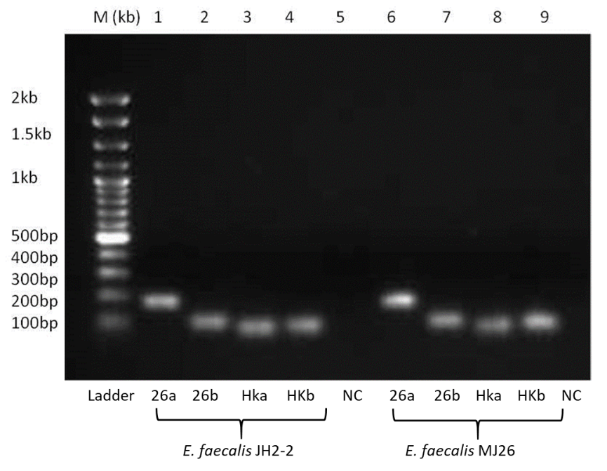

Figure S7. E. faecalis MK12 cells exhibit larger aggregates than E. faecalis JH2-2. Representative AFM error images of E. faecalis JH2-2 (A) and E. faecalis MK12 (B) collected in QI mode with a resolution of 128×128 pixels per image. Both JH2-2 and MK12 form relatively frequent cell aggregates that are larger for MK12. Since these clusters had irregular shapes and cell numbers, sizes could not be accurately estimated. Bar scale (5 µm) indicated at the bottom right corner of each image.
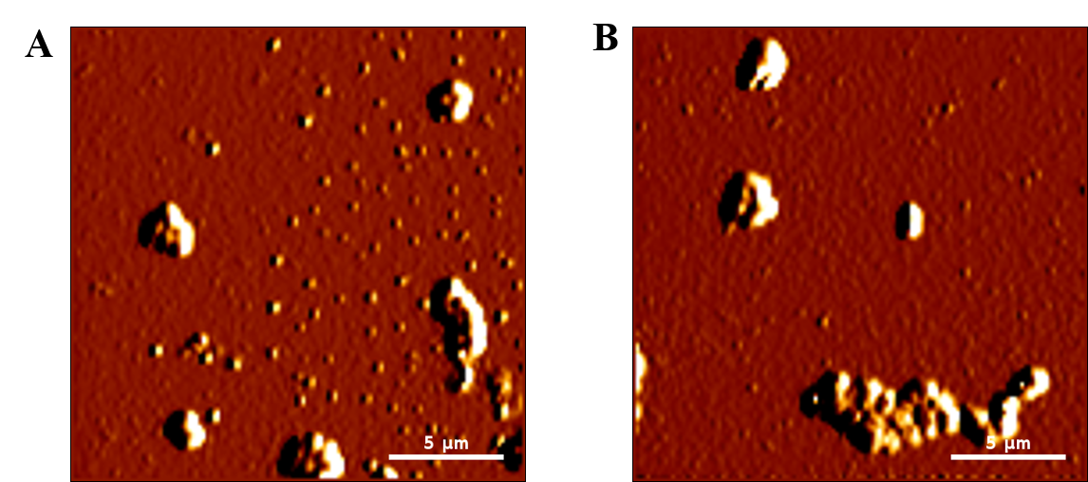

Figure S8. Shown are (A) Western blot probed with anti-Flag antibody to detect the presence of EF1025-flag in E. faecalis MK24. (B) Representative Western blot probed with anti-EF1025 to detect the presence of EF1025. Whole cell extract from: Lane 1: E. faecalis JH2-2; Lane 2: E. faecalis MK23; and Lane 3: E. faecalis MK24. (C) Densitometric quantification of band intensities corresponding to EF1025 from strains E. faecalis JH2-2, E. faecalis MK23, and E. faecalis MK24.
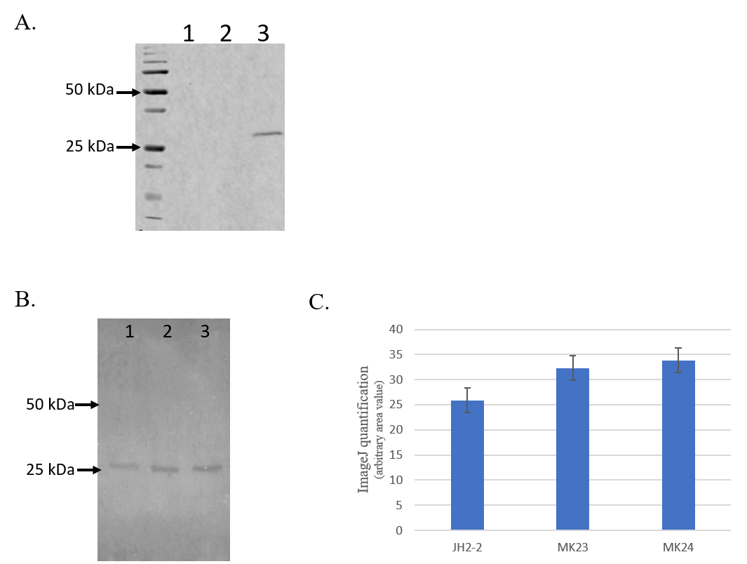

Figure S9. Overexpression of EF1025 in E. coli PB103 leads to severe cell elongation. Phase contrast microscopy of E. coli PB103 cells. (A) E. coli PB103 cells; (B) filamentous E. coli PB MK23 (>15 µm) cells transformed with pUCHisEF1025, and (C) E. coli PB MK25 overexpressing prgX_{Ef}. Scale bars represent 25 μm; n=89.

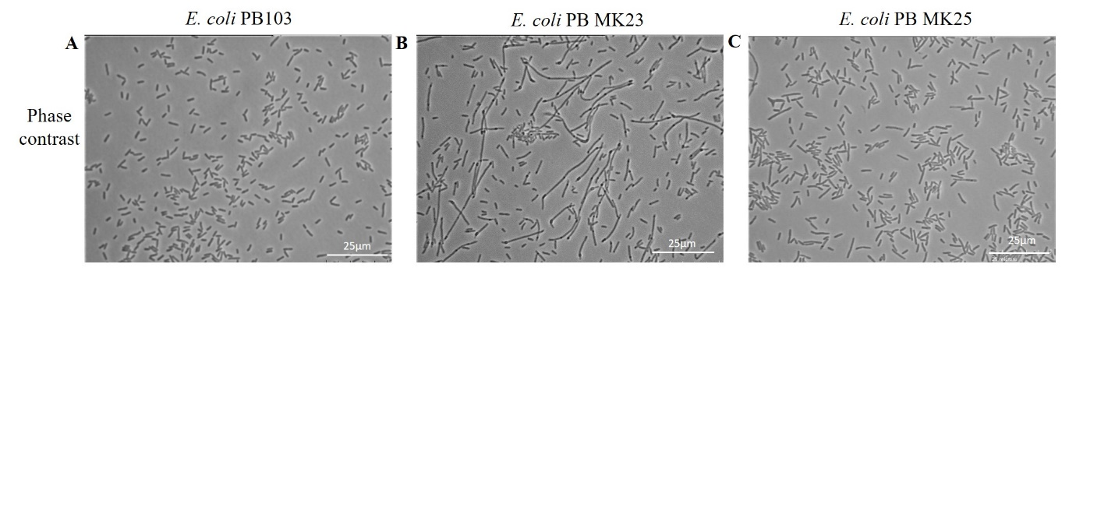
Figure S10. DivIVA_{Ef} exhibited loss of localization at the cell poles and midcell position in E. faecalis MWMR16 cells. Averaged images and fluorescence intensity traces of E. faecalis MWMR16 cells grown to mid-exponential phase in BHI broth and dual-stained with DAPI and Alexa-Fluor 488 as described in the methodology section and images were acquired using the InVitro 3 and ImagePro 6.0 softwares (Media Cybernetics) as described in Methodology. DivIVA_{Ef} with coiled-coil disrupted region localized along the cell membrane.

